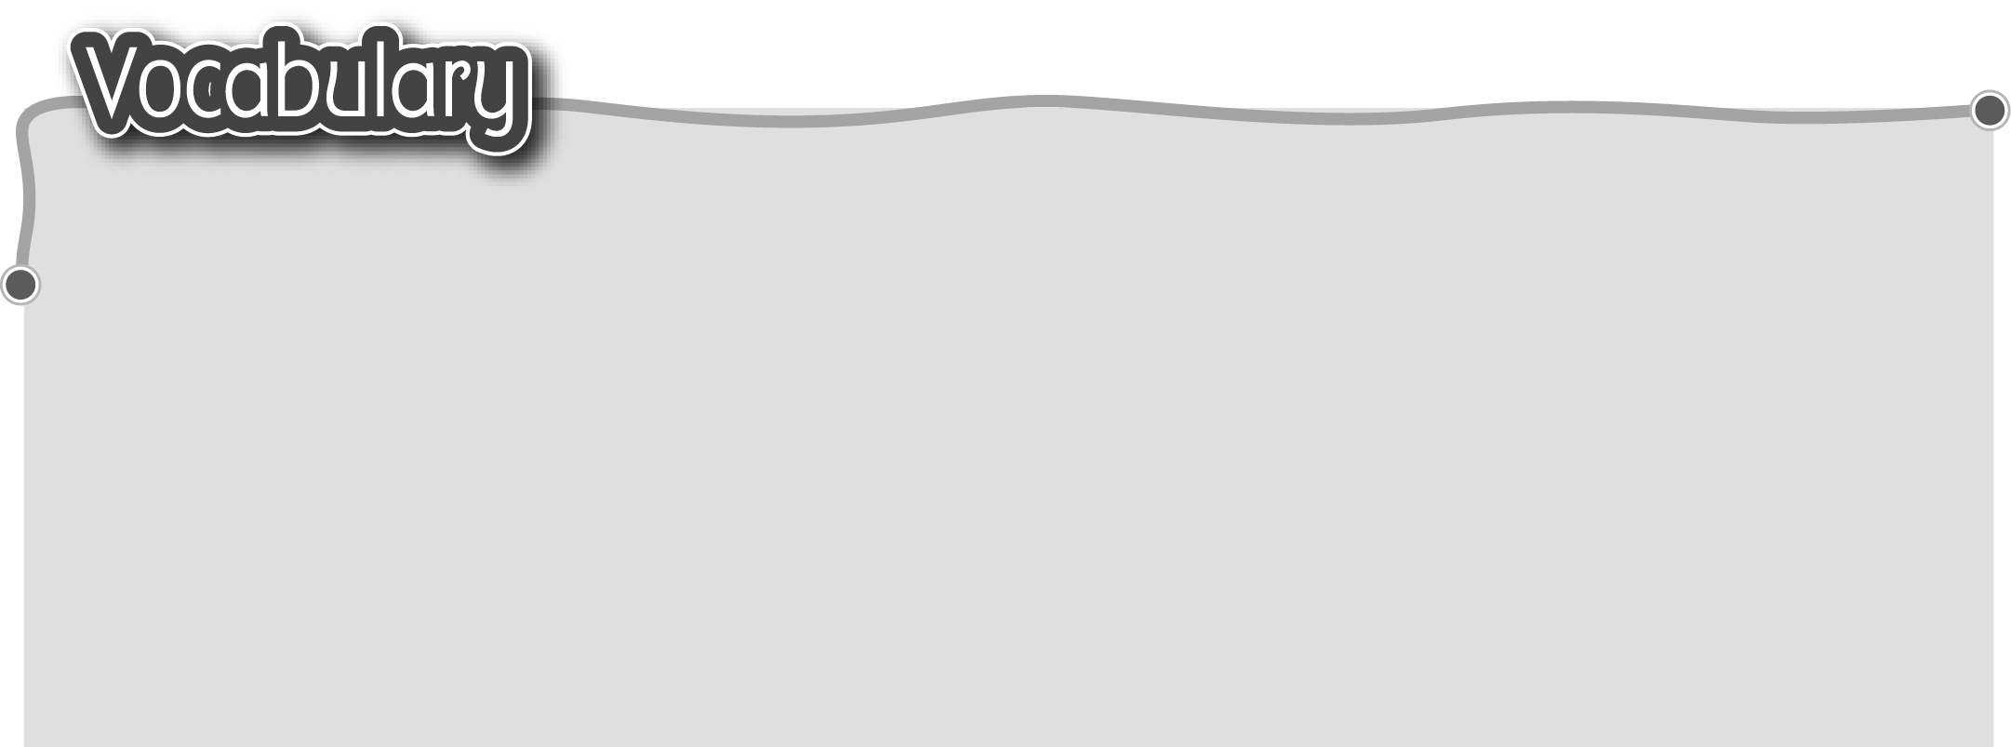
1 body parts 身體部分 6 eye (eyes) 眼睛
2 hand (hands) 手 7 mouth 嘴巴
3 hair 頭髮 8 nose 鼻子
4 arm (arms) 手臂 9 leg (legs) 腿
5 ear (ears) 耳朵 10 foot (feet) 腳掌
The words marked with * have different meanings in other
contexts. You can look up those meanings in a dictionary.
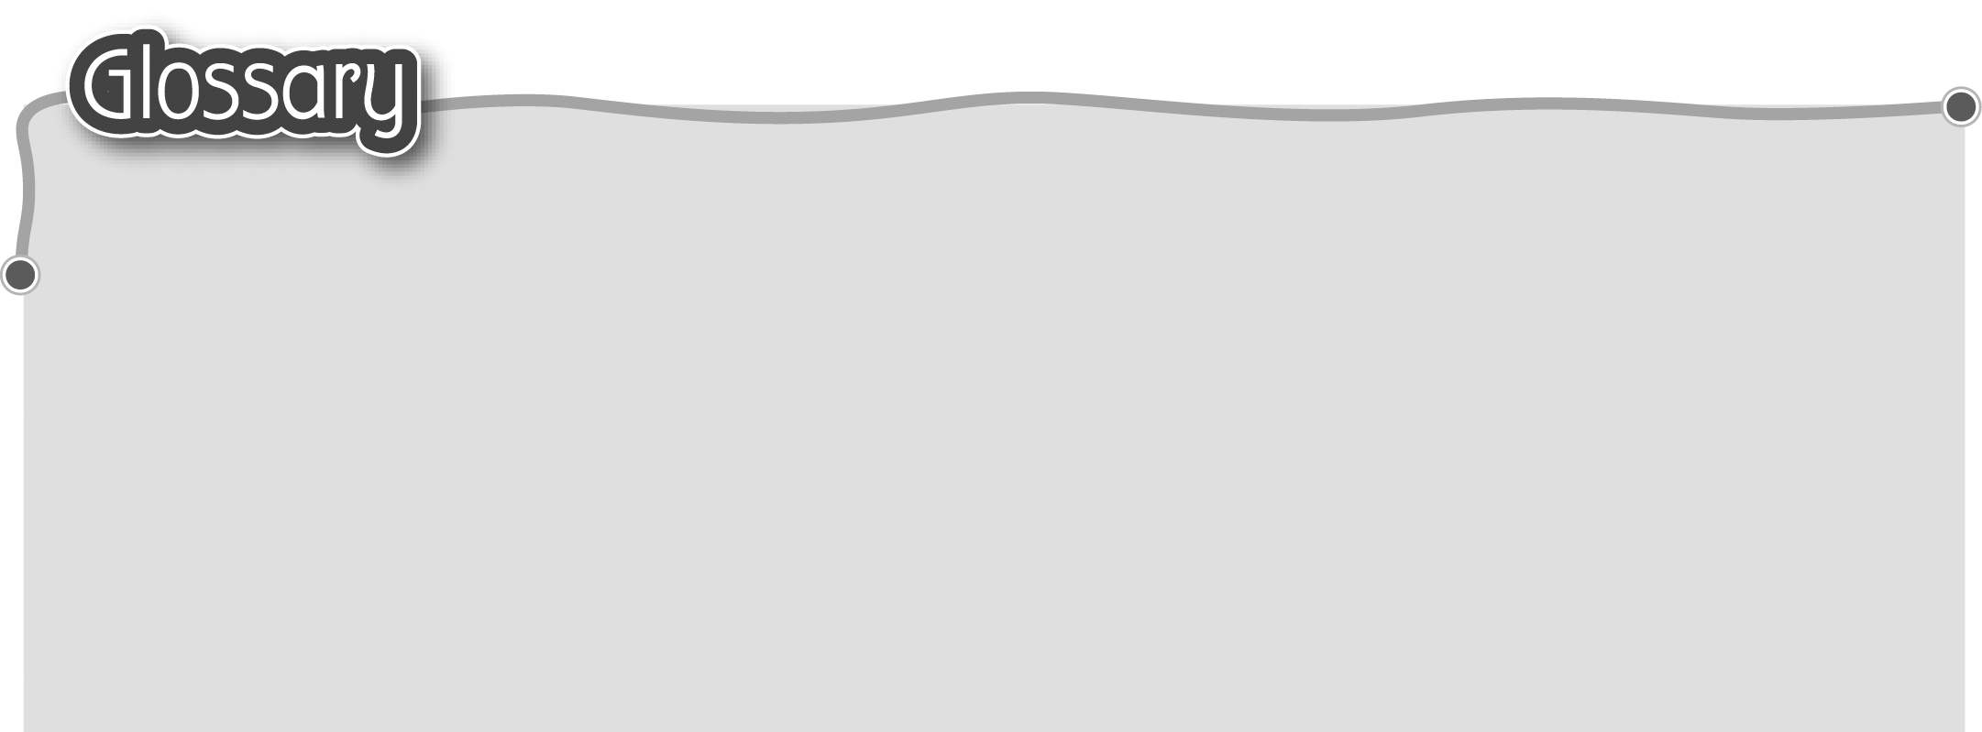
1 idea (p.54) 主意 6 tail (p.55) 尾巴
2 bring (p.54) 帶來 7 baby (p.55) 嬰兒
3 me (p.54) 我 8 sister (p.55) 姊妹
4 brown (p.55) 啡色 9 great* (p.55) 太好了
5 long / short (p.55) 長/短 10 play* (p.55) 玩（動詞）
