Task — Writing about my pet(s)

Write about your own pet(s). Do a drawing of the pet(s) in the space.
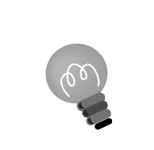
Hint: Remember to use the correct adjectives and nouns.
has / have
a / an / 
long / short
big / small
+ s?
eye ear
nose hair
mouth tail
leg

_____________________________________________________
_____________________________________________________
_____________________________________________________
_____________________________________________________

