RP no: Century Gothic 15pt
(所有圈號用15pt)
What actions can you see? Write.

1 | 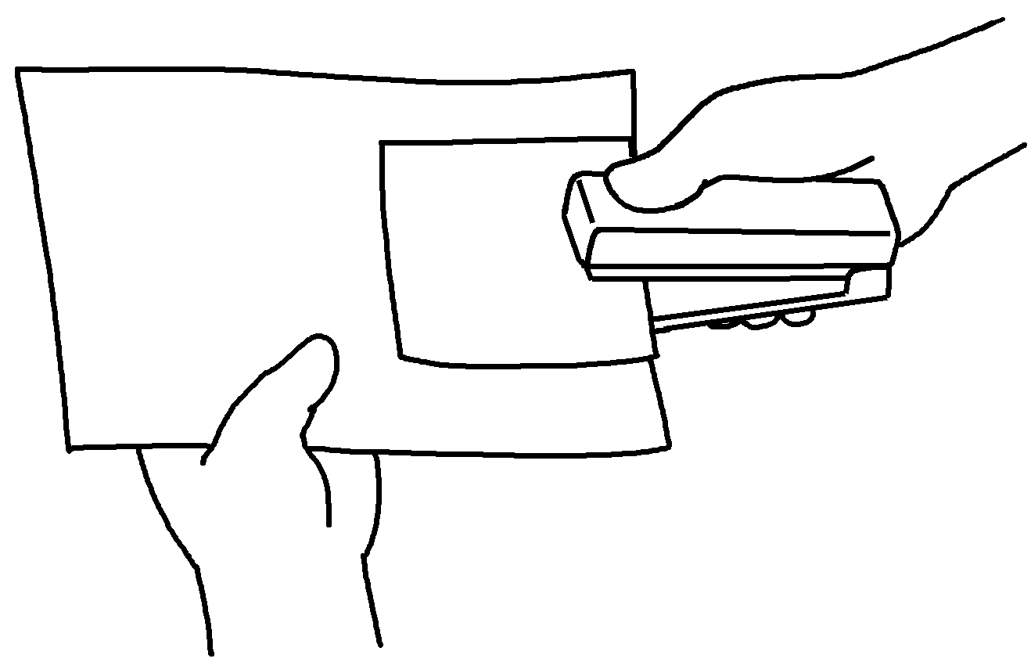 | 2 | 
 | s |  | f

3 | 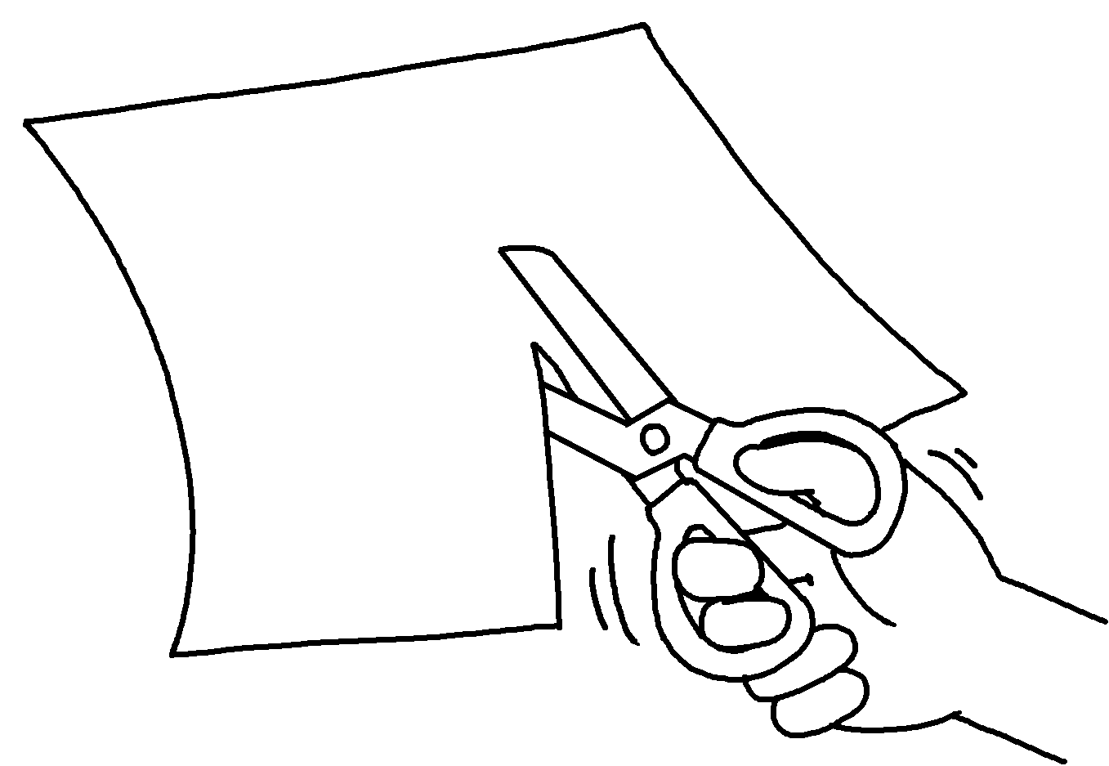 | 4 | 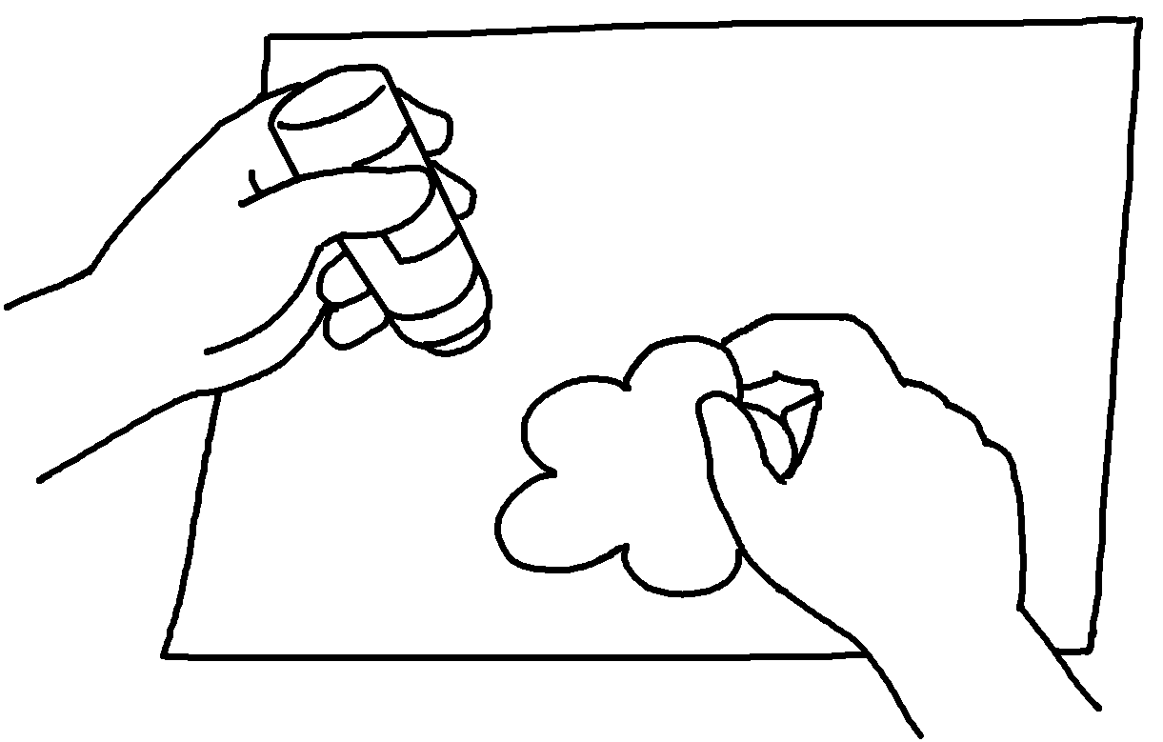
 | c |  | s

5 | 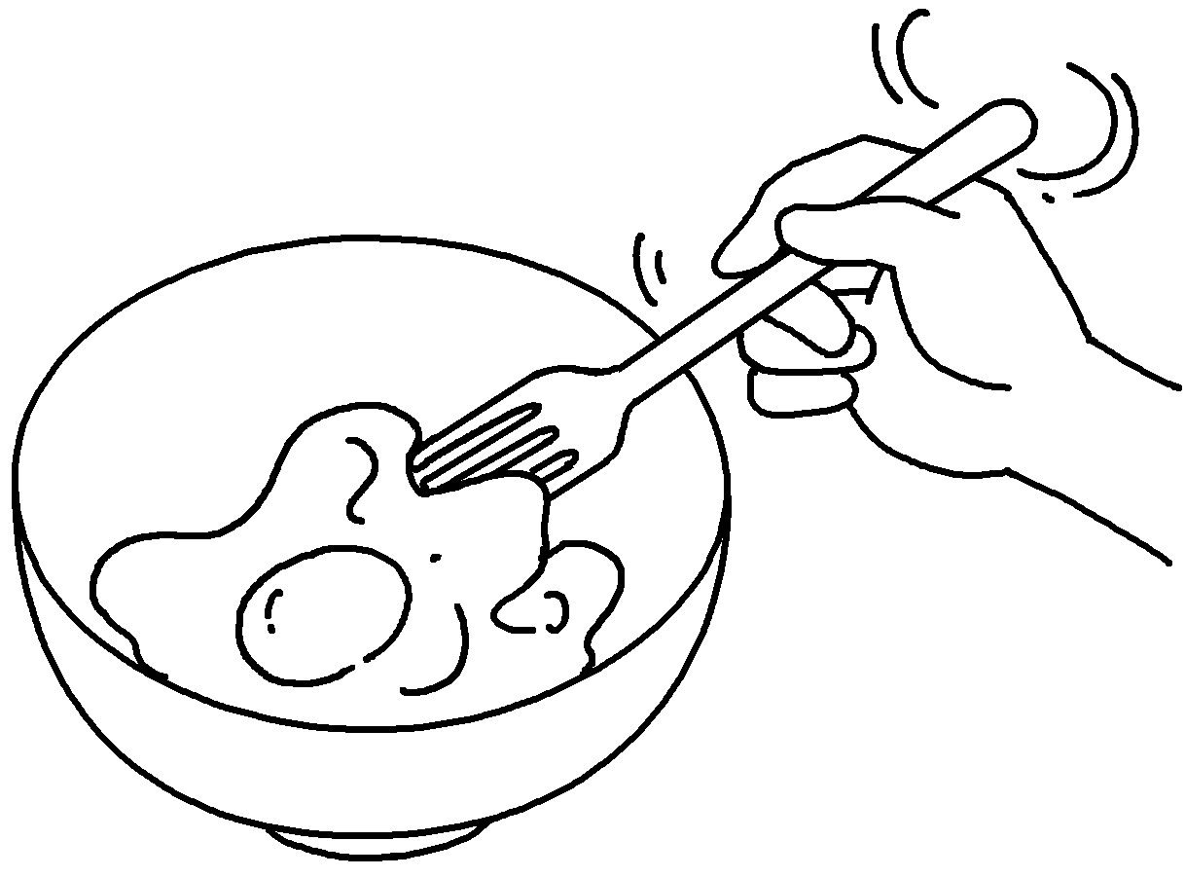 | 6 | 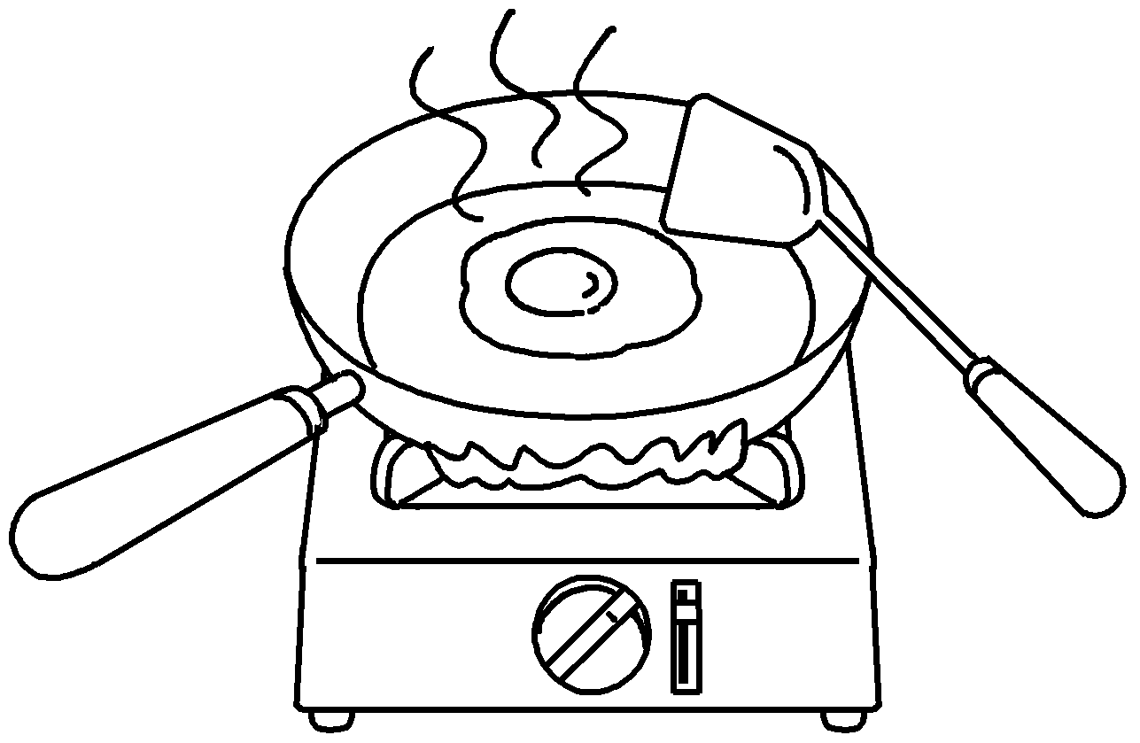 | 7 | 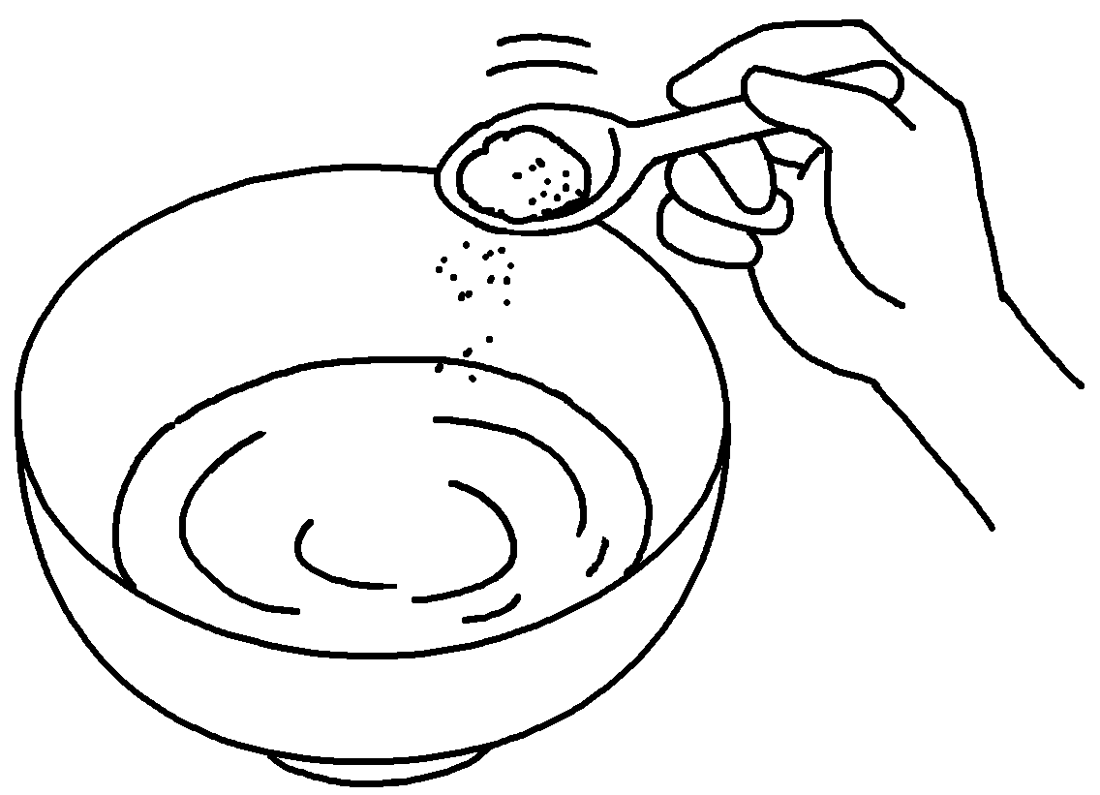
 | b |  | f |  | a

8 | 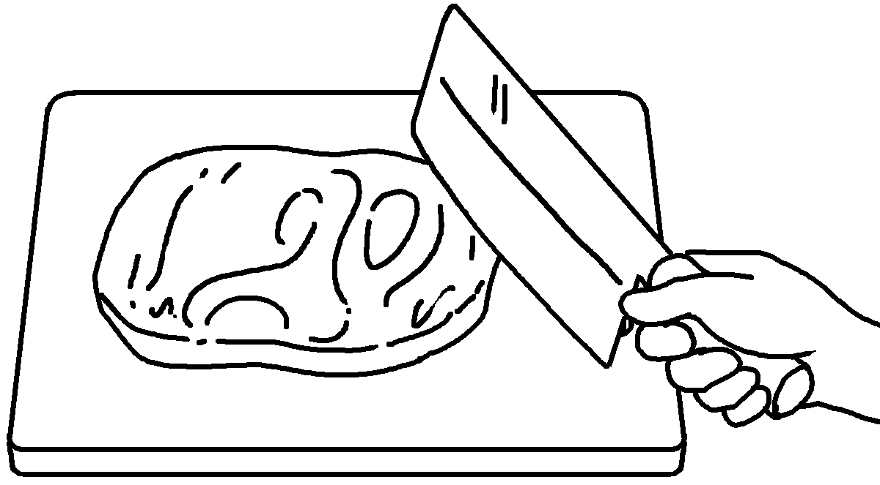 | 9 | 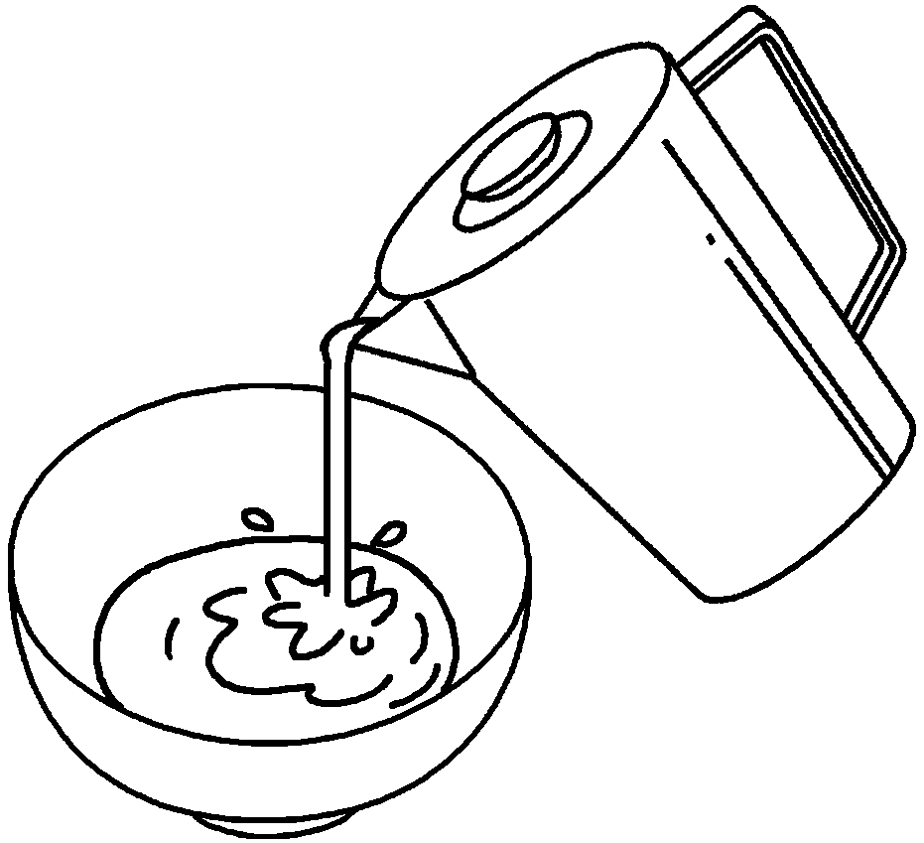 | 10 | 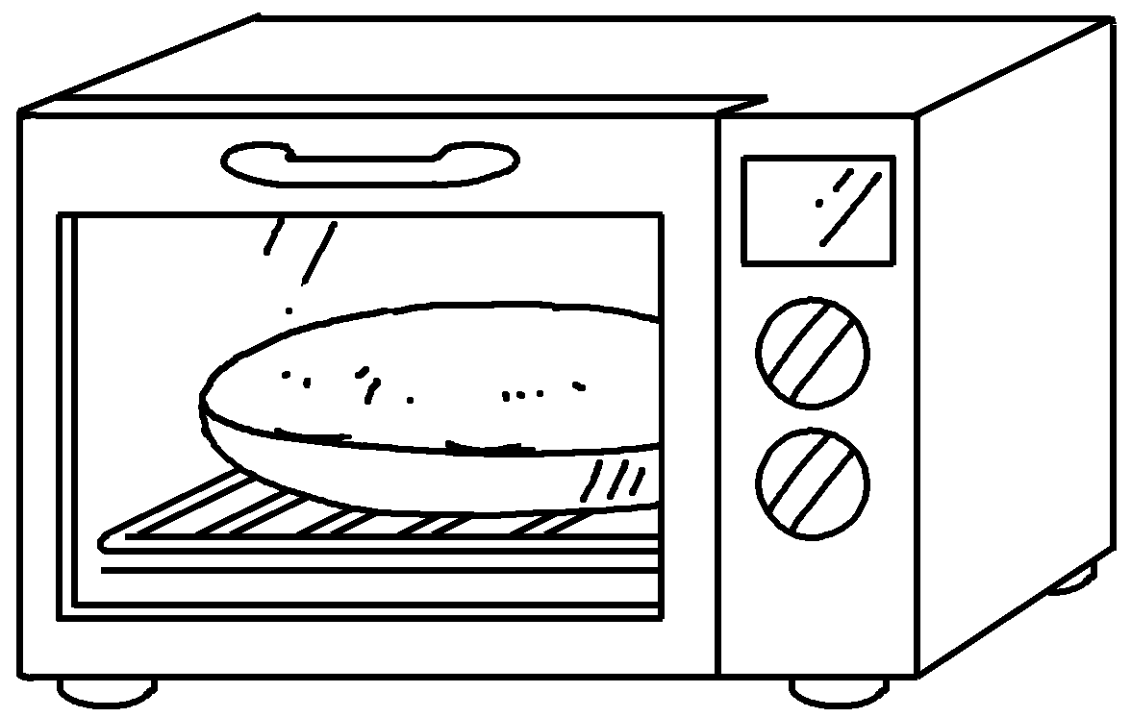
 | c |  | p |  | b

RP no: Century Gothic 15pt
(所有圈號用15pt)


Book 5B Chapter 1 Graded Worksheets
Worksheet 1⬇⬇
- staple 2 fold
3 cut 4 stick
5 beat 6 fry 7 add
8 chop 9 pour 10 bake

