RP no: Century Gothic 15pt
(所有圈號用15pt)
What actions can you see? Write.

1 | 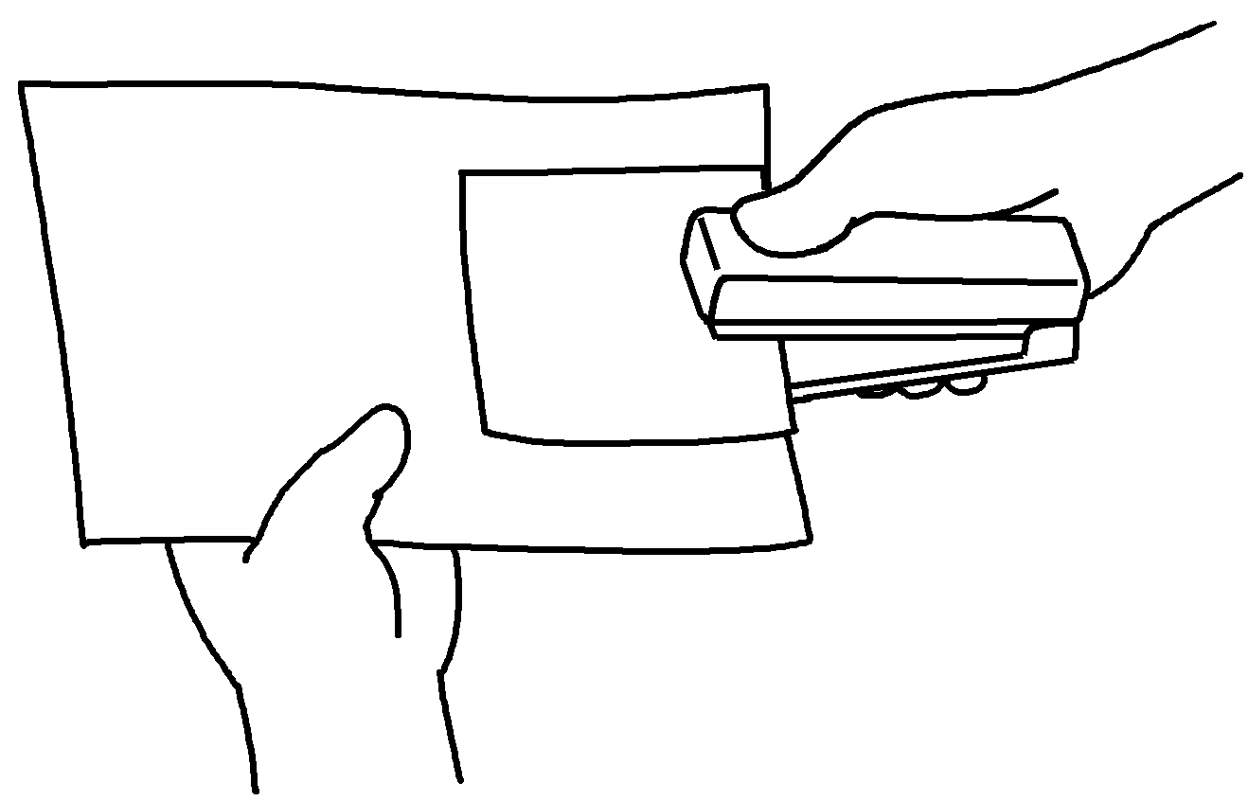 | 2 | 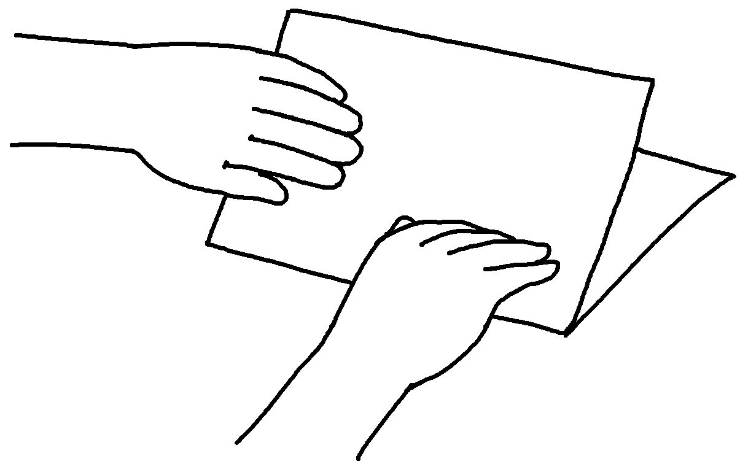

3 | 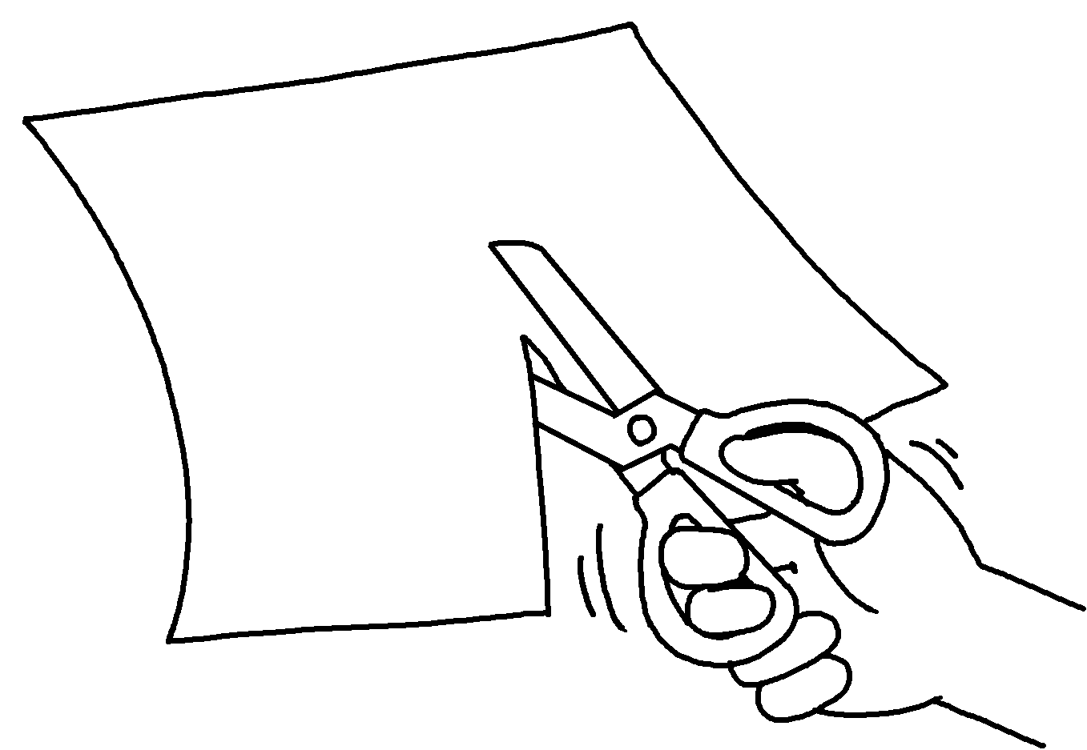 | 4 | 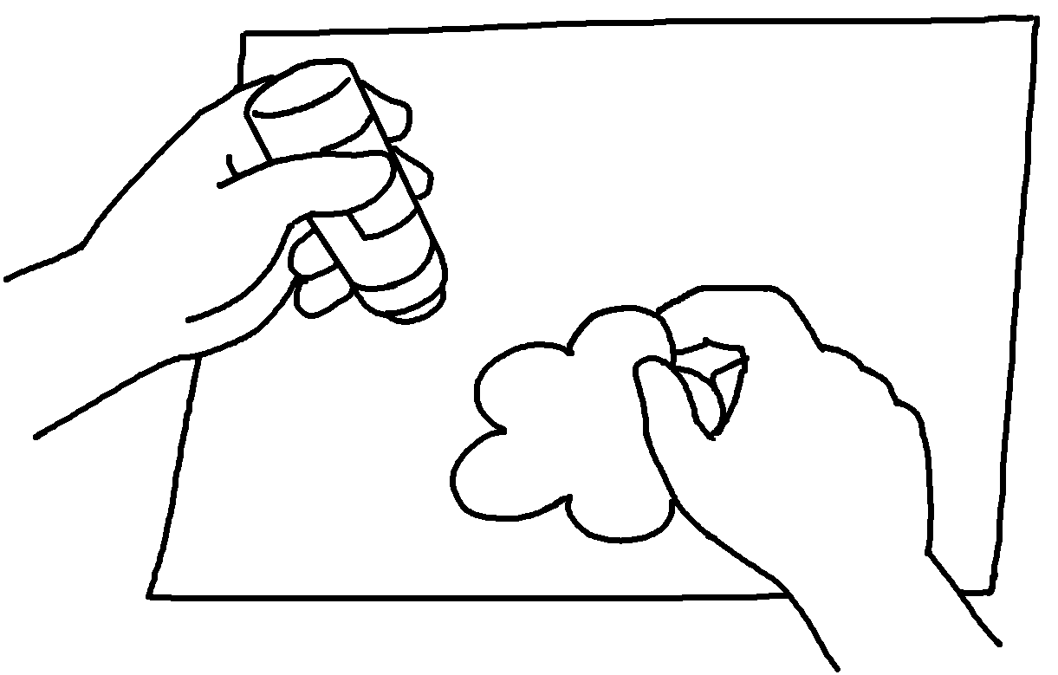

5 | 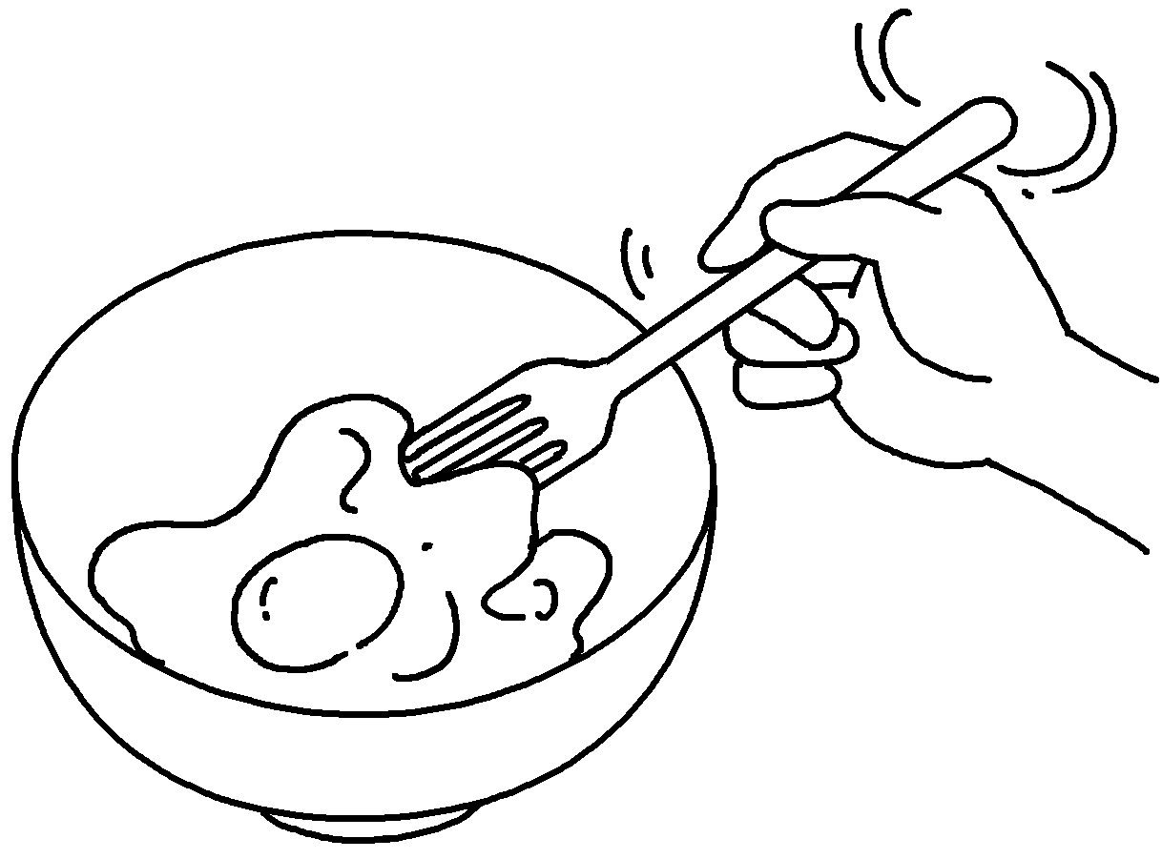 | 6 | 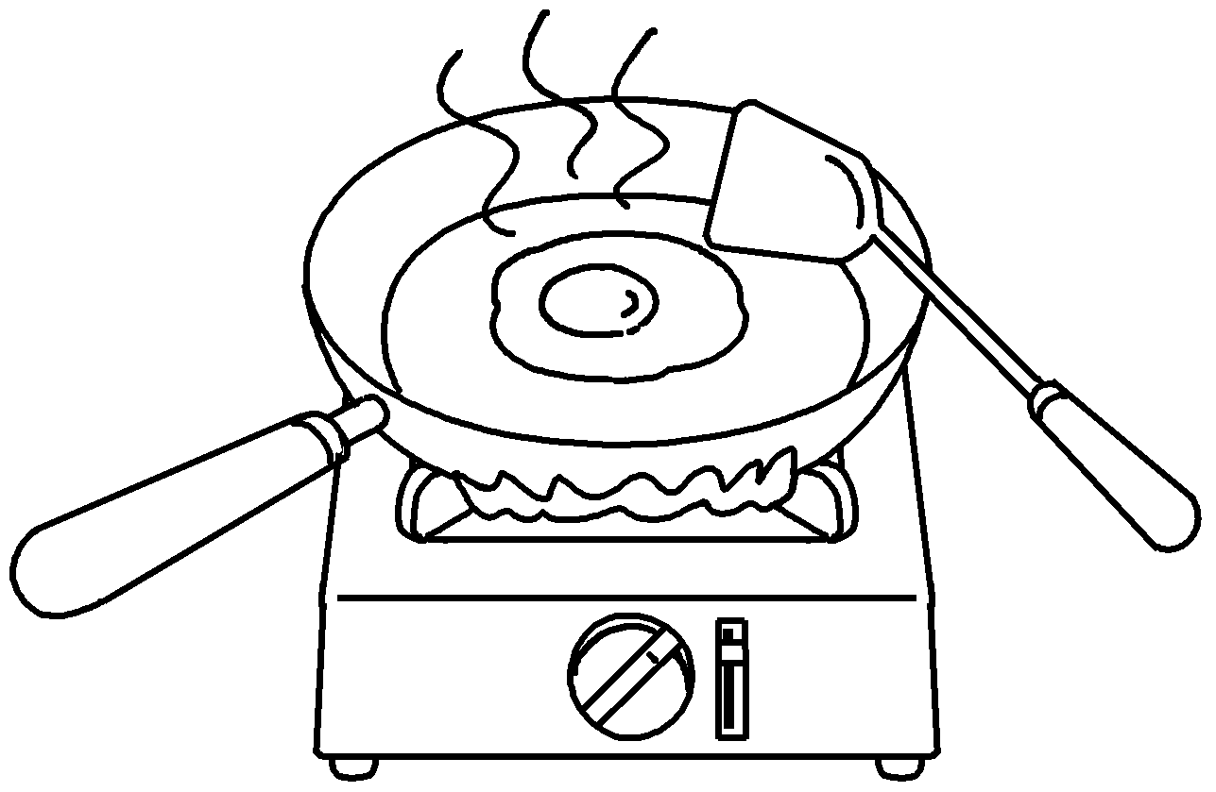 | 7 | 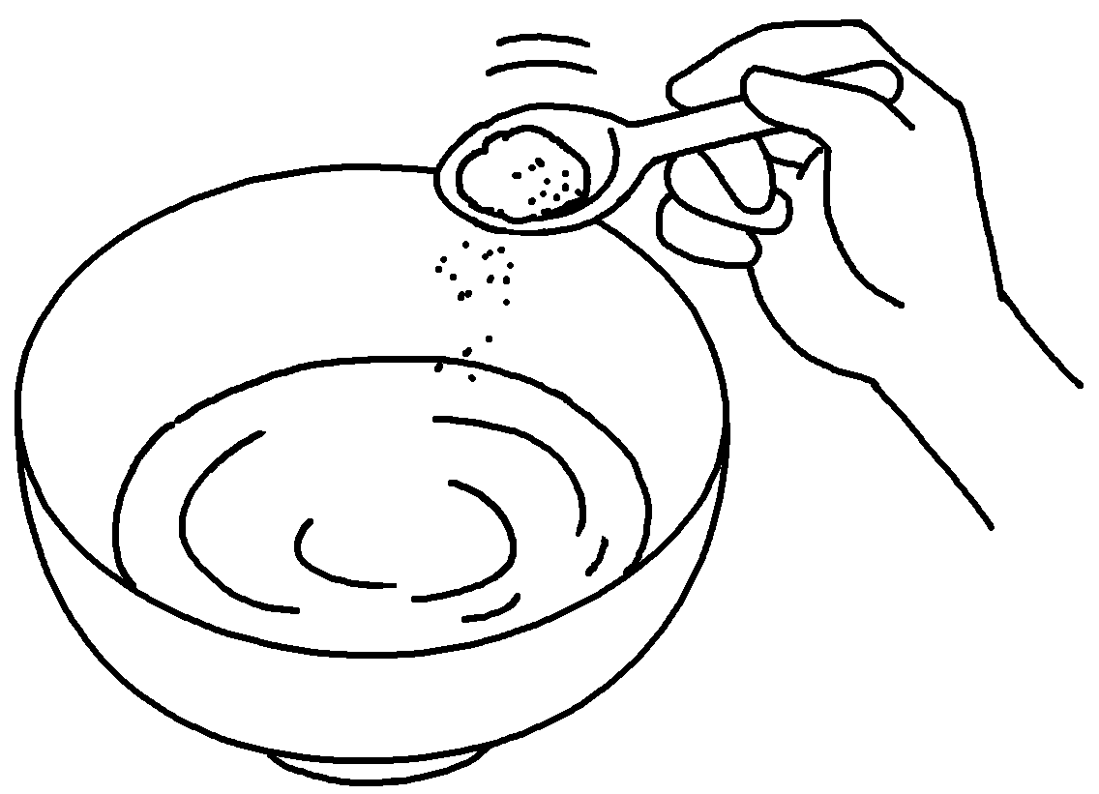

8 | 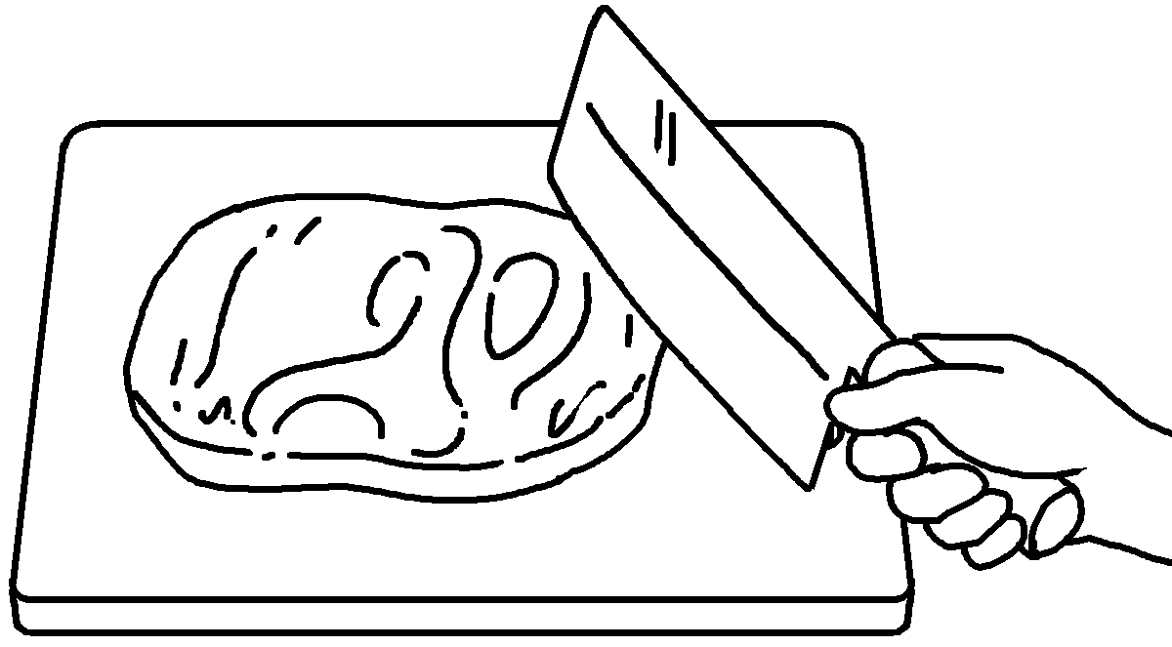 | 9 | 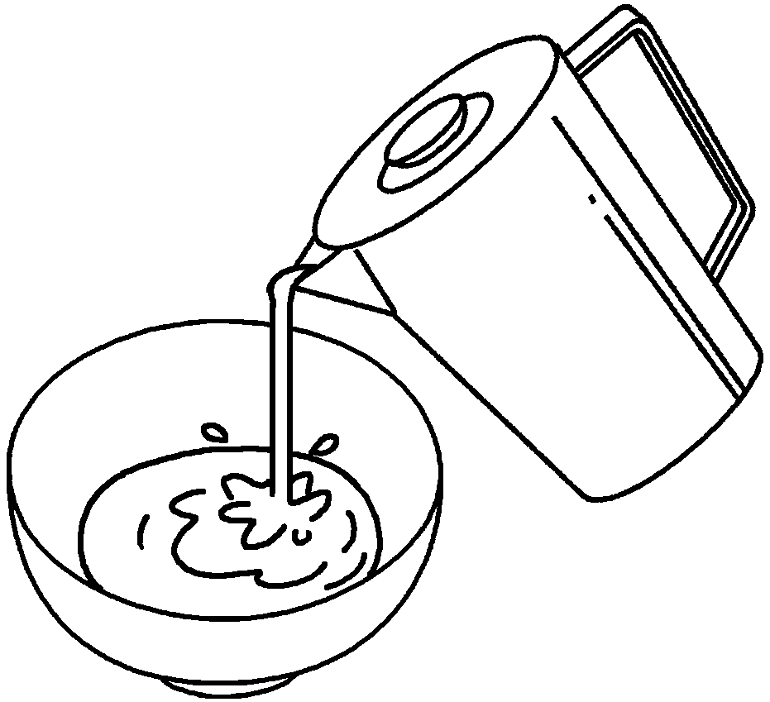 | 10 | 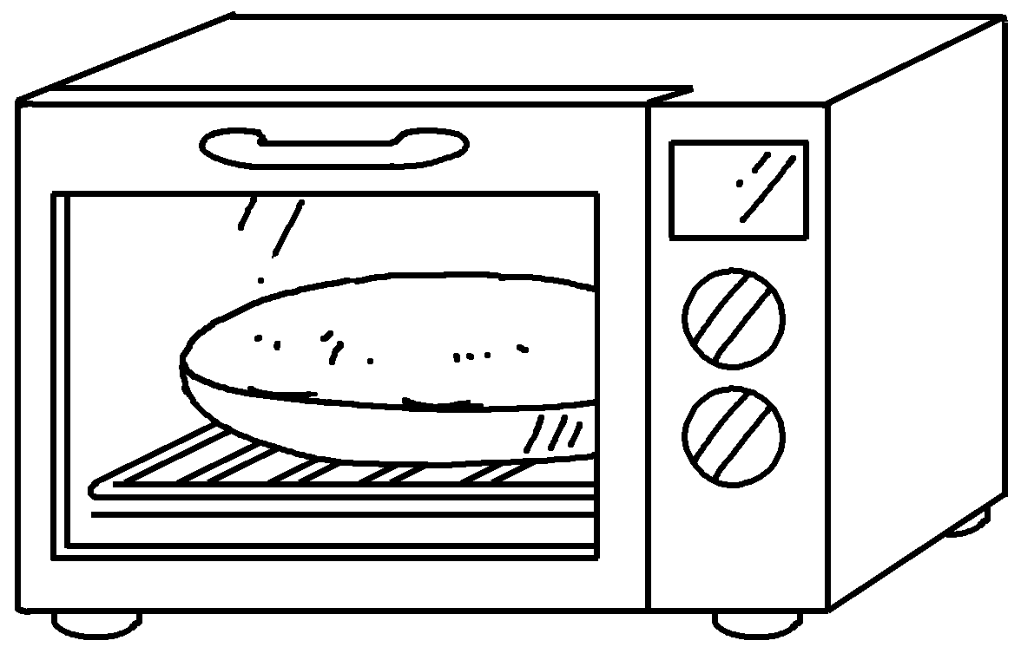


Book 5B Chapter 1 Graded Worksheets
Worksheet 1⬇⬇⬇
- staple 2 fold
3 cut 4 stick
5 beat 6 fry 7 add
8 chop 9 pour 10 bake

