Finish the sentences.
 | Use | to

beat cut draw make stick

1 | 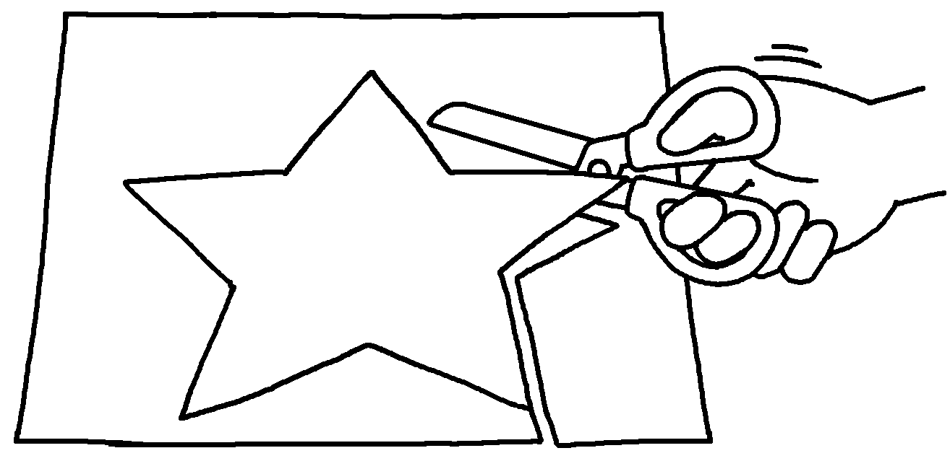 | scissors cut out the shape of a star.
2 | 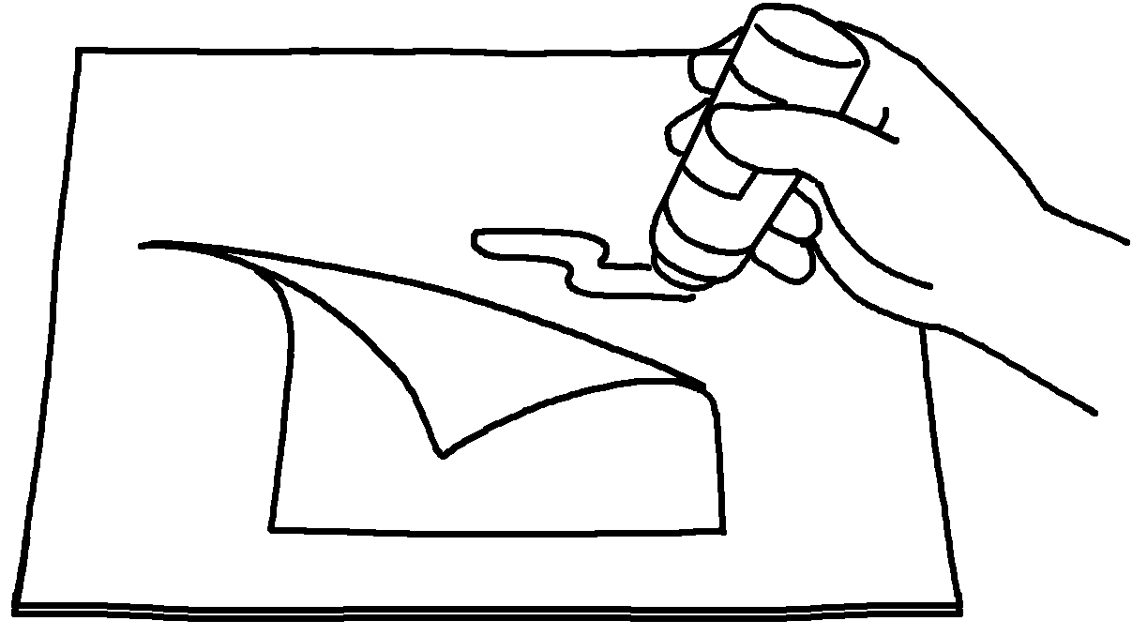 | glue  a piece of paper onto a piece of cardboard.
3 | 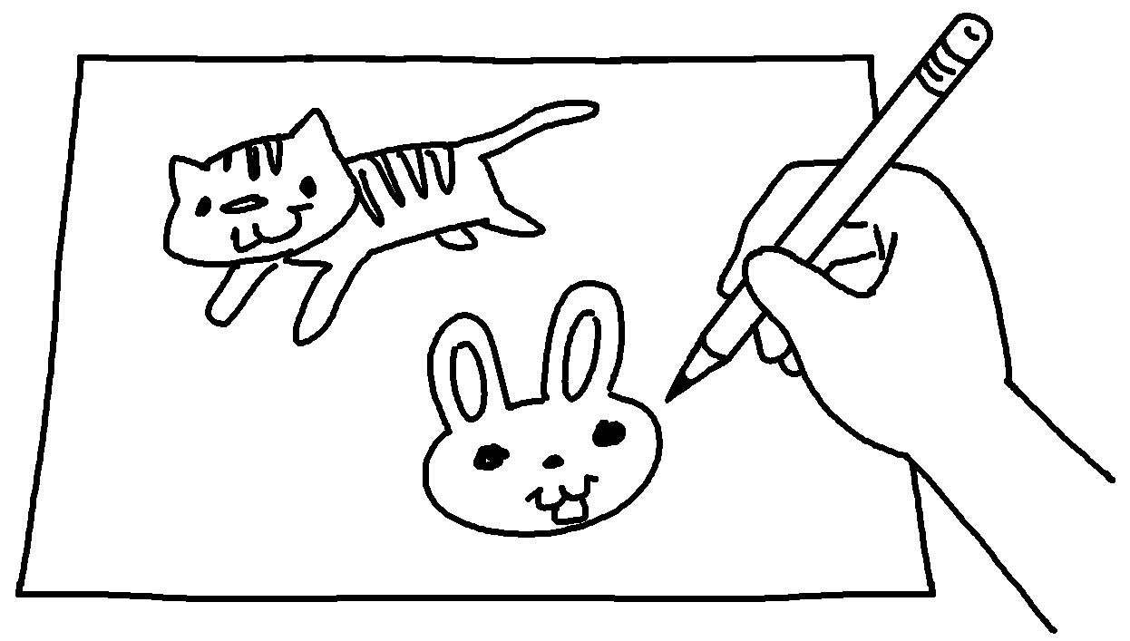 | a pencil some animals on a piece of paper.
4 | 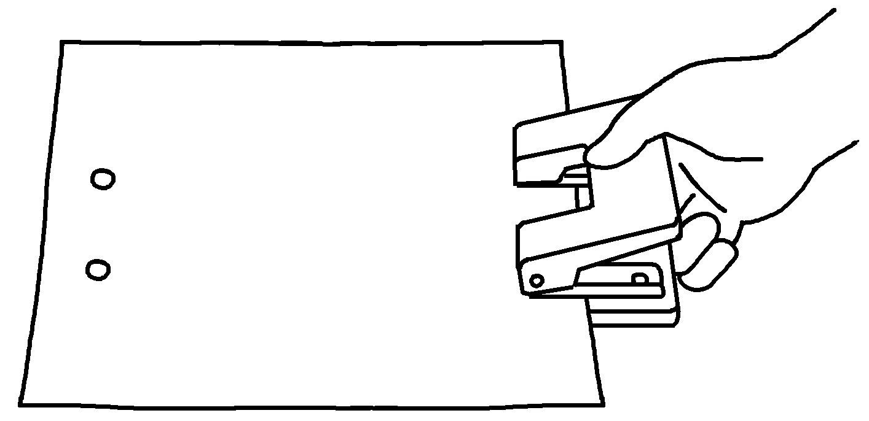 | a hole punch  holes in a piece of paper.
5 | 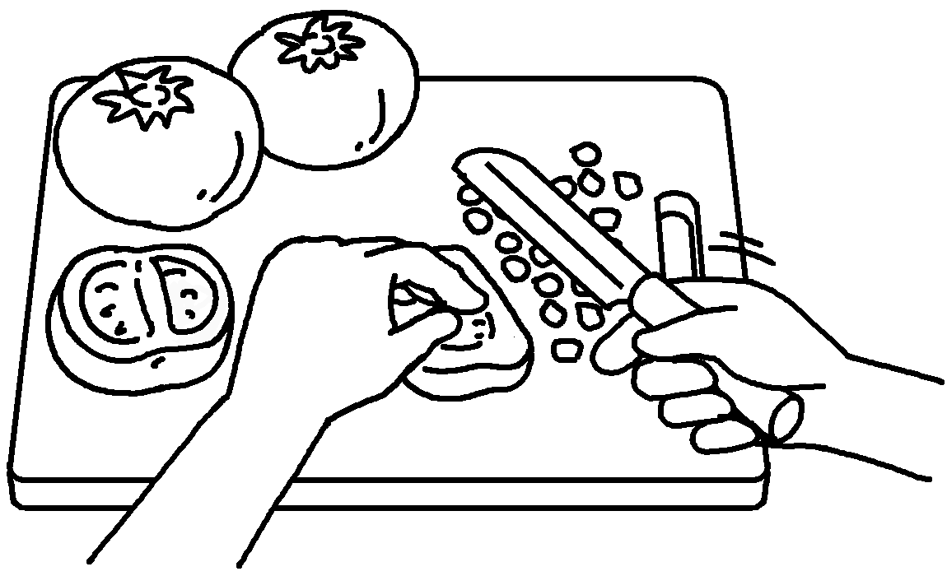 | a knife  some tomatoes into small pieces.
6 | 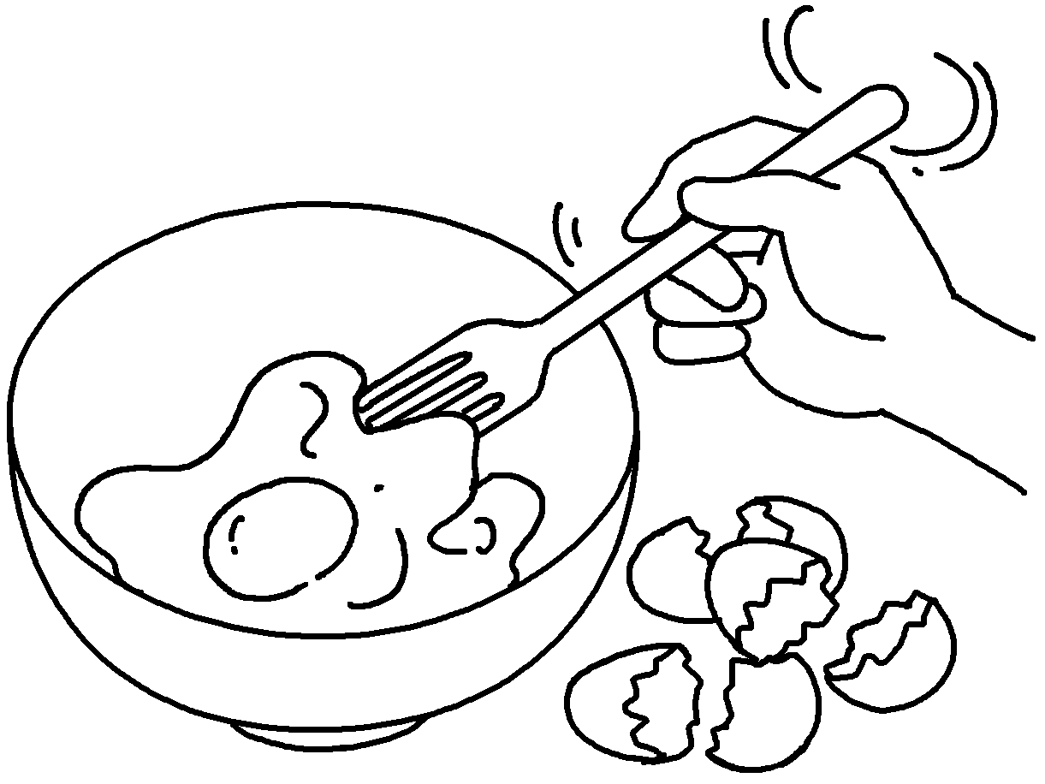 | a fork  some eggs.


Book 5B Chapter 1 Graded Worksheets
Worksheet 2⬇⬇
- Use to
- Use to stick
- Use to draw
- Use to make
- Use to cut
- Use to beat

