Circle the correct answers.
a | Window card  1  2  3  4
a | 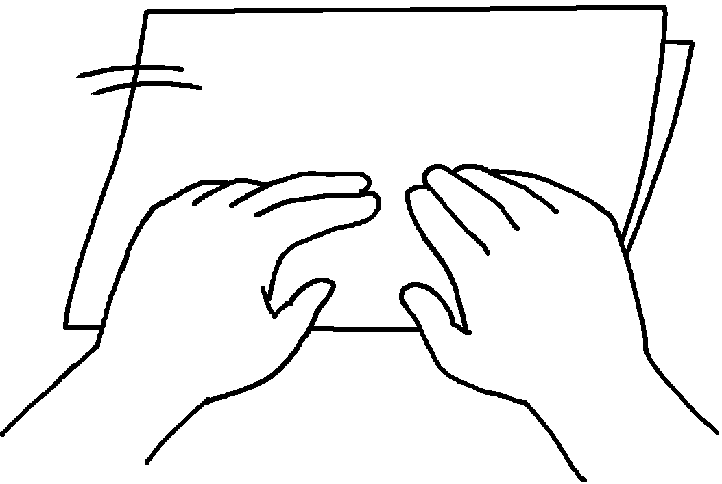 |  | 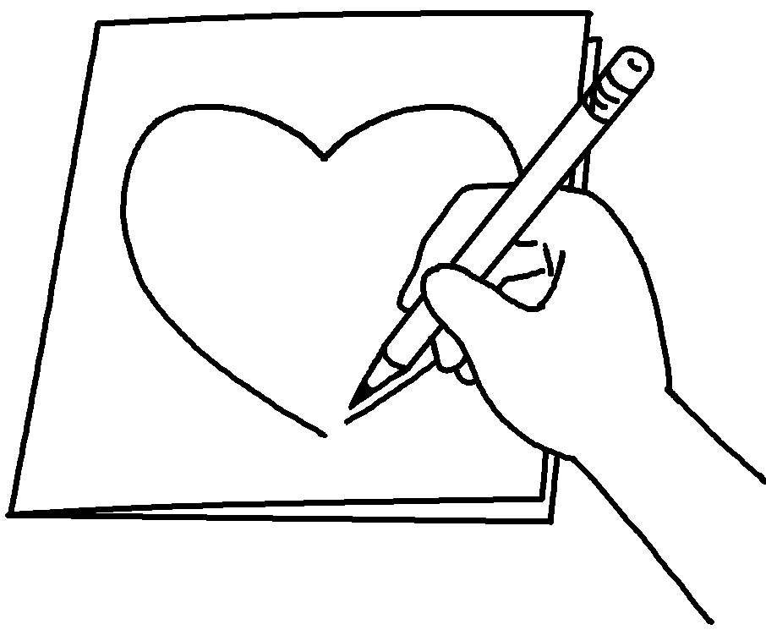 | 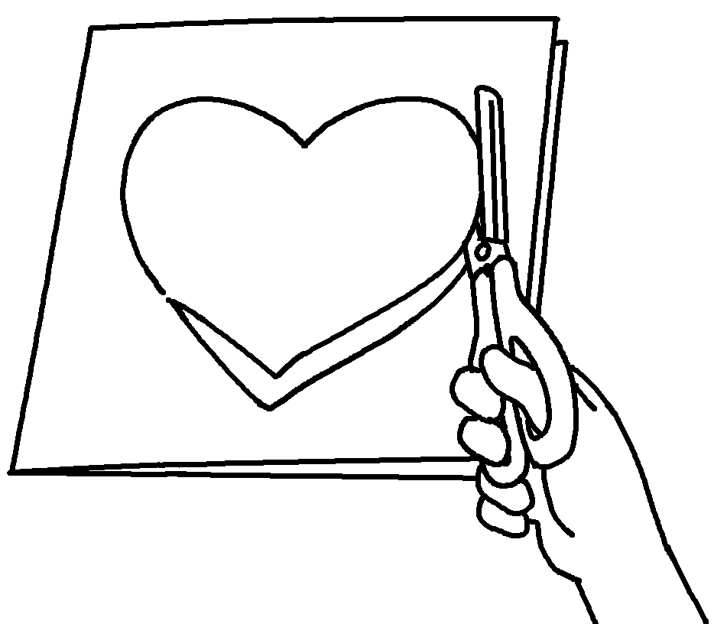 | 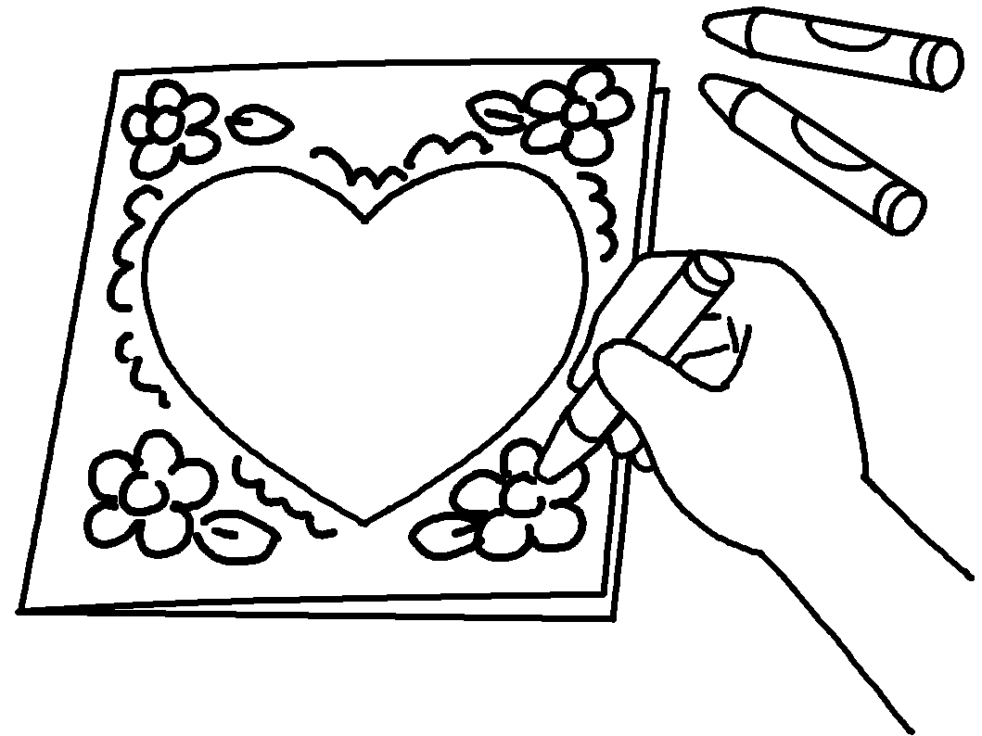
Steps:
1
 | 2  3  4 | ( Then / First ) fold a piece of paper.  ( Next / Finally ) use a pencil to draw a heart shape on the  front cover.  ( First / Then ) use scissors to cut out the heart shape.  ( Finally / First ) use crayons to draw pictures on the cover.

b | Rabbit mask
b | 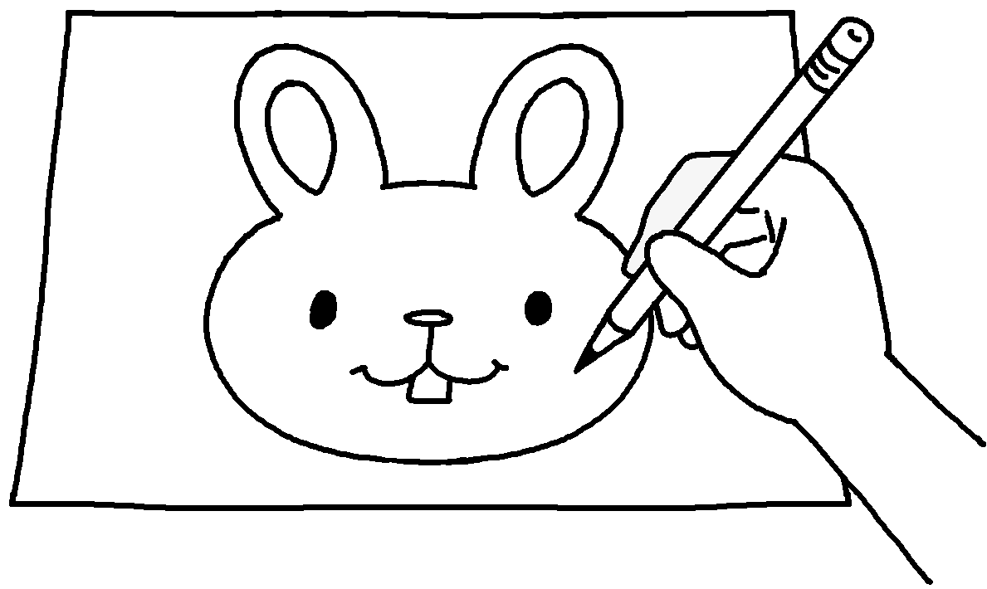  1 |  | 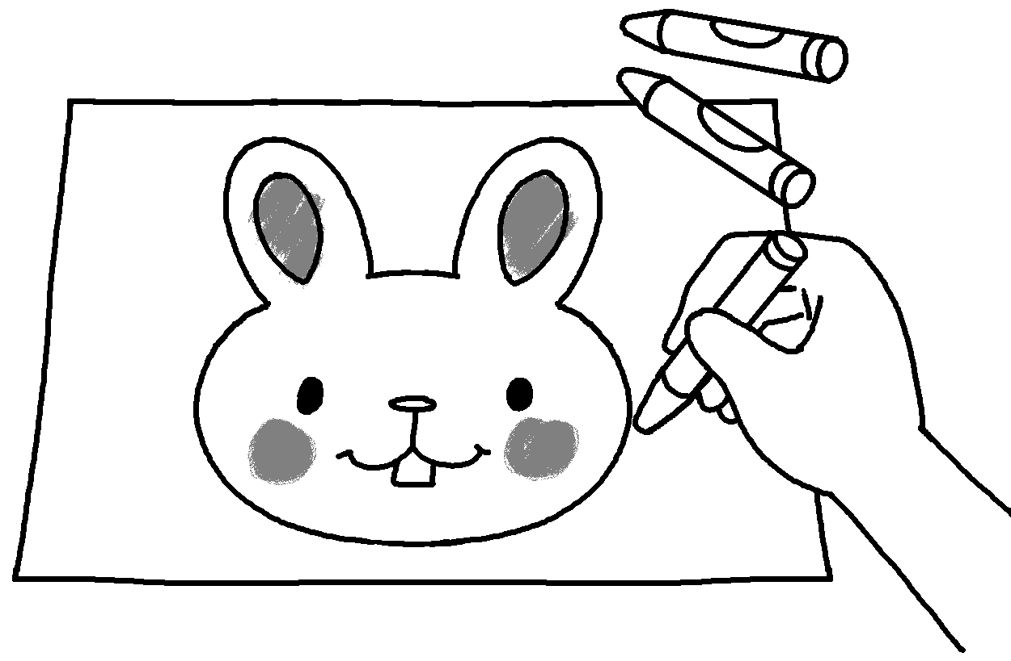  2  3  5 | 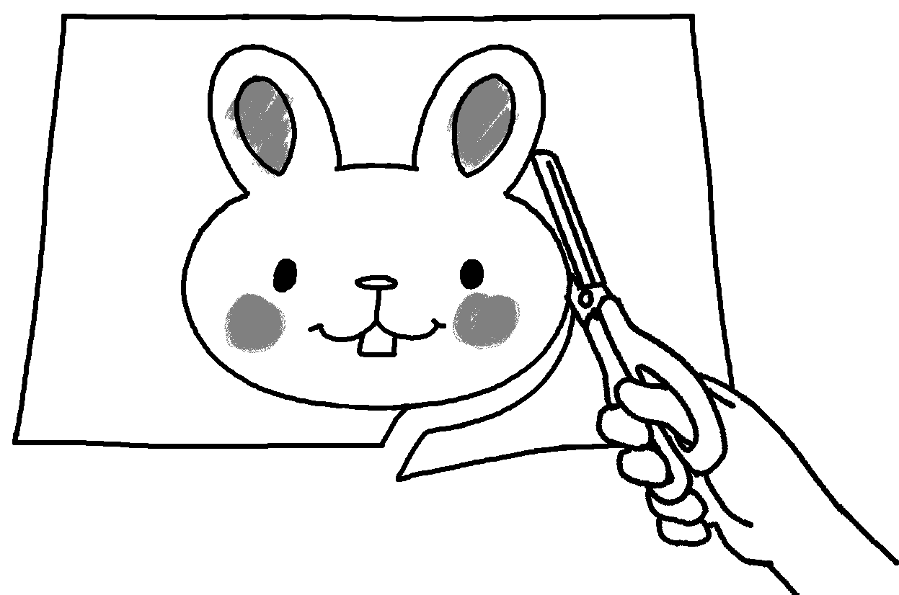 | 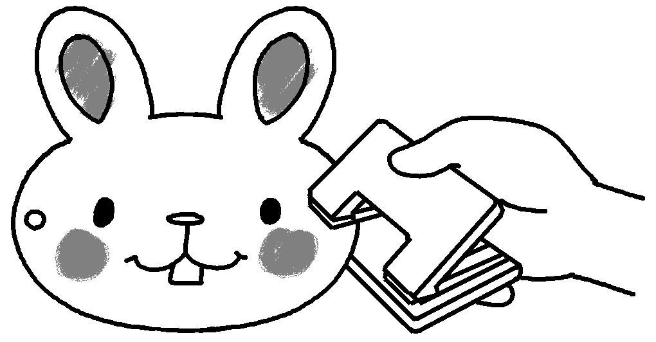 | 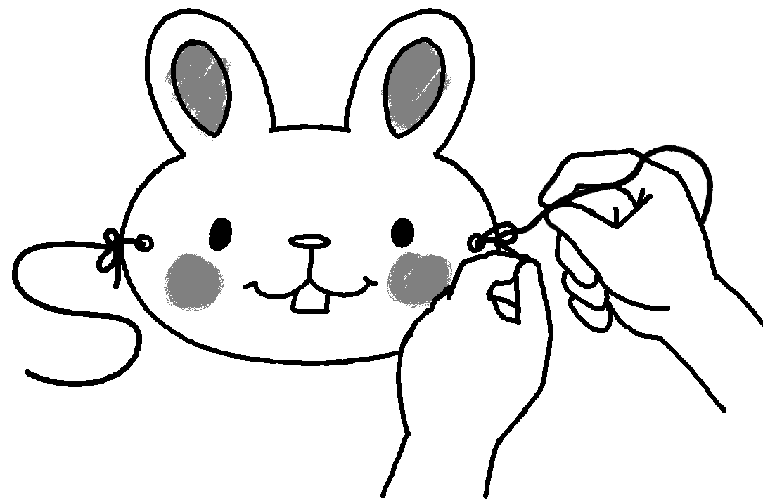
 | Steps: |  |  |  | 4
 | 1  2  3  4  5 | ( After that / First ) use a pencil to draw a rabbit’s head on a piece of cardboard.  ( Next / First ) use crayons to colour the rabbit’s head.  ( Finally / Then ) use scissors to cut out the rabbit’s head.  ( First / After that ) use a hole punch to make two holes in the cardboard.  ( Finally / First ) tie a piece of string to each hole.


Book 5B Chapter 1 Graded Worksheets
Worksheet 3⬇

a 1 ( Then / First )
2 ( Next / Finally )
3 ( First / Then )
4 ( Finally / First )
b 1 ( After that / First )
2 ( Next / First )
3 ( Finally / Then )
4 ( First / After that )
5 ( Finally / First )

