Choose and write.

then first finally after that next

a | Window card  1  2  3  4
a | 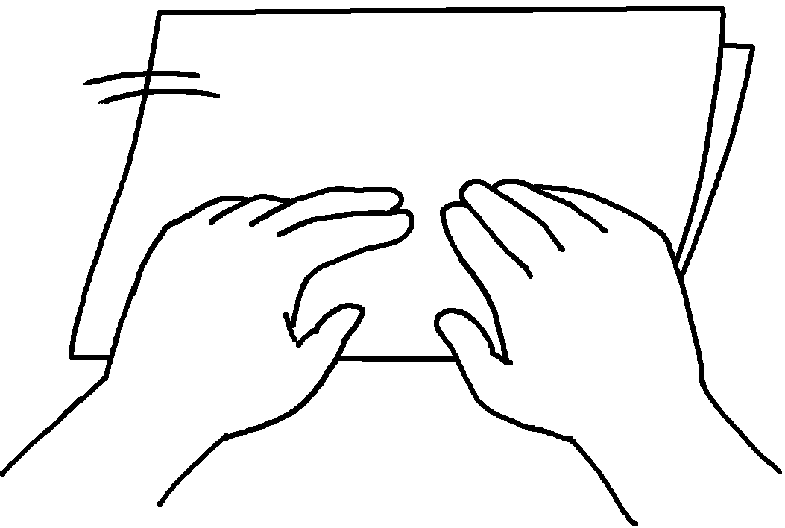 |  | 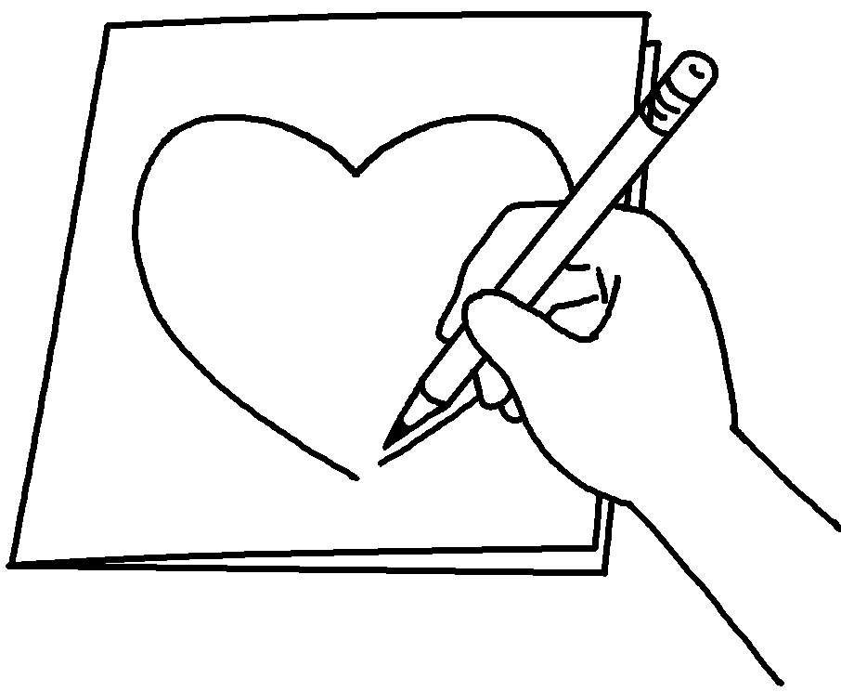 | 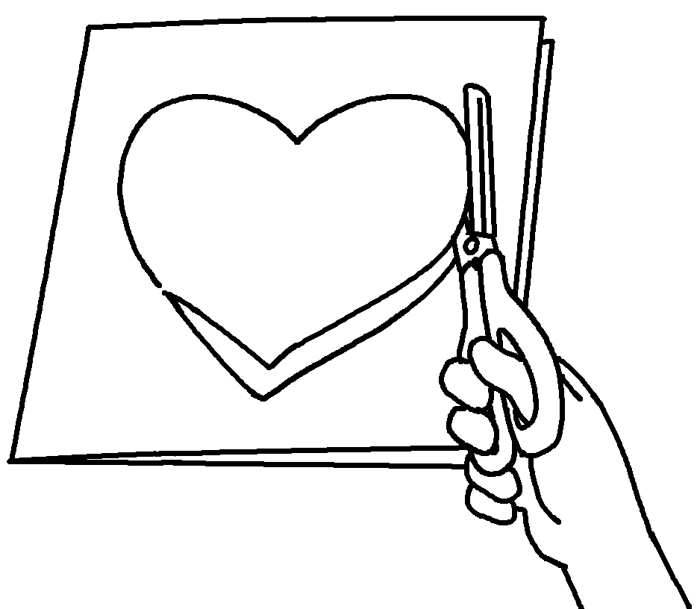 | 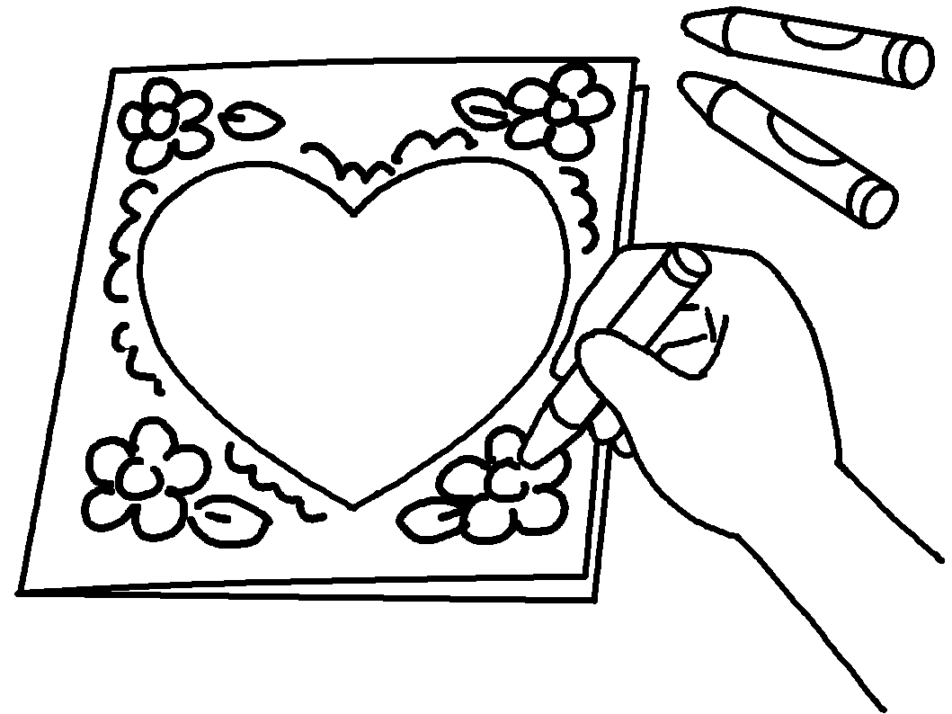
Steps:
1
 | 2  3  4 | ___________________ fold a piece of paper.  ___________________ use a pencil to draw a heart shape on the front cover.  ___________________ use scissors to cut out the heart shape.  ___________________ use crayons to draw pictures on the cover.

b | Rabbit mask
b | 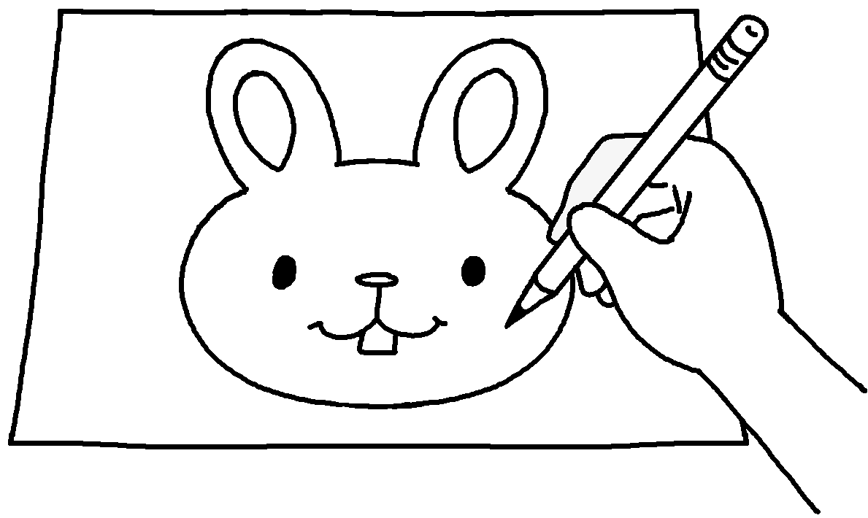  1 |  | 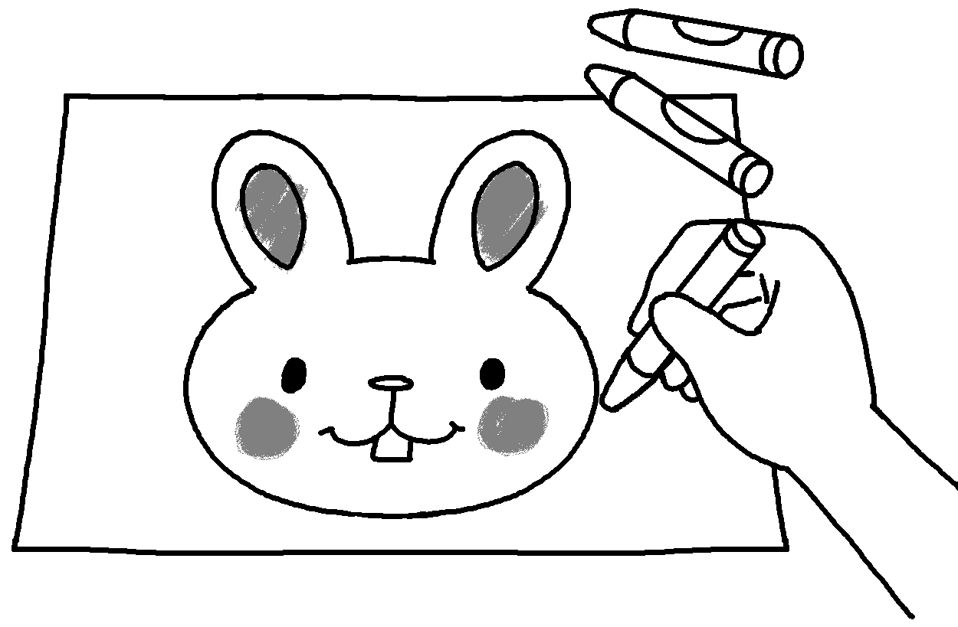  2  5 | 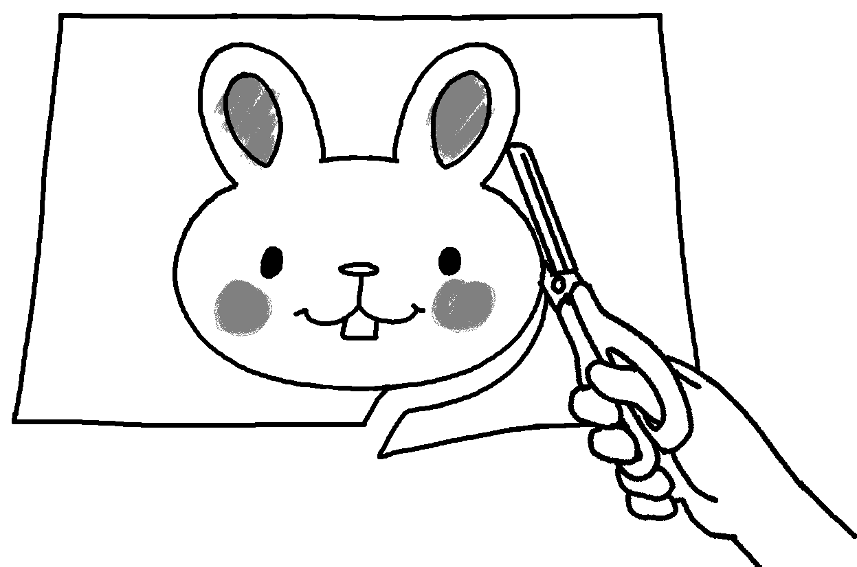  3 | 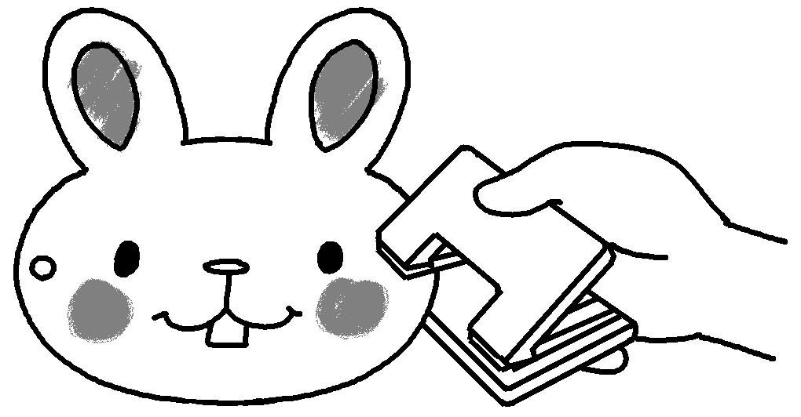 | 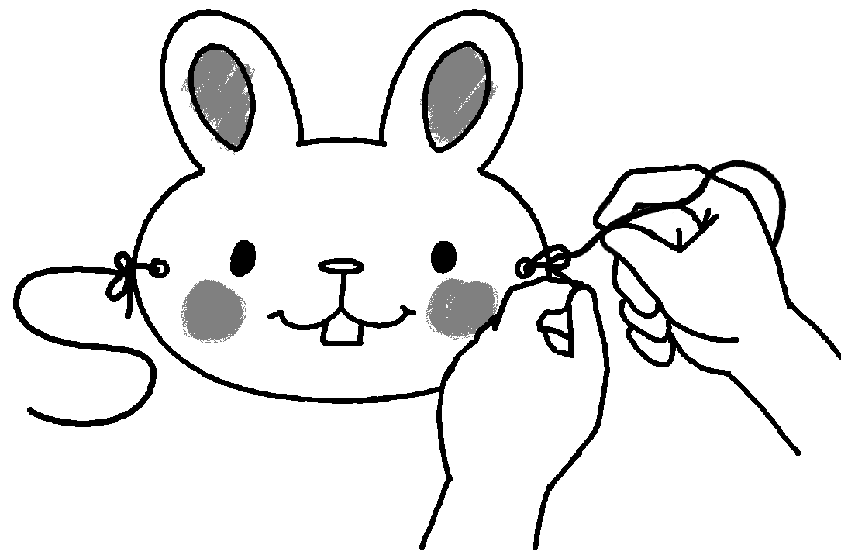
 | Steps: |  |  |  | 4
 | 1  2  3  4  5 | ___________________ use a pencil to draw a rabbit’s head on a piece of cardboard.  ___________________ use crayons to colour the rabbit’s head.  ___________________ use scissors to cut out the rabbit’s head.  ___________________ use a hole punch to make two holes in the cardboard.  ___________________ tie a piece of string to each hole.


Book 5B Chapter 1 Graded Worksheets
Worksheet 3⬇⬇

a 1 First
2 Next / Then / After that
3 Then / After that / Next
4 Finally
b 1 First
2 Next / Then / After that
3 Then / After that / Next
4 After that / Next / Then
5 Finally

