Fill in the blanks.

then first finally after that next

a | Window card  1  2  3  4
a | 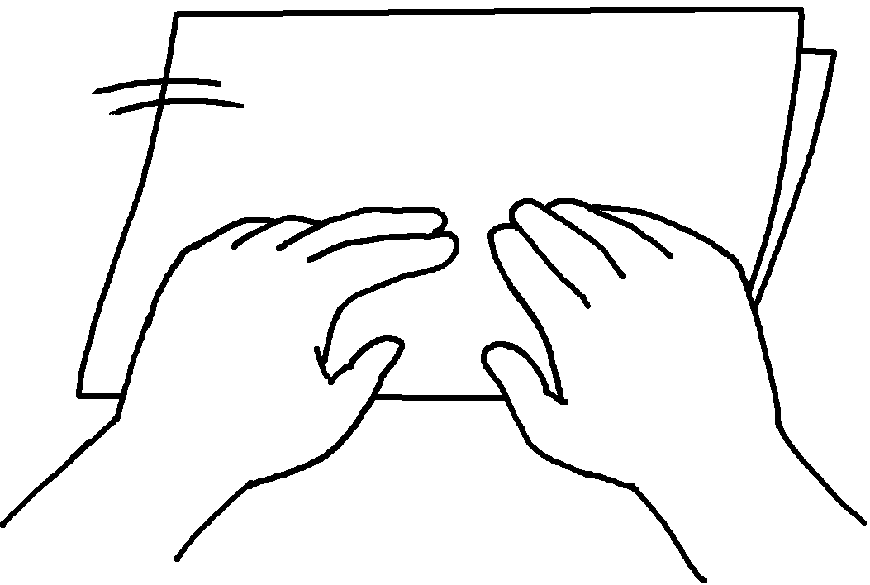 |  | 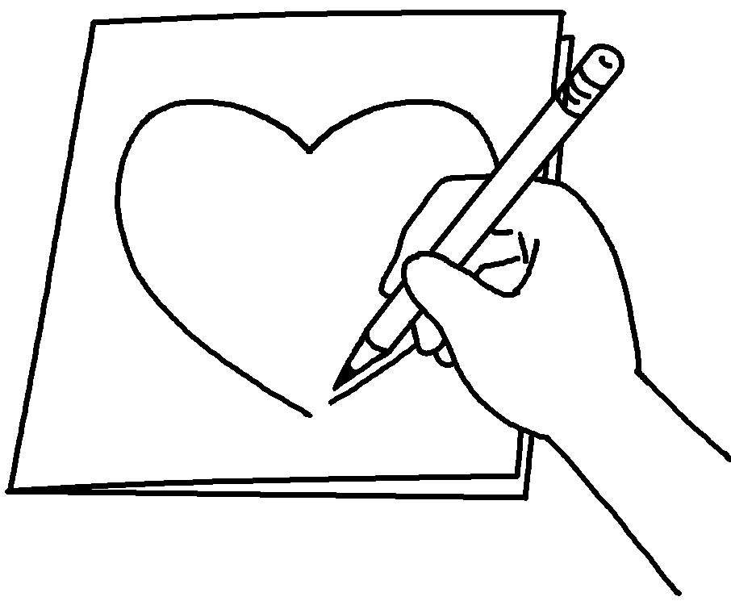 | 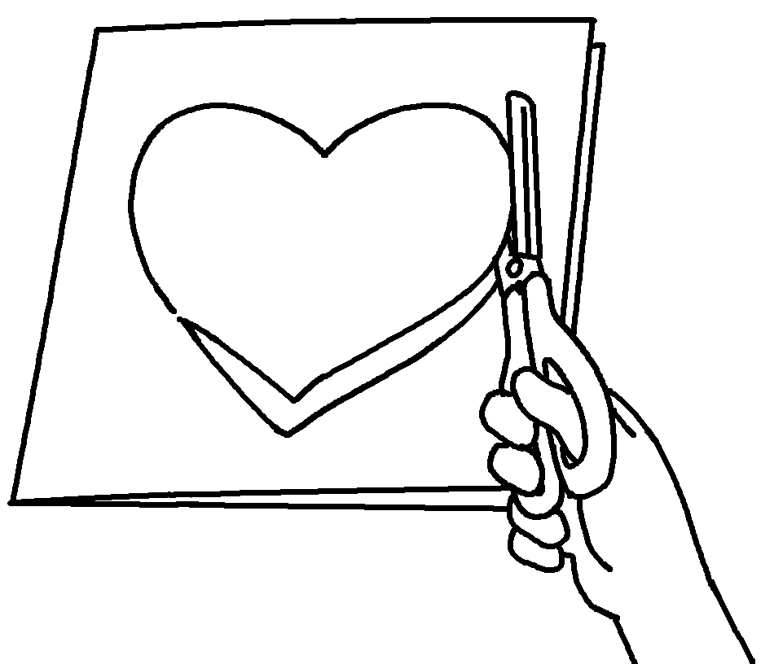 | 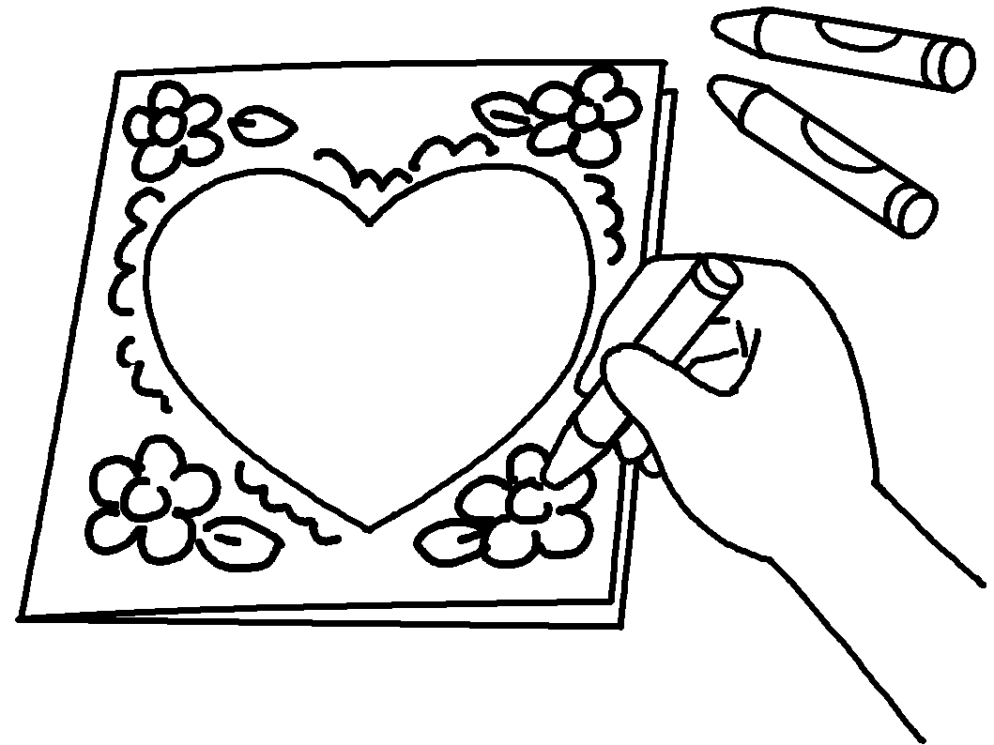
Steps:
1
 | 2  3  4 | ___________________ fold a piece of paper.  ___________________ use a pencil to ____________ a heart shape on the front cover.  ___________________ use scissors to __________ out the heart shape.  _________________________ crayons to draw pictures on the cover.

b | Rabbit mask
b | 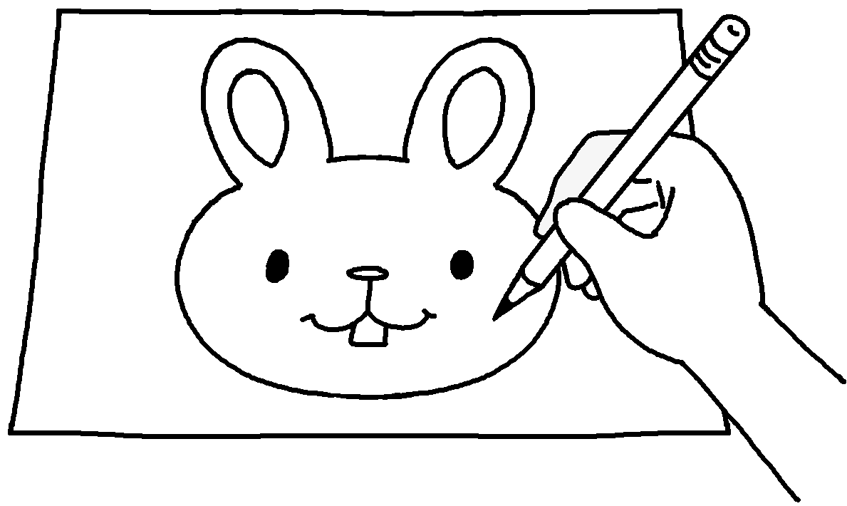  1 |  |  | 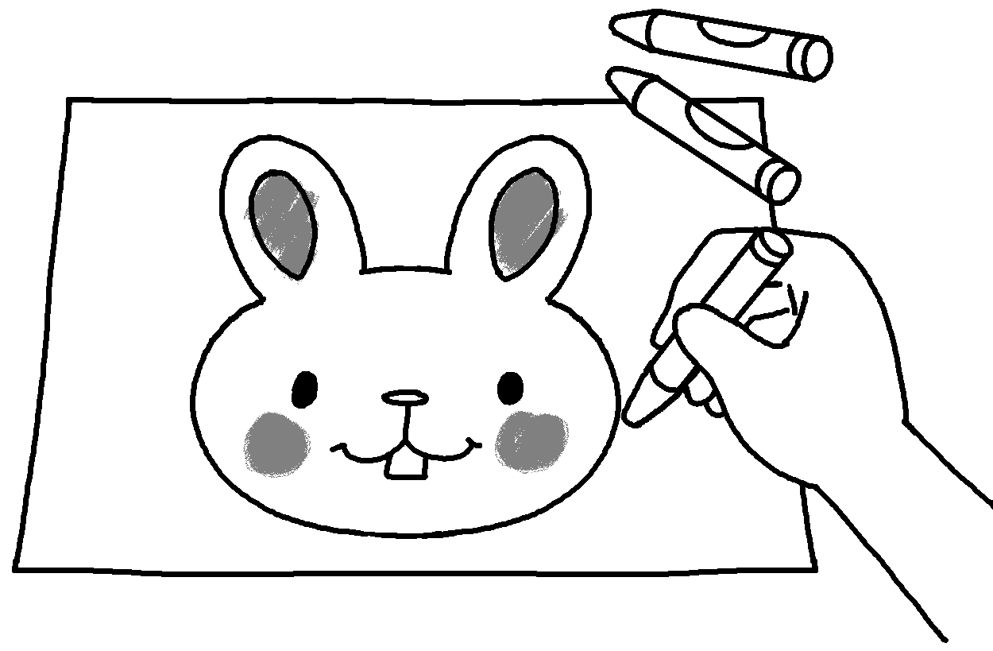  2  3 |  | 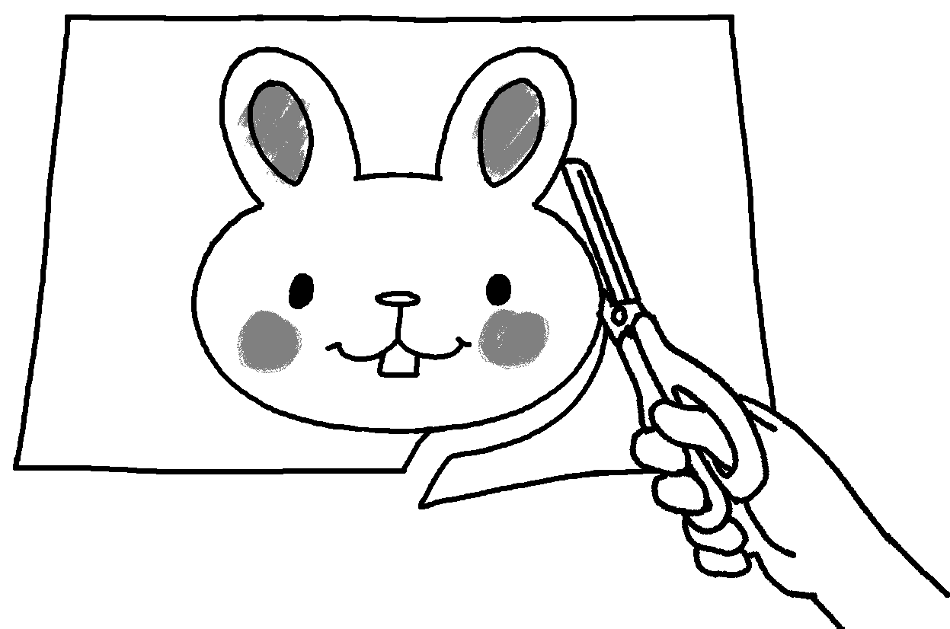 |  | 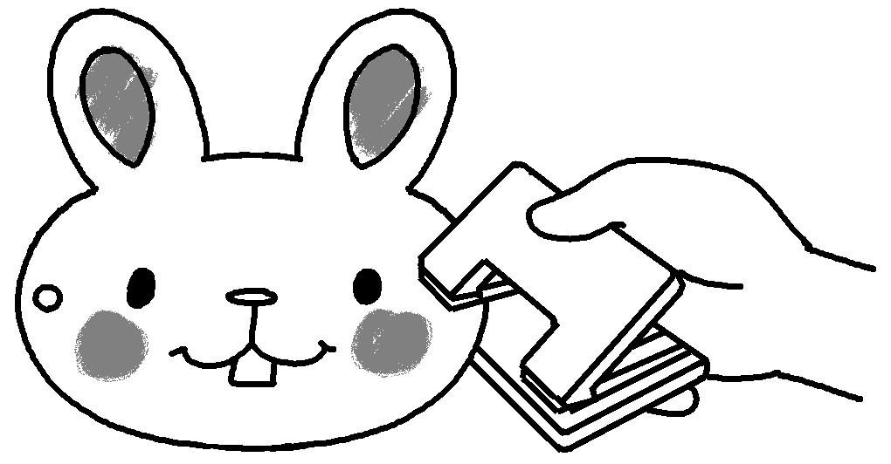  5 |  | 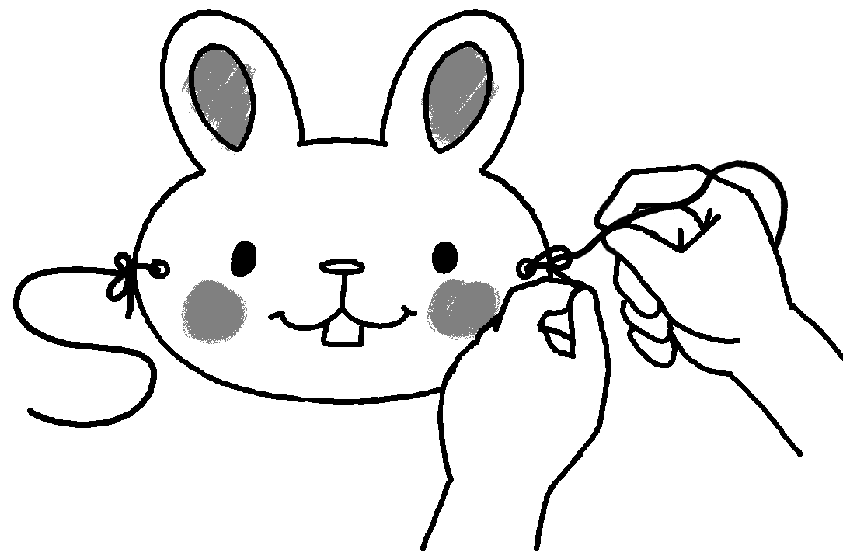
 | Steps: |  |  |  |  |  | 4
 | 1  2  3  4  5 | ___________________ use ______________ to draw a rabbit’s head on a piece of cardboard.  ___________________ use crayons to ___________ the rabbit’s head.  ____________________________ scissors to cut out the rabbit’s head.  ___________________ use a hole punch to ___________ two holes in the cardboard.  ___________________ tie a piece of string to each hole.

Book 5B Chapter 1 Graded Worksheets
Worksheet 3⬇⬇⬇

a 1 First
2 Next / Then / After that draw
3 Then / After that / Next cut
4 Finally use
b 1 First a pencil
2 Next / Then / After that colour
3 Then / After that / Next use
4 After that / Next / Then make
5 Finally



