Choose and write.
can | chopsticks | egg carton | glass | lid
lolly stick | margarine tub | shoe box | candy container | vase
1
metal
2
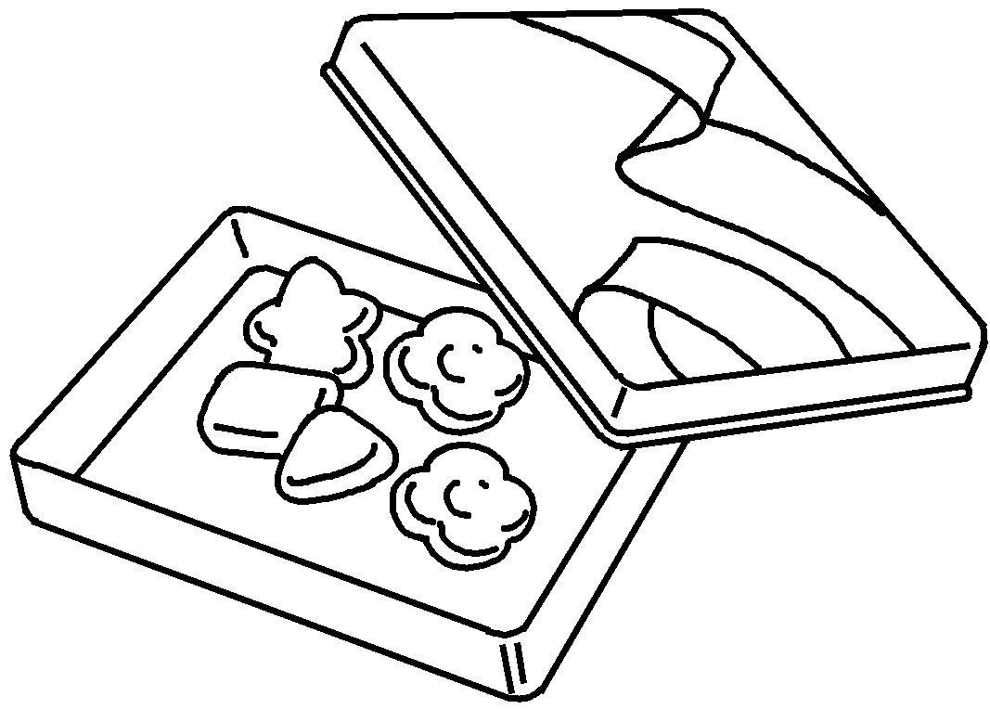 | 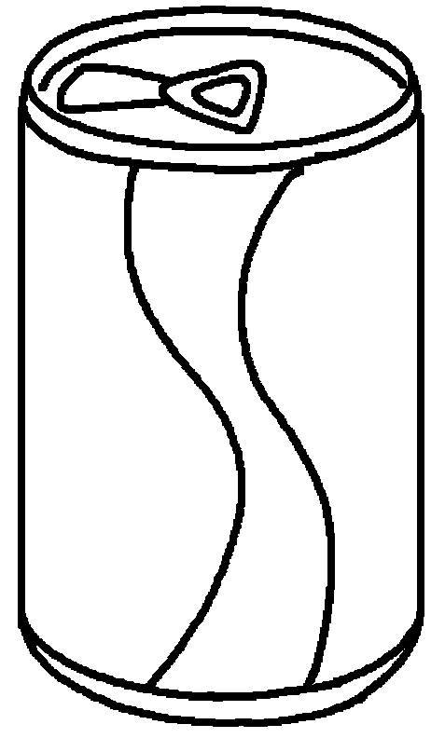 | 1  2 | a  a
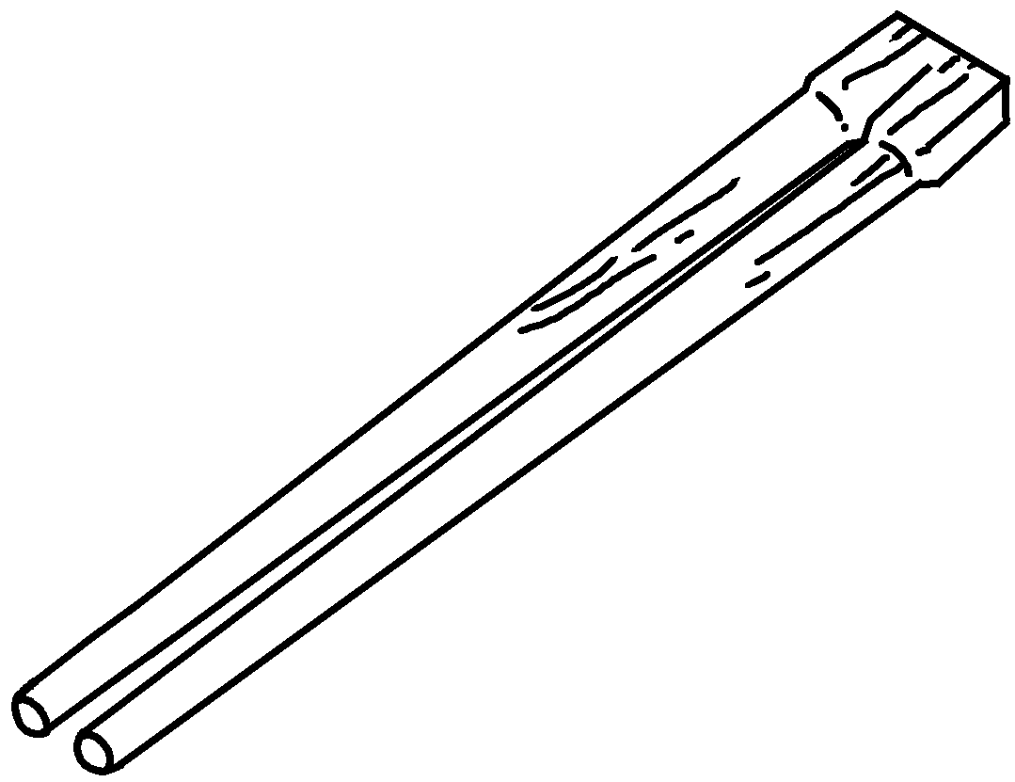  3  wood  4 | 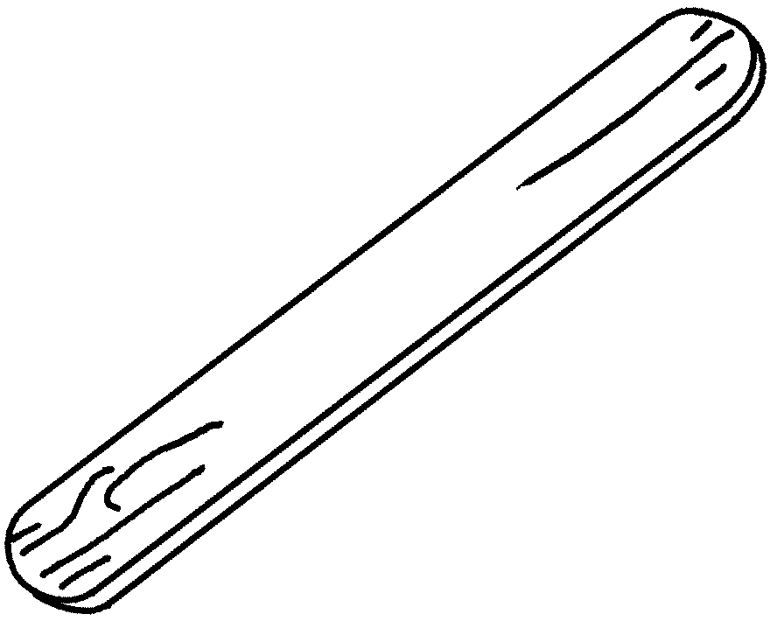 | 3  4 | a
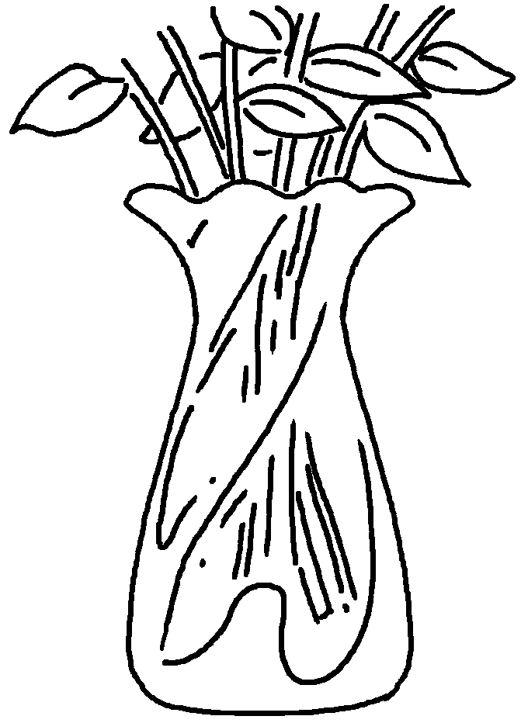  5  glass  6 | 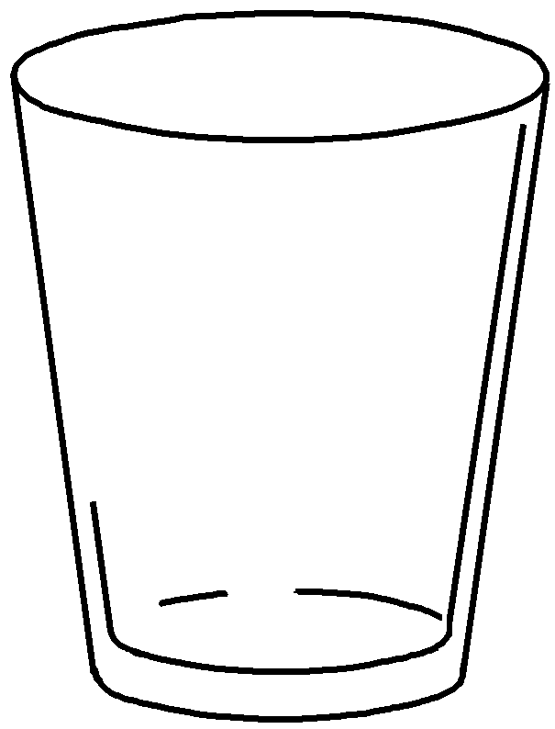 | 5  6 | a  a
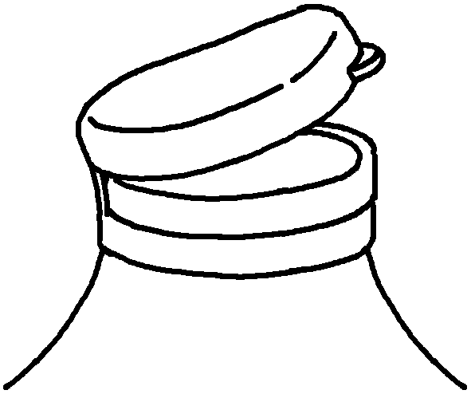  7  plastic  8 | 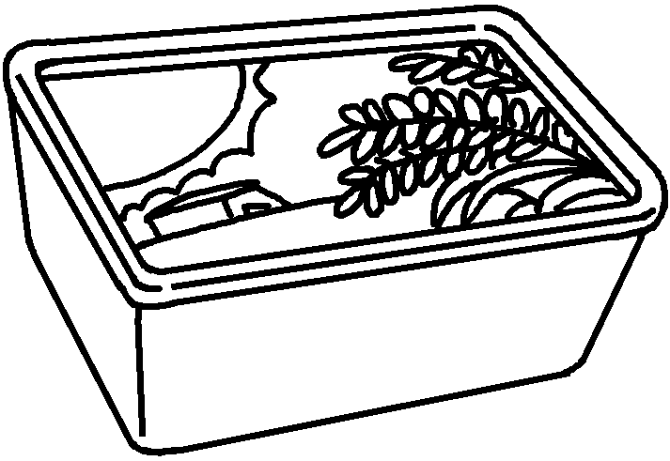 | 7  8 | a  a
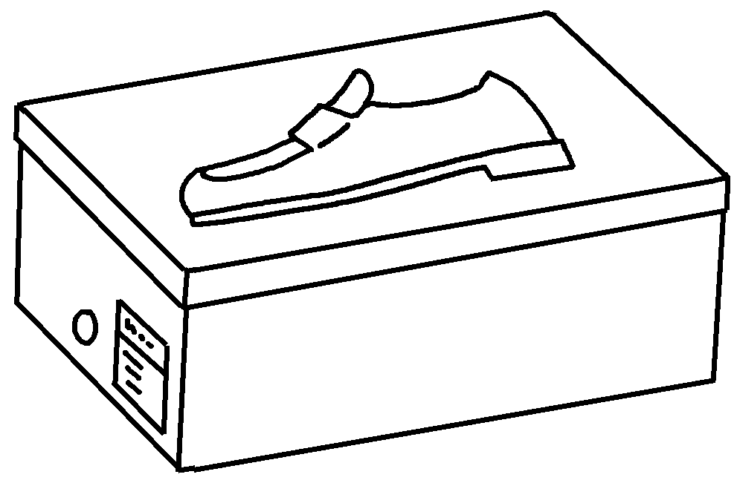  9  cardboard  10 | 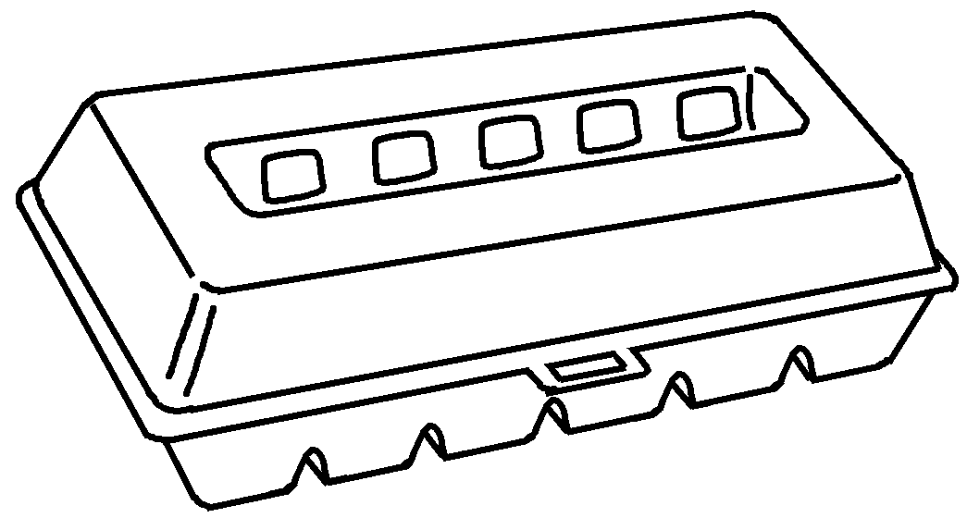 | 9  10 | a  an


Book 5B Chapter 2 Graded Worksheets
Worksheet 1⬇
- candy container
- can
- chopsticks
- lolly stick
- vase
- glass
- lid
- margarine tub
- shoe box
- egg carton

