What are they? Write.
1
metal
2
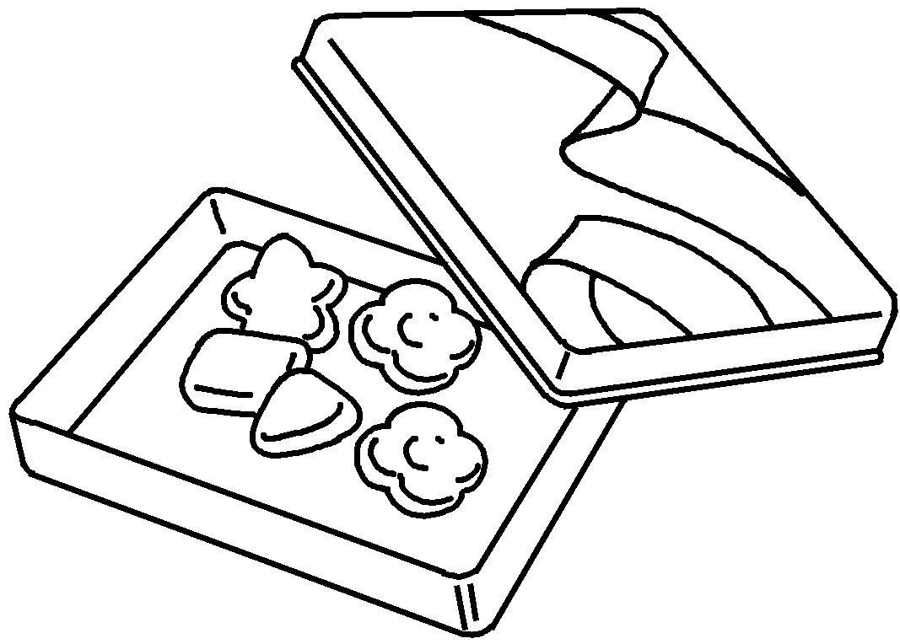 | 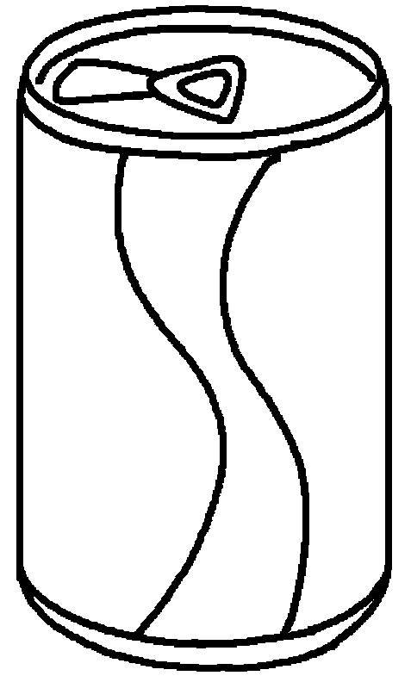 | 1  2 | a candy c  a c

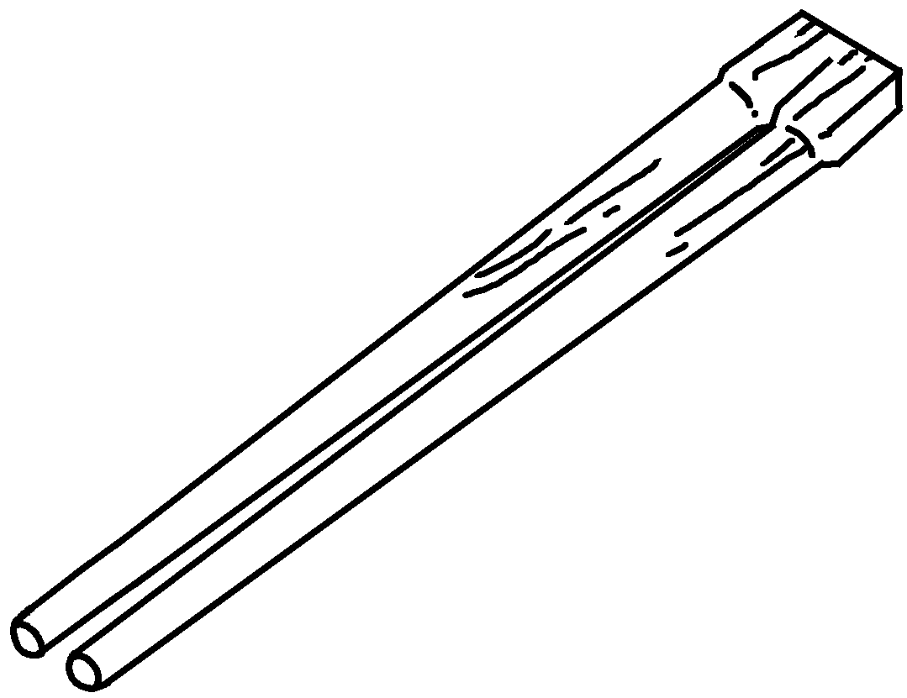  3  wood  4 | 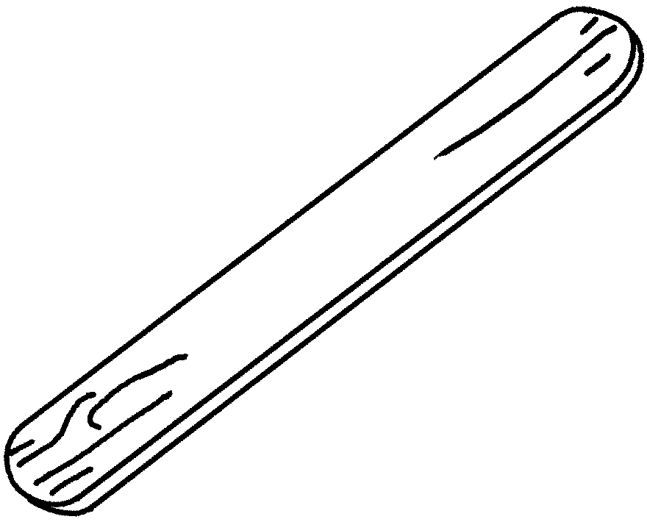 | 3  4 | c  a l s

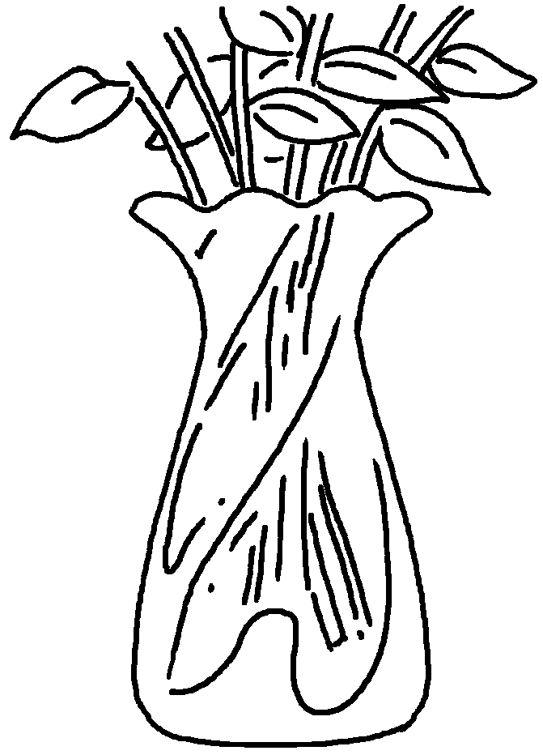  5  glass  6 | 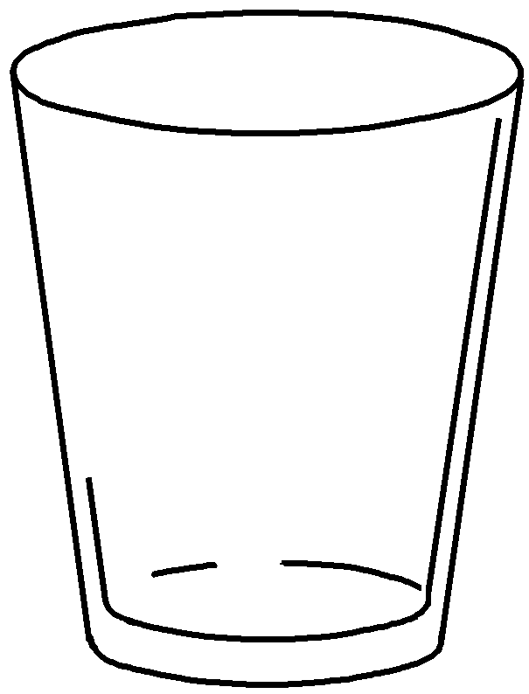 | 5  6 | a v  a g

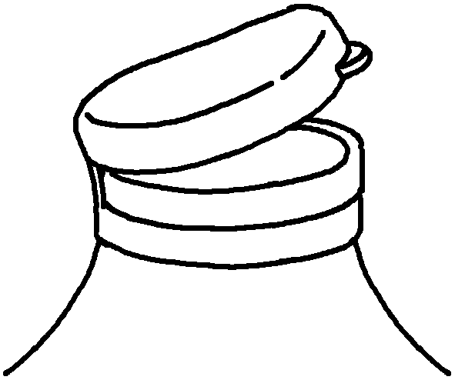  7  plastic  8 | 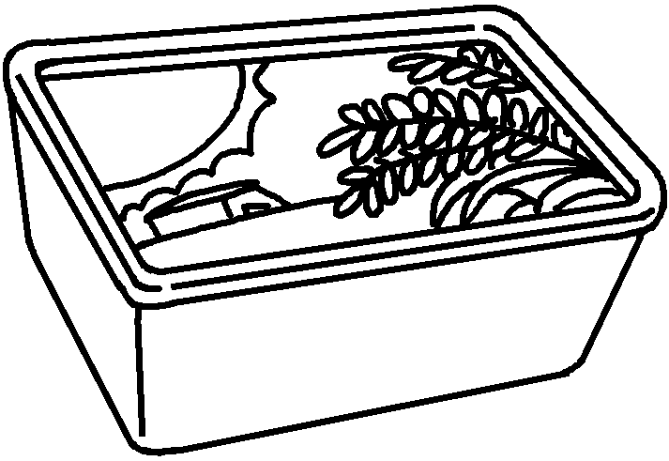 | 7  8 | a l  a m t

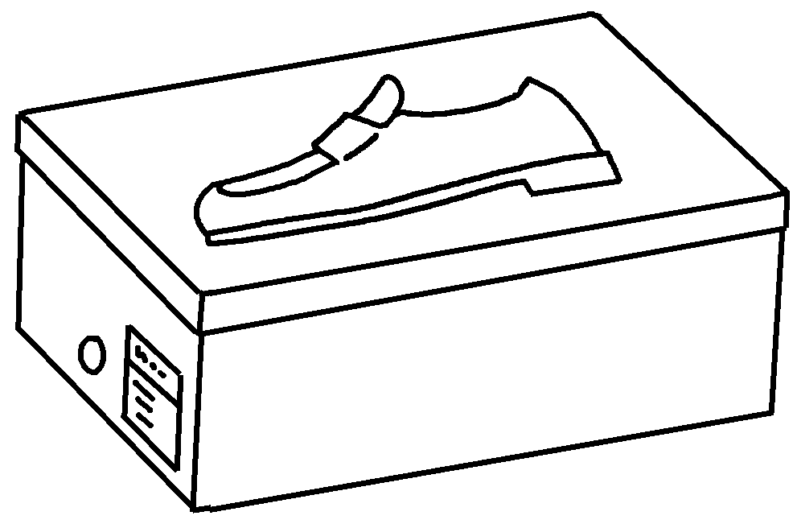  9  cardboard  10 | 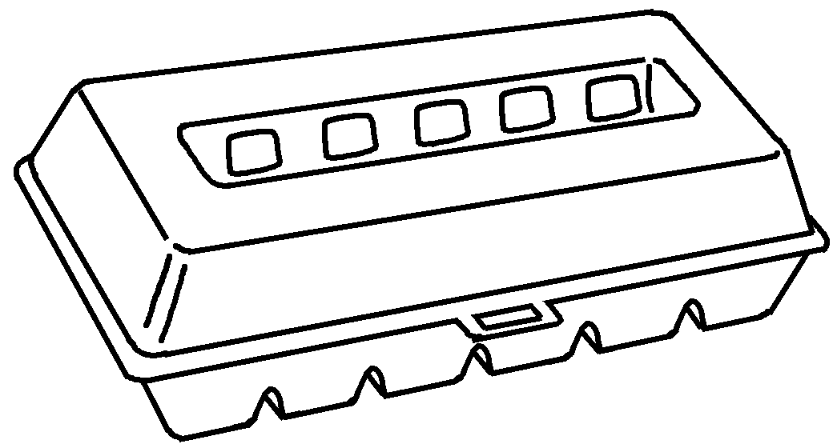 | 9  10 | a s b  an e c


Book 5B Chapter 2 Graded Worksheets
Worksheet 1⬇⬇
- container
- can
- chopsticks
- lolly stick
- vase
- glass
- lid
- margarine tub
- shoe box
- egg carton

