What are they? Write.
1
metal
2
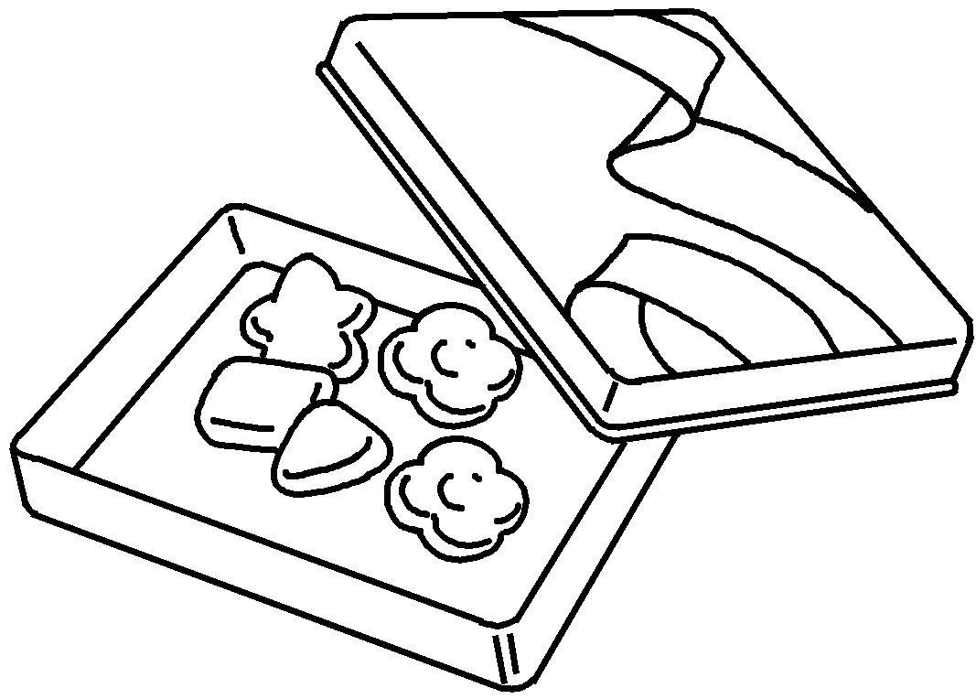 | 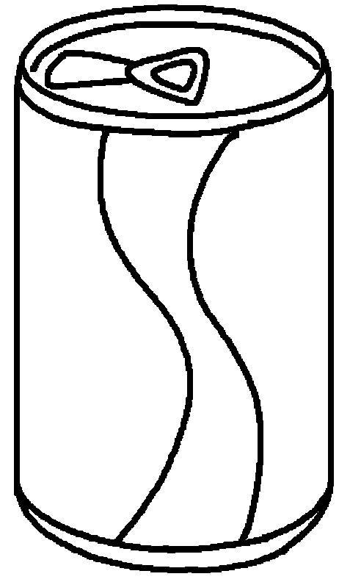 | 1  2 | a candy  a

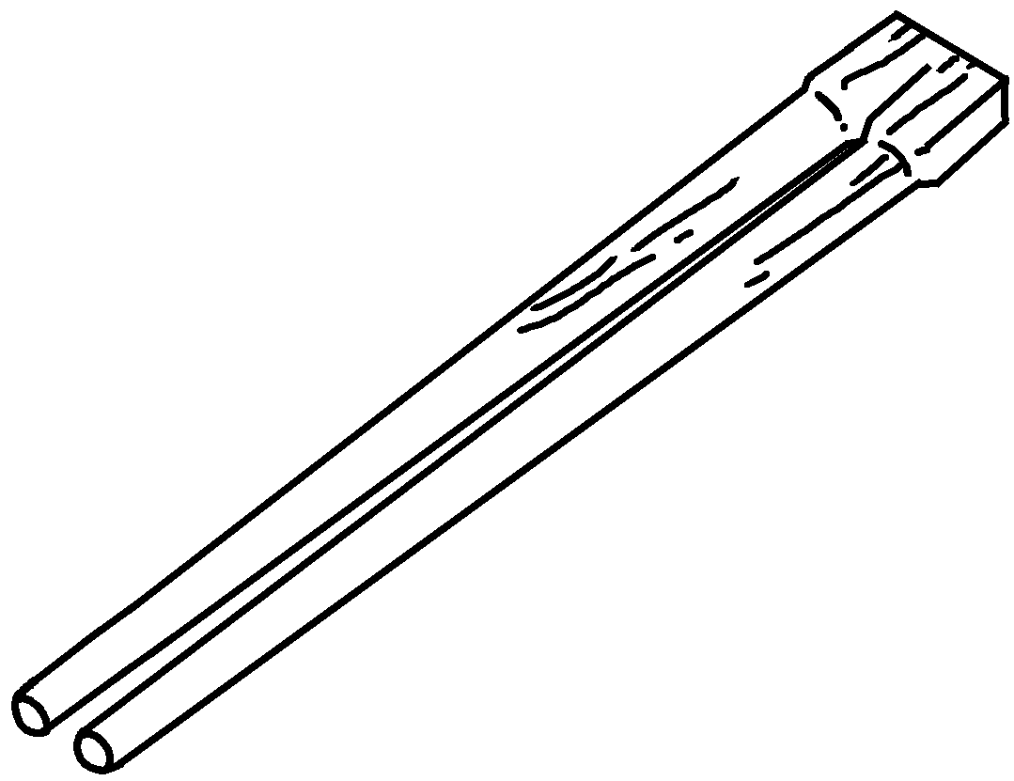  3  wood  4 | 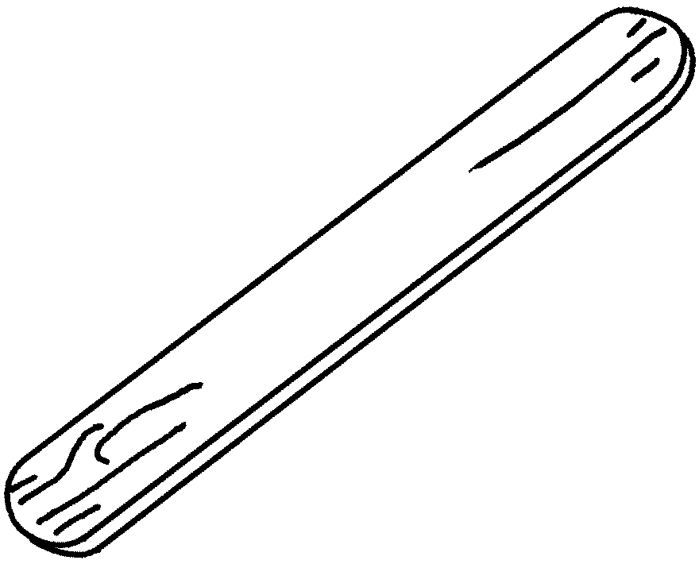 | 3  4

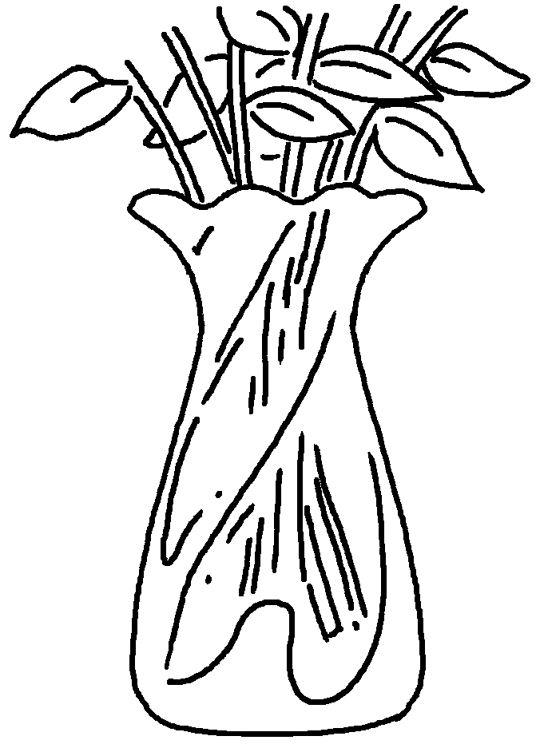  5  glass  6 | 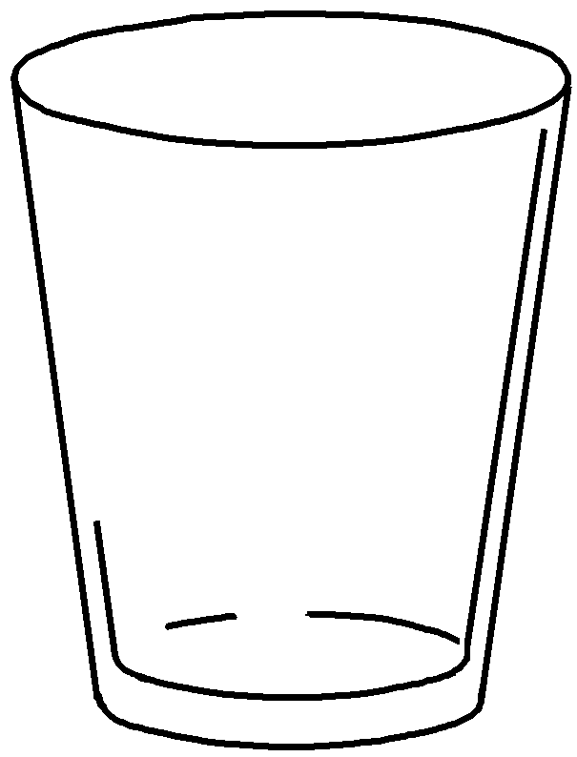 | 5  6

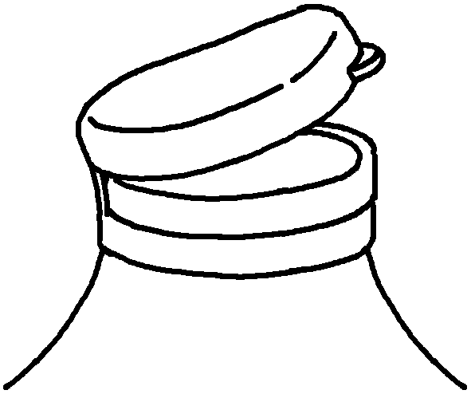  7  plastic  8 | 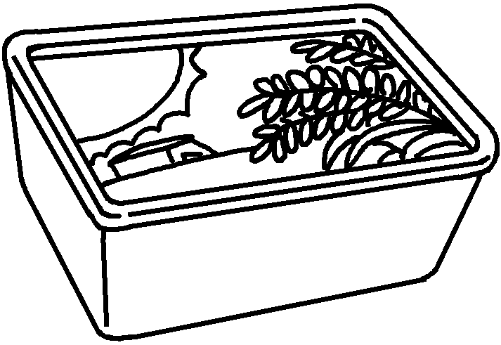 | 7  8

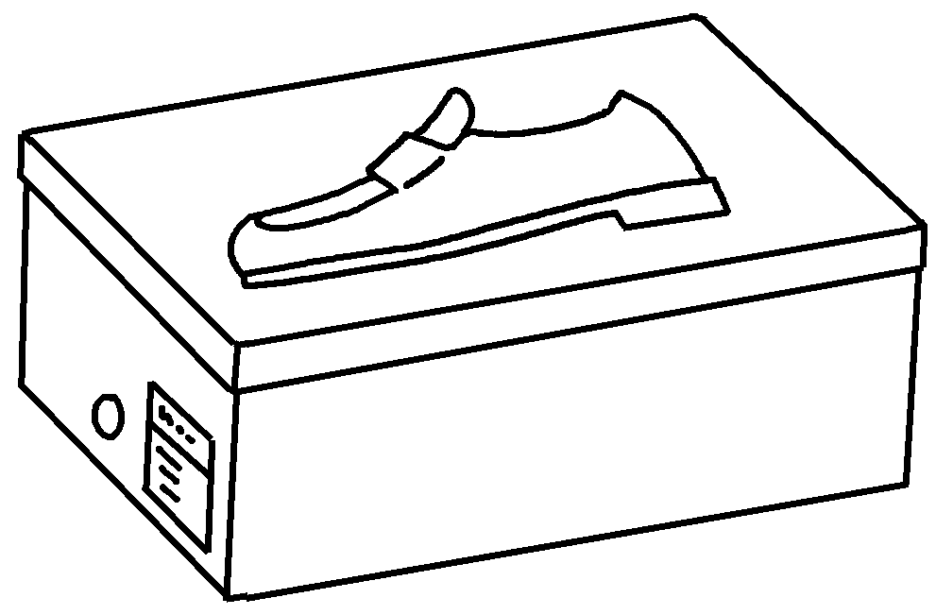  9  cardboard  10 | 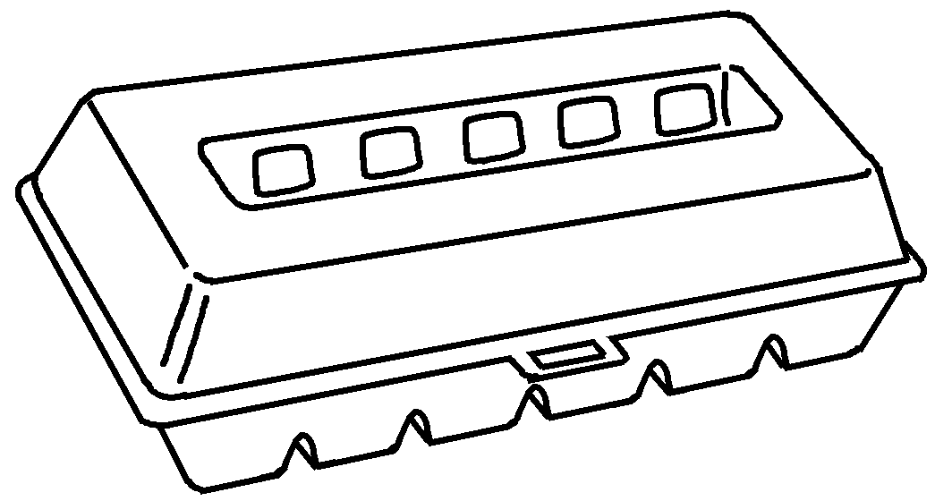 | 9  10


Book 5B Chapter 2 Graded Worksheets
Worksheet 1⬇⬇⬇
- container
- can
- chopsticks
- a lolly stick
- a vase
- a glass
- a lid
- a margarine tub
- a shoe box
- an egg carton
(Accept any reasonable answers.)

