What are the following things used for? Write.

bake beat hang hold squeeze store

1 | 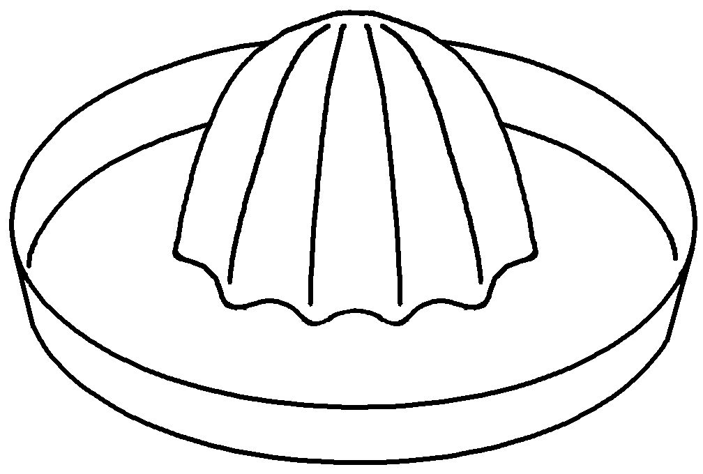 | This is used for juice.
2 | 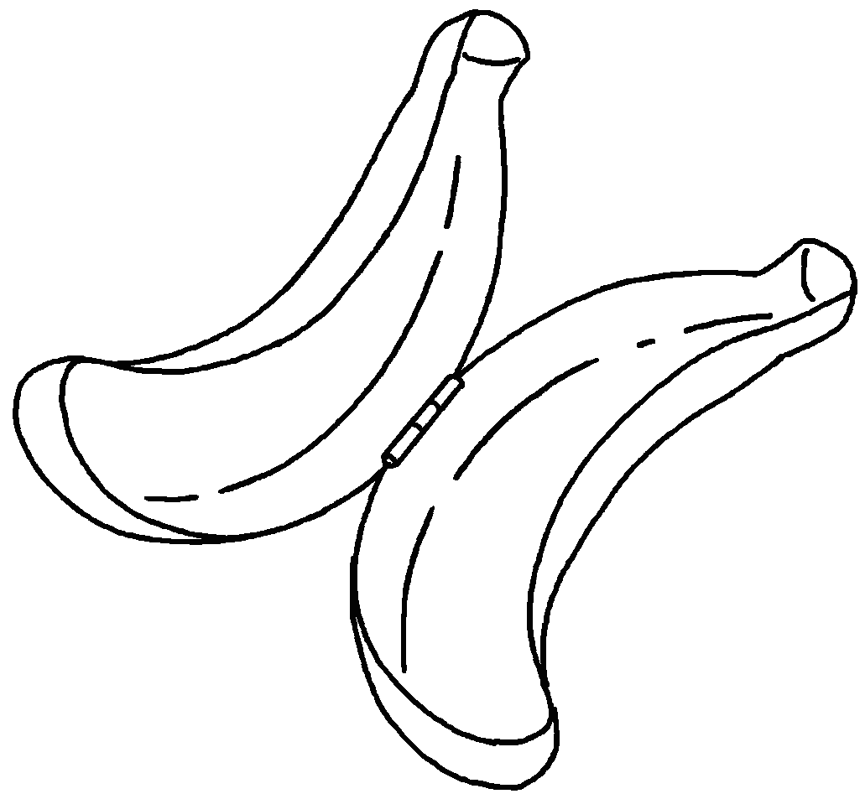 | This is used a banana.
3 | 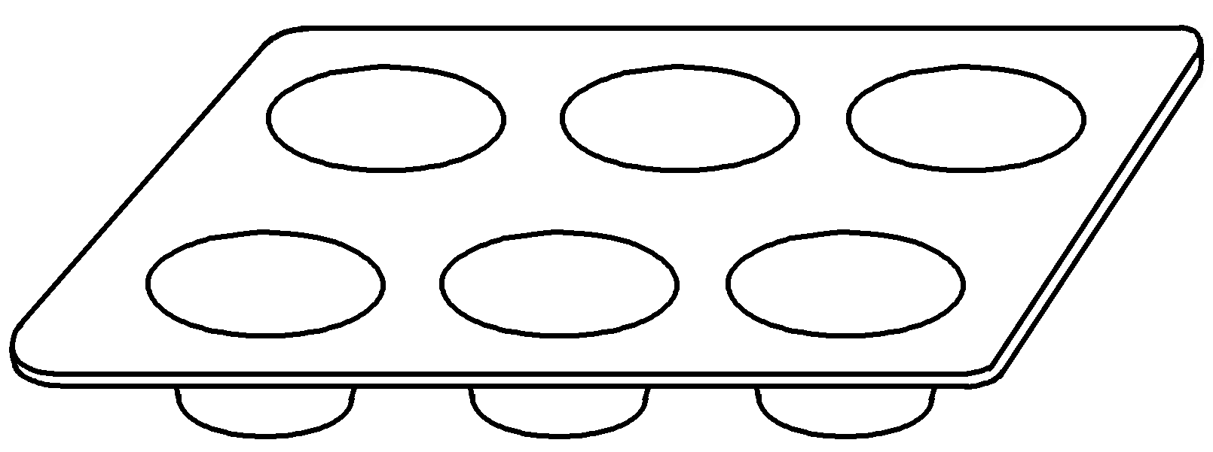 | This  cup cakes.
4 | 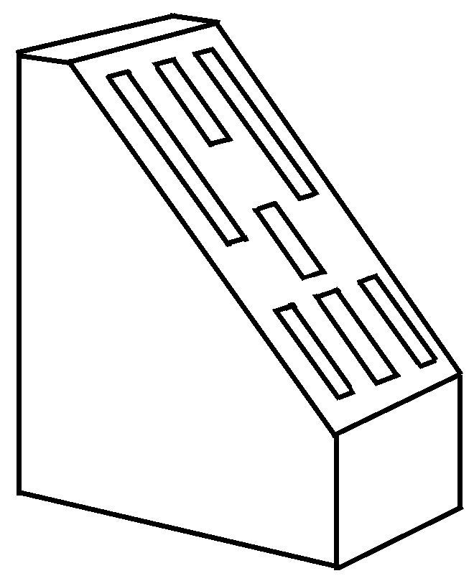 | This  knives.
5 | 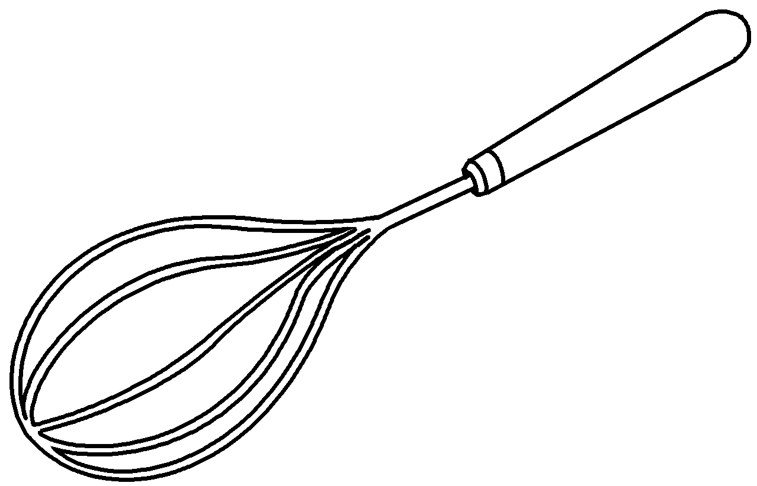 | eggs.
6 | 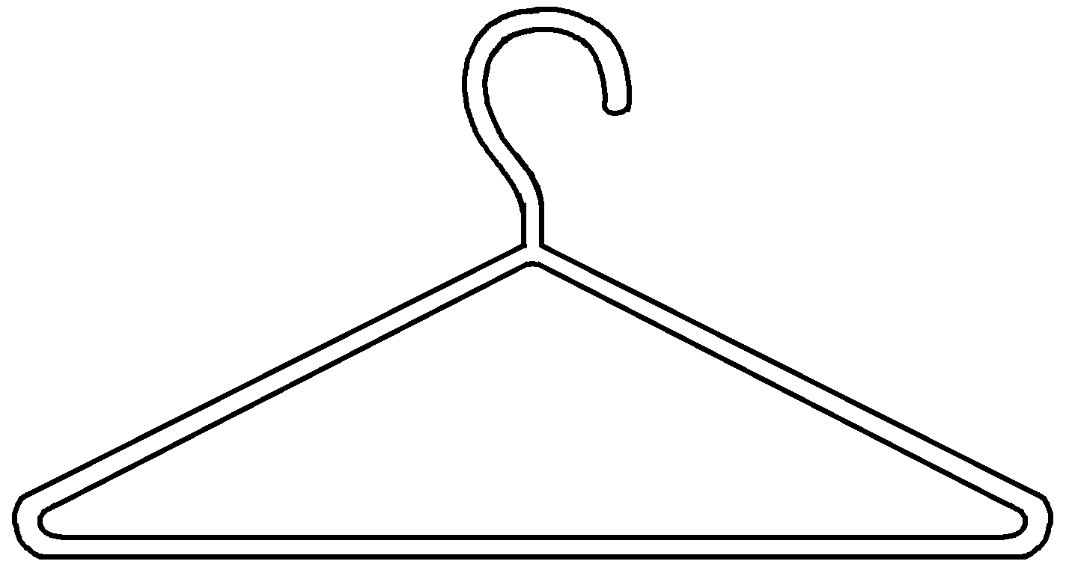 | clothes.



Book 5B Chapter 2 Graded Worksheets
Worksheet 2⬇⬇
- squeezing
- for storing
- is used for baking
- is used for holding
- This is used for beating
- This is used for hanging

