What are the following things used for? Write.

bake beat hang cup cakes eggs clothes
hold squeeze store a banana knives

1 | 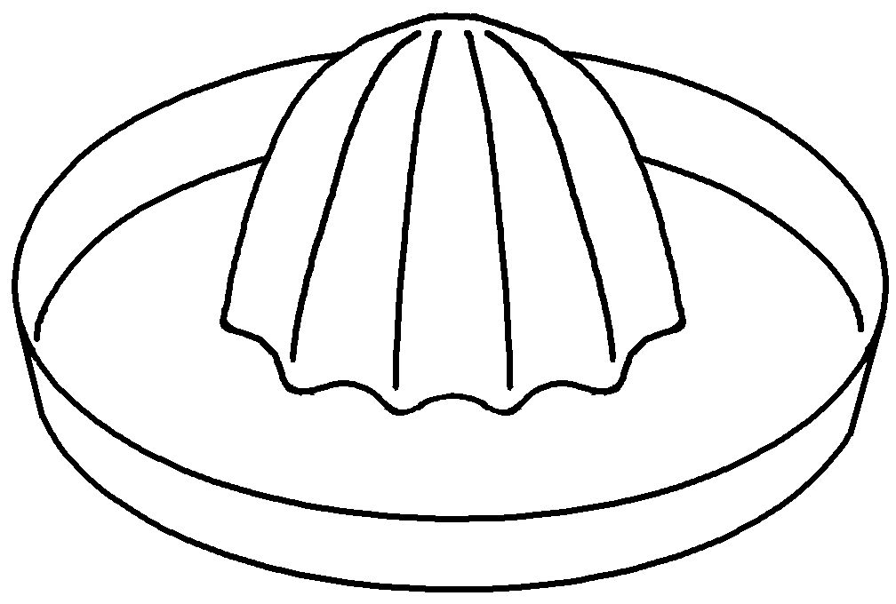 | This is used for juice.
2 | 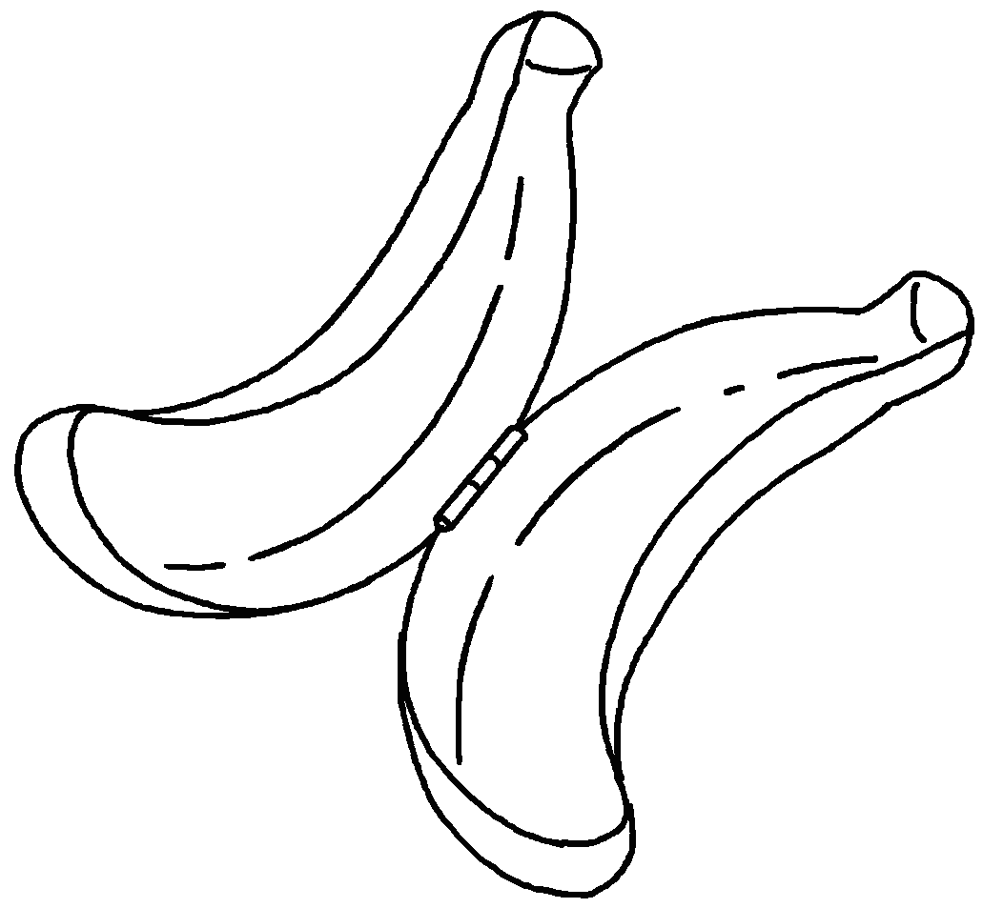 | This is used  .
3 | 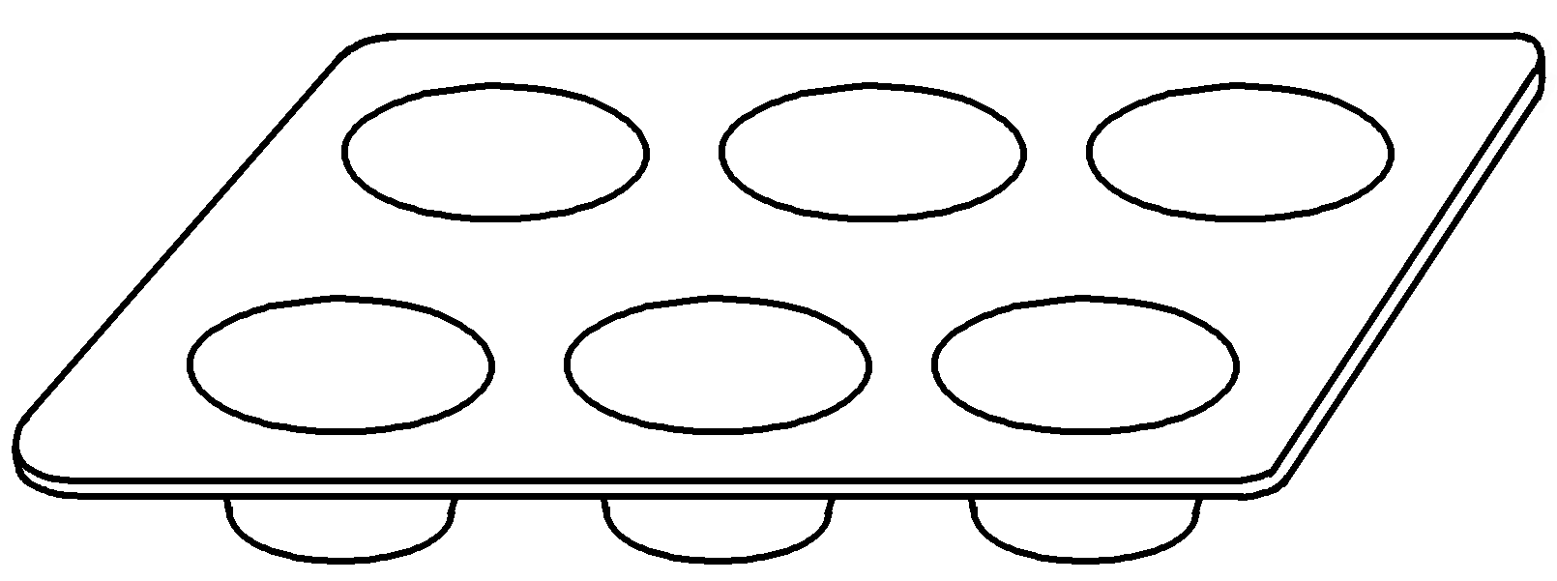 | This  .
4 | 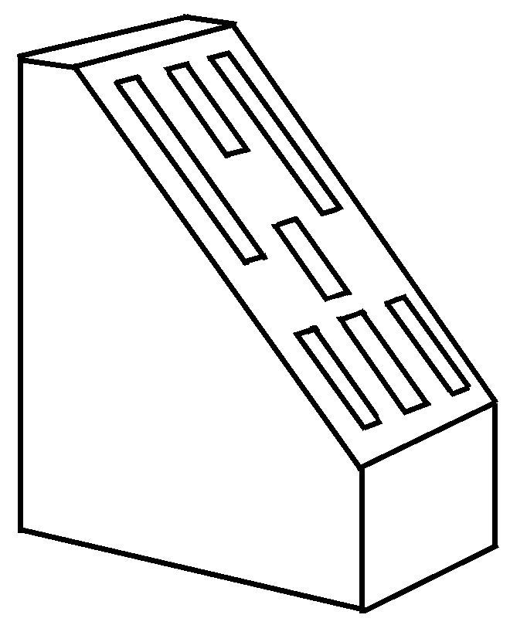 | This  .
5 | 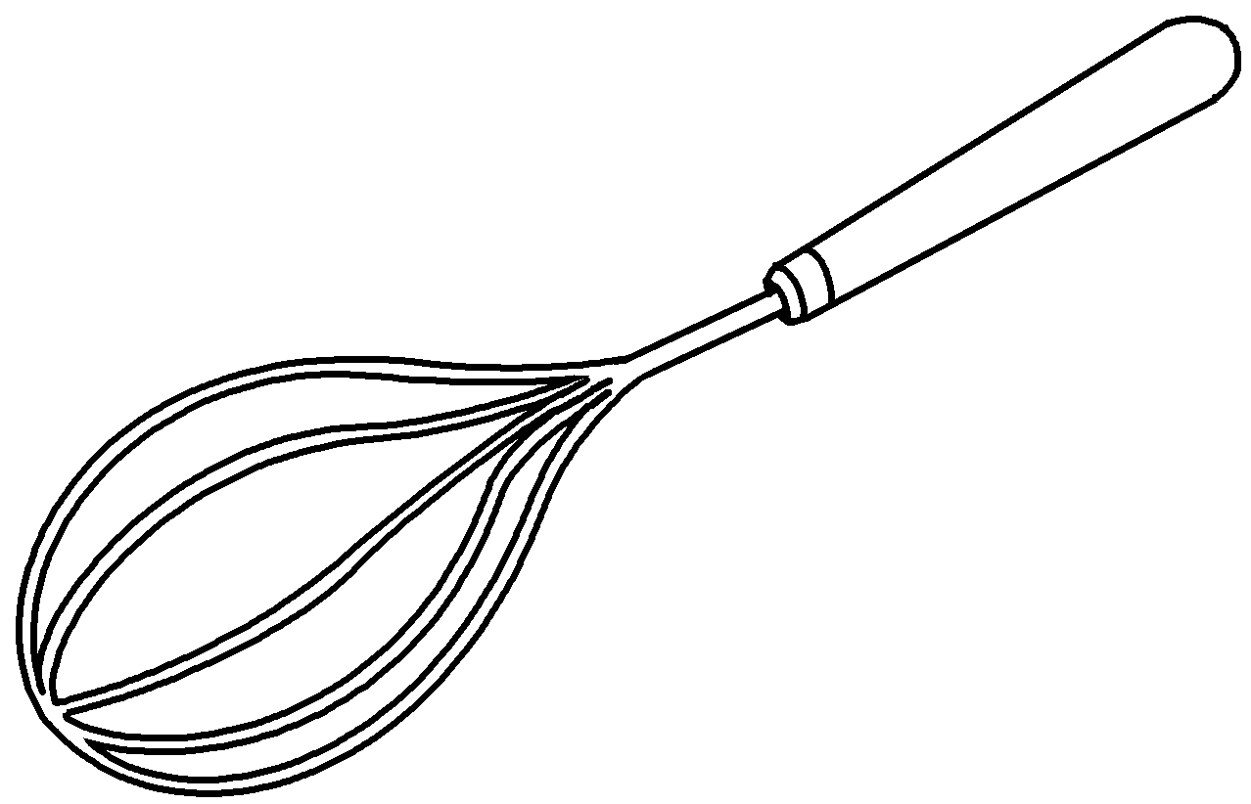
6 | 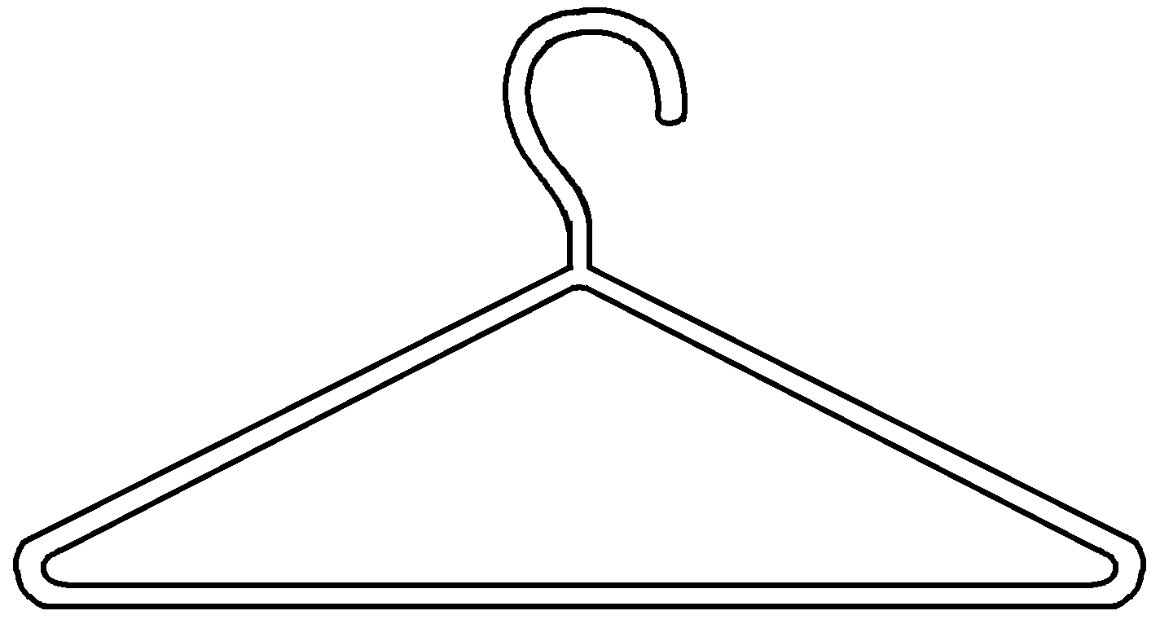



Book 5B Chapter 2 Graded Worksheets
Worksheet 2⬇⬇⬇
1 squeezing
2 for storing a banana
3 is used for baking cup cakes
4 is used for holding knives
5 This is used for beating eggs.
6 This is used for hanging clothes.

