Finish the sentences.
( plastic )
( cardboard )
( glass )
( metal )
is | made of

1 | 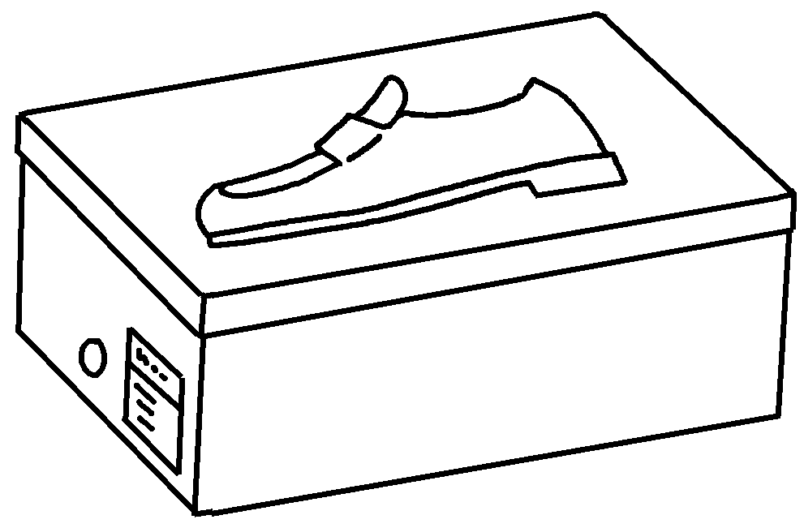 | This shoe box is cardboard.
2 | 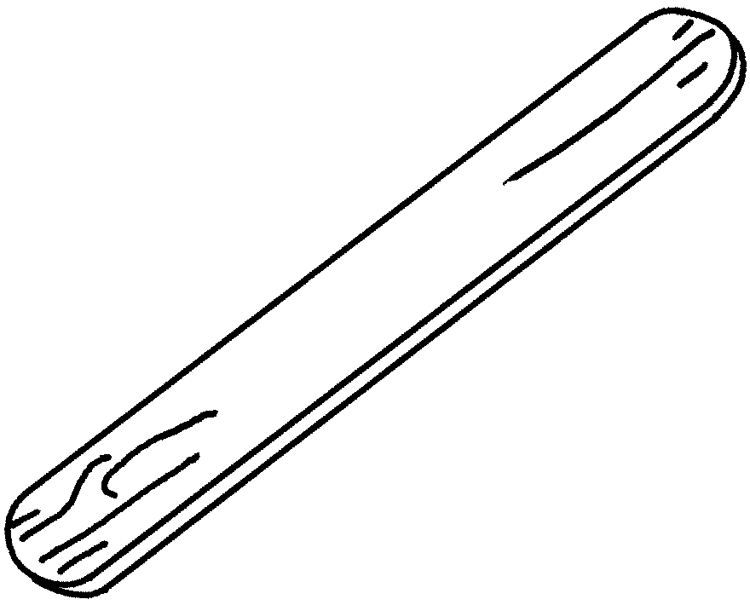 | This lolly stick wood.
3 | 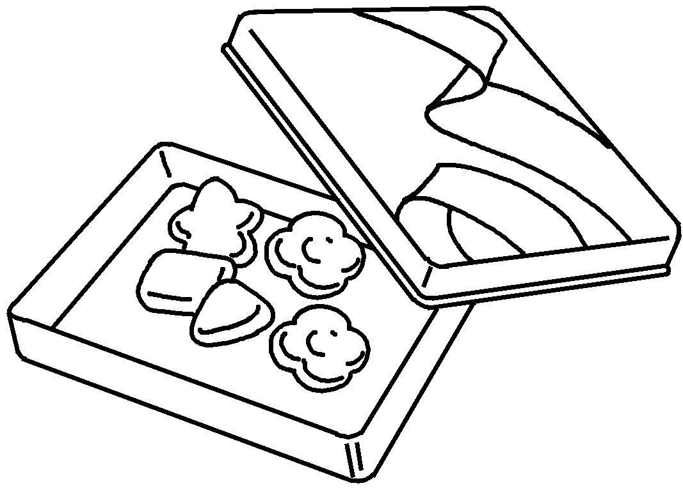 | This candy container  .
4 | 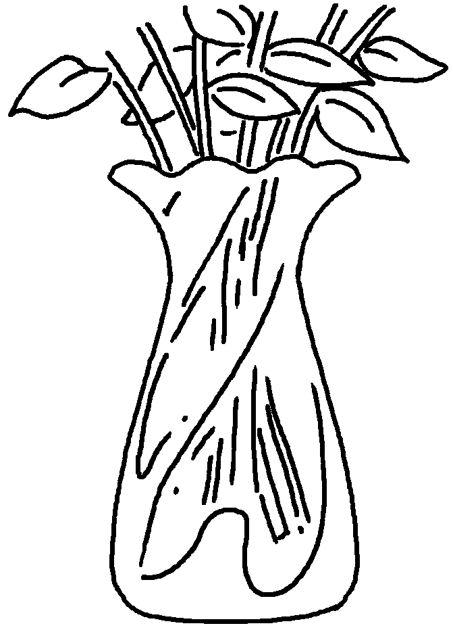 | This vase  .
5 | 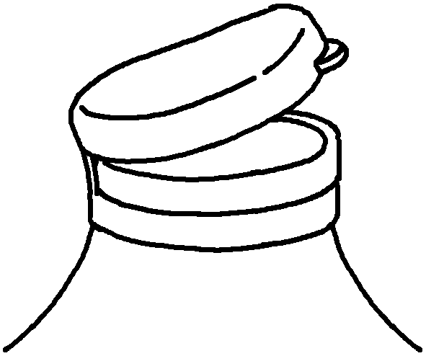 | This lid  .
6 | 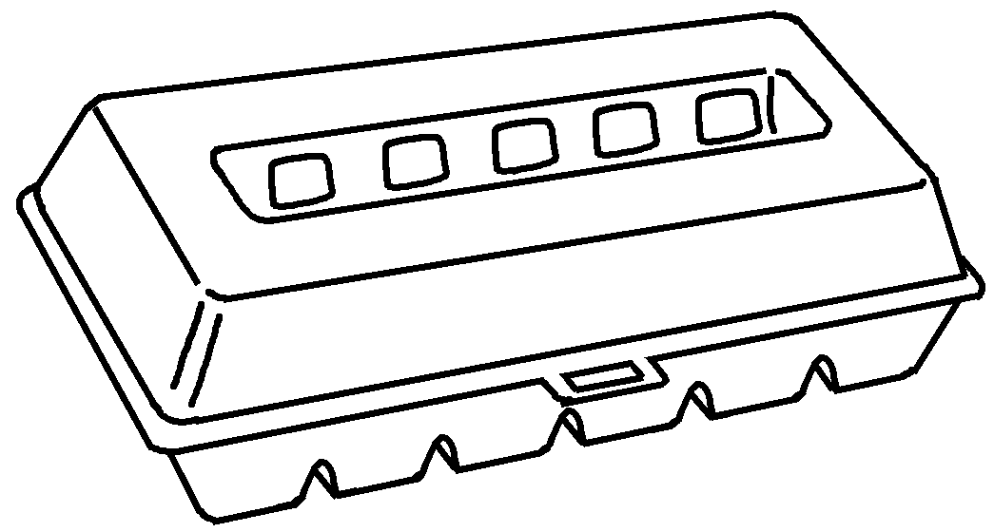 | This egg carton  .


Book 5B Chapter 2 Graded Worksheets
Worksheet 3⬇
- made of
- is made of
- is made of metal
- is made of glass
- is made of plastic
- is made of cardboard

