What are the following things made of? Write.

cardboard glass metal plastic wood

1 | 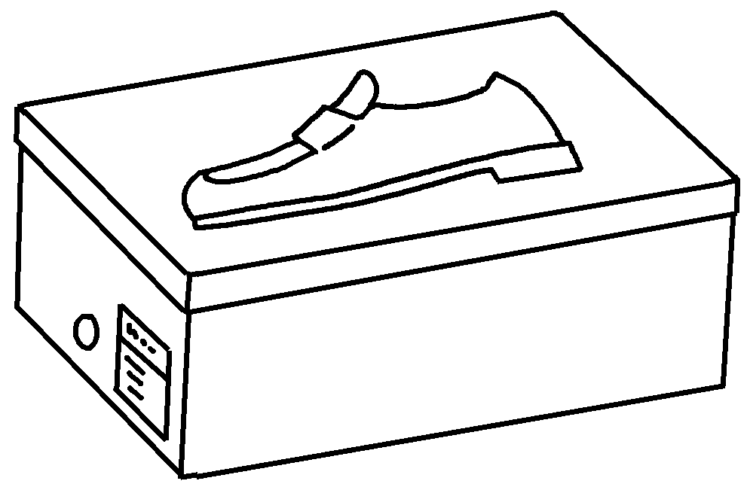 | This shoe box is made of .
2 | 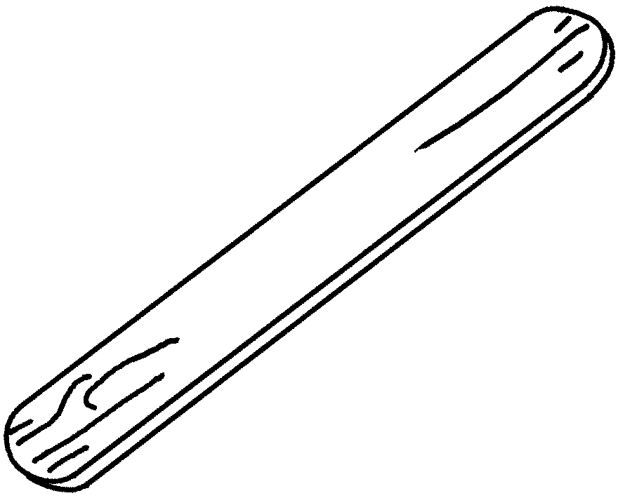 | This lolly stick is .
3 | 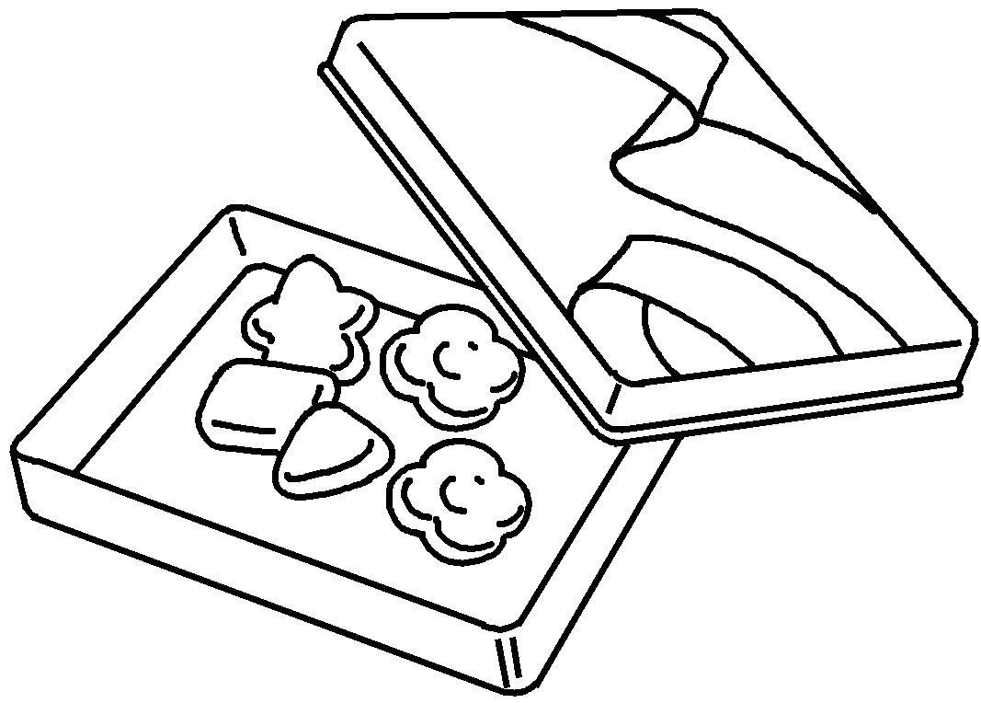 | This candy container  .
4 | 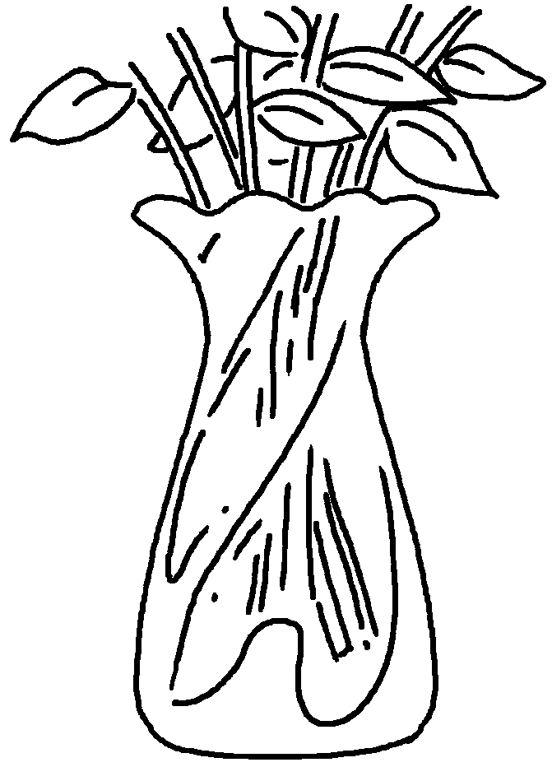 | This vase  .
5 | 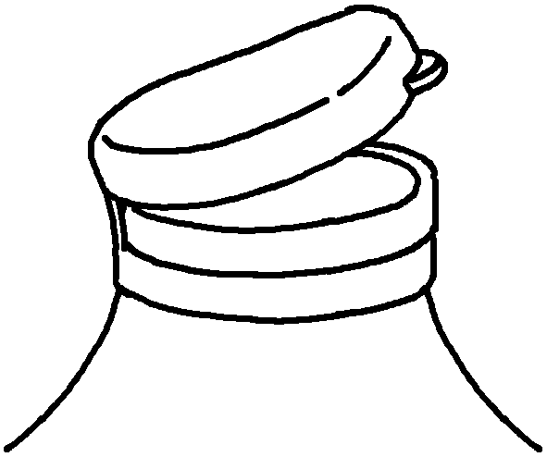 | This lid  .
6 | 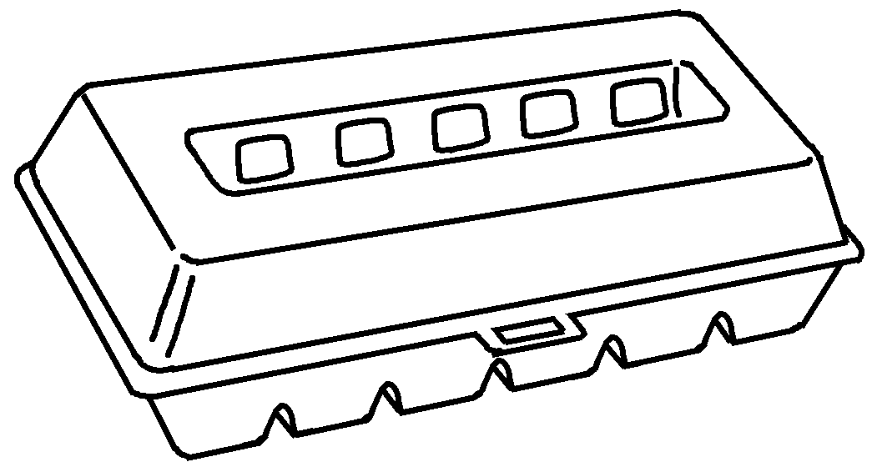 | This egg carton  .


Book 5B Chapter 2 Graded Worksheets
Worksheet 3⬇⬇
- cardboard
- made of wood
- is made of metal
- is made of glass
- is made of plastic
- is made of cardboard

