What are the following things made of? Write.

cardboard glass metal plastic wood

1 | 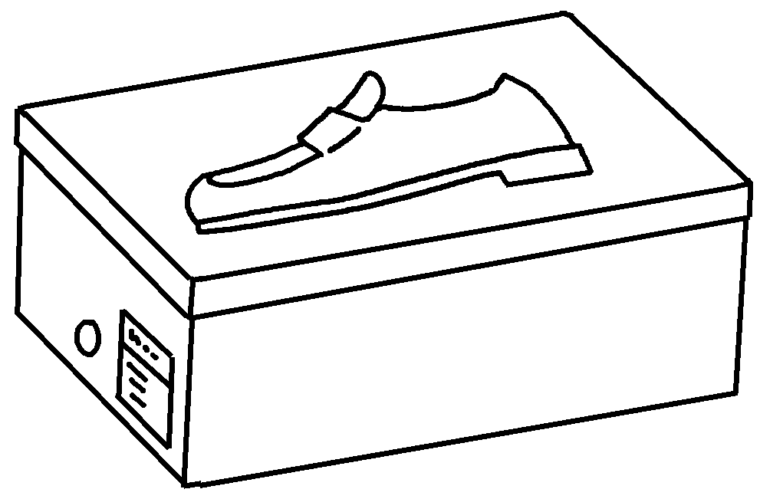 | This shoe box is made of .
2 | 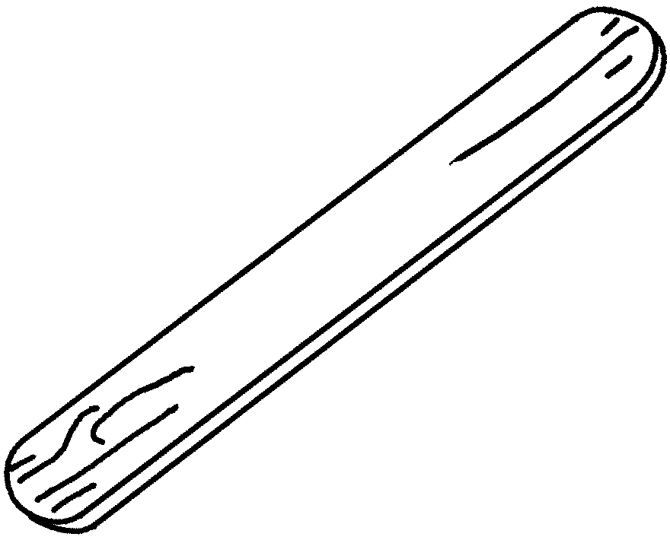 | This lolly stick is .
3 | 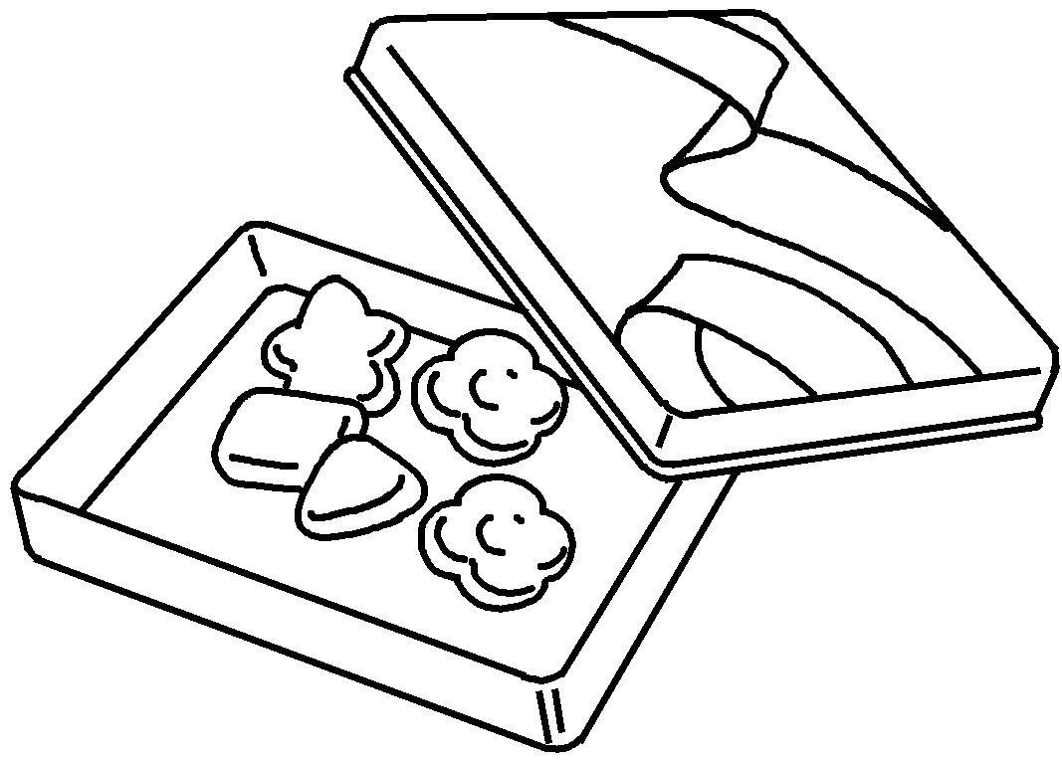 | This candy container  .
4 | 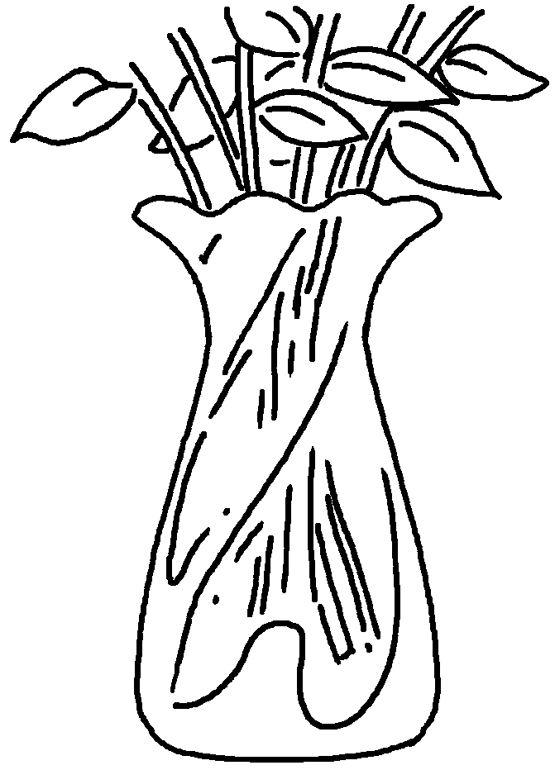 | This  .
5 | 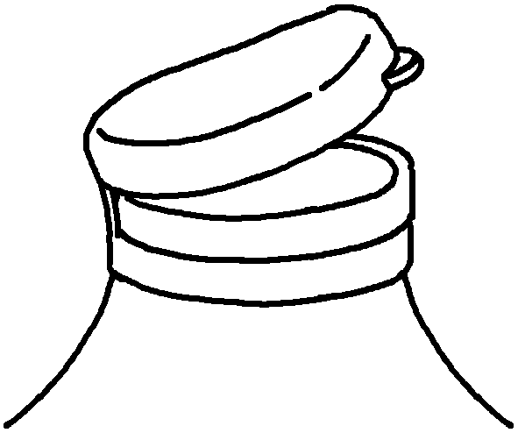
6 | 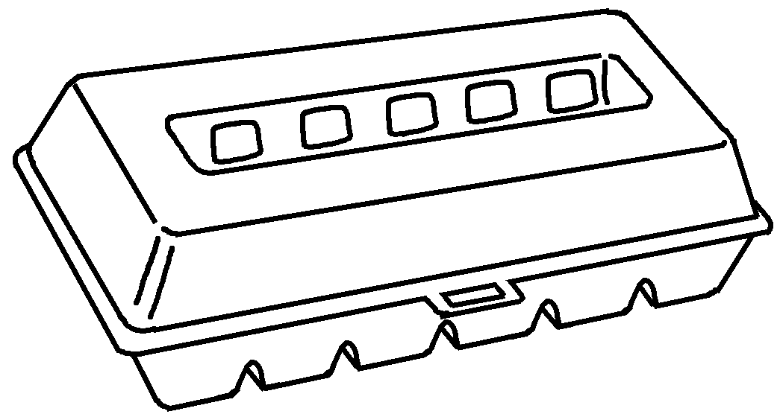


Book 5B Chapter 2 Graded Worksheets
Worksheet 3⬇⬇⬇
- cardboard
- made of wood
- is made of metal
- vase is made of glass
- This lid is made of plastic.
- This egg carton is made of cardboard.

