- Be creative!
Do you know the names of any famous inventors? Do you think children can be inventors? Read the magazine article and find out.
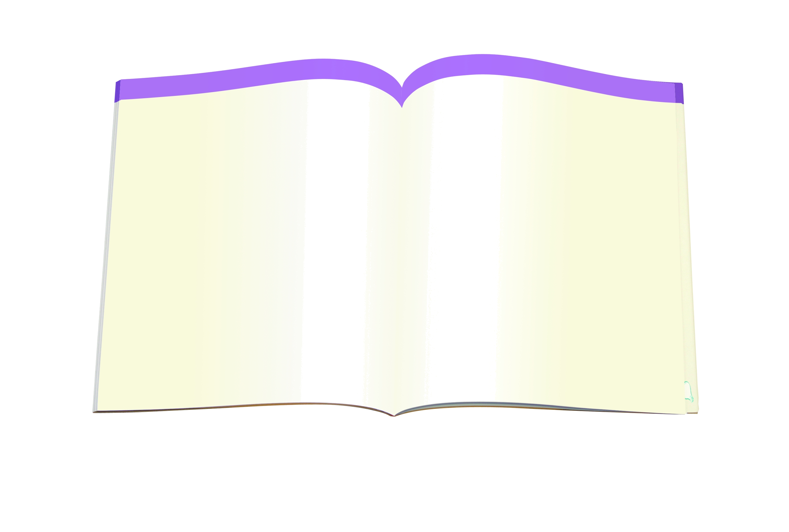
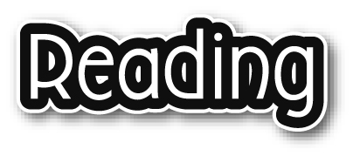

This Month’s Feature

Children can be inventors too!
By William Evans

Chester loved ice-skating, but he hated having cold ears. His solution – earmuffs! They were made of metal wire and animal fur. At first Chester’s friends laughed at him. Then they saw that Chester could keep warm while they went home with cold ears. Everybody wanted earmuffs then!

Becky’s invention helps doctors all over the world – and astronauts all over space! Becky put special paint under her writing paper because she wanted to write in the dark. Now her invention, Glo-Sheet, is used for reading patients’ information in hospitals at night. It is also used in spaceships when the lights are turned off.

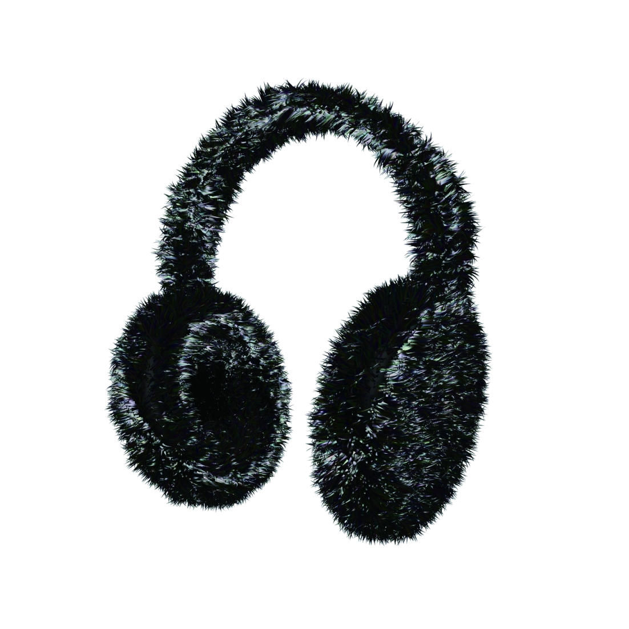

Girl wearing Chester’s invention

Becky making use of her own invention
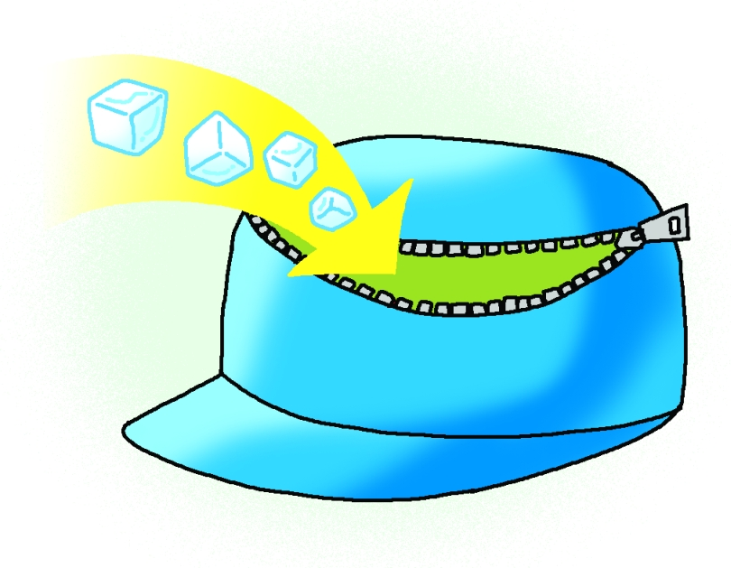
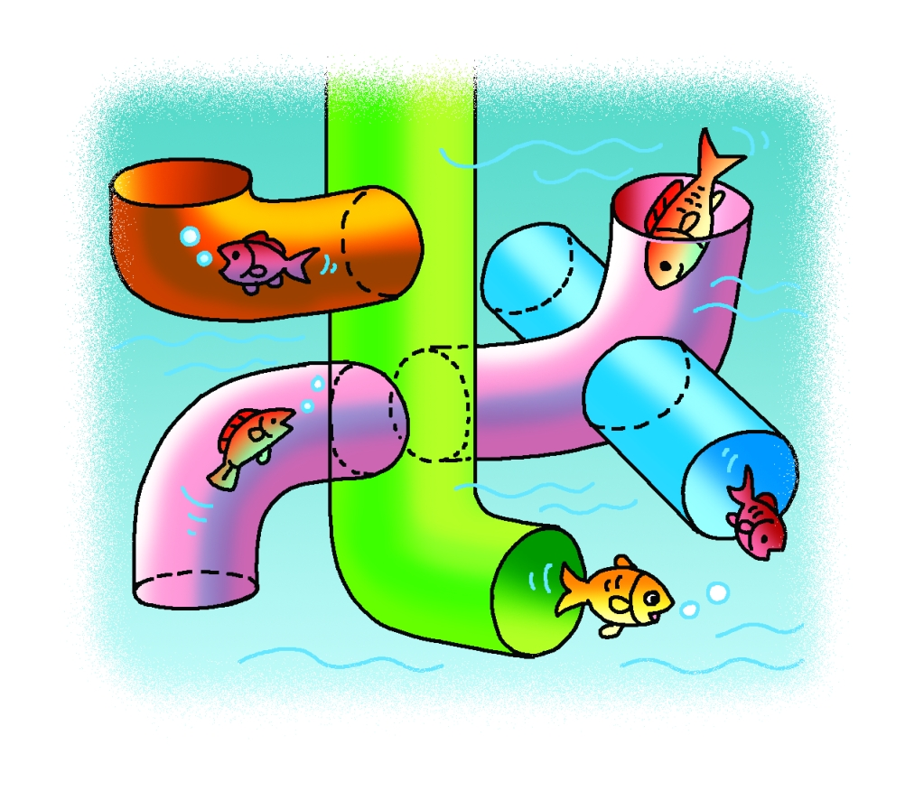
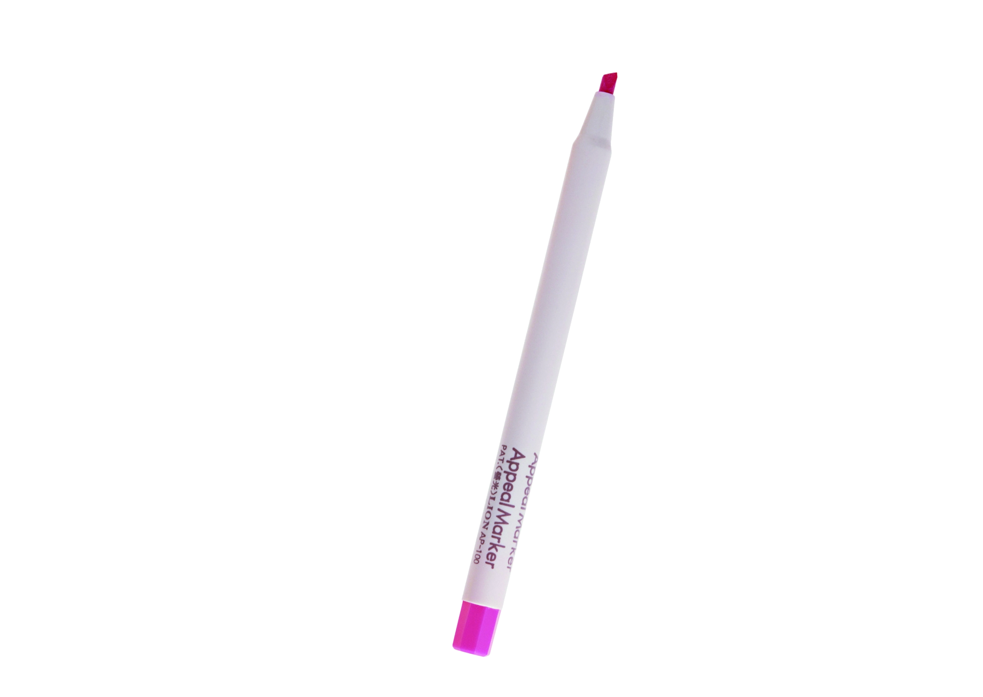
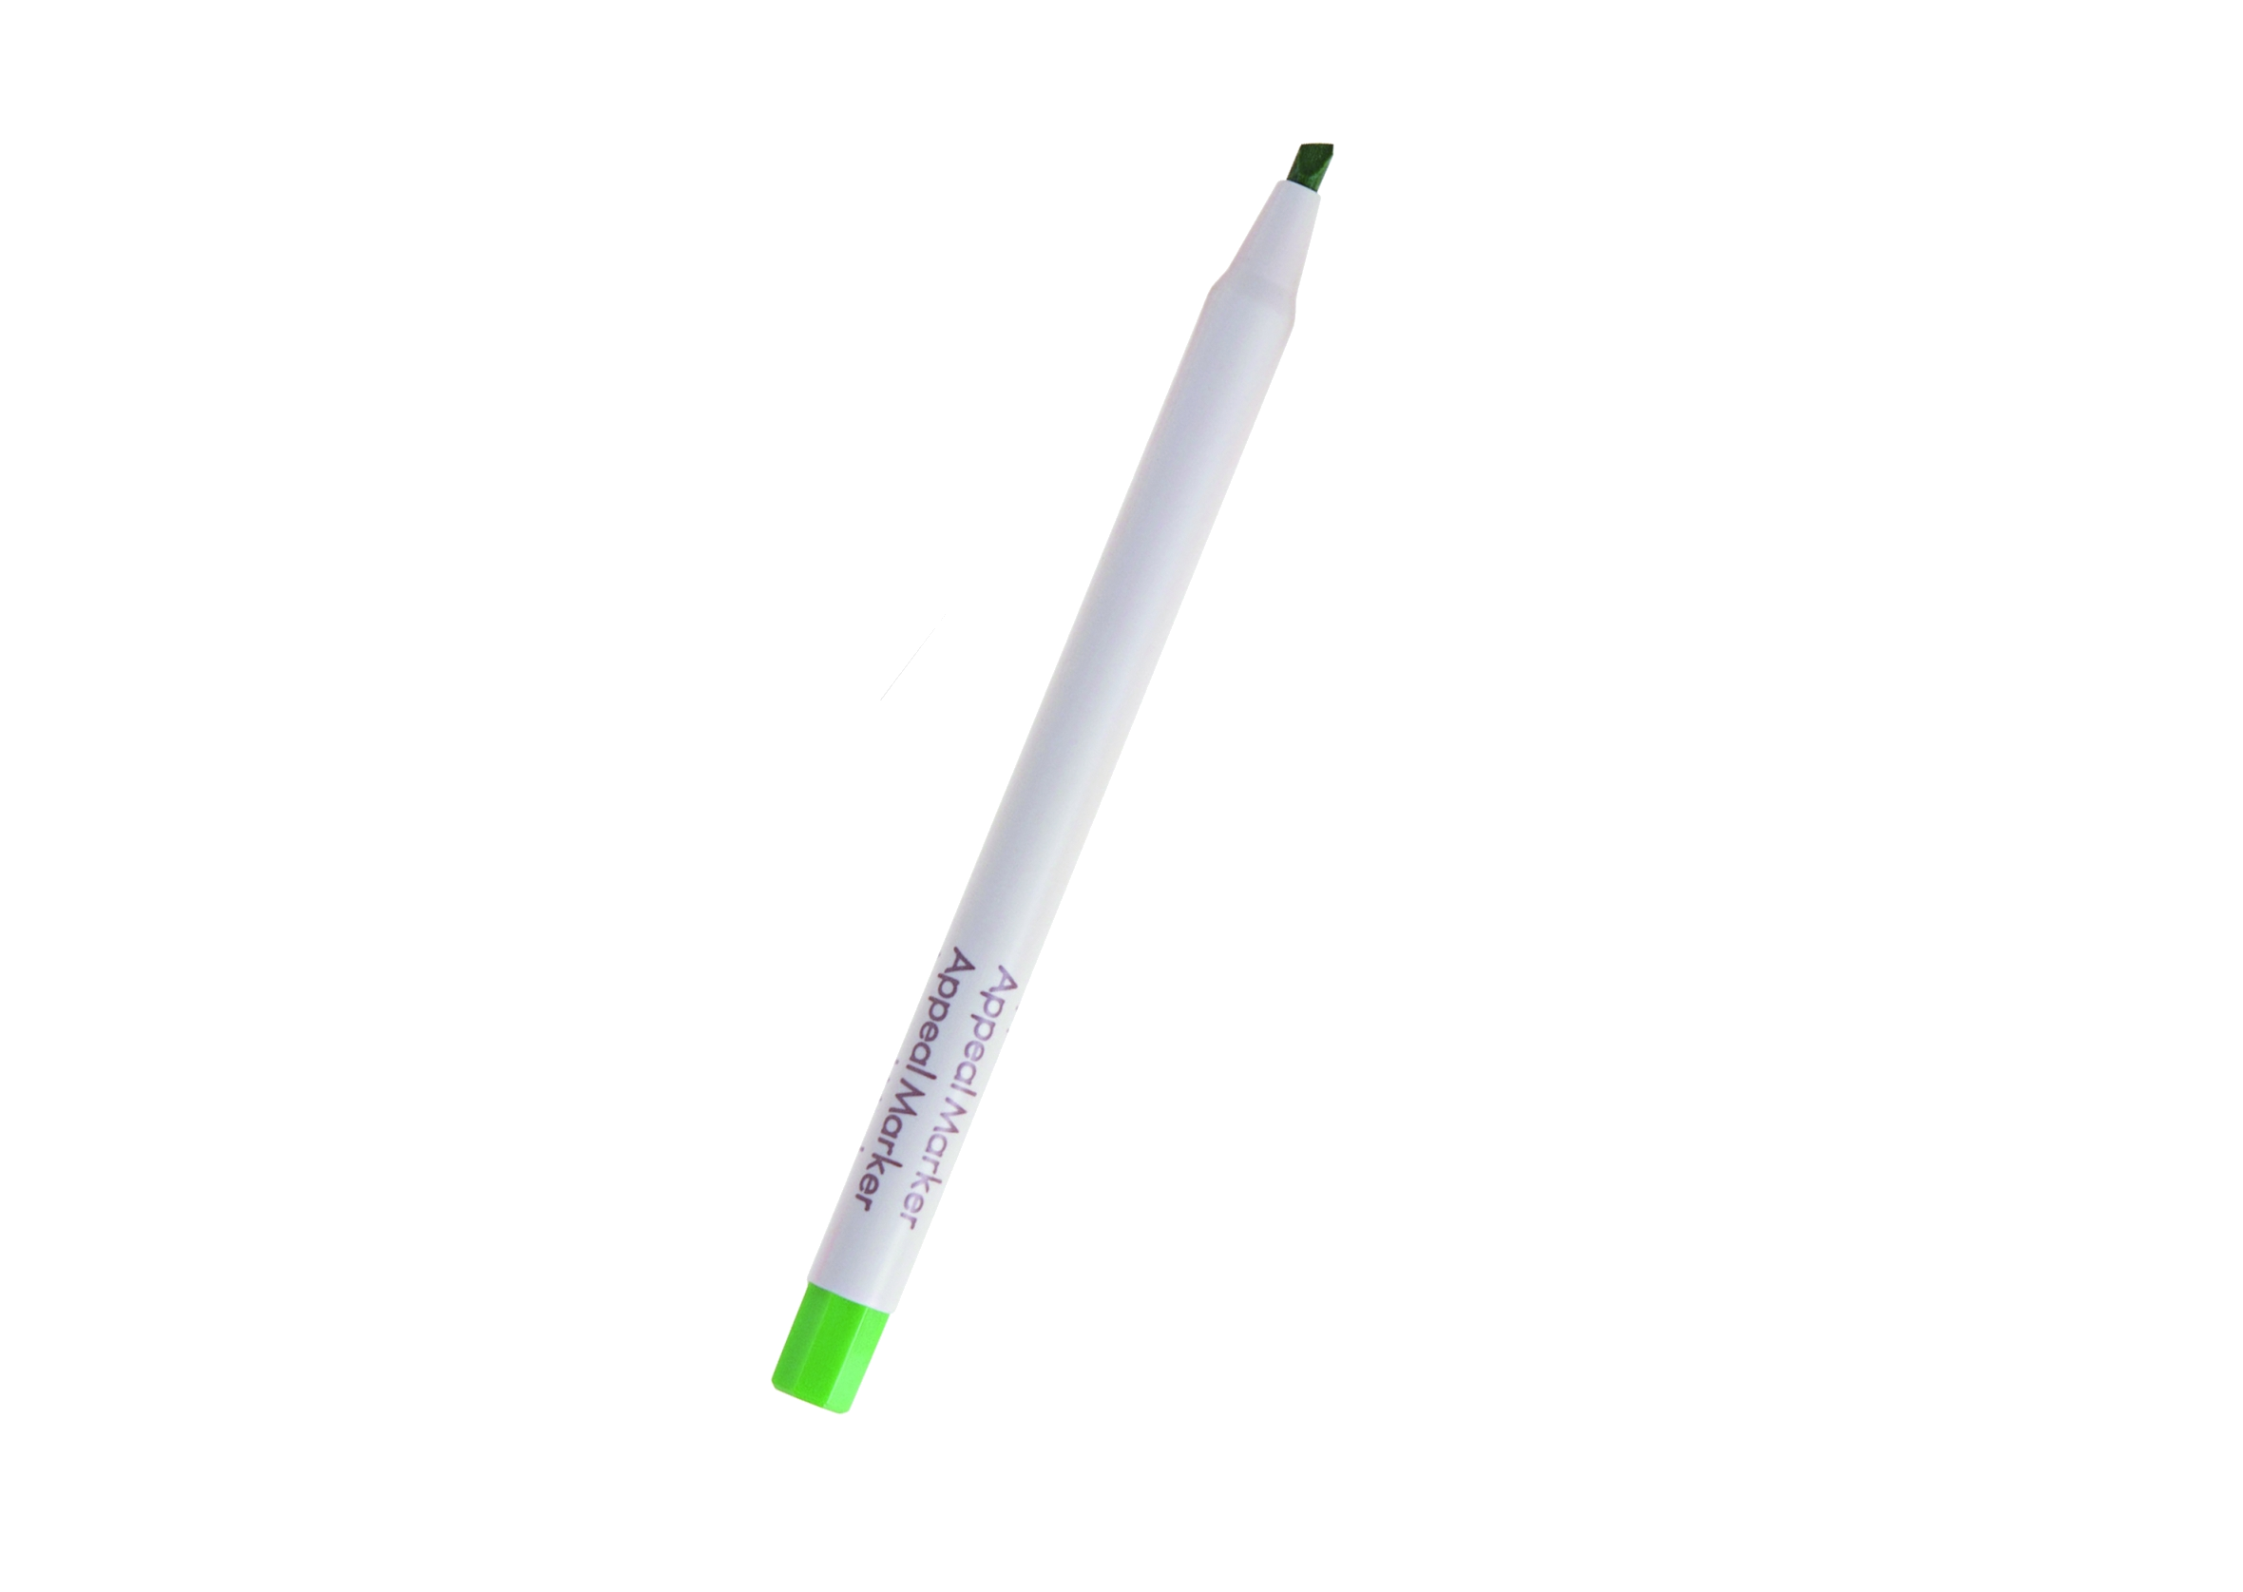
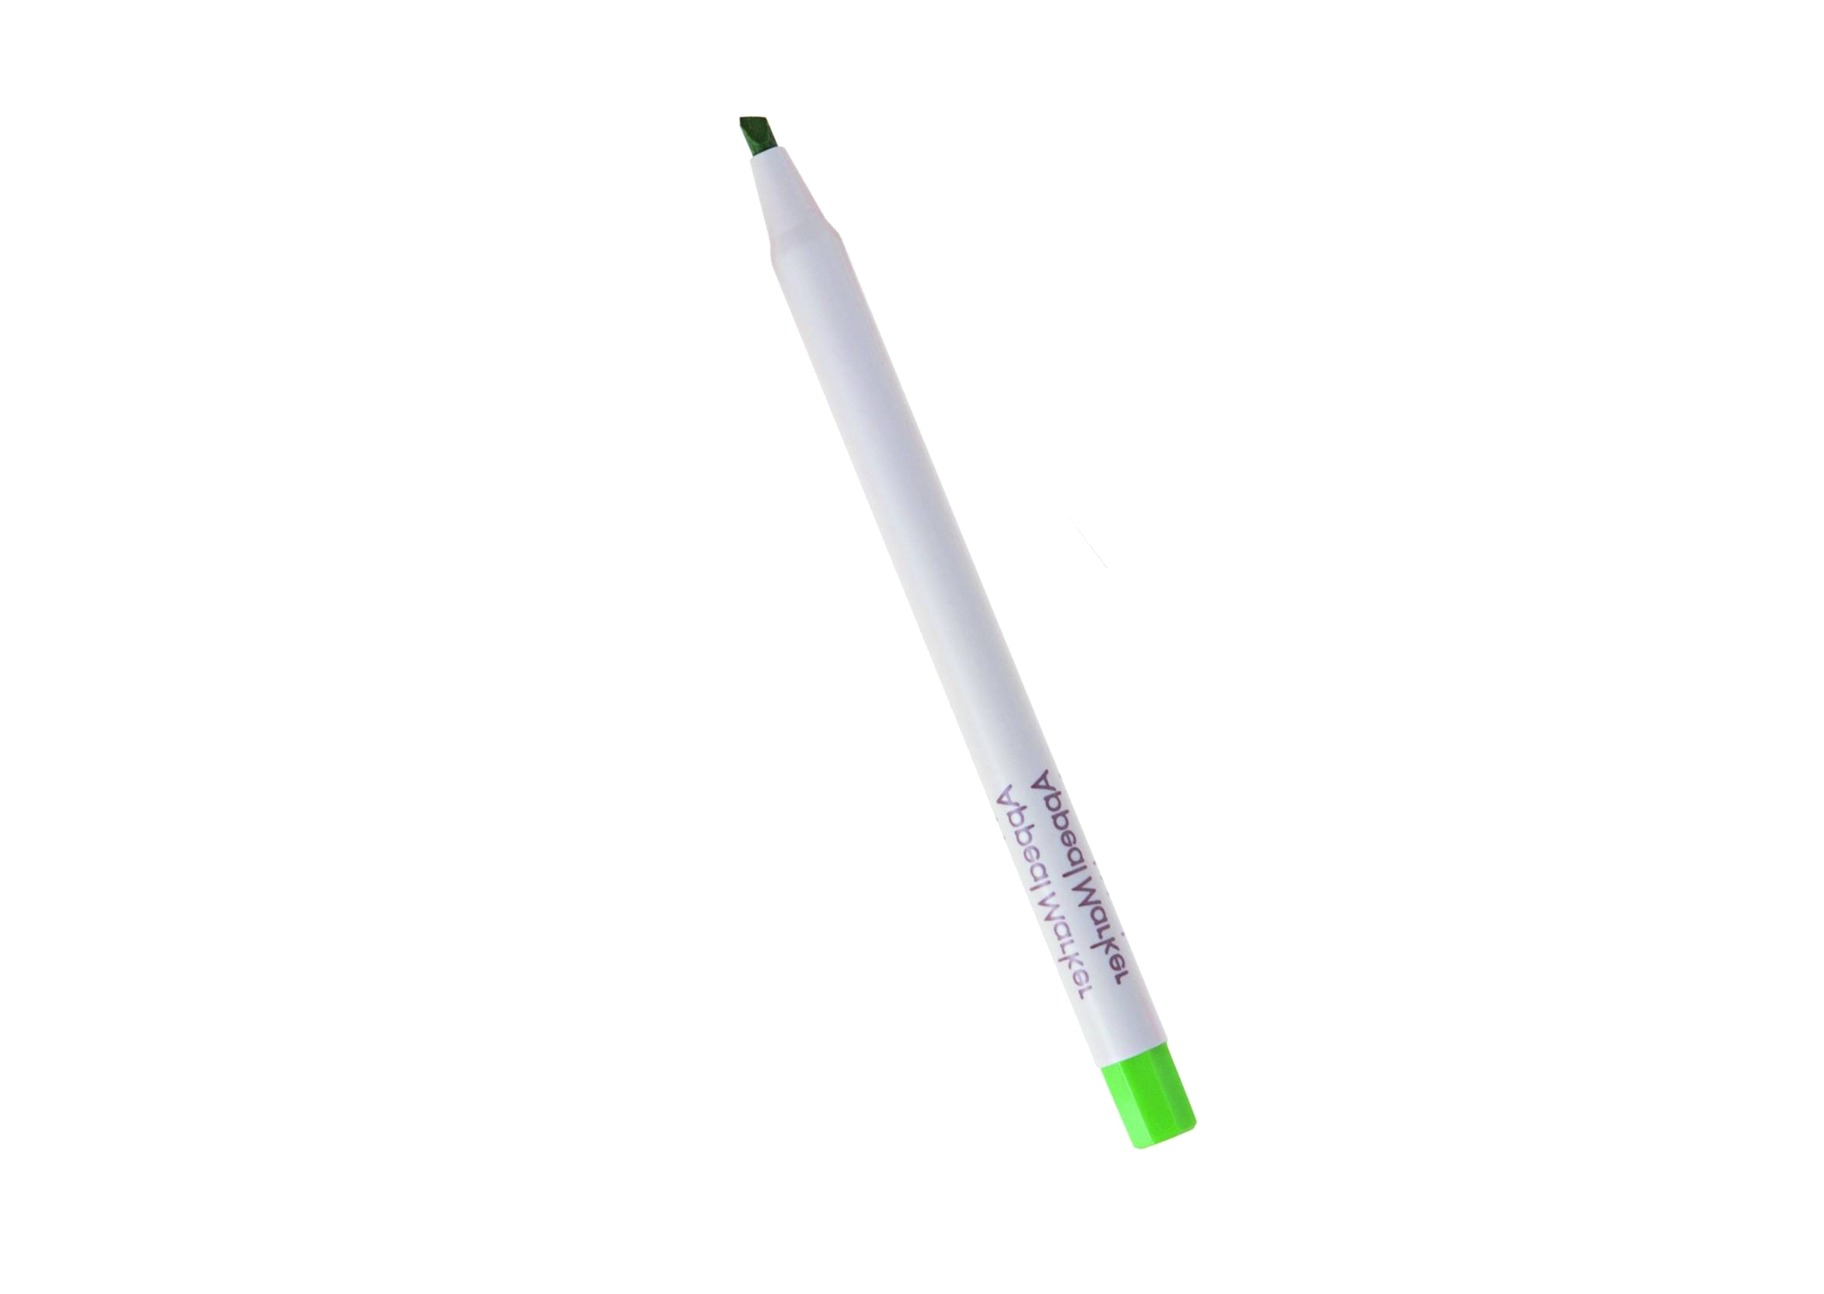

A Primary 5 student, David, invented a ‘cool cap’. David said, ‘I get hot running around. My cap is used for staying cool on hot days.’

Another student, Lucy, was worried that her fish were bored. Her invention is made of plastic tubes. Lucy’s fish love swimming through them.

If you have an idea, try it out! The first television was made of cardboard, wood, string and metal needles. It was very different from today’s televisions, but it was a start. A journey of a thousand miles starts with a single step. Take that step today!
David
Lucy
Inventors’ World

