Task — Writing the steps for making something from recycled materials
1 Decide on a craft item to make. Think of a name for the item. Then write the things you need below.

Write the name of your craft item.

Things we need | It is / They are made of …

- Draw pictures and write the steps to make it.
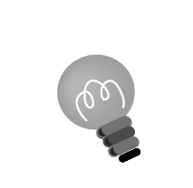
Hints: a) Use these words to show the order of the steps: ‘First’, ‘After that’, etc.
b) Use these words to describe the action: ‘use’, ‘cut’, etc.

1

2

3

4

5

6

Checklist for Ch 2 Task

Check your writing and tick (✓).

Checking for ourselves | ☺ ☺ | ☺ | ☹
- We all participated in writing the steps for making something out of recycled materials.
- Our ideas are creative.
- We used connectives correctly (e.g. First, Next, Then, Finally) to show the sequence.
- We used the correct verbs to give instructions, e.g. use scissors to cut out the shape …, fold the paper …
- We spelt all the words correctly (checked spellings using the textbook or dictionary).
- We used complete sentences.

Now ask another group of pupils to check your writing and tick (✓).

Checking by ( ____________________ ) | ☺ ☺ | ☺ | ☹
- Do we understand the steps?
- Are the ideas creative?
- Did our classmates use connectives correctly?
- Did our classmates use the correct verbs to give instructions?
- Did our classmates spell all the words correctly?
- Did our classmates use complete sentences?
Remember to make changes to your writing before you hand it in.

