RP no: Century Gothic 15pt
(所有圈號用15pt)
Choose and write.

cheap | comfortable | convenient | crowded | fast
expensive | uncomfortable | inconvenient | not crowded | slow
1
2
3
4
5
6
7
8
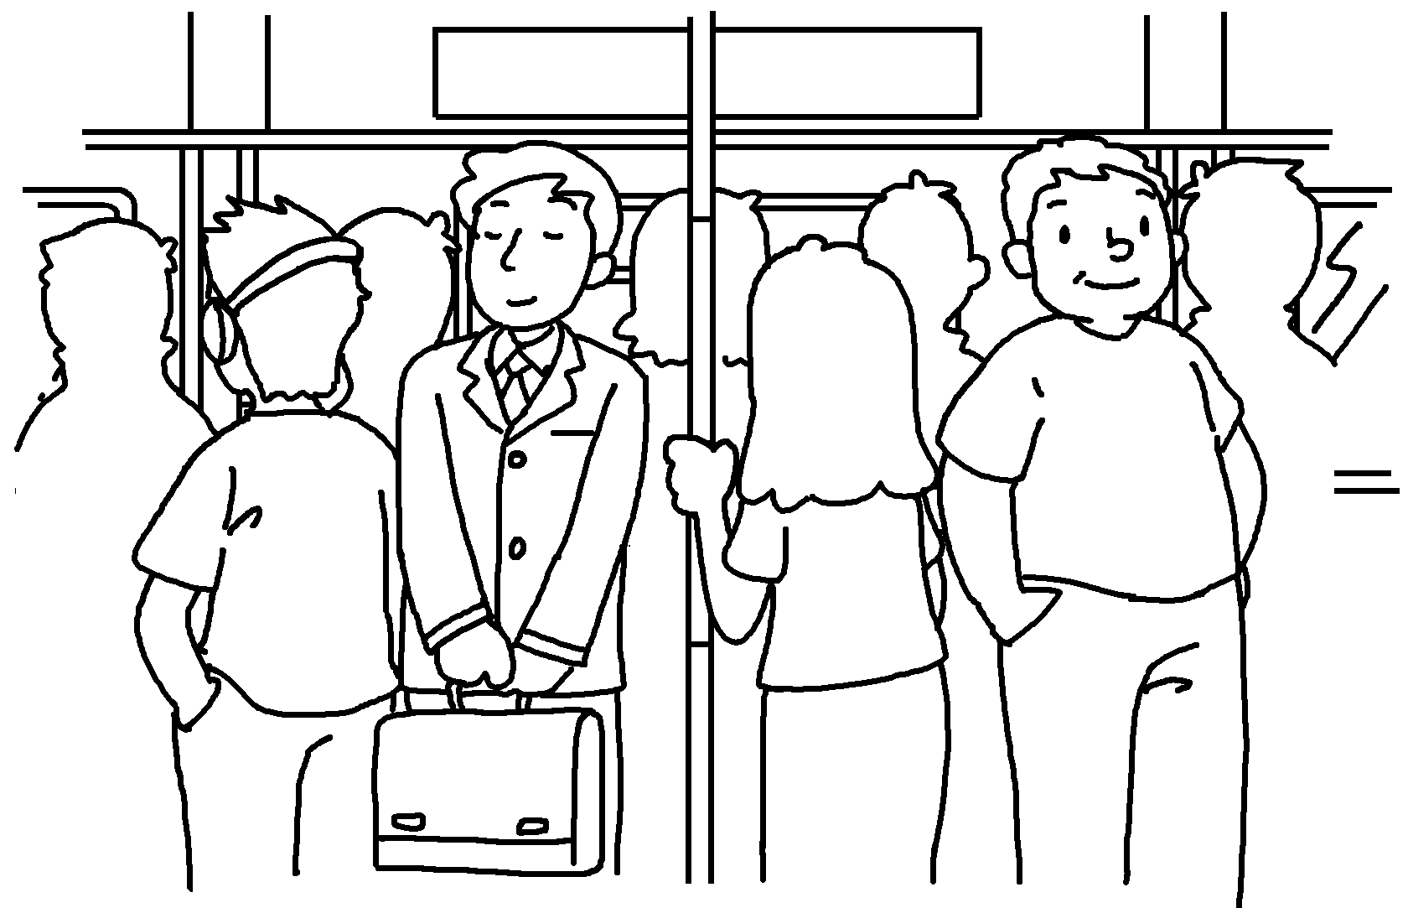 | 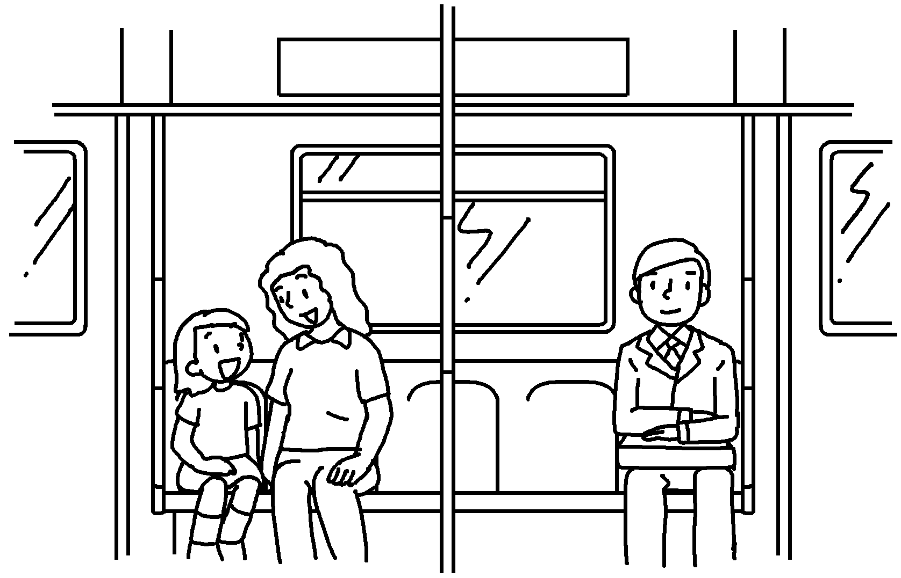 | 1  2
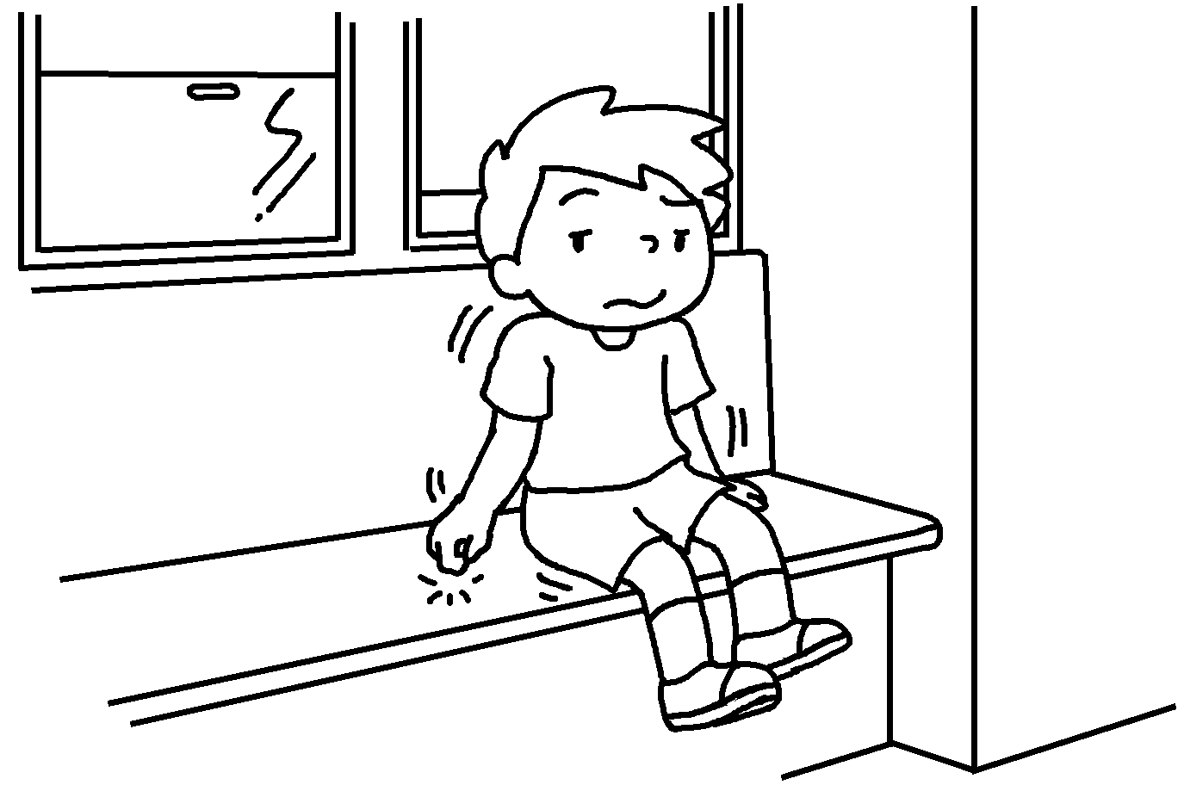 |  | 3  4
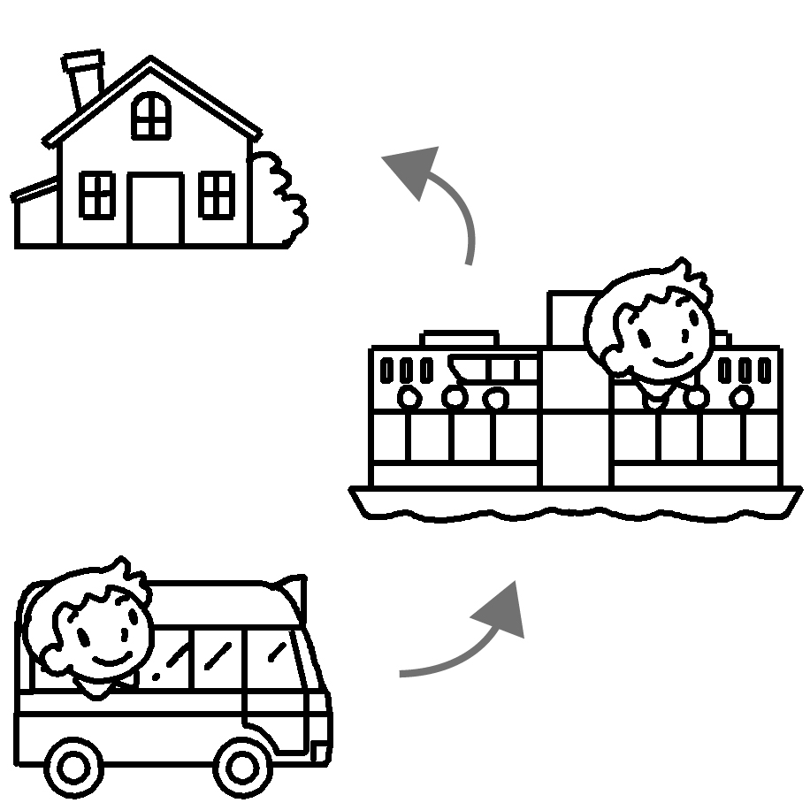 | 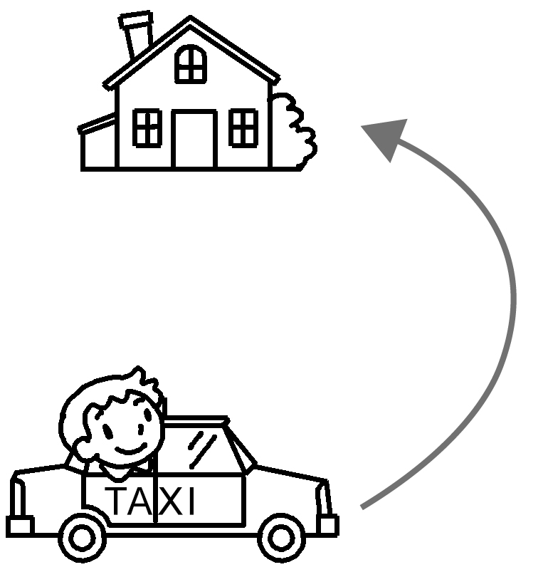 | 5  6
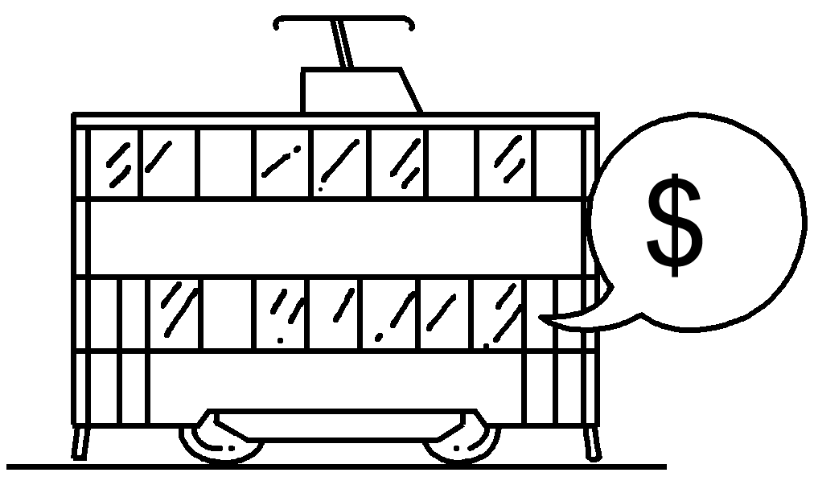  1 | 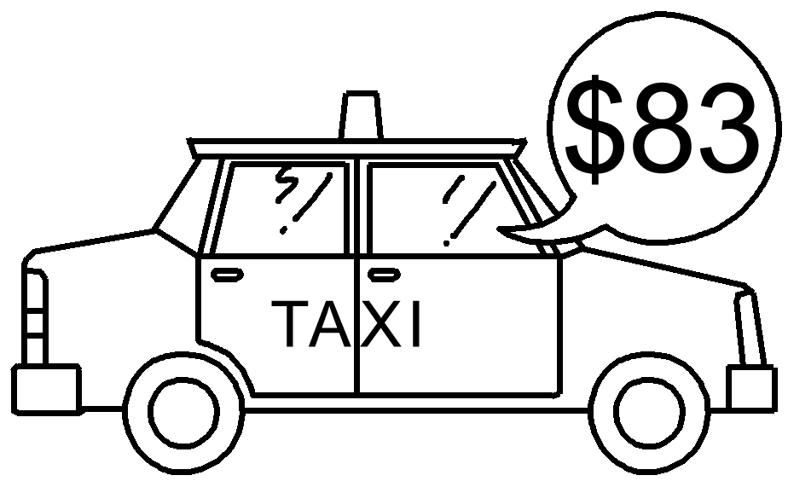 | 7  8
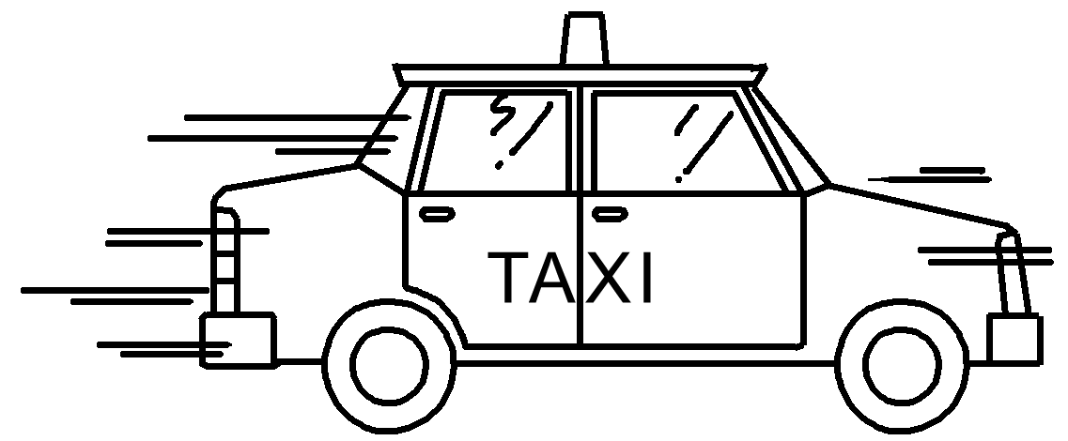 | 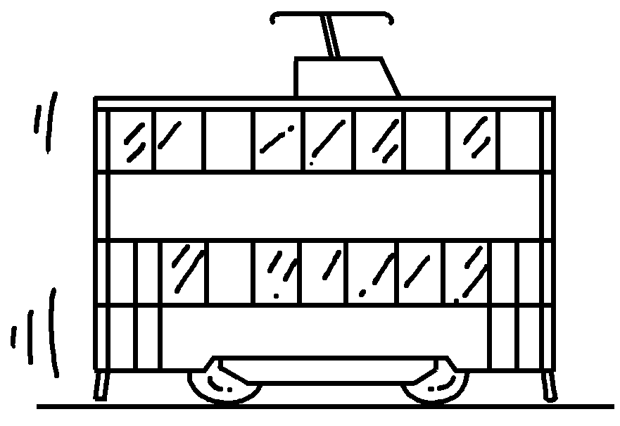  9  10 | 9  10


RP no: Century Gothic 15pt
(所有圈號用15pt)

Book 5B Chapter 3 Graded Worksheets
Worksheet 1⬇
1 crowded
2 not crowded
3 uncomfortable
4 comfortable
5 inconvenient
6 convenient
7 cheap
8 expensive
9 fast
10 slow

