I like ( sit / sitting ) comfortably so I enjoy ( travel / travelling ) by taxi.
I hate ( waiting / wait ) at bus stops so I don’t like
( travel / travelling ) by bus.
I ( don’t like / like ) feeling hot so I hate ( travel / travelling ) by tram.
I ( enjoying / enjoy ) looking at the view so I ( hate / like ) travelling by ferry.
I don’t like ( stand / standing ) up so I like ( travelling / travel ) by minibus and taxi.

Circle the correct answers.
1 | 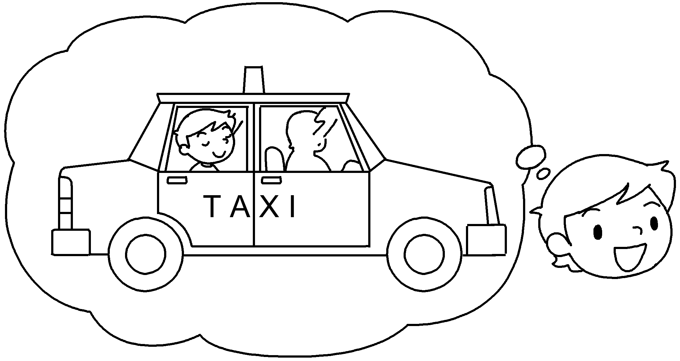
2 | 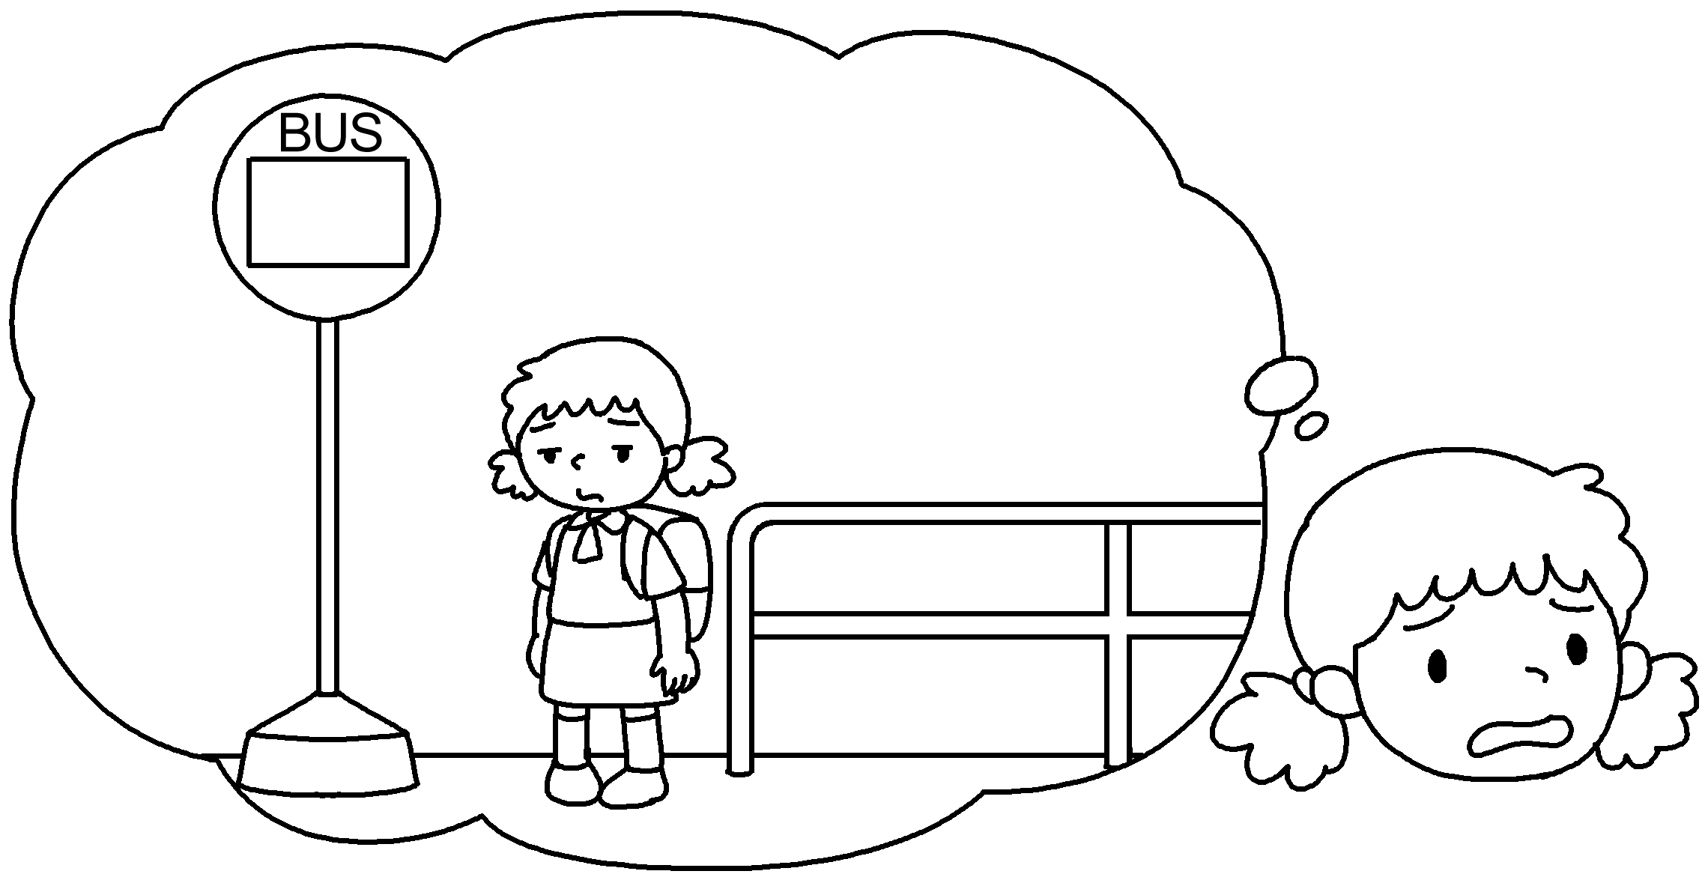
3 | 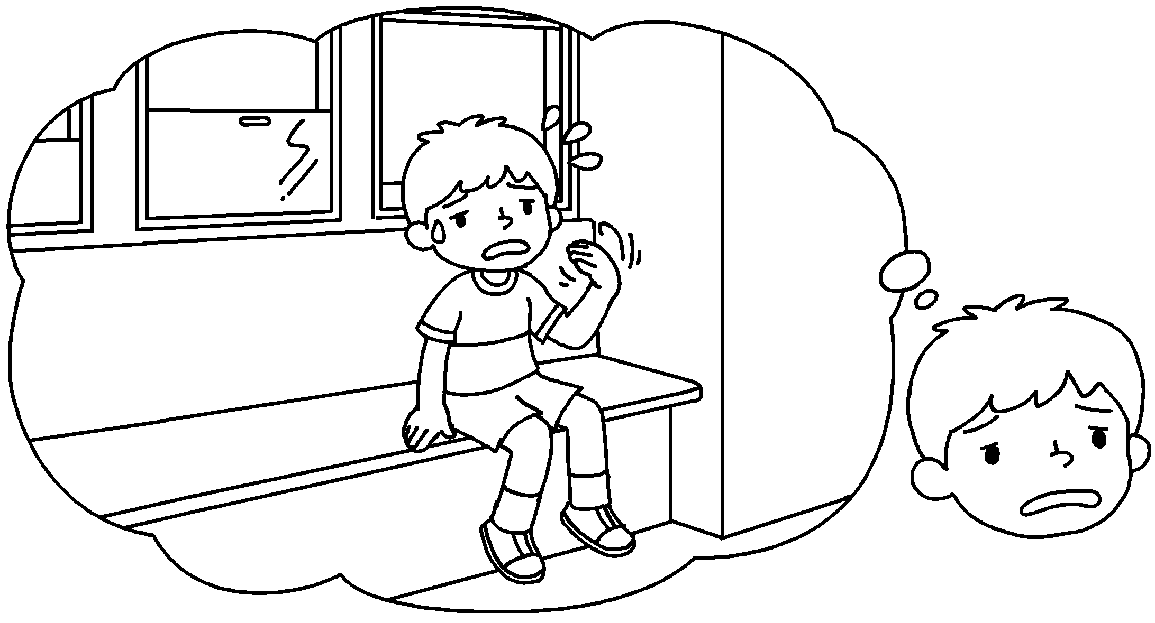
4 | 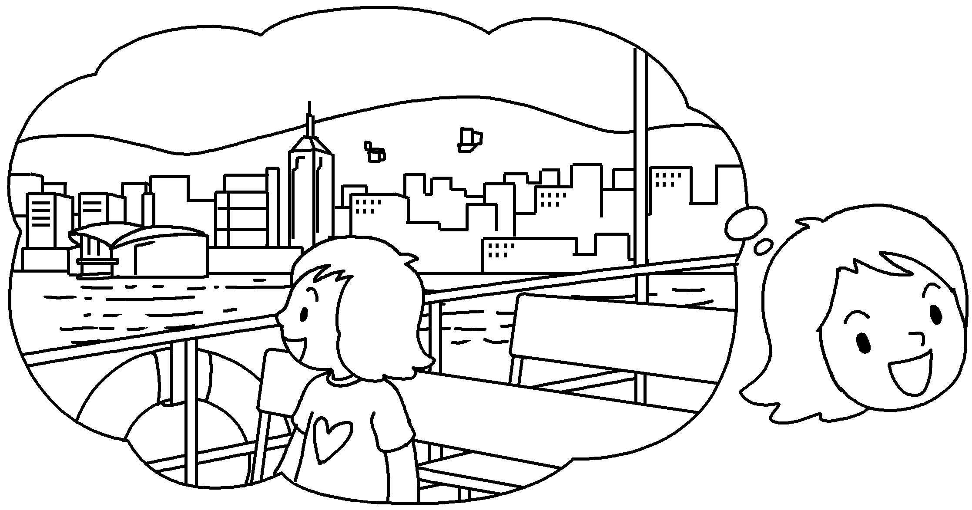
5 | 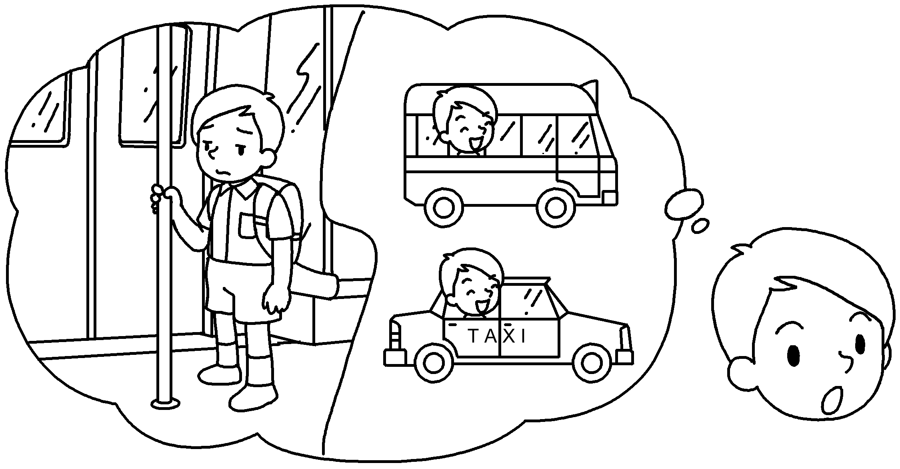


Book 5B Chapter 3 Graded Worksheets
Worksheet 2⬇
- ( sit / sitting ) ( travel / travelling )
- ( waiting / wait ) ( travel / travelling )
- ( don’t like / like ) ( travel / travelling )
- ( enjoying / enjoy ) ( hate / like )
- ( stand / standing ) ( travelling / travel )

