Finish what the children say using ‘so’.
1 | sit  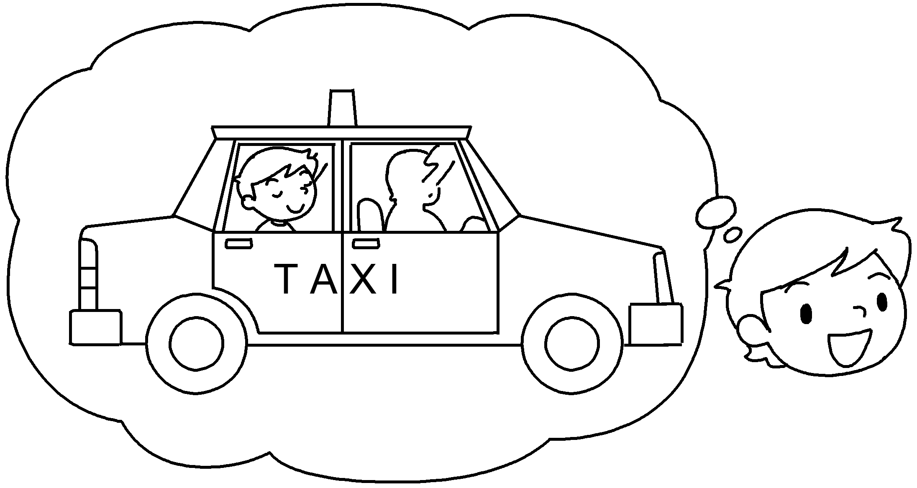 | I like _______________ comfortably  ________ I enjoy travelling by taxi.  so
2 | wait at bus stops  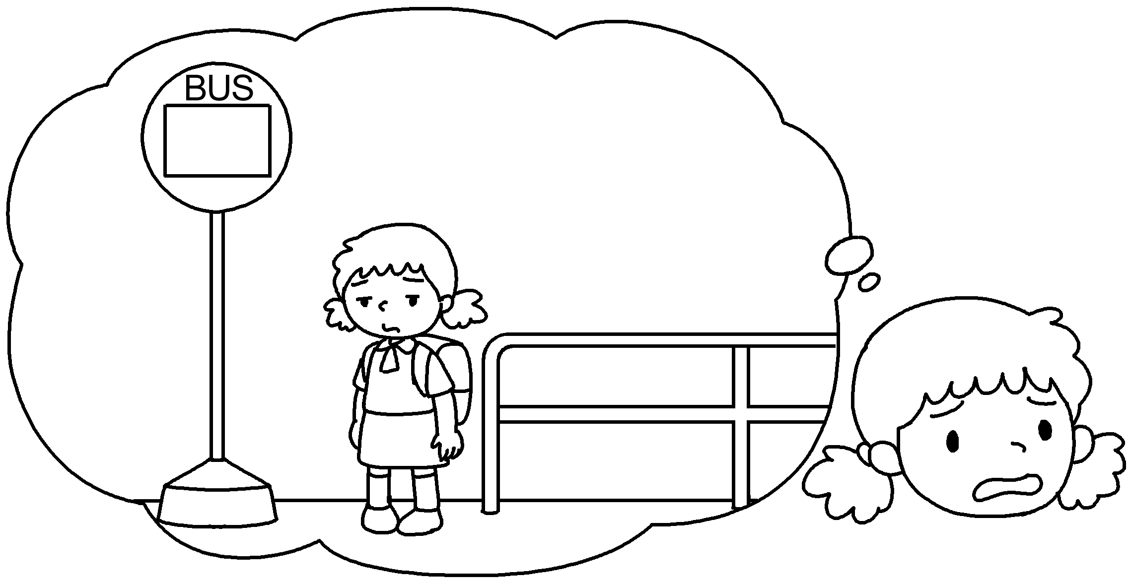 | I hate ___________________ at  bus stops so I don’t like travelling  by bus.
3 | feel hot  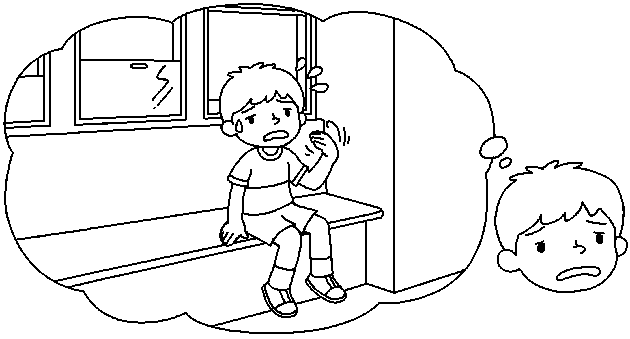 | I don’t like ______________________  ________ I hate _________________  by tram.
4 | enjoy (look) at the view  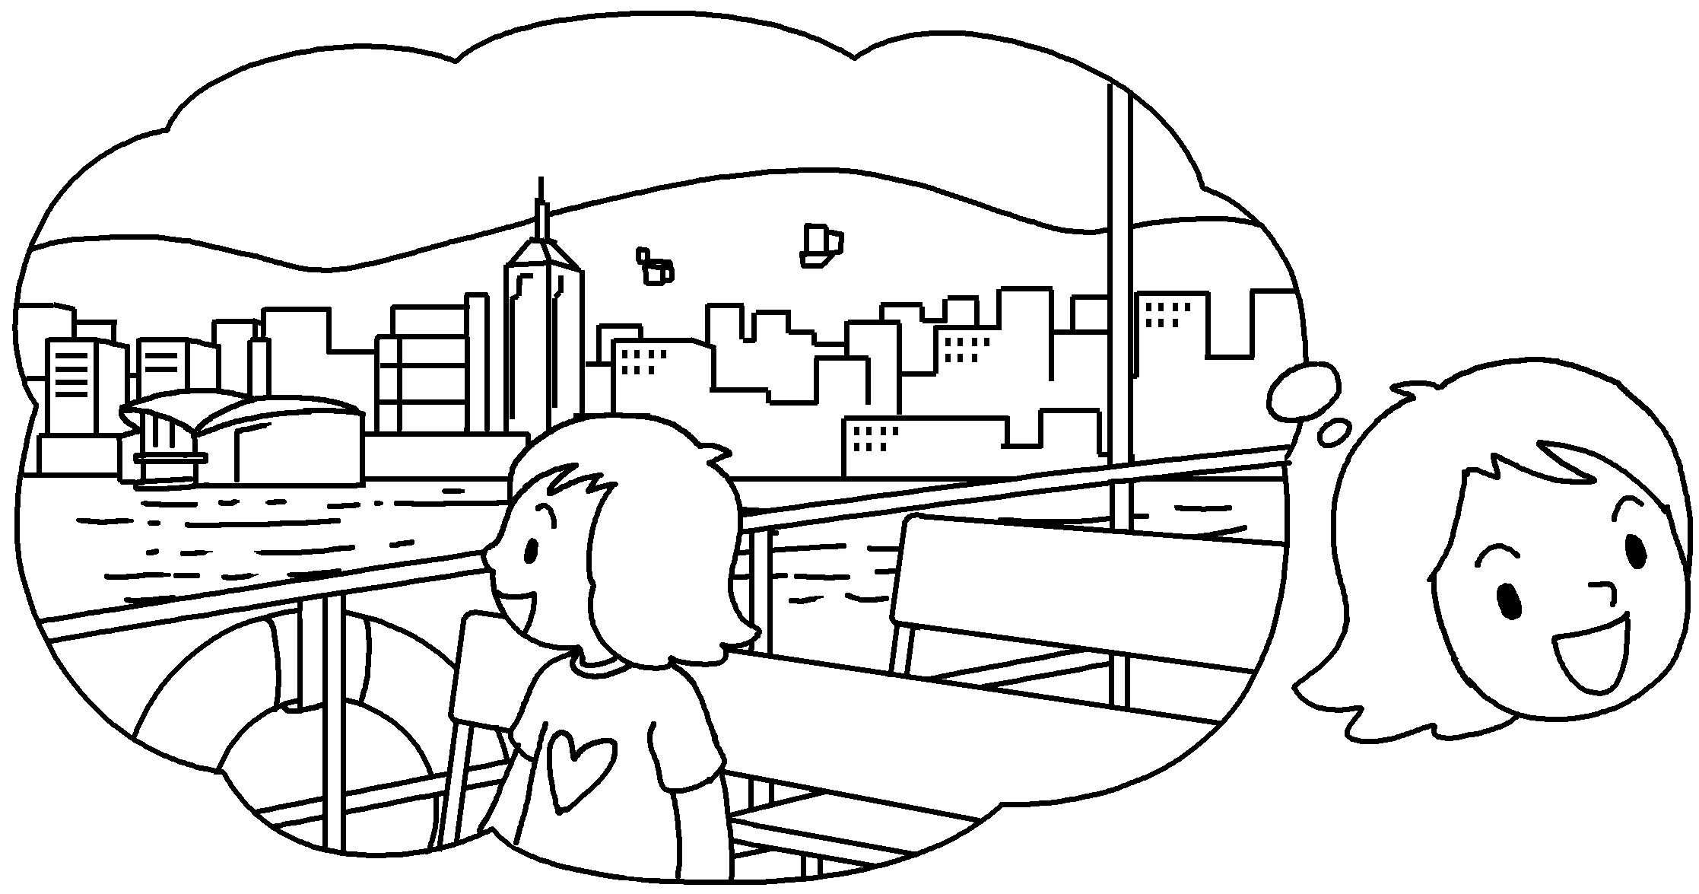 | I _______________________________  ________________________________  I like __________________________ .
5 | don’t like (stand) up  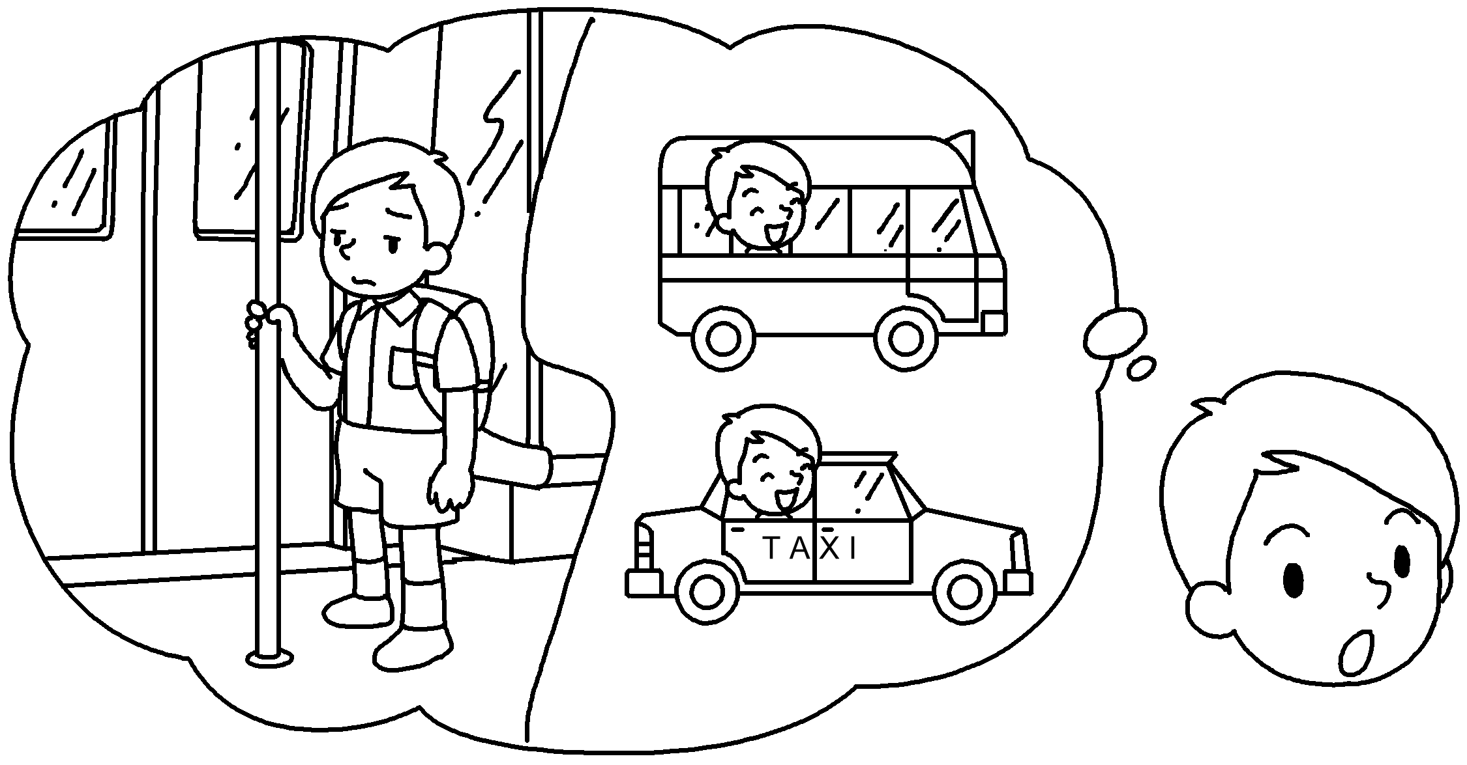 | I _______________________________  ________________________________  I like ___________________________  and _____________ .


Book 5B Chapter 3 Graded Worksheets
Worksheet 2⬇⬇⬇
- sitting / to sit
- waiting / to wait
- feeling / to feel hot so travelling / to travel
- enjoy looking at the view so travelling / to travel by ferry
- don’t like standing up / to stand up so travelling / to travel by minibus / taxi taxi / minibus

