Choose and write.
1.5 hr
1 hr
Although | expensive | inconvenient |  | uncomfortable
Although | comfortable | fast | cheap |  | slow

1 | travelling by  tram is cheap, it is slow. | 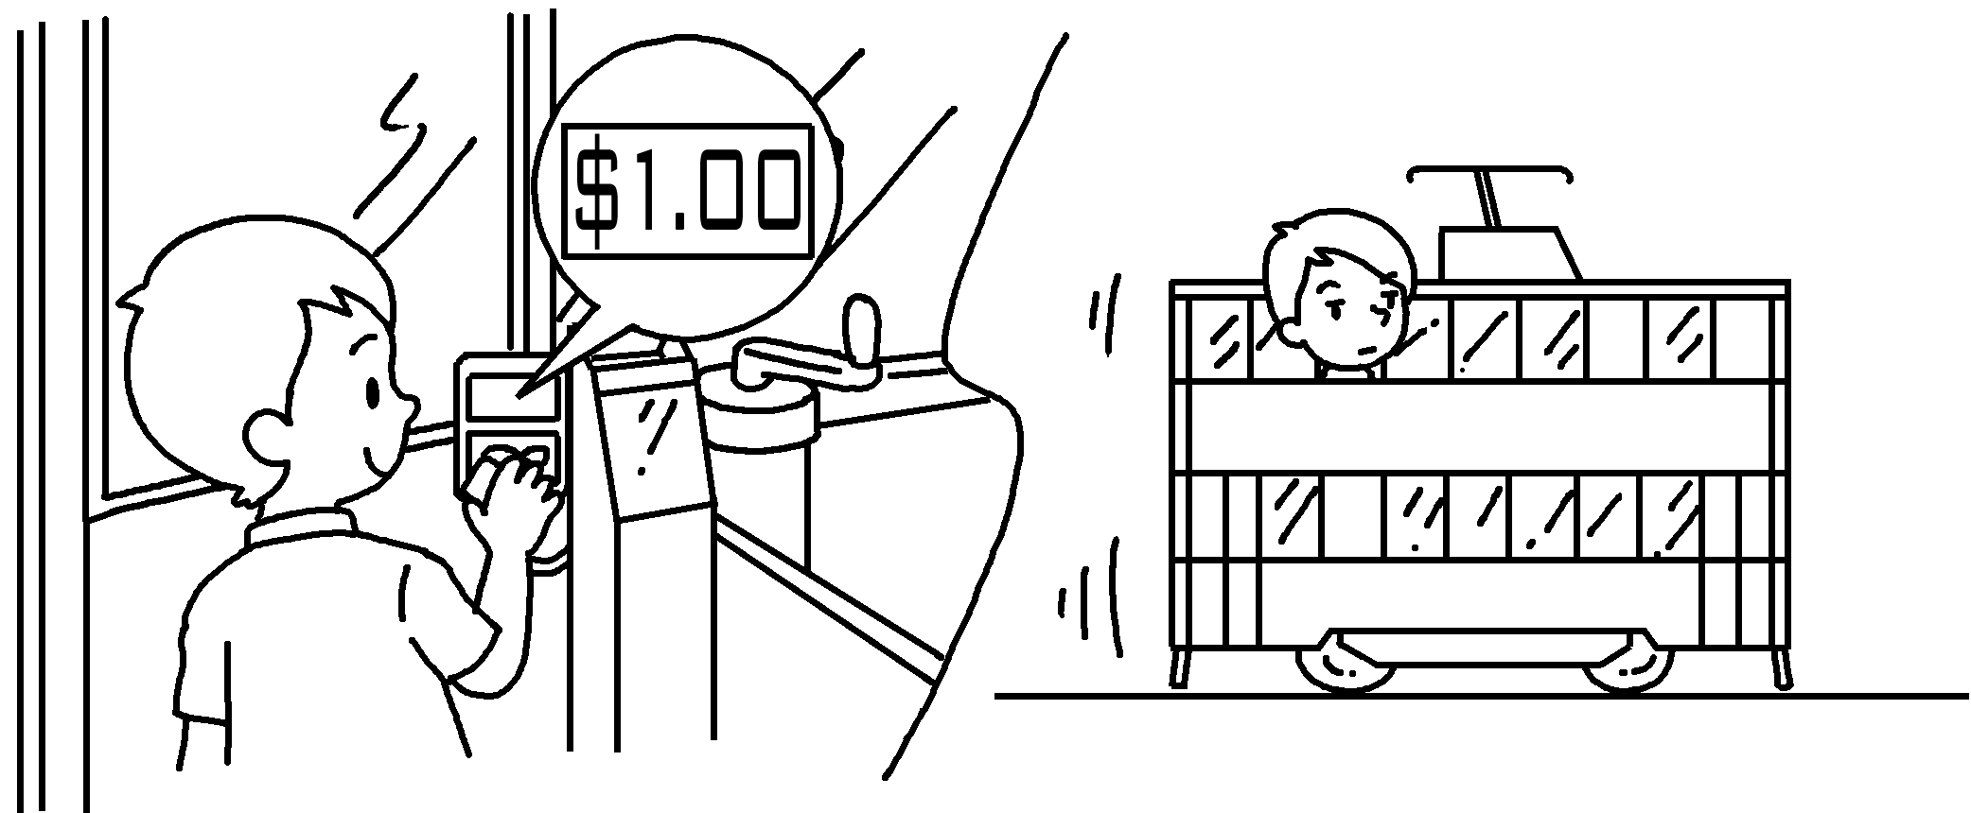
2 | Although travelling by tram is  convenient, it is  . | 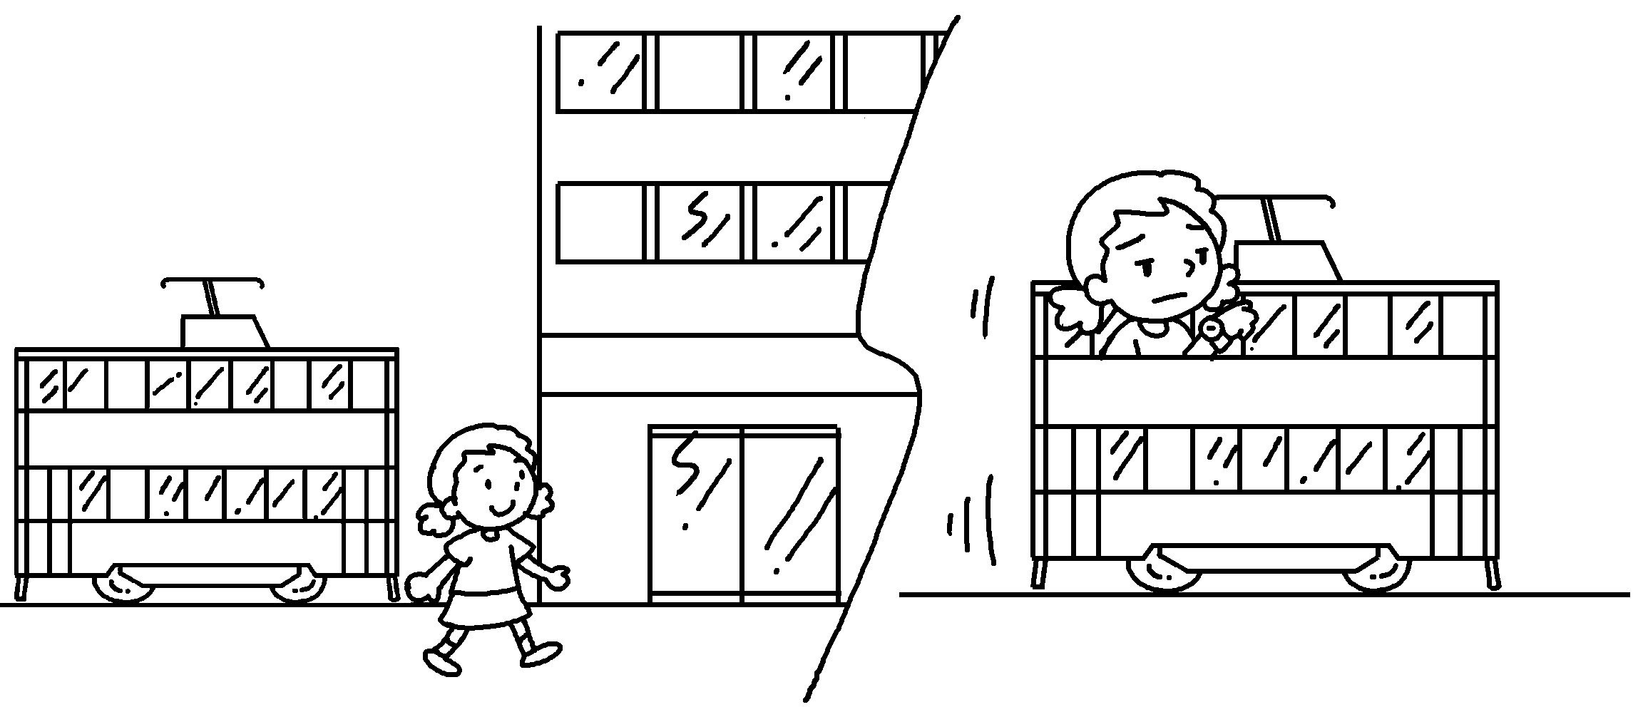
3 | Although travelling by MTR is  , it is  . | 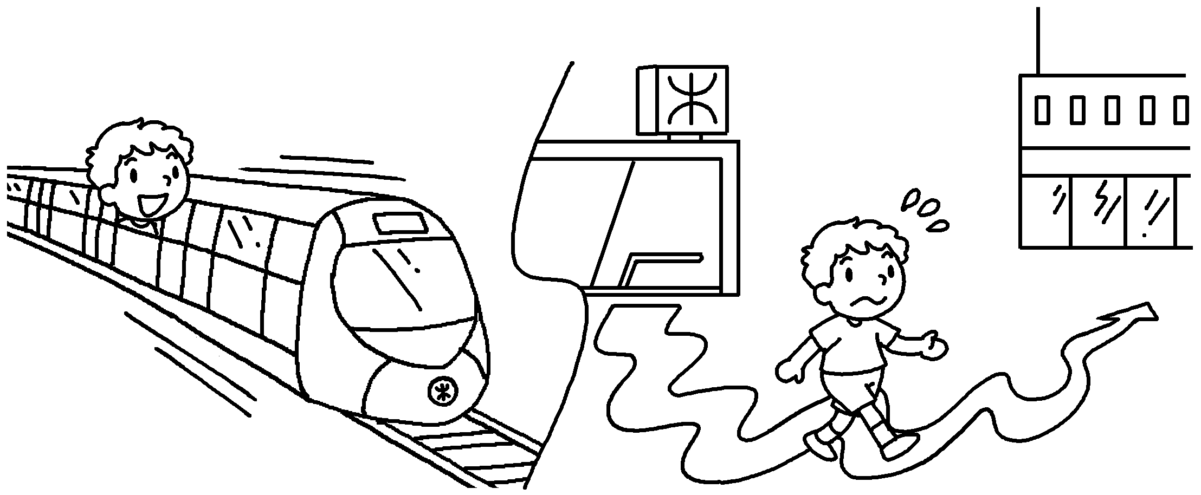
4 | travelling  by tram is ,  it is . | 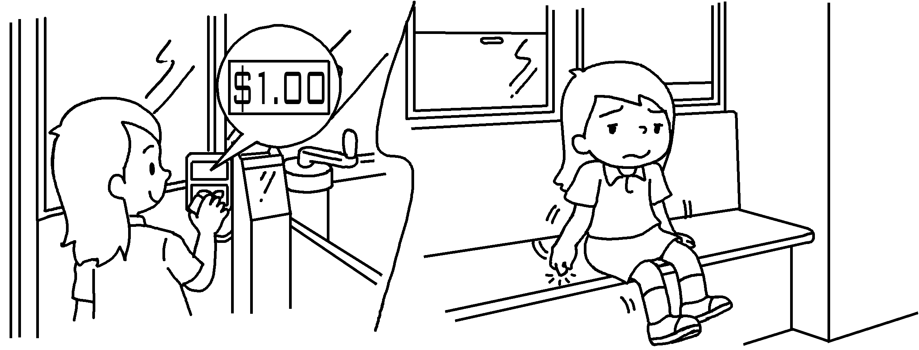
5 | travelling by  taxi is ,  it is . | 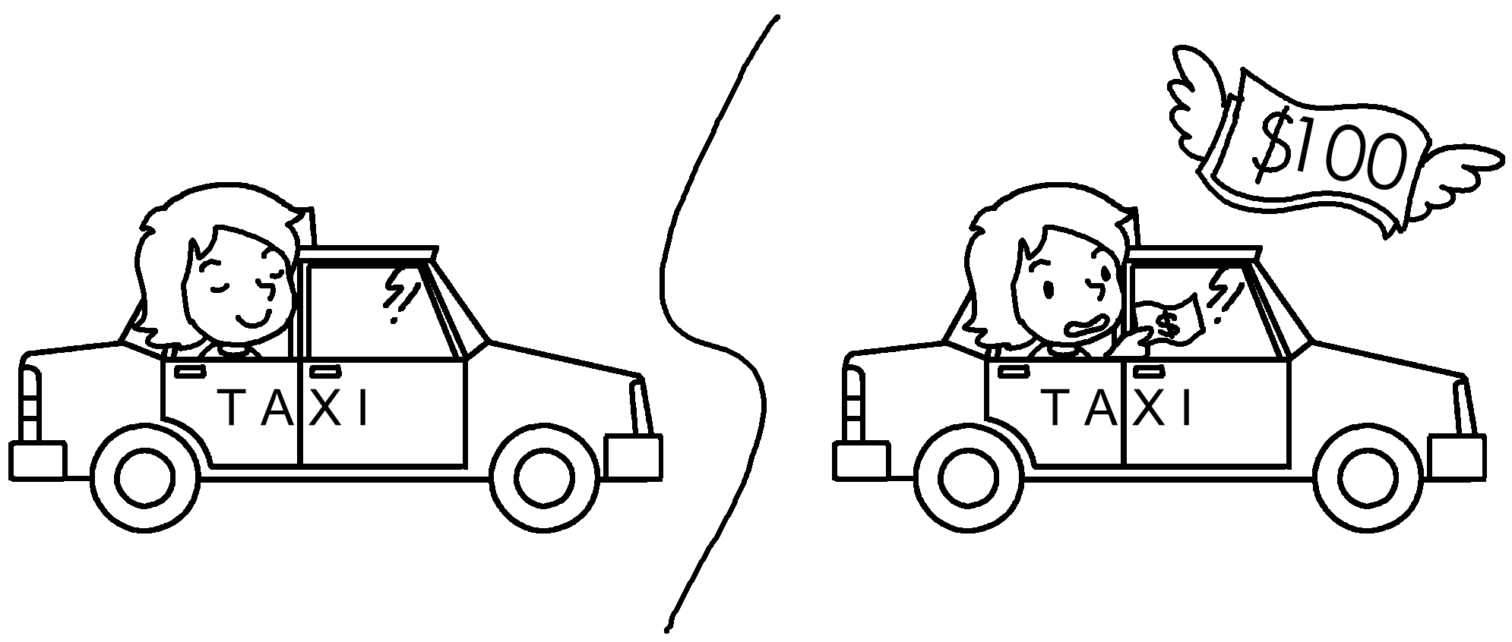


Book 5B Chapter 3 Graded Worksheets
Worksheet 3⬇
- Although
- slow
- fast inconvenient
- Although cheap uncomfortable
- Although comfortable expensive

