Write sentences about the pictures using ‘although’.
1.5 hr
1 hr

1 | travelling by  tram is cheap, it is slow. | 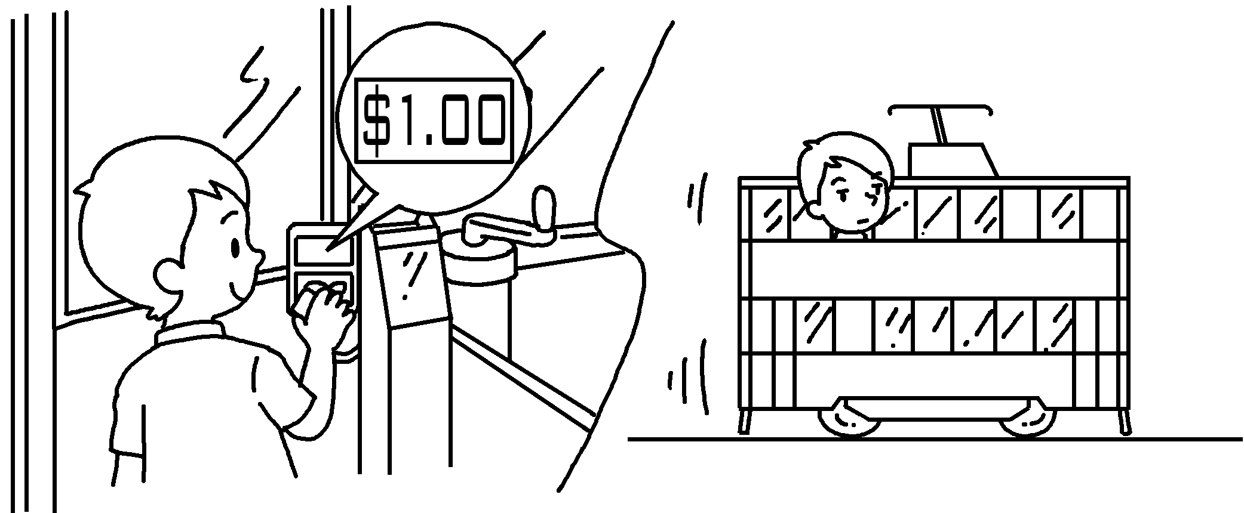
2 | Although travelling by tram is  convenient, it is  . | 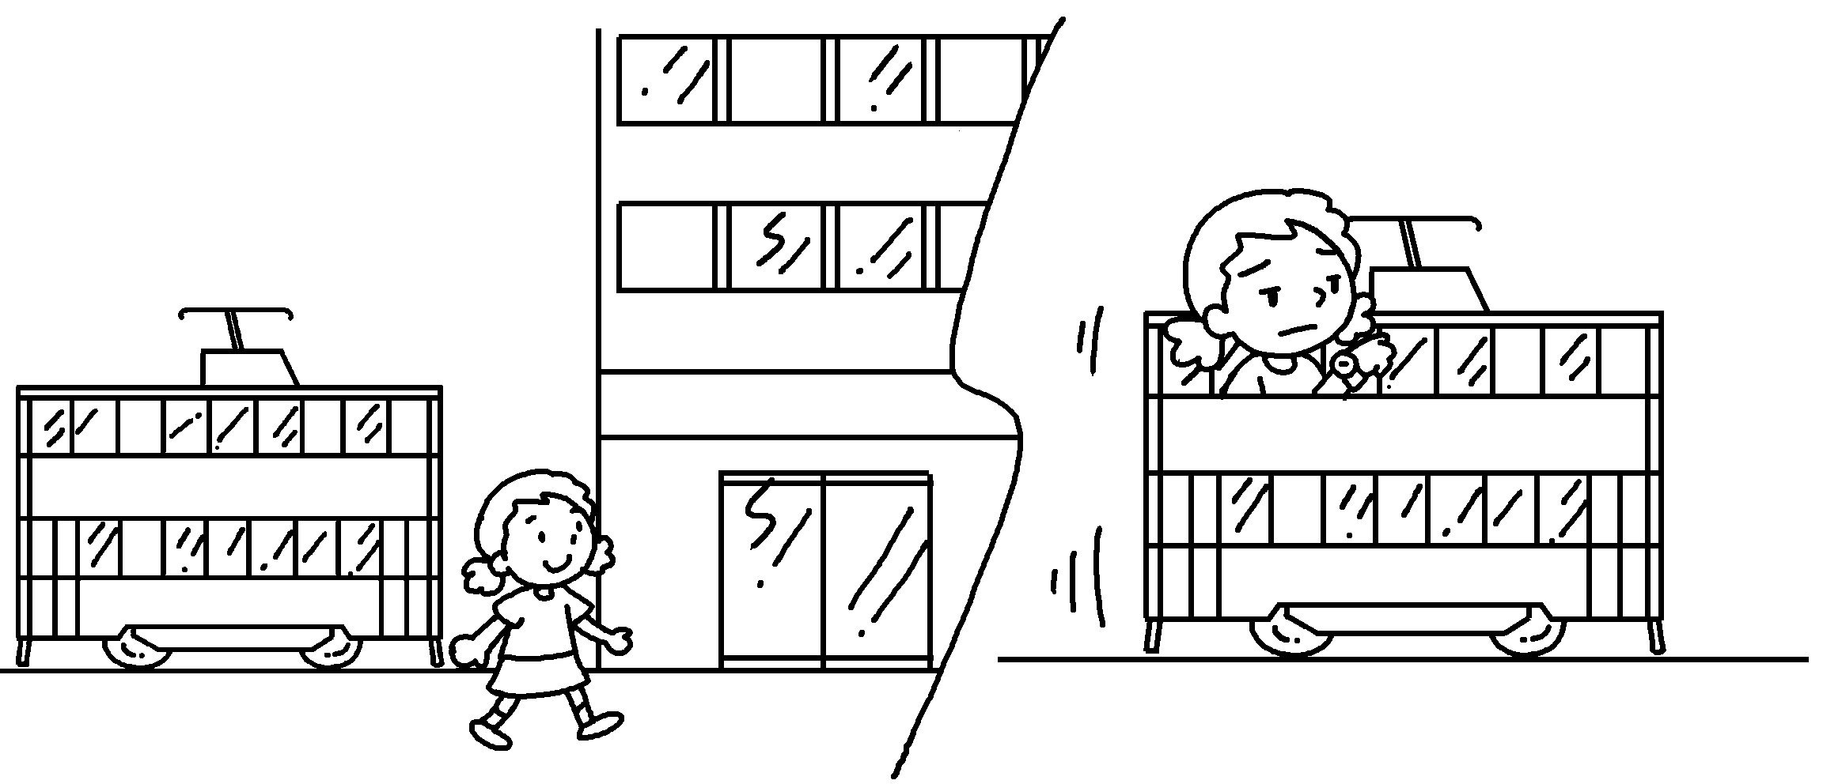
3 | Although travelling ______________  ________ is ,  it is . | 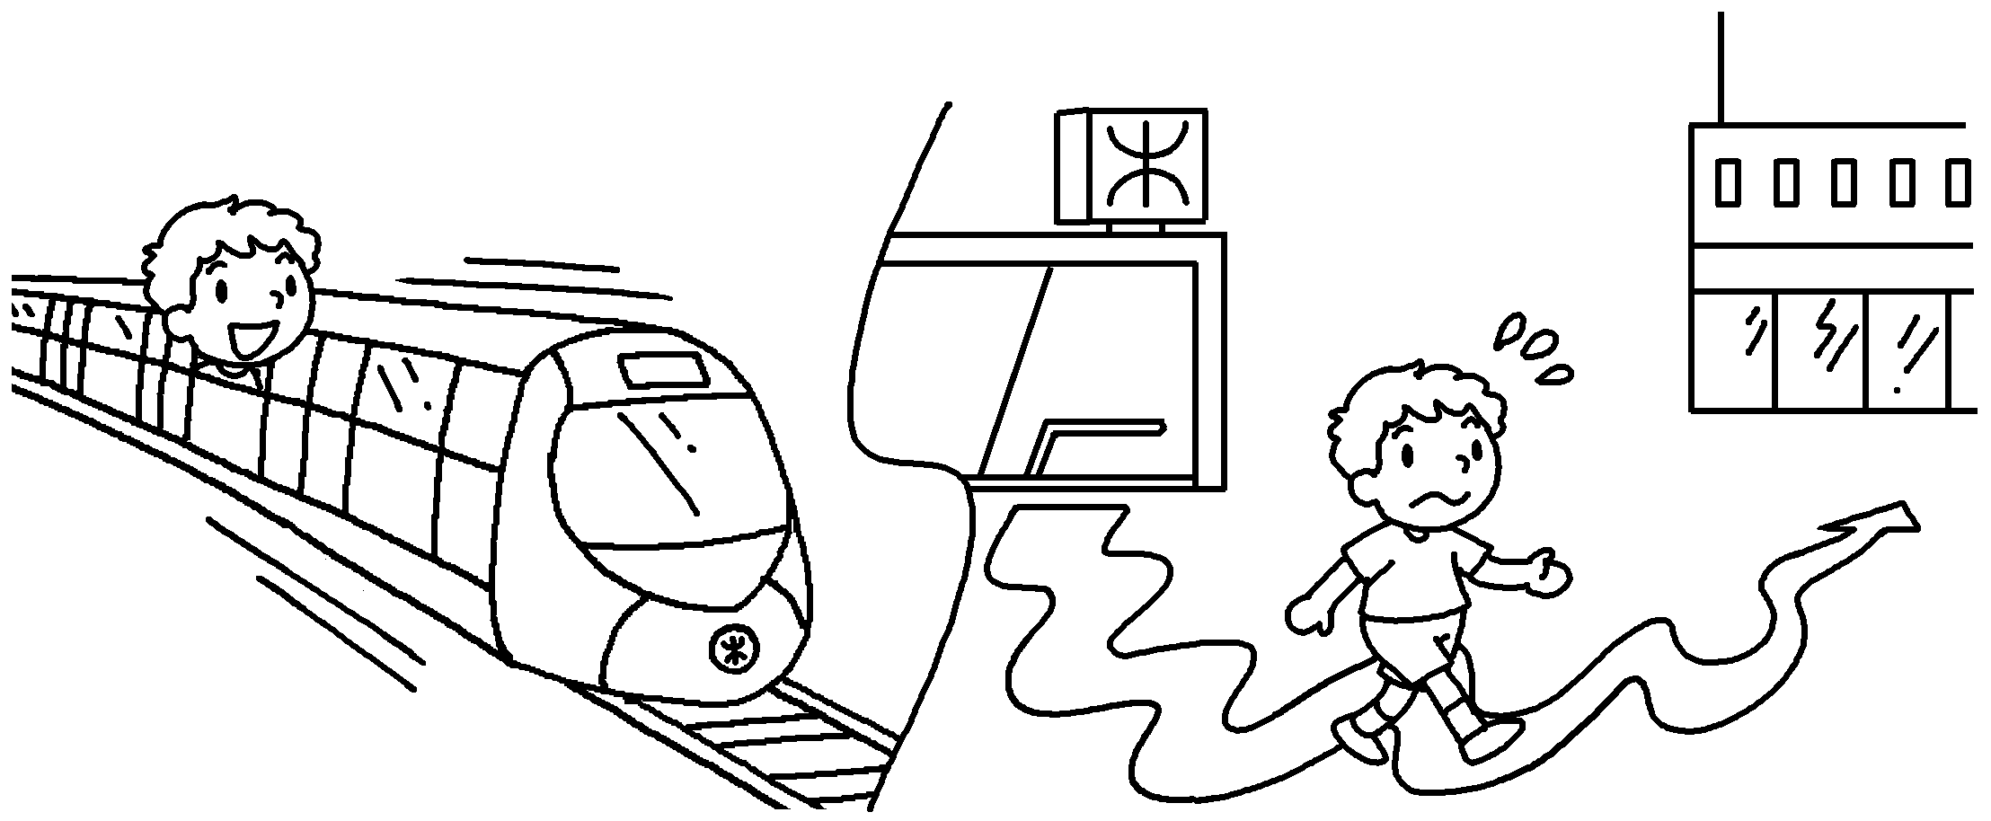
4 |  | 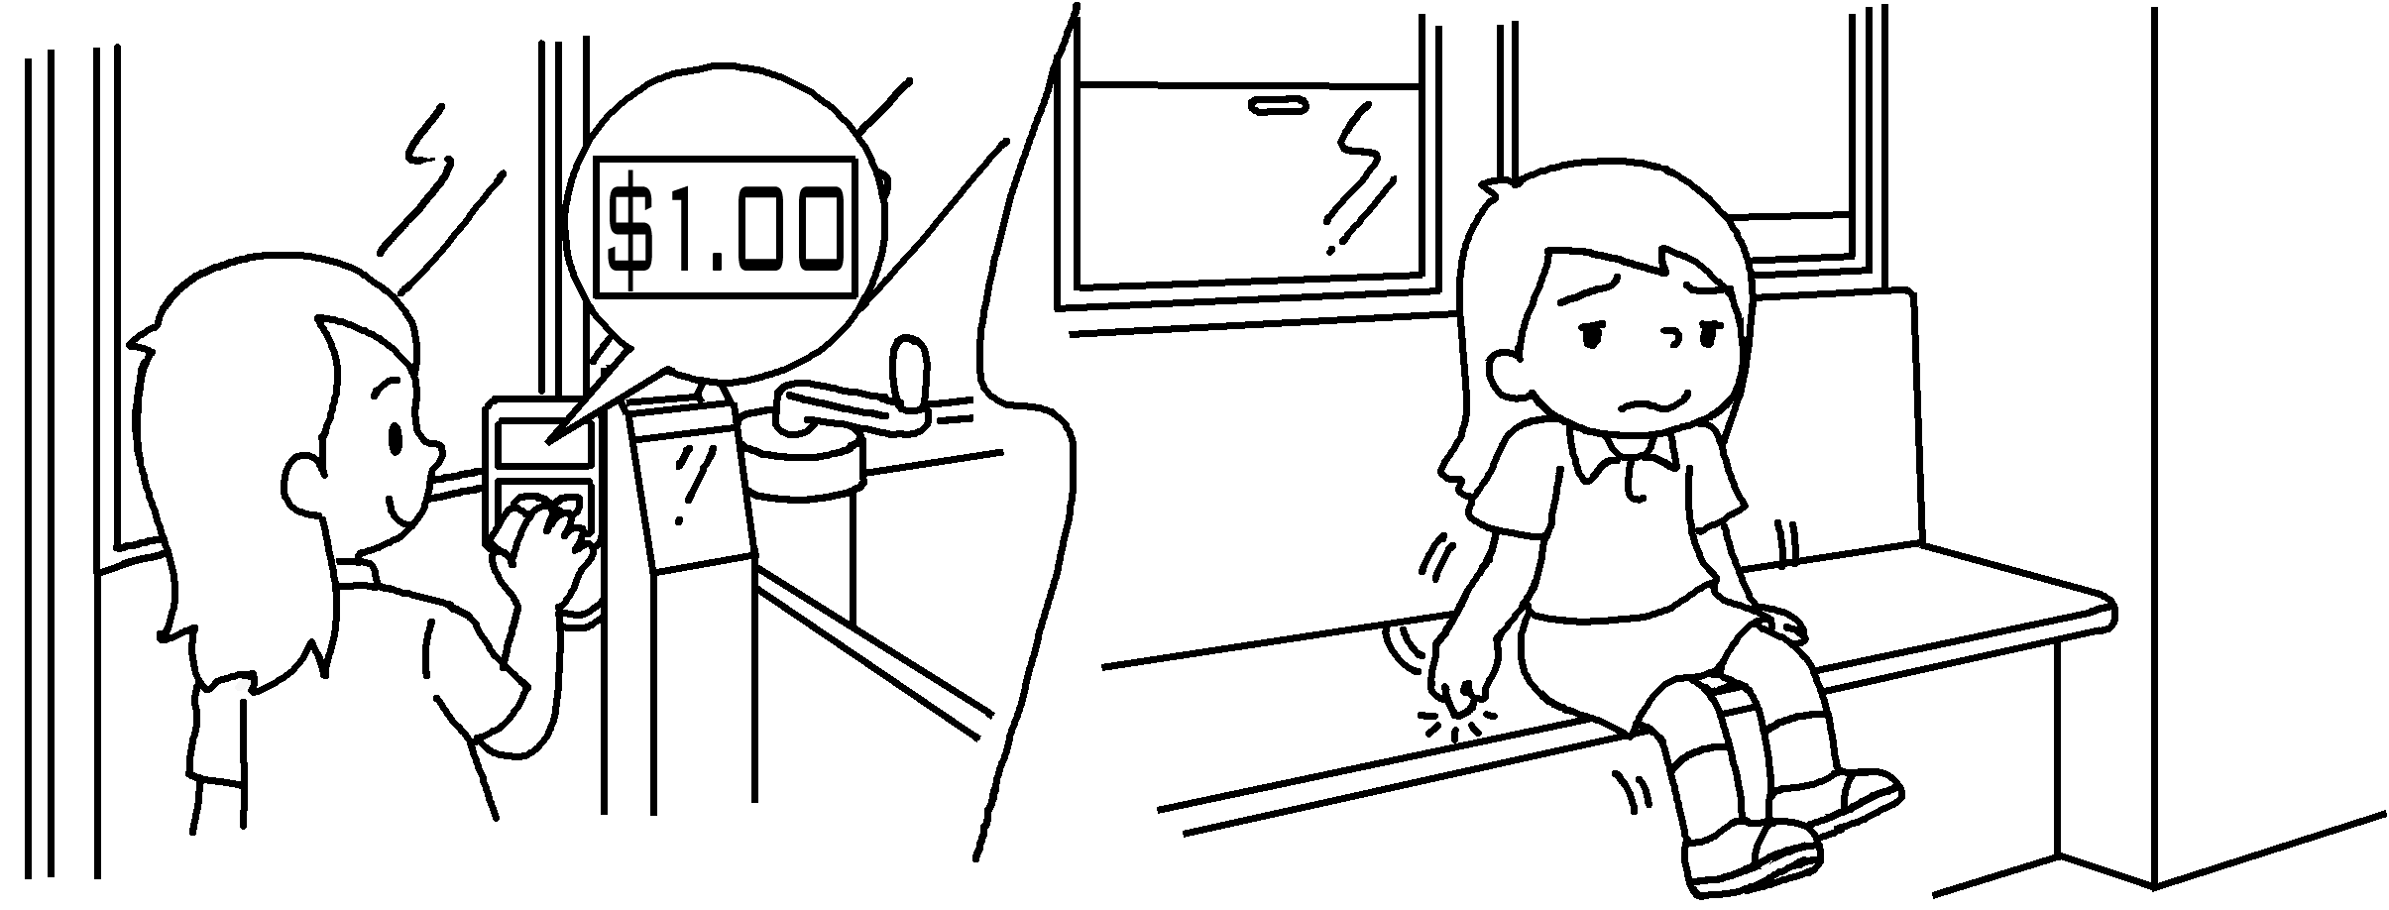
5 |  | 


Book 5B Chapter 3 Graded Worksheets
Worksheet 3⬇⬇⬇
- Although
- slow
- by MTR fast inconvenient
- Although travelling by tram is slow, it is uncomfortable.
- Although travelling by taxi is comfortable, it is expensive.
(Accept any reasonable answers.)

