What are they? Write.

1 | 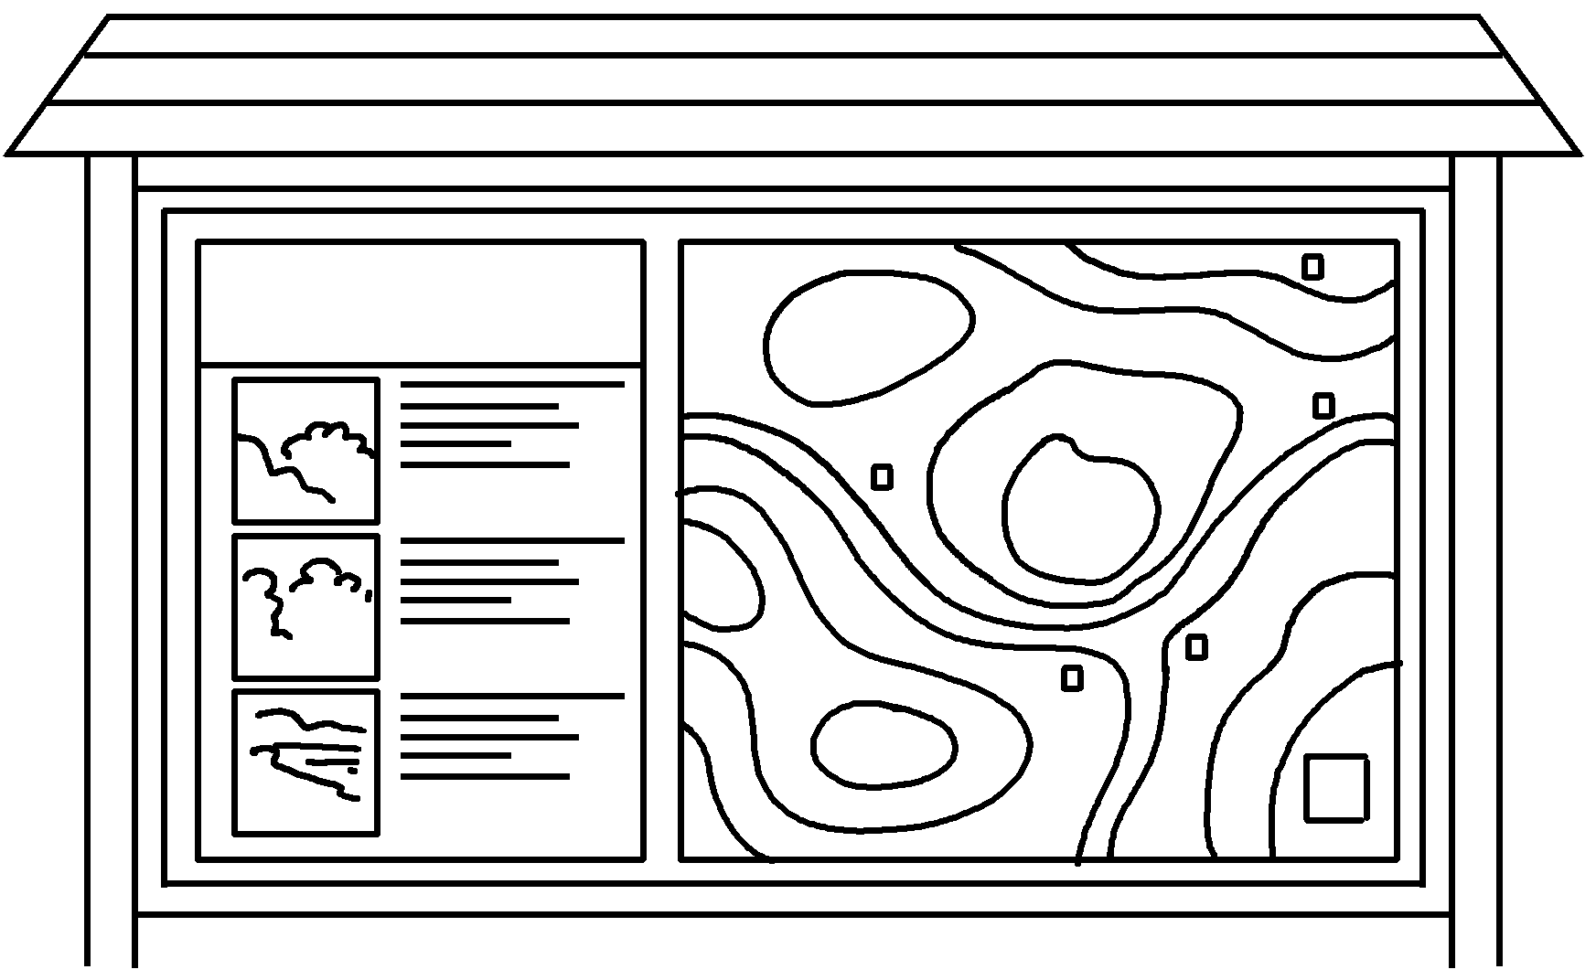  an i  b | 2 | 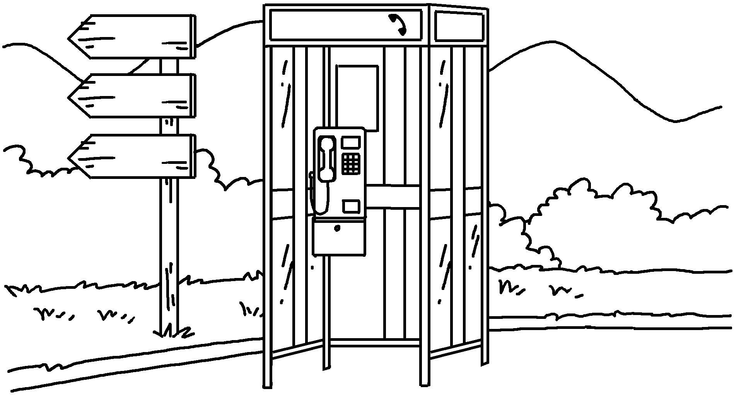  a p  t
3 | 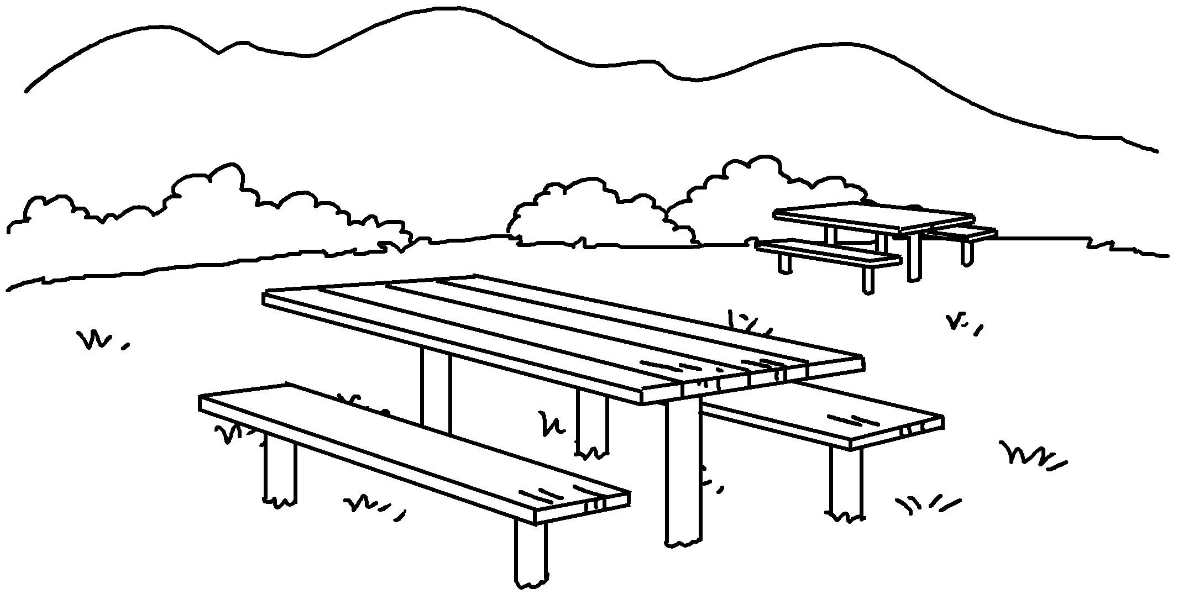  a p  s | 4 | 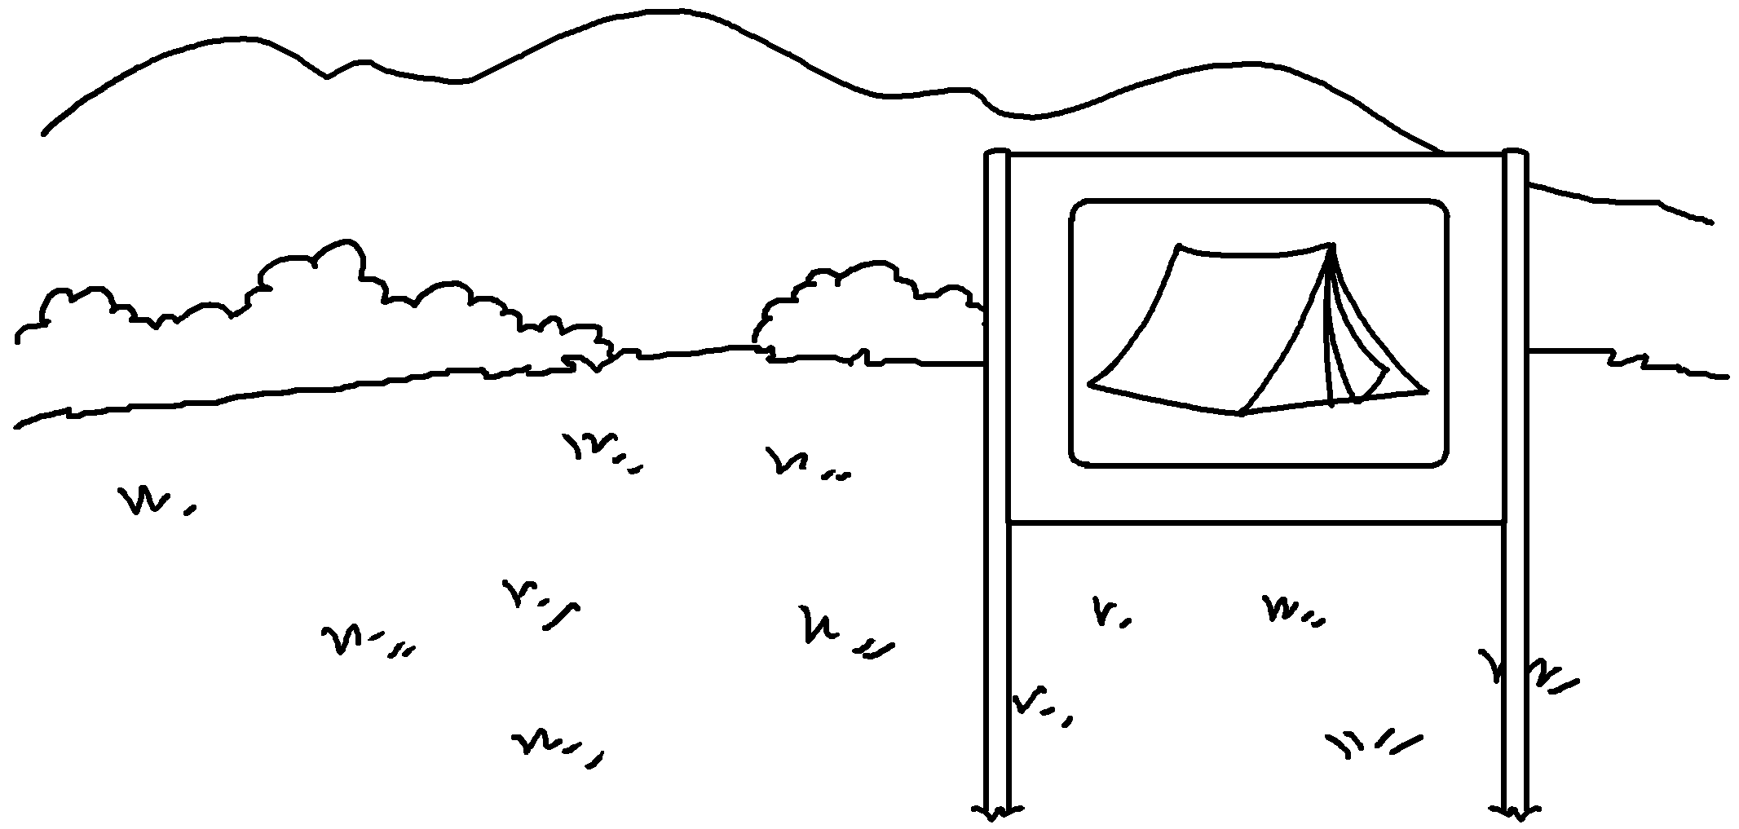  a c
5 | 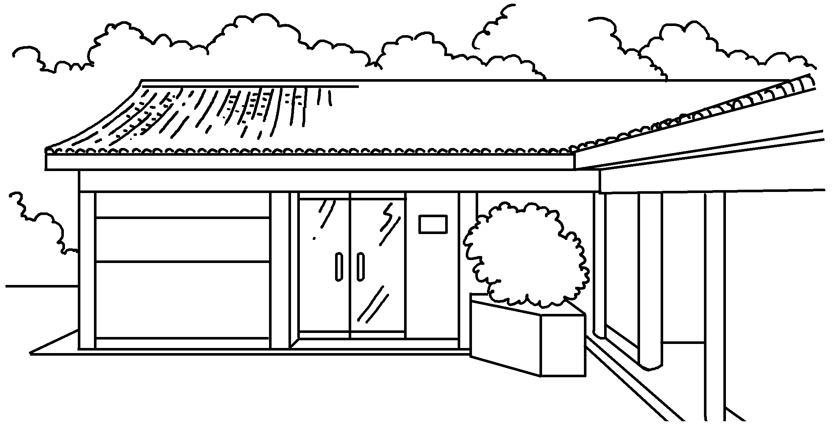  a v  c | 6 | 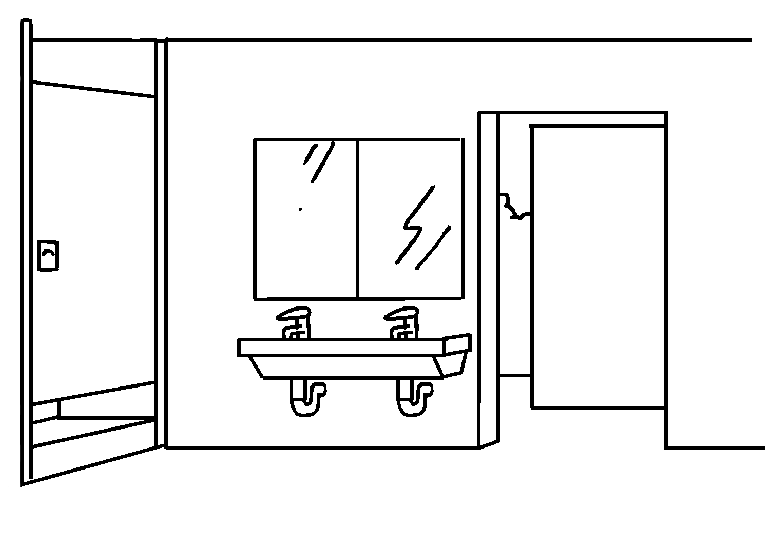  a p  t


Book 5B Chapter 4 Graded Worksheets
Worksheet 1⬇⬇
- information board 2 public telephone
3 picnic site 4 campsite
5 visitor centre 6 public toilet

