Choose and write.
campsiteinformation boardpicnic sitepublic telephonepublic toiletvisitor centre

1 | 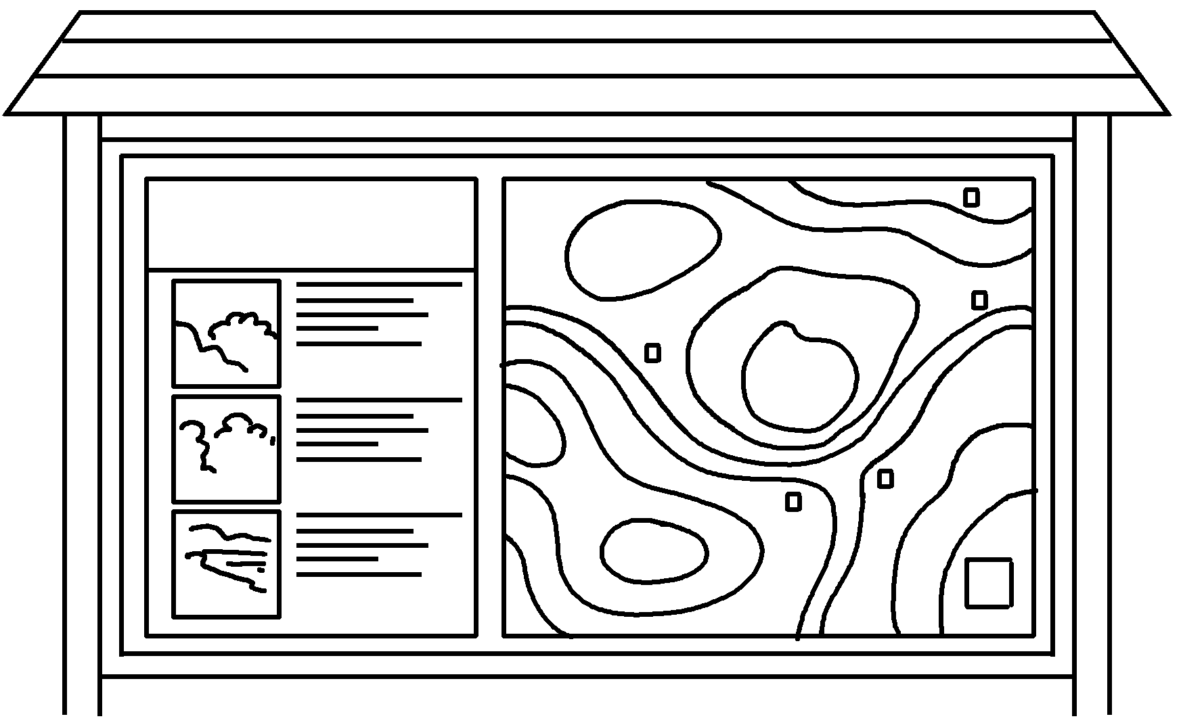  an | 2 | 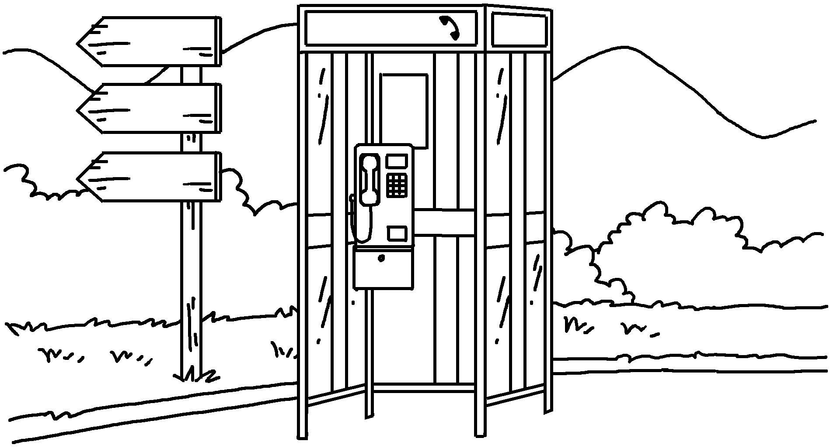  a
3 | 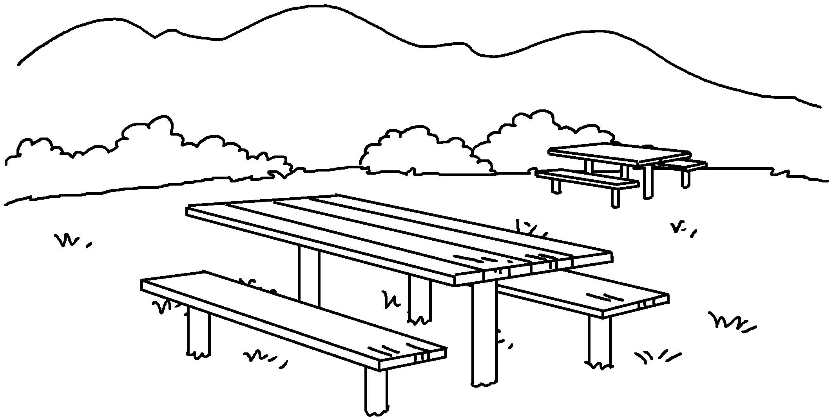  a | 4 | 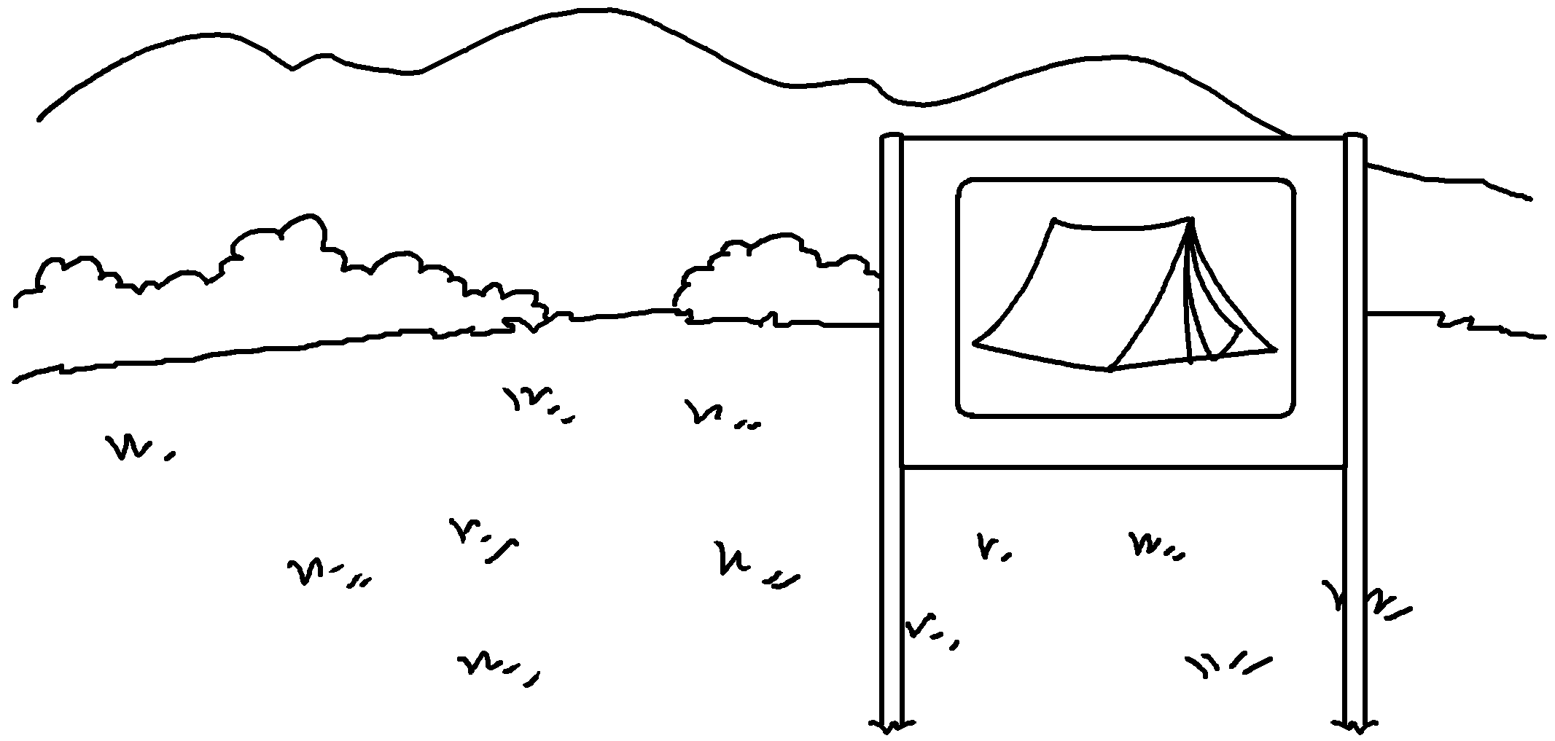  a
5 | 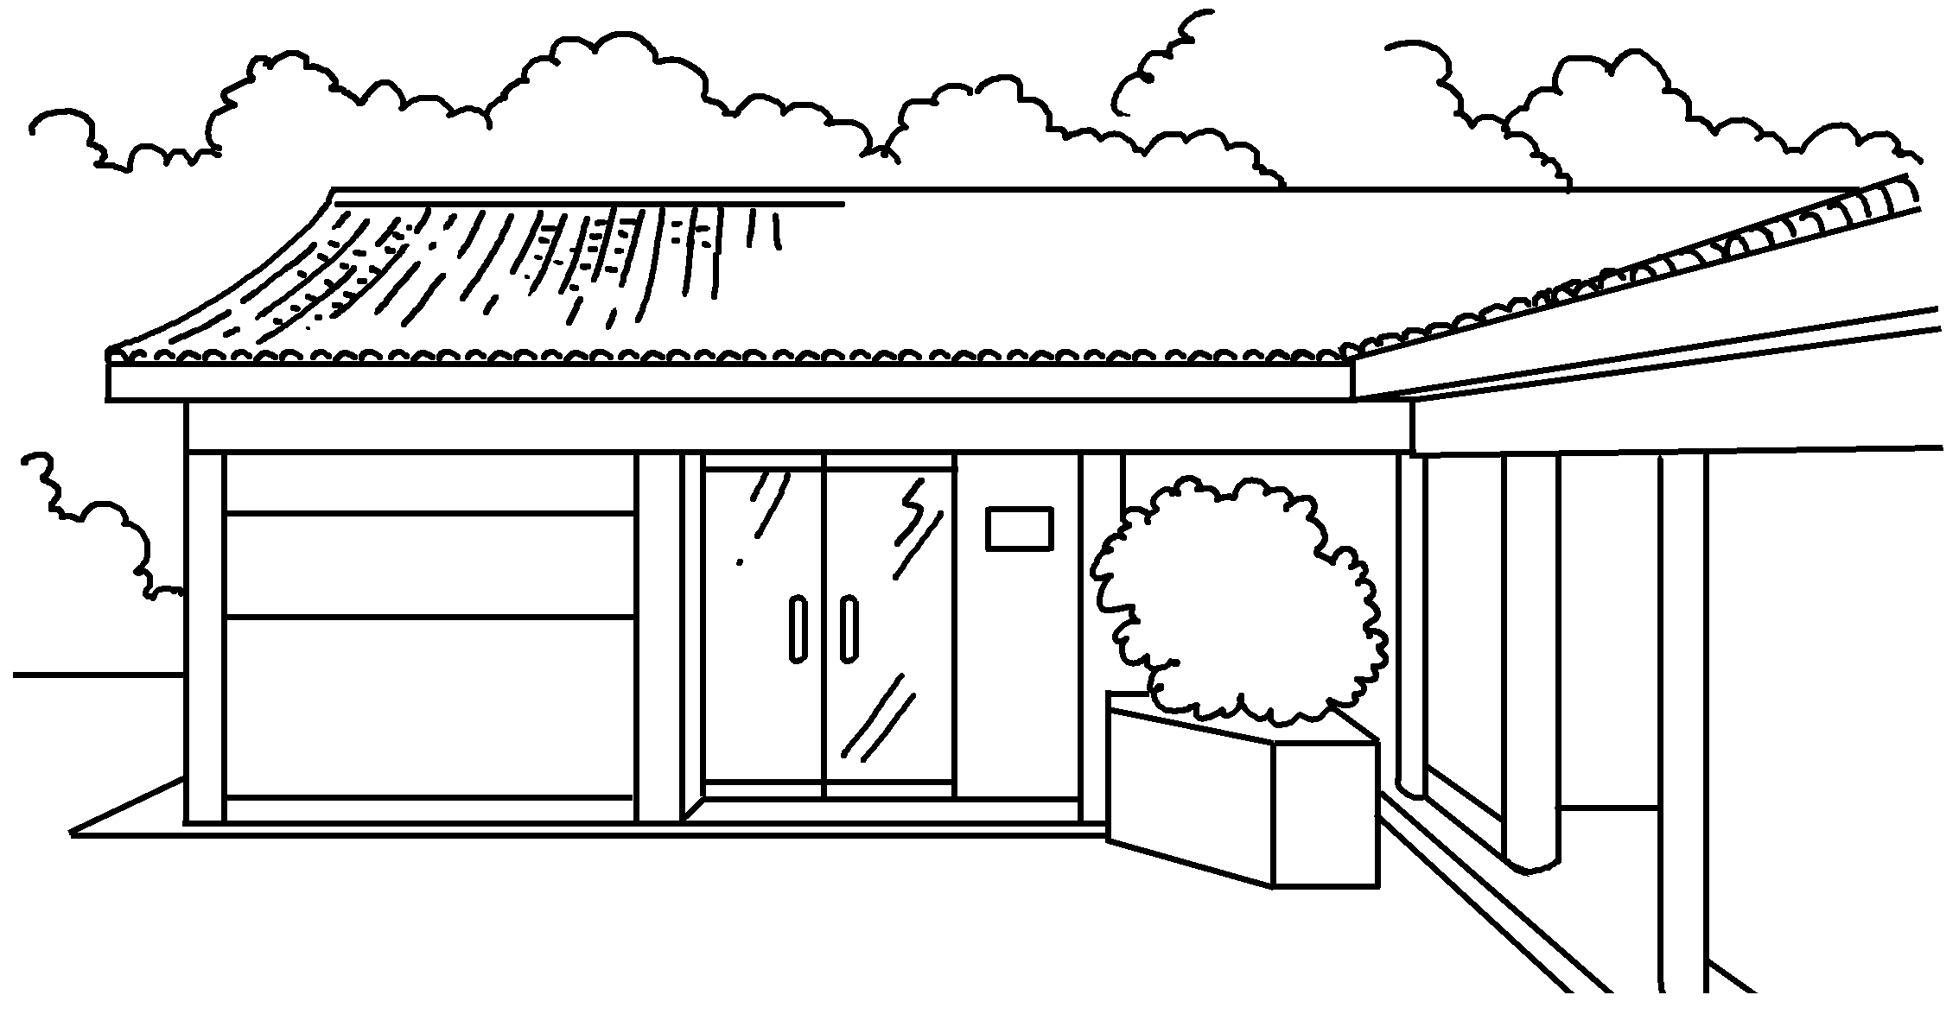  a | 6 | 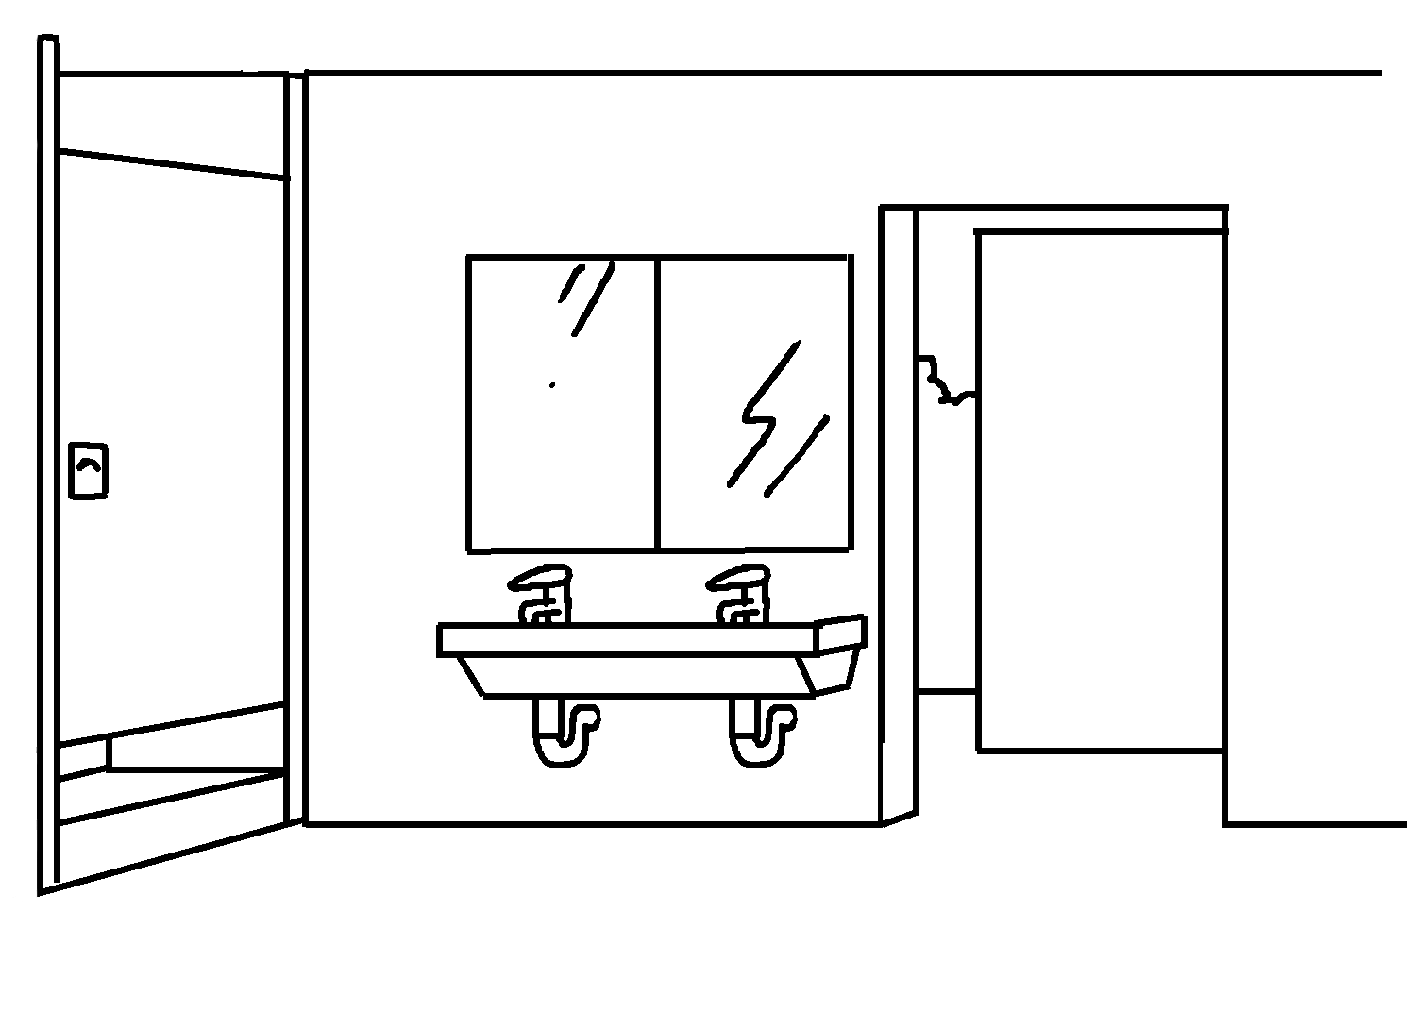  a


Book 5B Chapter 4 Graded Worksheets
Worksheet 1⬇⬇⬇
- information board 2 public telephone
3 a picnic site 4 a campsite
5 a visitor centre 6 a public toilet

