Finish the questions and answers.

campsite picnic site public toilets public telephone

1 | 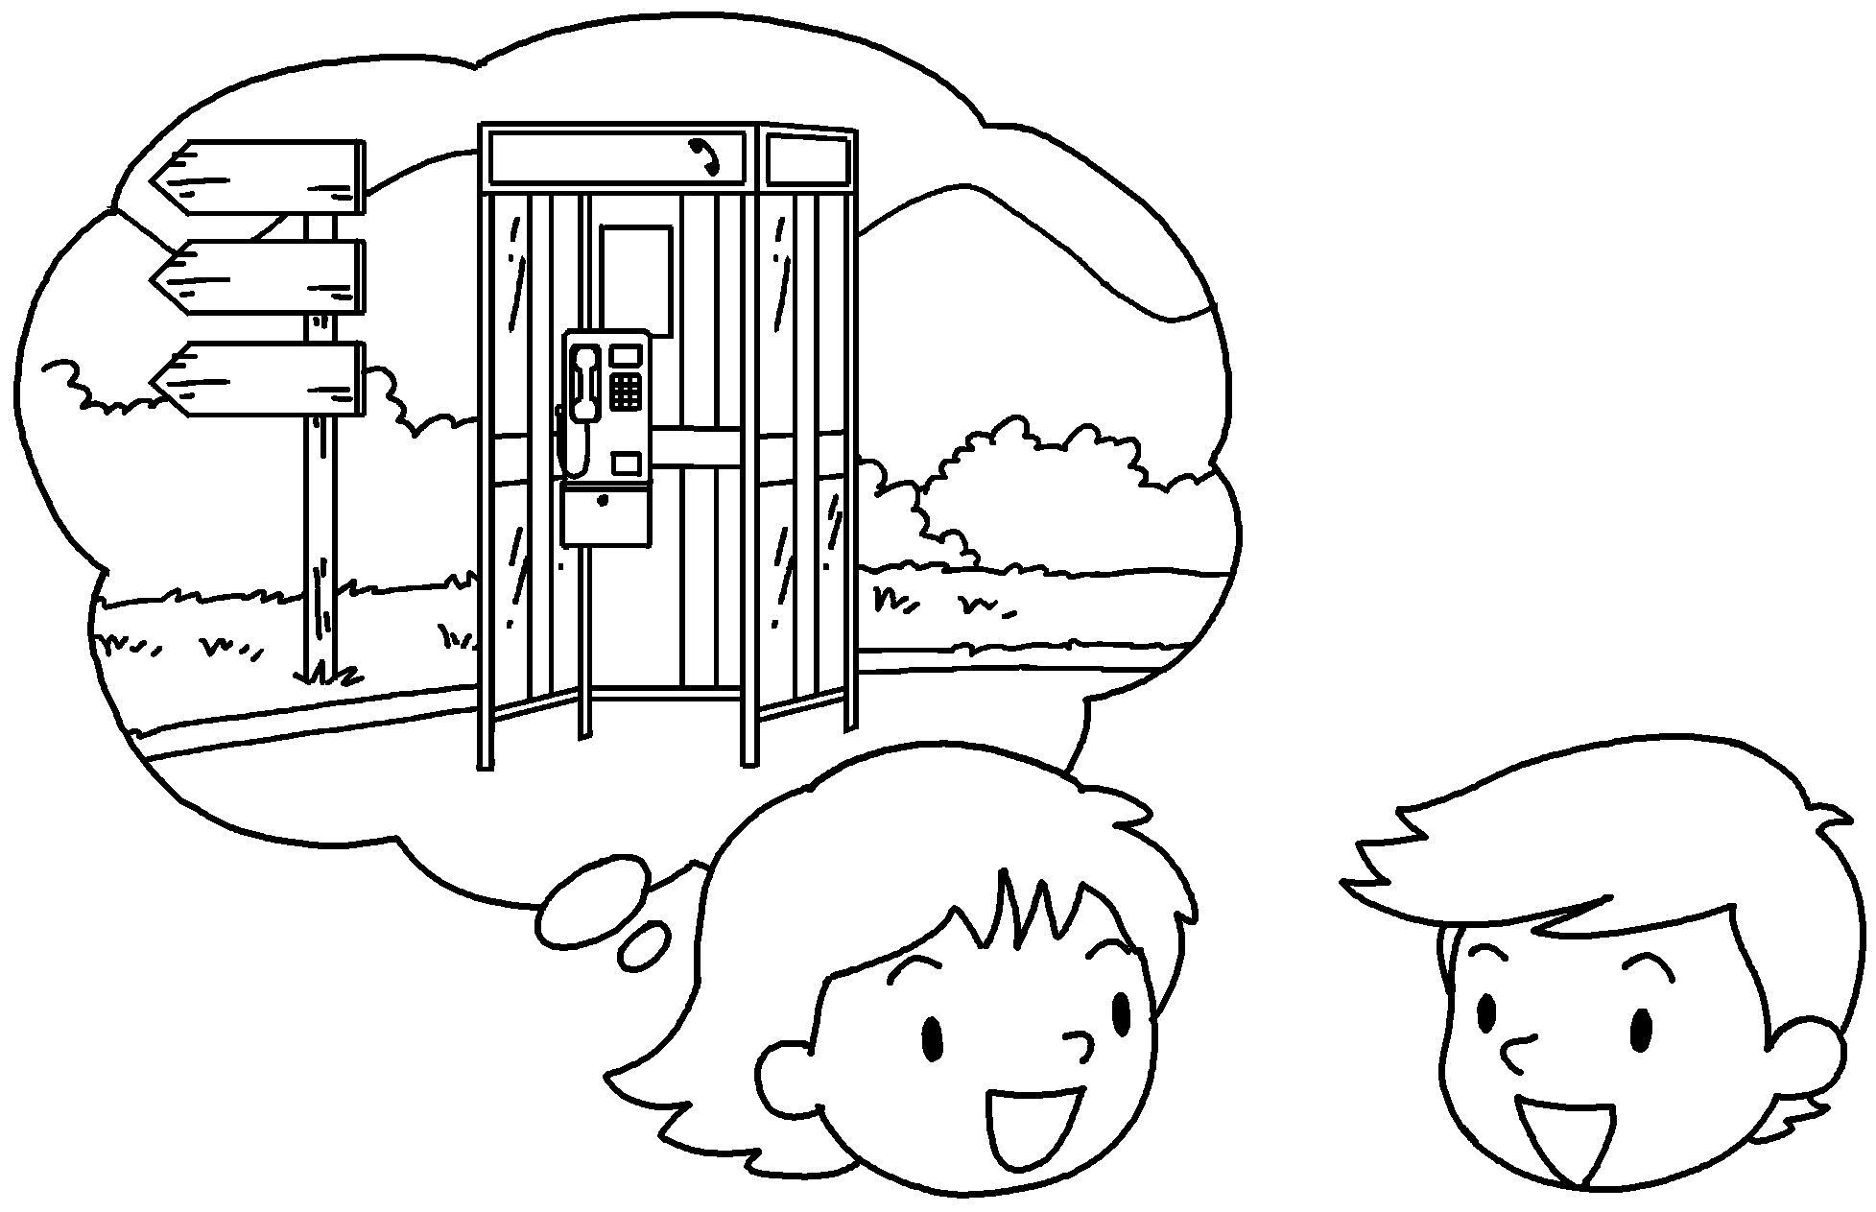  2 km  A  B | A : is it from here  How far  to the ___________________________ ?  B : It’s not far. It’s 2 kilometres.
2 | 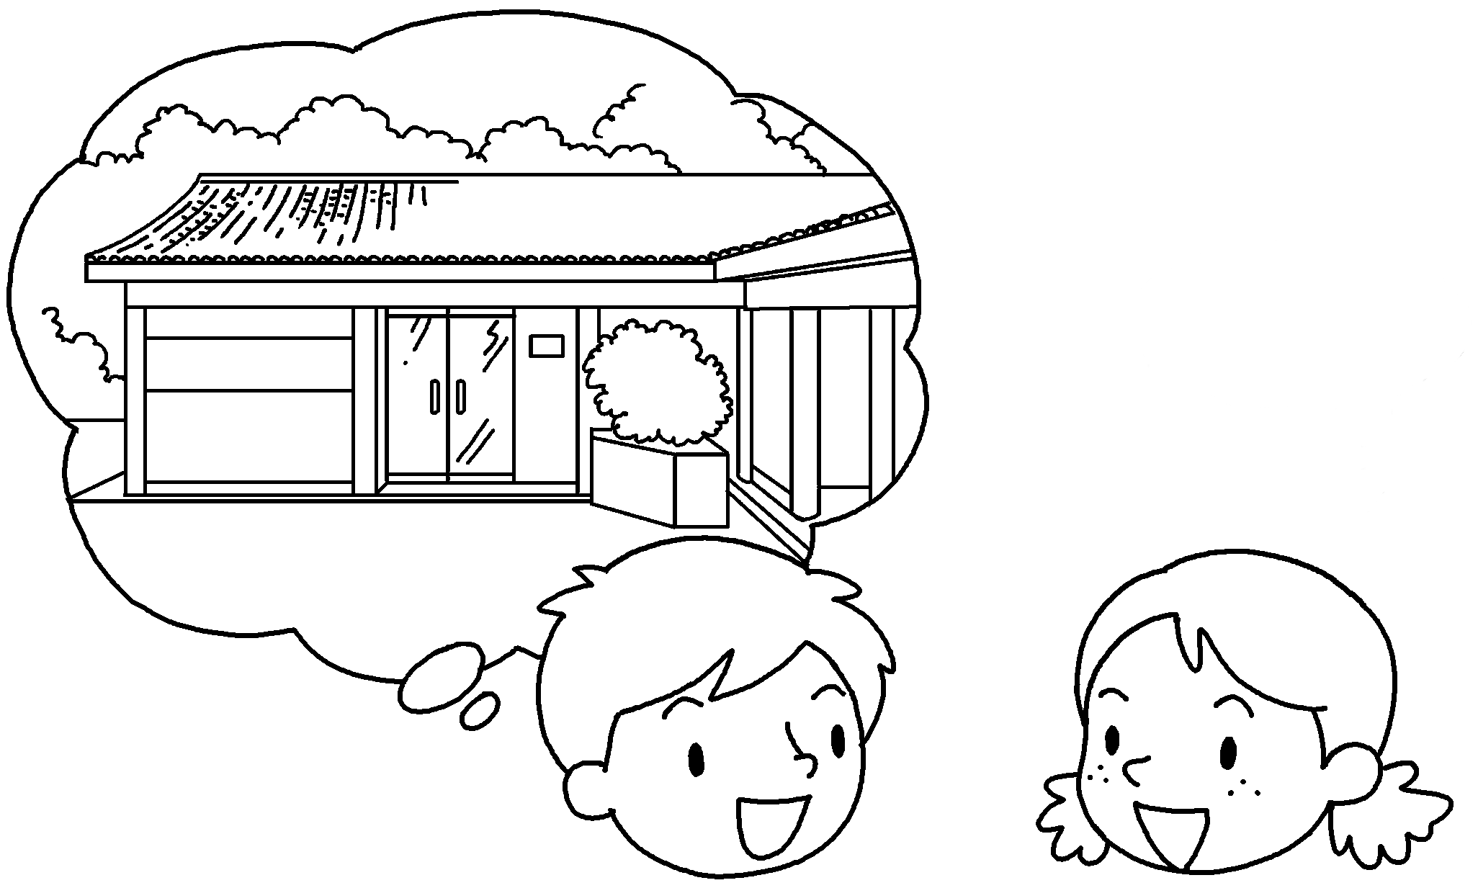  5 km  A  B | A : is it from here to the visitor centre?  B : It’s a long way.  It’s 5 .
3 | 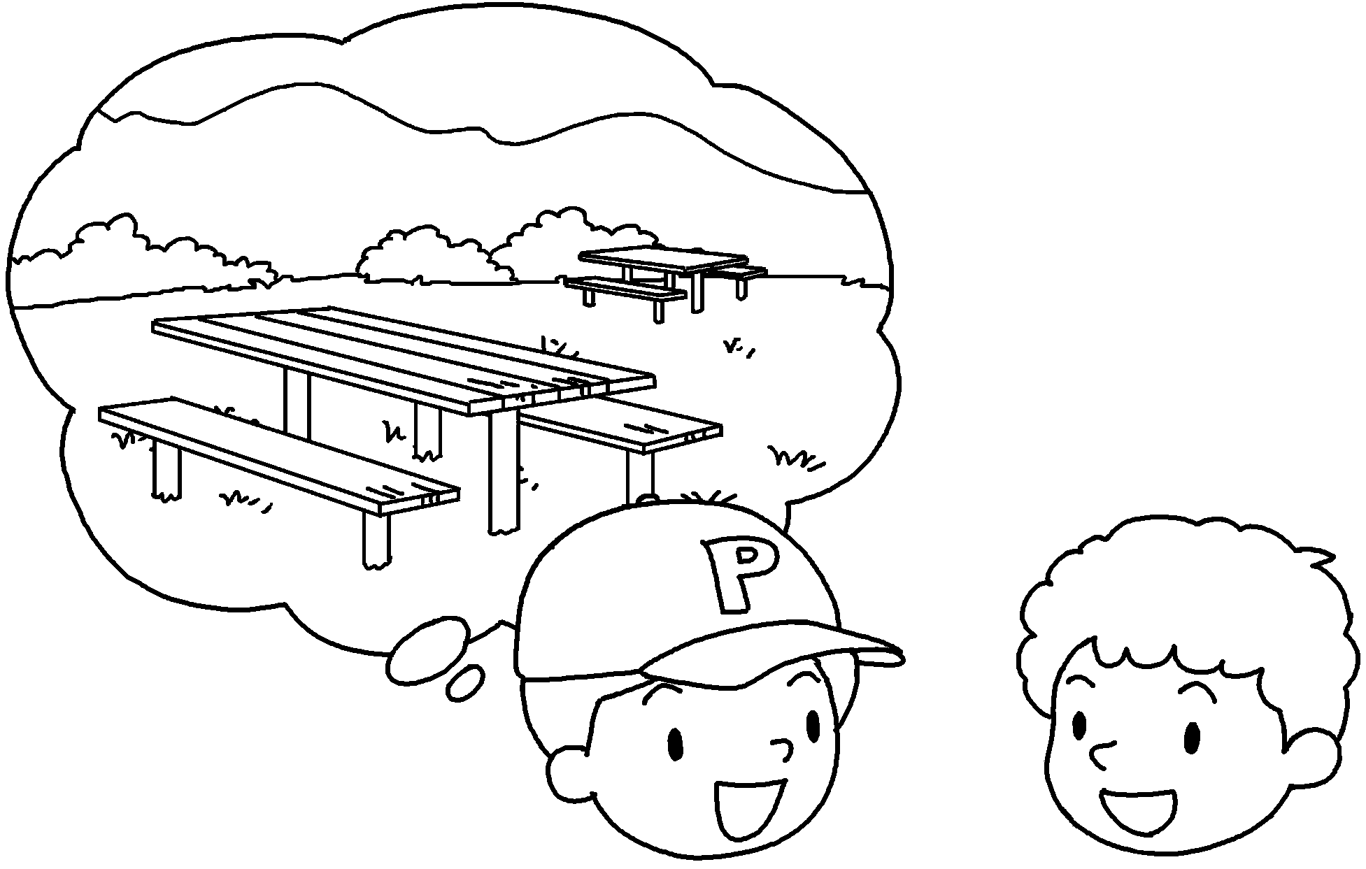  1 km  A  B | A : is it from here to the ?  B : It’s not .  It’s 1 kilometre.
4 | 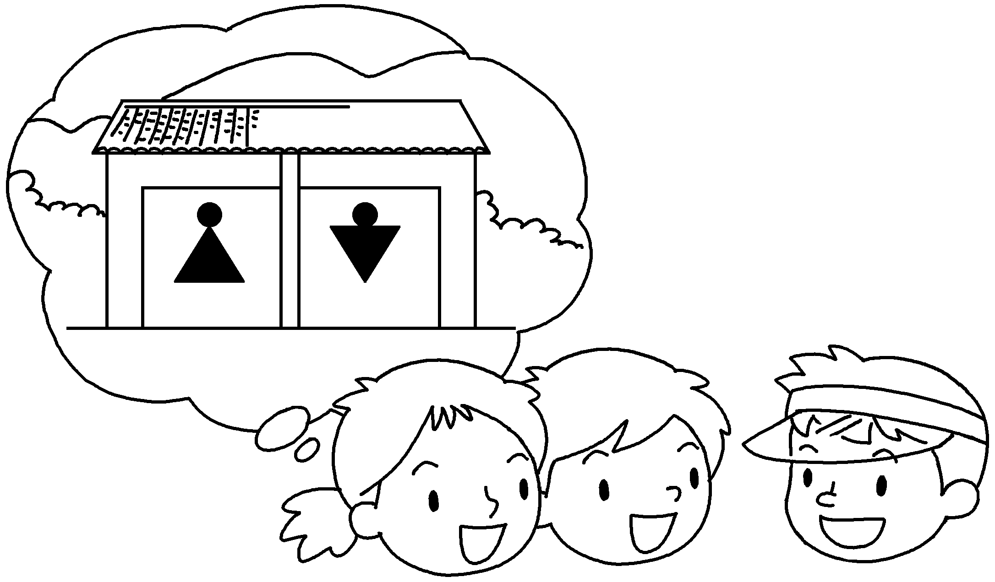  1.5 km  A  B  Cc | A&B : is it from  here to the ___________________  ?  C : It’s not .  It’s 1.5 .
5 | 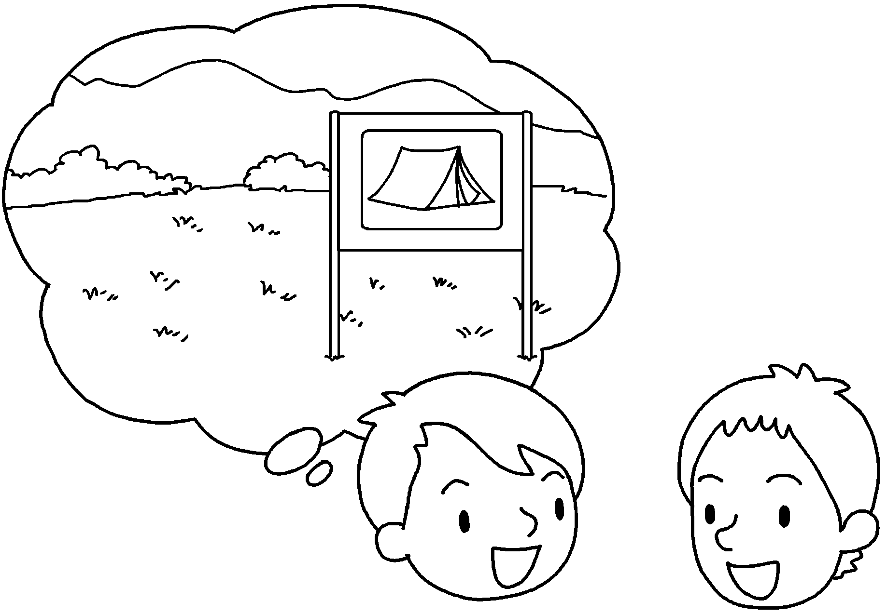  7 km  A  B | A : is it from here to ?  B : It’s a .  It’s 7 .


Book 5B Chapter 4 Graded Worksheets
Worksheet 3⬇⬇
- public telephone
- How far
kilometres
- How far picnic site
far
4 How far public toilets
far
kilometres
5 How far the campsite
long way
kilometres

