Choose and write.
How far
far
long
kilometres

1 | 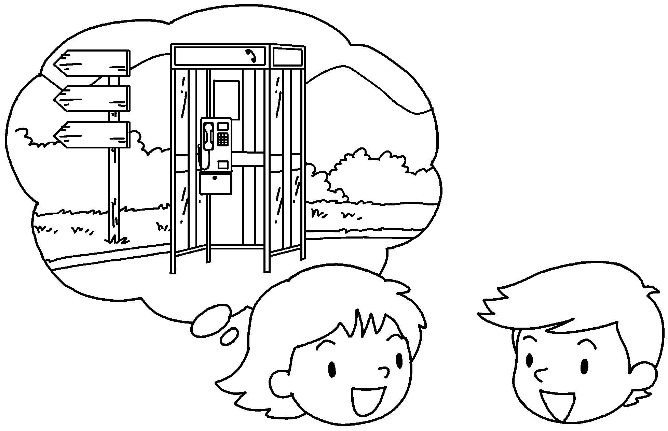  2 km  A  B | A : is it from  here to the public telephone?  B : It’s not far. It’s 2 .
2 | 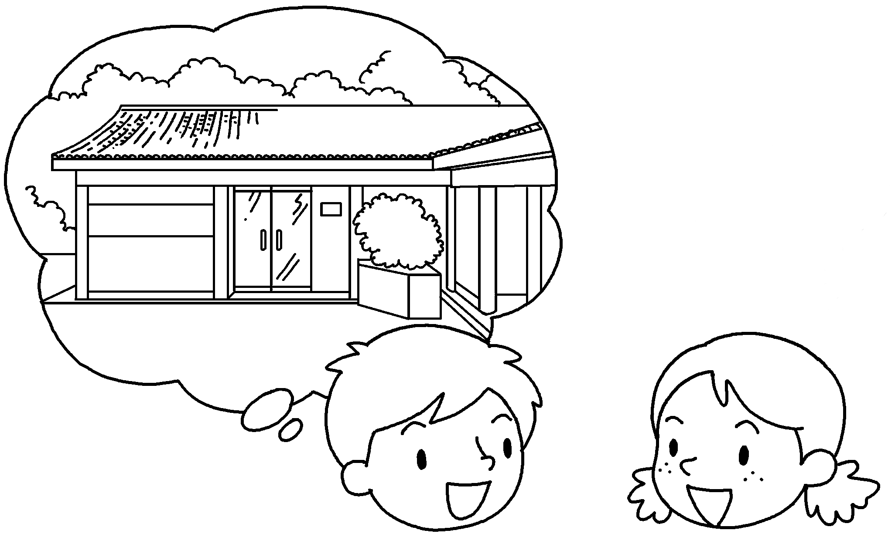  5 km  A  B | A : How far is it from here to the  visitor centre?  B : It’s a way.  It’s 5 kilometres.
3 | 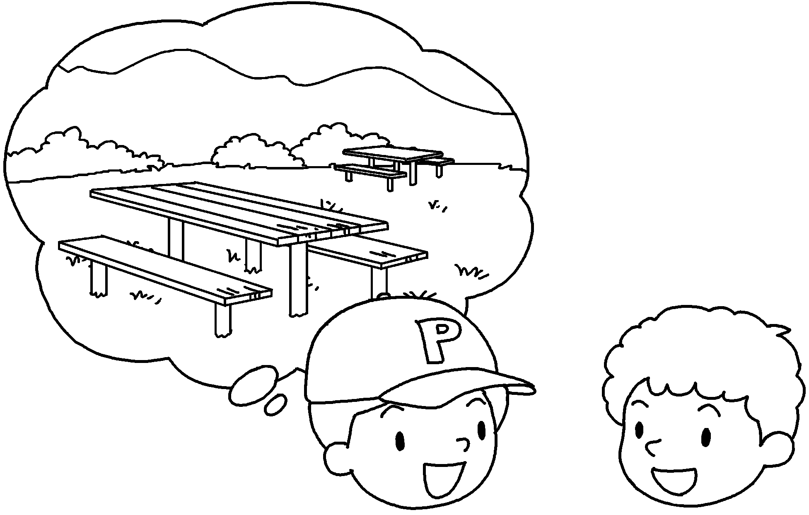  1 km  A  B | A : How far is it from here to the picnic  site?  B : It’s not .  It’s 1 kilometre.
4 |   1.5 km  A  B  Cc | A&B : is it  from here to the public toilets?  C : It’s not .  It’s 1.5 .
5 | 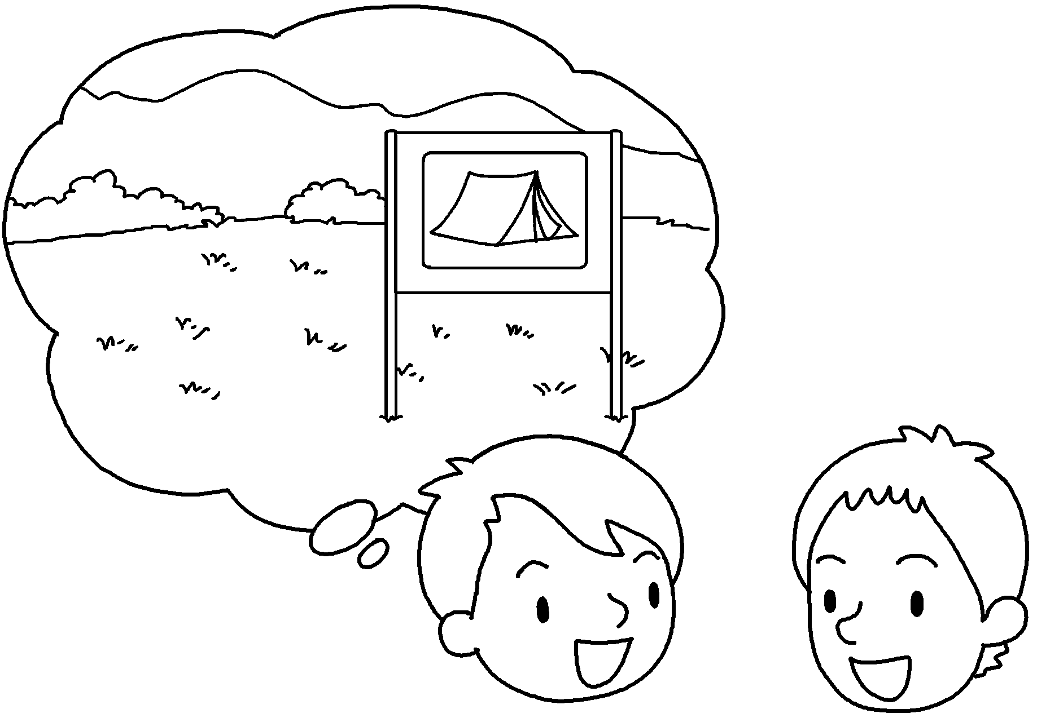  7 km  A  B | A : is it from  here to the campsite?  B : It’s a way.  It’s 7 .


Book 5B Chapter 4 Graded Worksheets
Worksheet 3⬇⬇⬇
- telephone
- How far
kilometres
- How far picnic site
far
4 How far is it from here to the public toilets?
far
It’s 1.5 kilometres.
5 How far is it from here to the campsite?
long way
It’s 7 kilometres.

