- Near and far
The children needed to find some things to win a competition. Look at the list. Where did they get these things? Read the story and find out.


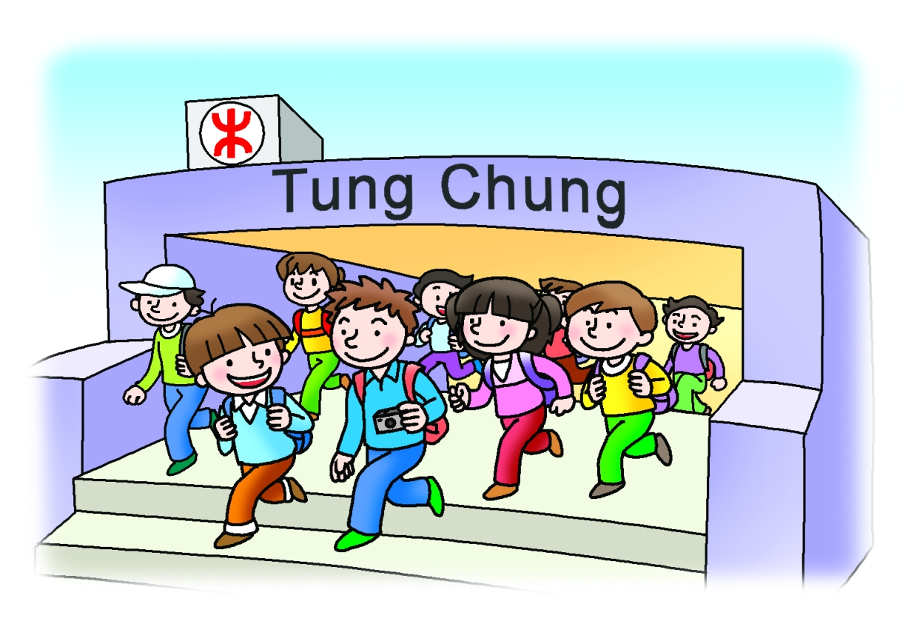
Lantau Collectors Race 2010
Sunday 7th March 9:30 a.m. − 2:00 p.m.
Collect the treasure below. Return to Tung Chung MTR station first to win the competition!
- a map of Ngong Ping hiking trail
- a photo of houses on water
- the flower of Hong Kong
- a photo of the Big Buddha
- a salted fish

‘Let’s go to the Ngong Ping Visitor Centre first,’ said Mike.

‘How long does it take to get to Ngong Ping?’ asked Henry.

‘It takes 25 minutes,’ said Kelly. ‘Come on! It’s quarter to ten already.’

‘How far is it to Ngong Ping?’ asked Henry.

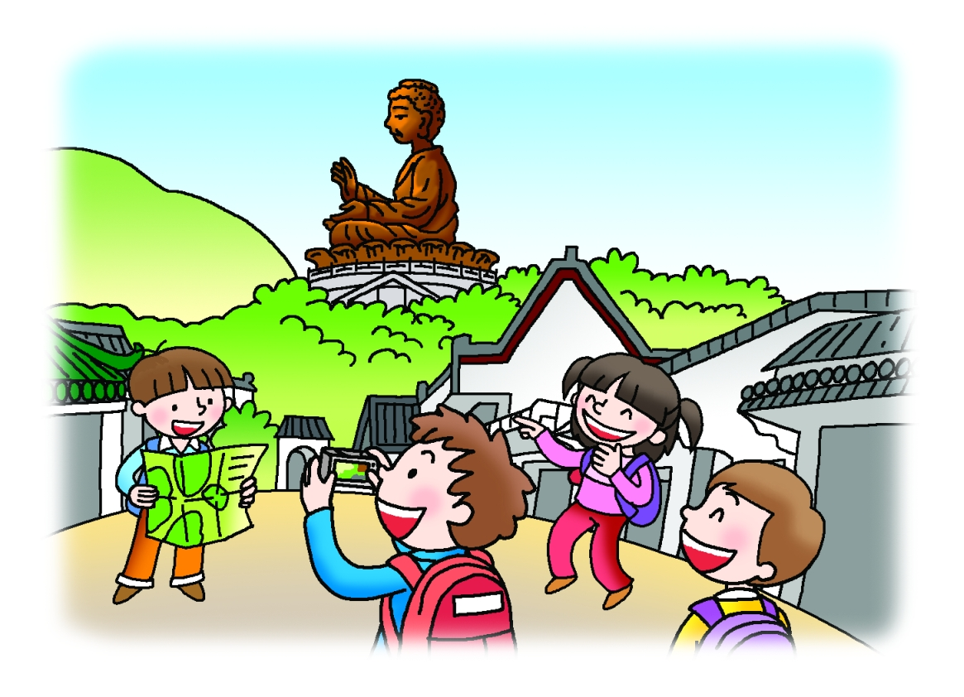
‘About 6 kilometres,’ Gary replied.

The journey was over too quickly for the children. They got off the cable car and picked up a map at the visitor centre.

‘The Buddha isn’t far. It’s about 500 metres. We can walk,’ said Mike.

The others laughed. ‘Look!’

They took a photo. Henry looked at the list. ‘Houses on water?’

‘There are houses on stilts in Tai O. We can take a bus there,’ Kelly said.

They arrived at the bus stop. ‘Oh dear! We’ve missed the bus. Now we have to wait for thirty minutes for the next bus,’ said Kelly.

They finally got to Tai O but they were lost. Luckily a man showed them where the houses on stilts were. Gary took some photos and then bought a salted fish.
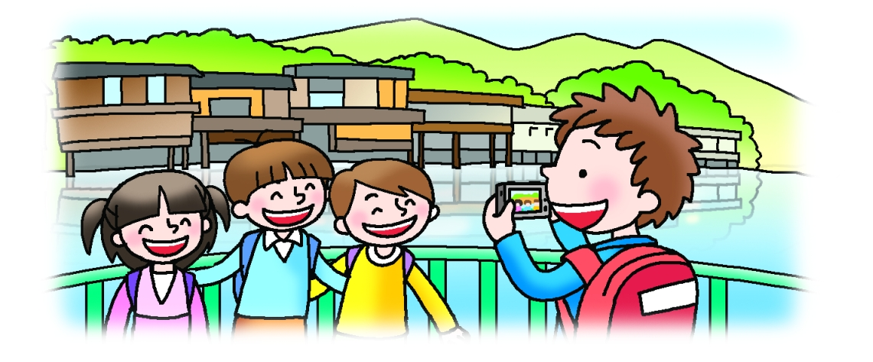
‘How long does it take to get to Tung Chung?’ asked Mike. ‘About 50 minutes,’ said Gary.

At quarter past twelve they ran into the MTR station.

‘You’re the first team back!’ said the competition organiser. ‘But where is your bauhinia flower?’

Gary took a $2 coin from his pocket. ‘The flower of Hong Kong – here you are!’
