RP no: Century Gothic 15pt
(所有圈號用15pt)
Choose and write.
999
1
2
3
4
5
Bank
call the policechaseescaperobsteal

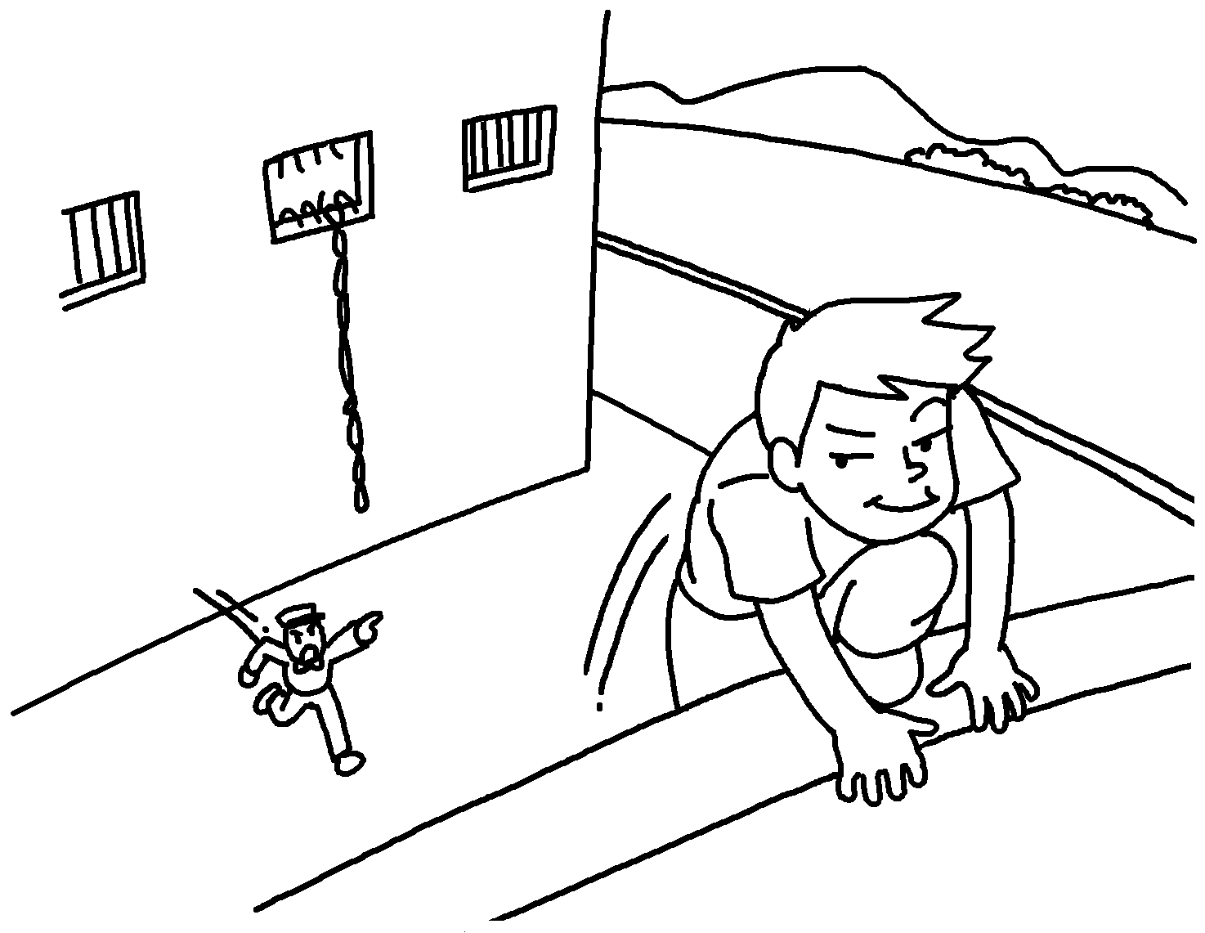 |  |  | 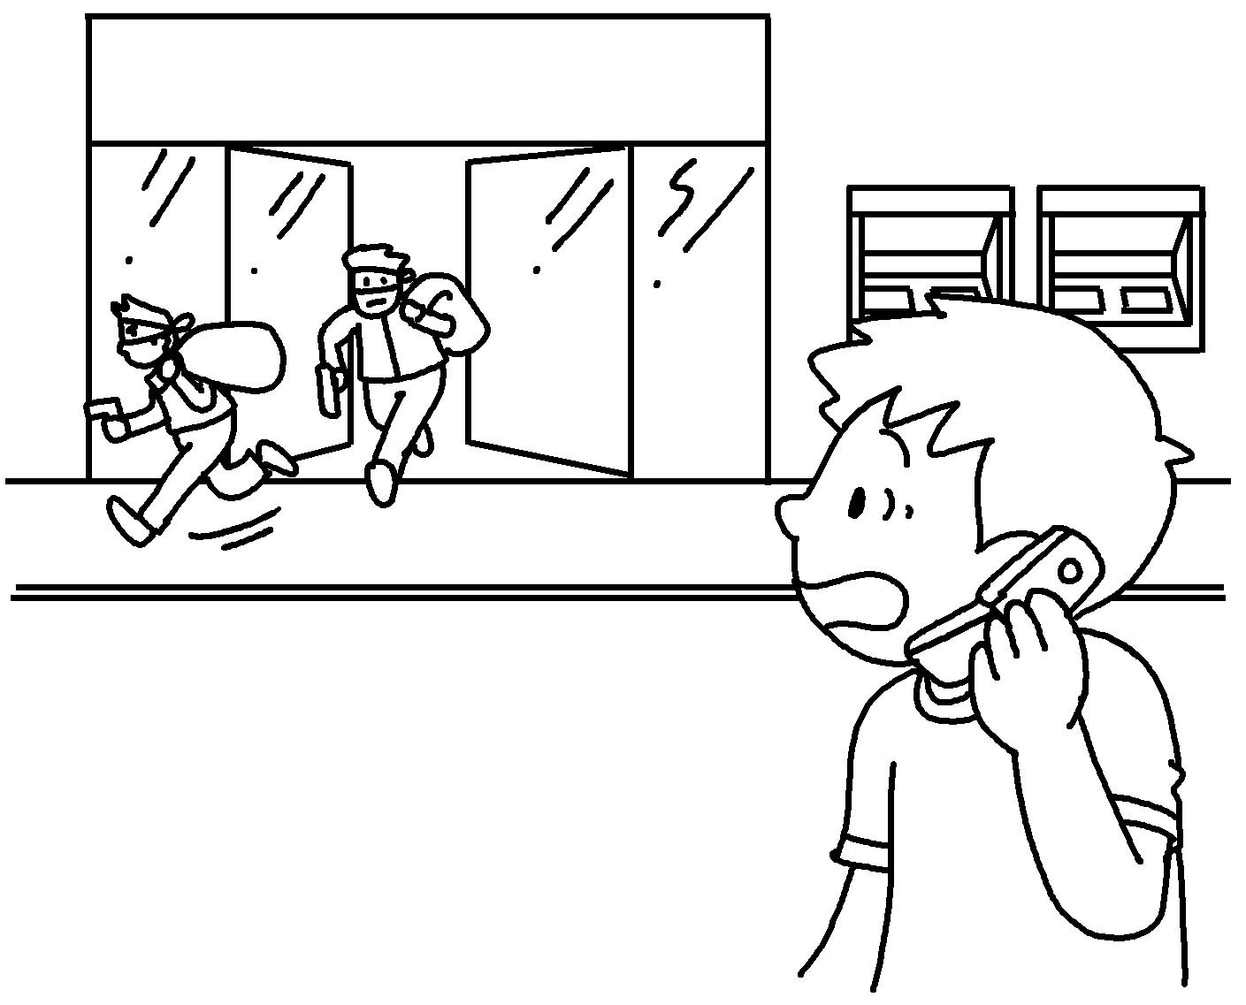
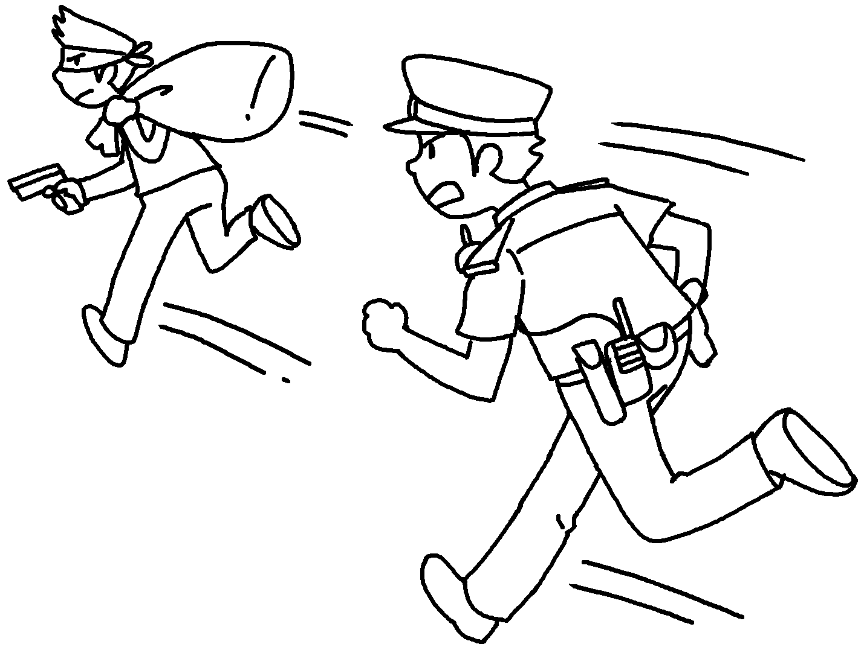 |  | 

1 |  |  | 2
3 |  |  | 4
5

Answer the question.
6 |  | Who is this man?  He is a r .


Book 5B Chapter 5 Graded Worksheets
Worksheet 1⬇
- escape
- steal
- call the police
- chase
- rob
- r o b b e r

