RP no: Century Gothic 15pt
(所有圈號用15pt)
RP no: Century Gothic 15pt
(所有圈號用15pt)
What actions can you see? Fill in the missing letters.
999
1
2
3
4
5
Bank

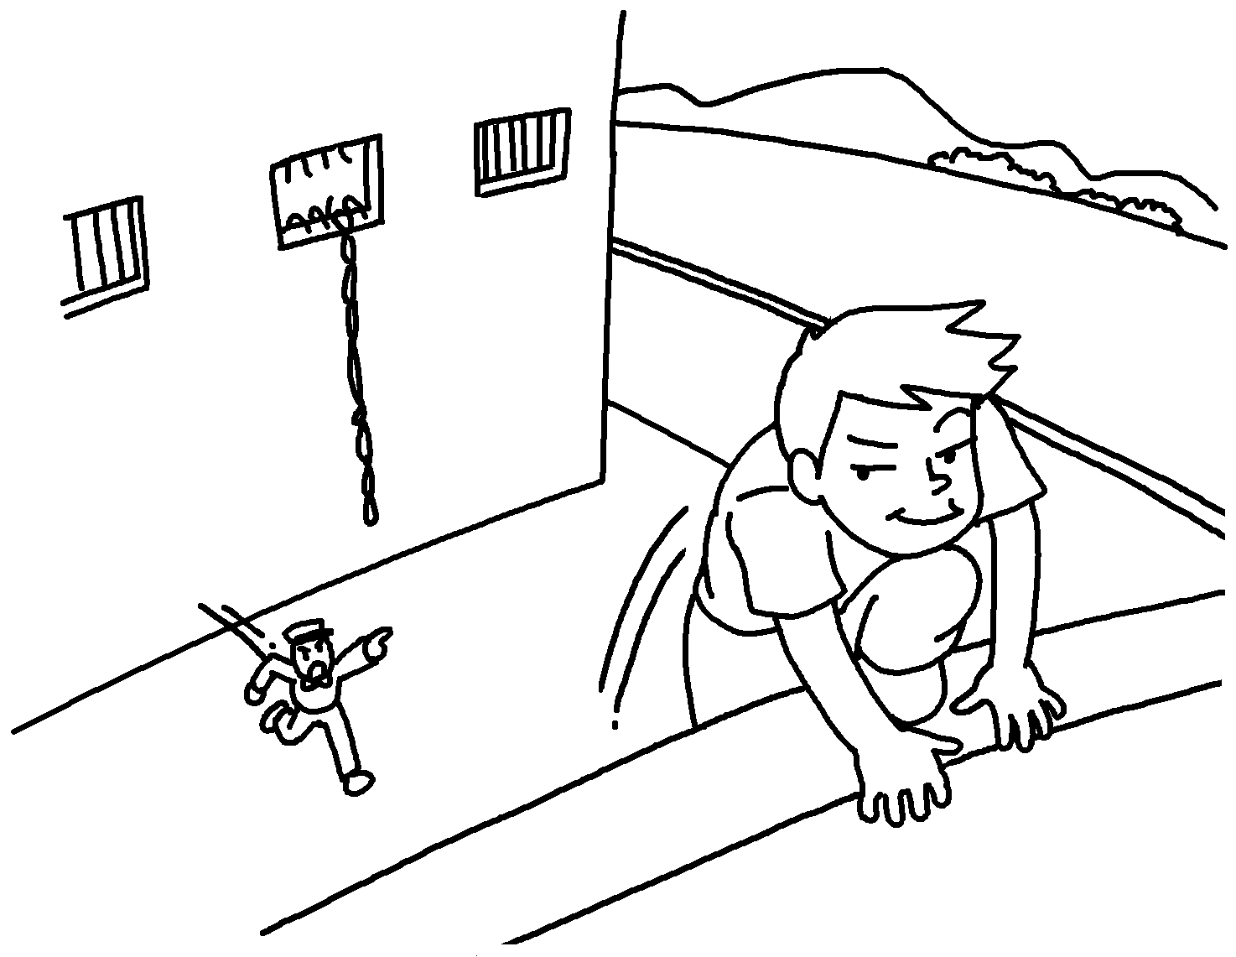 |  |  | 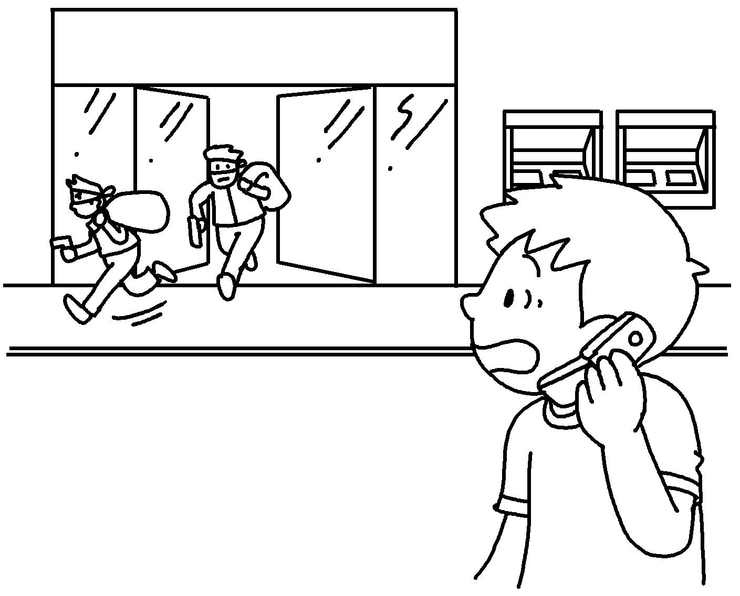
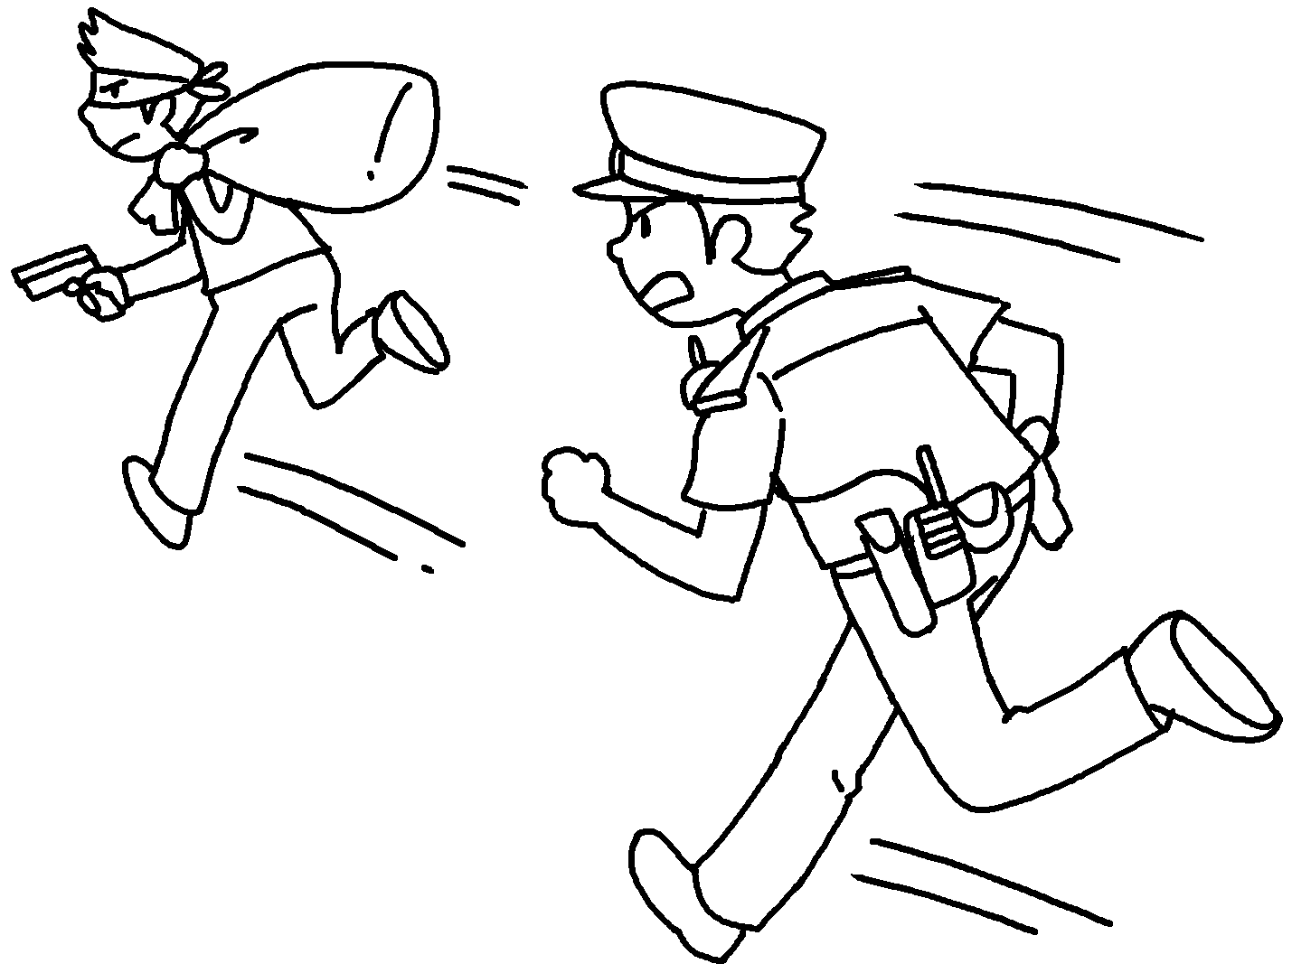 |  | 

1 | e __ __ __ __ __ |  | 2 | s __ __ __ __
3 | c __ __ __ the p __ __ __ __ __ |  | 4 | c __ __ __ __
5 | r __ __

Answer the question.
6 |  | Who is this man?  He is a r .

RP no: Century Gothic 15pt
(所有圈號用15pt)


Book 5B Chapter 5 Graded Worksheets
Worksheet 1⬇⬇
- e s c a p e
- s t e a l
- c a l l p o l i c e
- c h a s e
- r o b
- r o b b e r

