RP no: Century Gothic 15pt
(所有圈號用15pt)
What actions can you see? Write.
999
1
2
3
4
5
Bank

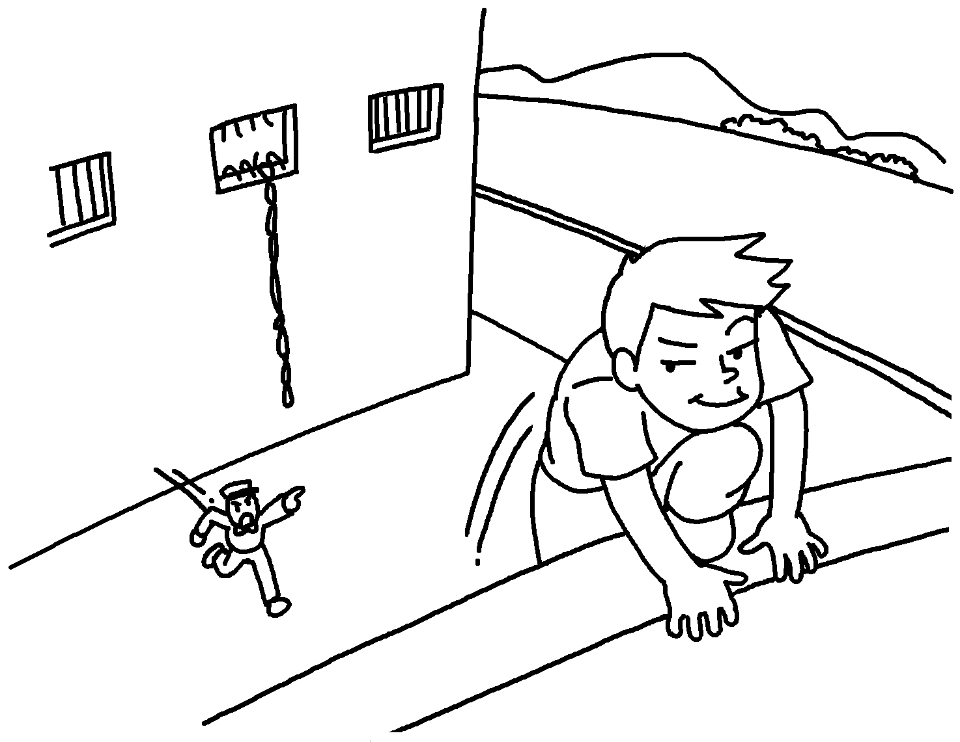 | 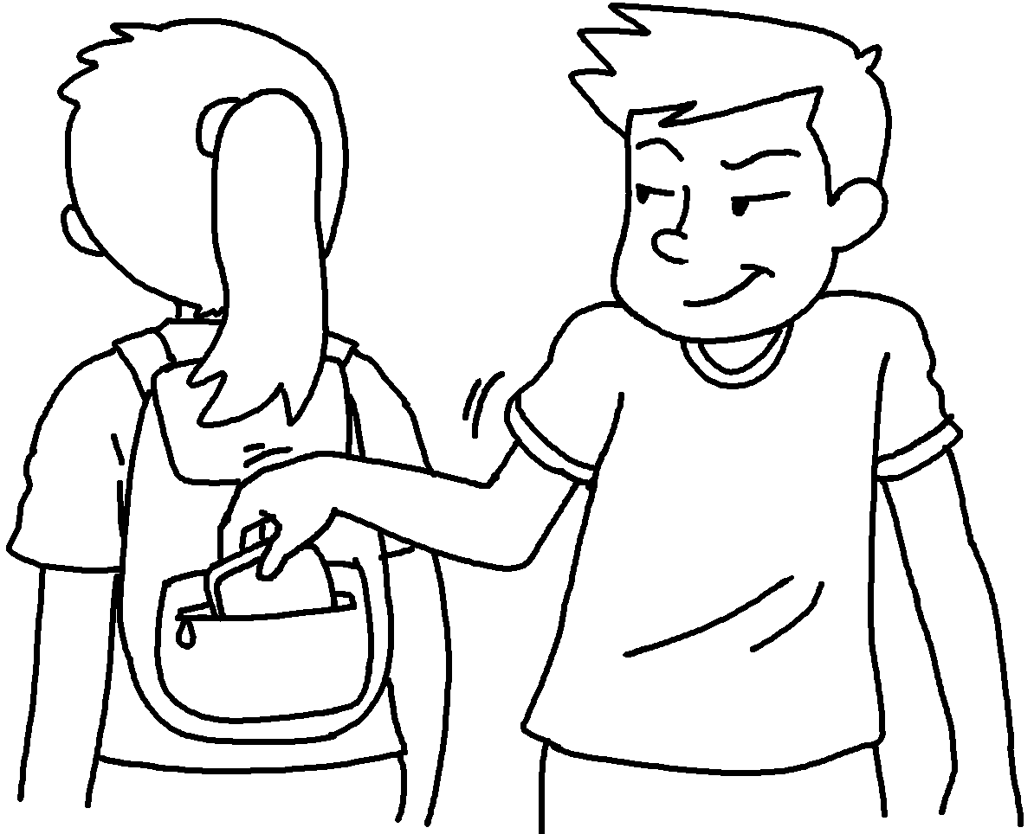 |  | 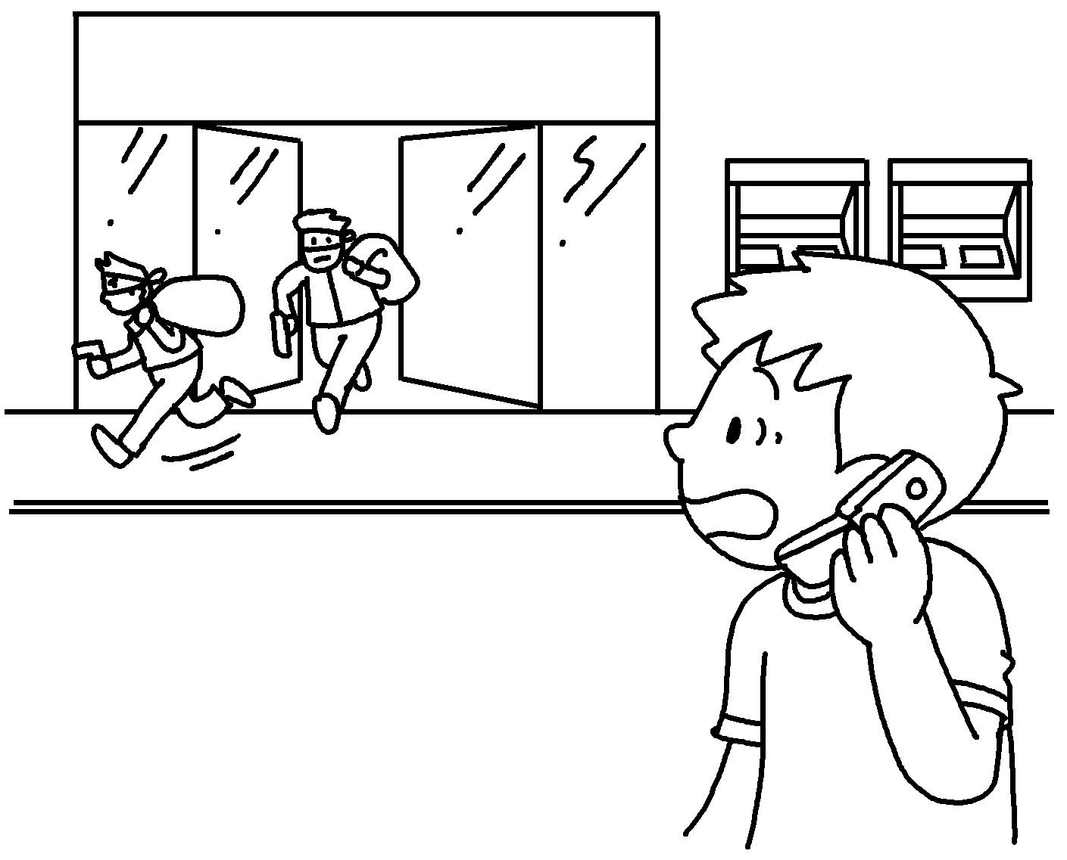
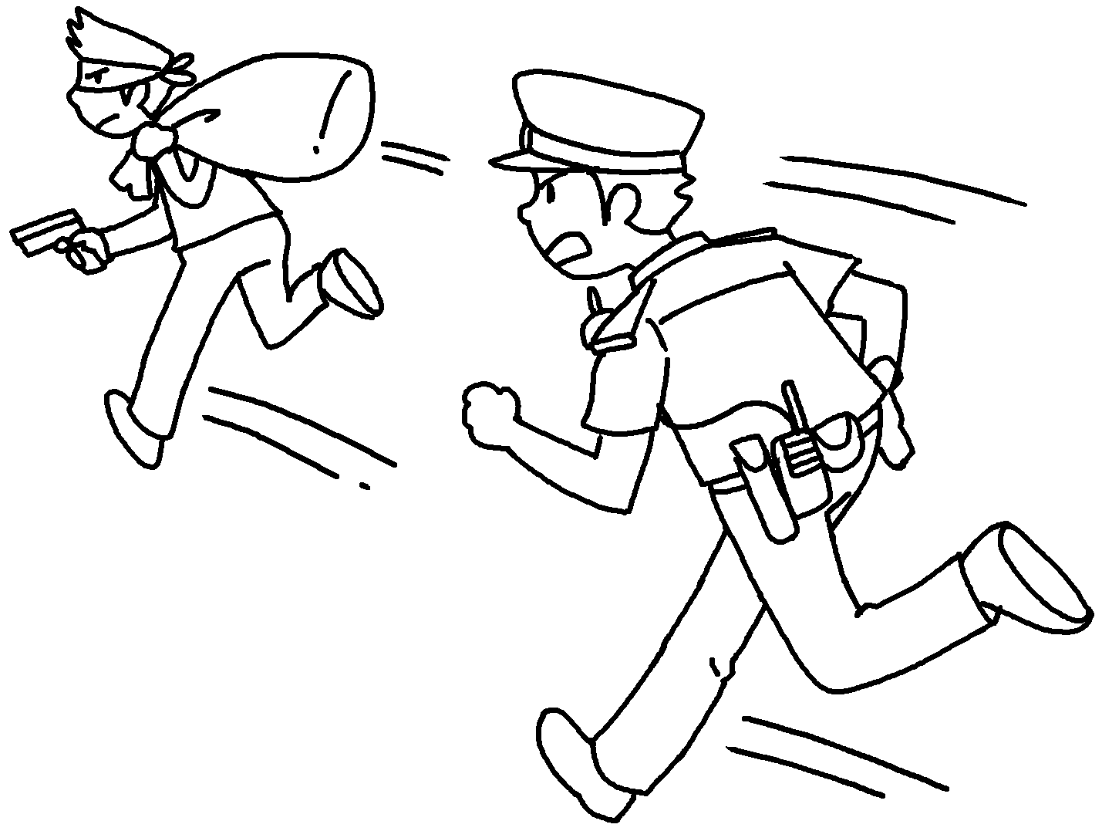 |  | 

1 | e |  | 2 | s
3 | c the p |  | 4 | c
5 | r

Answer the question.
6 |  | Who is this man?  He is a __________________ .


Book 5B Chapter 5 Graded Worksheets
Worksheet 1⬇⬇⬇
- escape
- steal
- call the police
- chase
- rob
- robber

