Finish the questions and answers.
were
was
…ing

1  A  B |  | 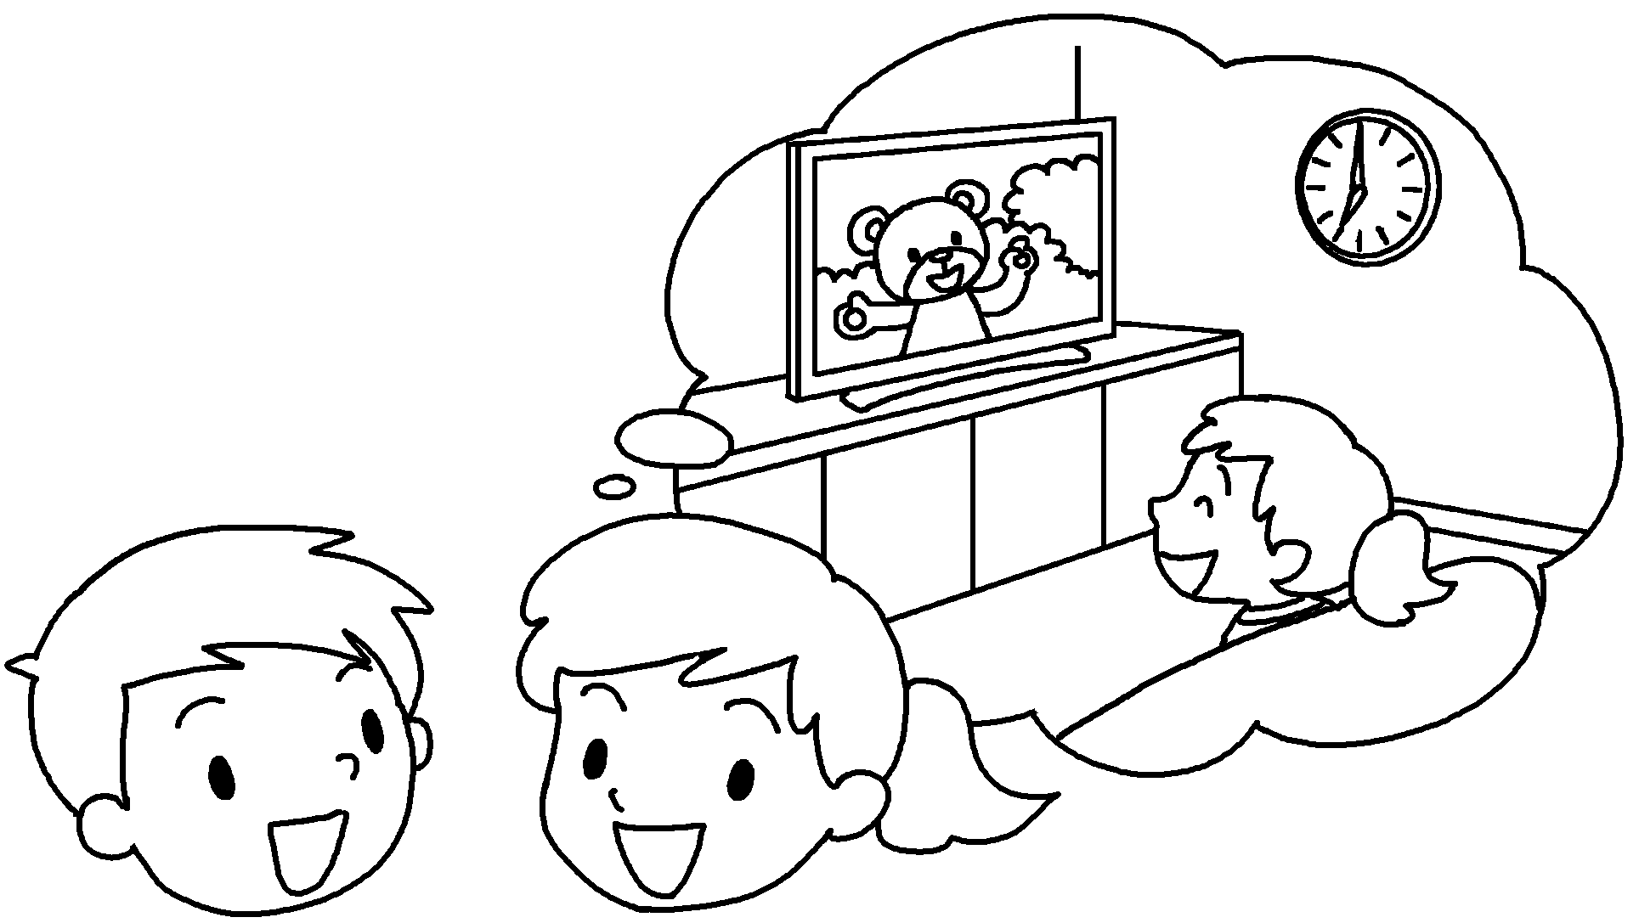 | A : What were you doing at seven o’clock last night?  B : I  ( watch ) TV.
2  A  B |  | 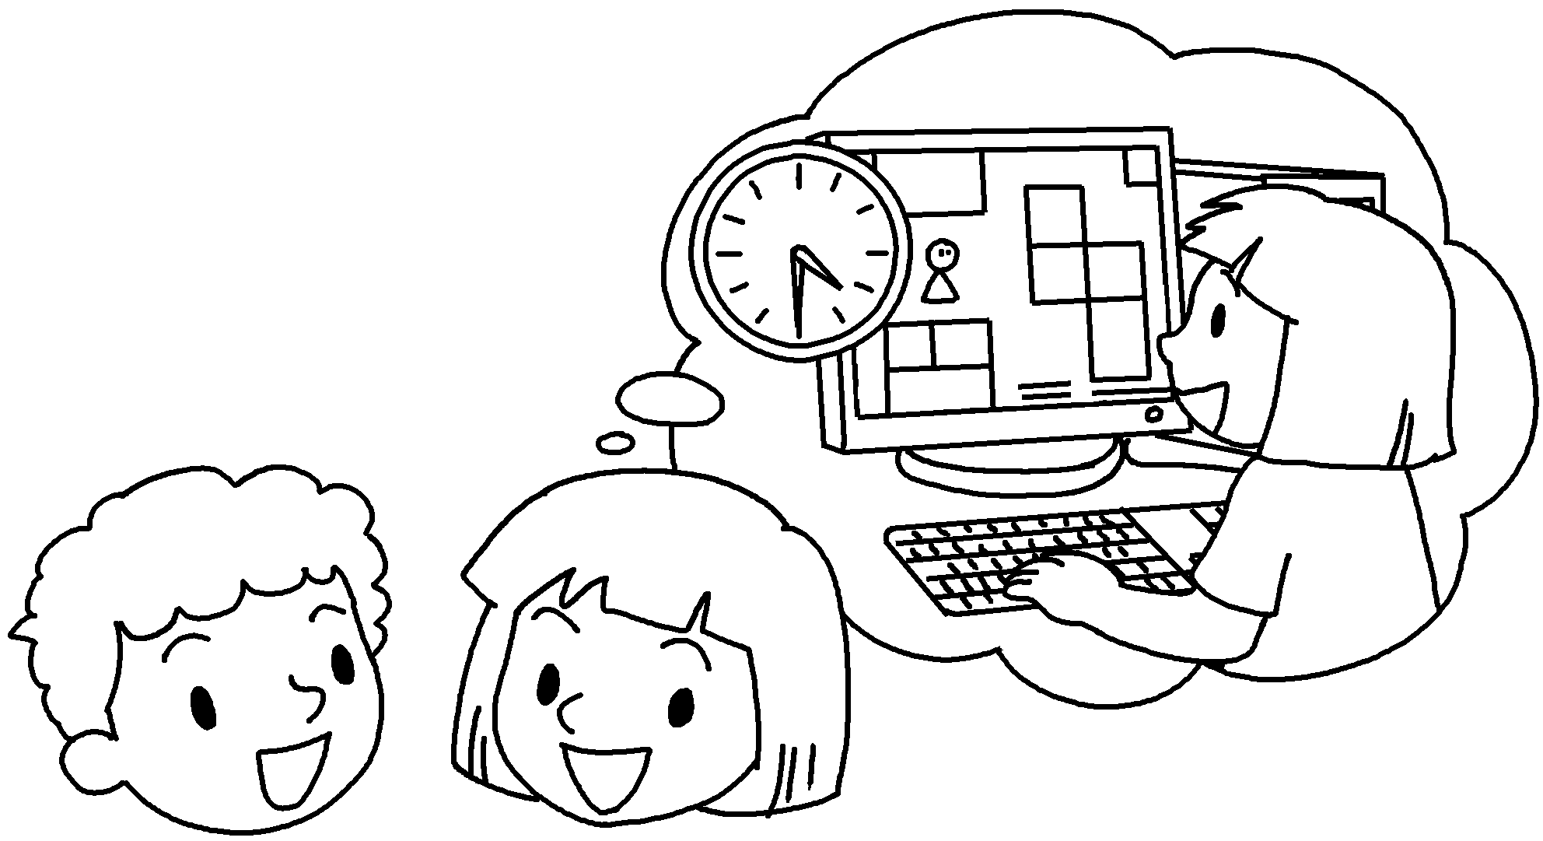 | A : What you  ( do ) at four thirty yesterday?  B : I was playing a computer game.
3  A  B |  | 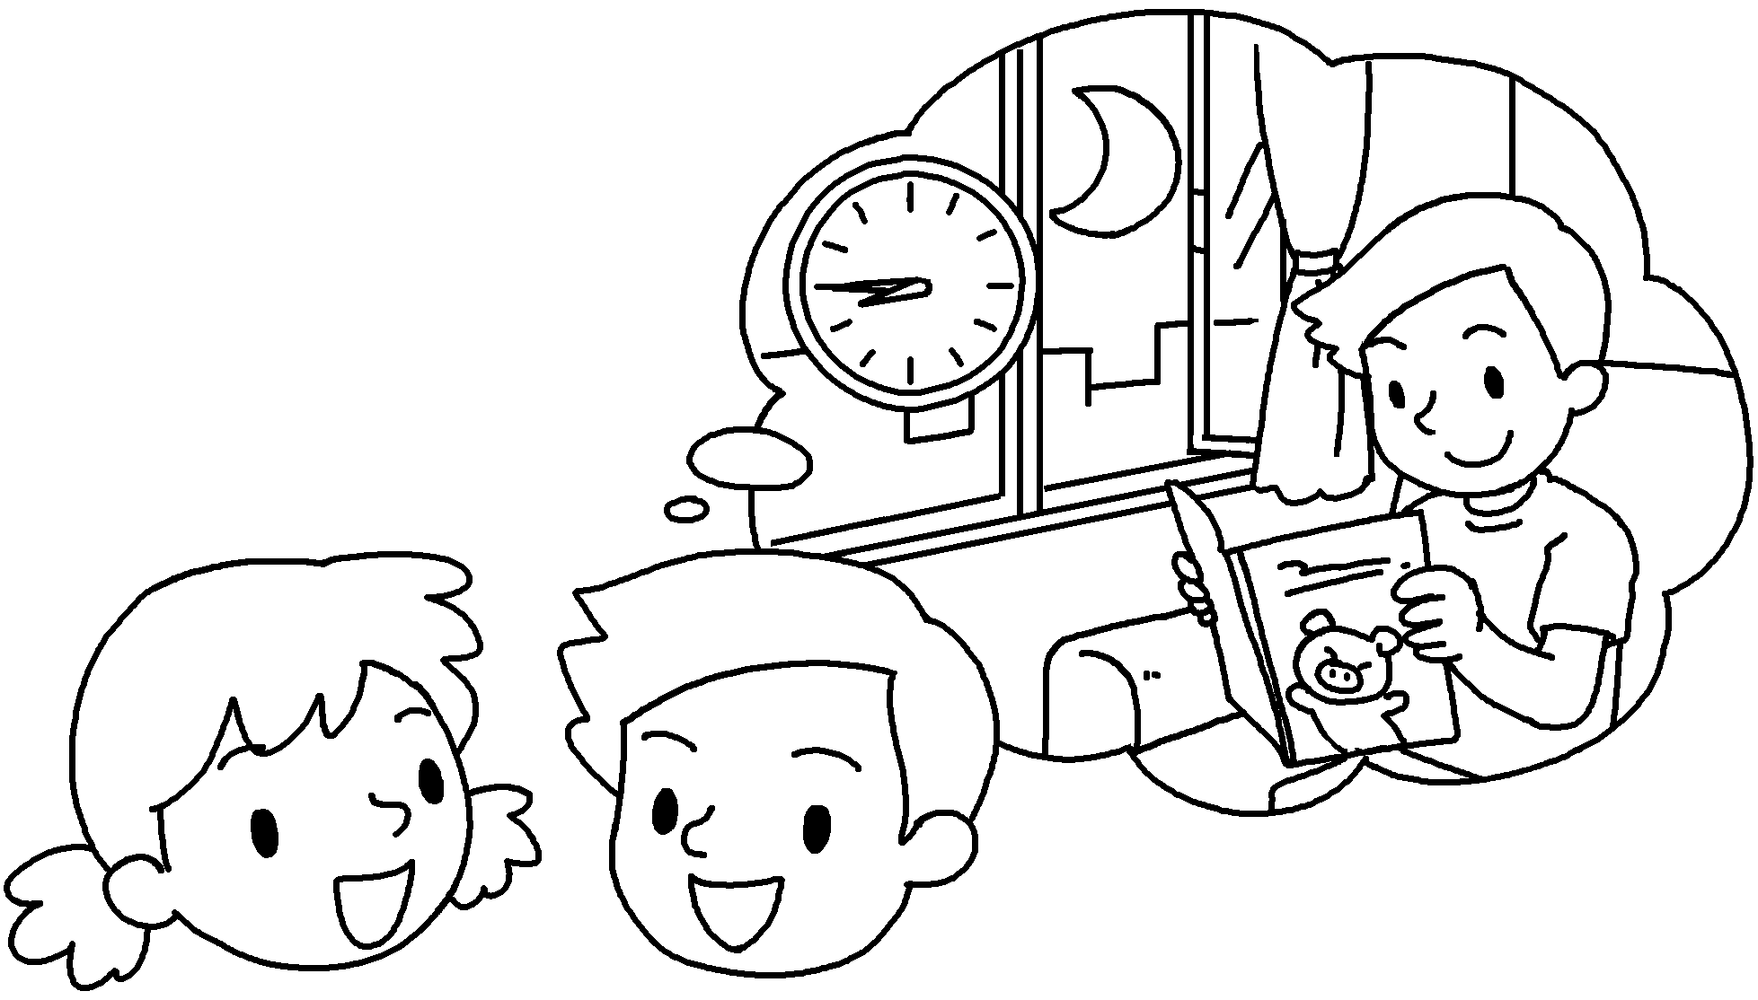 | A : What you  ( do ) at eight forty-five last night?  B : I  ( read ) a book.
4  A  B |  | 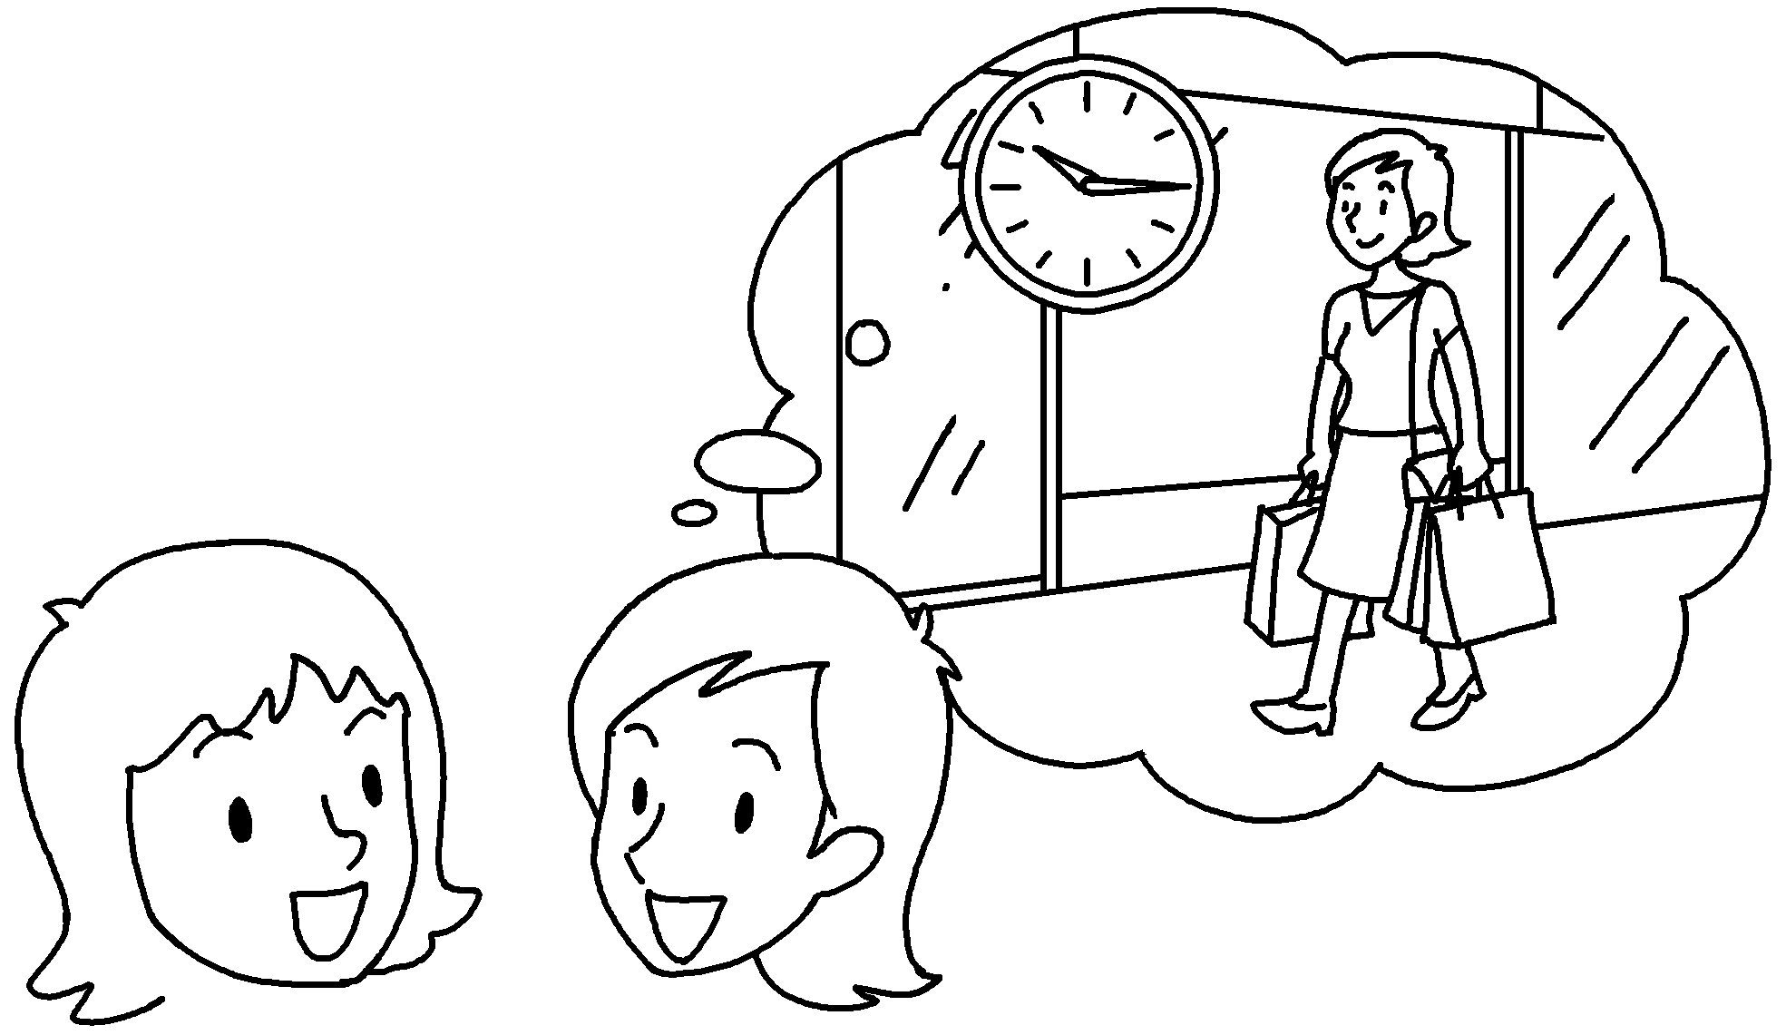 | A : What you  ( do ) at ten fifteen yesterday?  B : I  ( shop ) in Tsim Sha Tsui.
5  A  B |  | 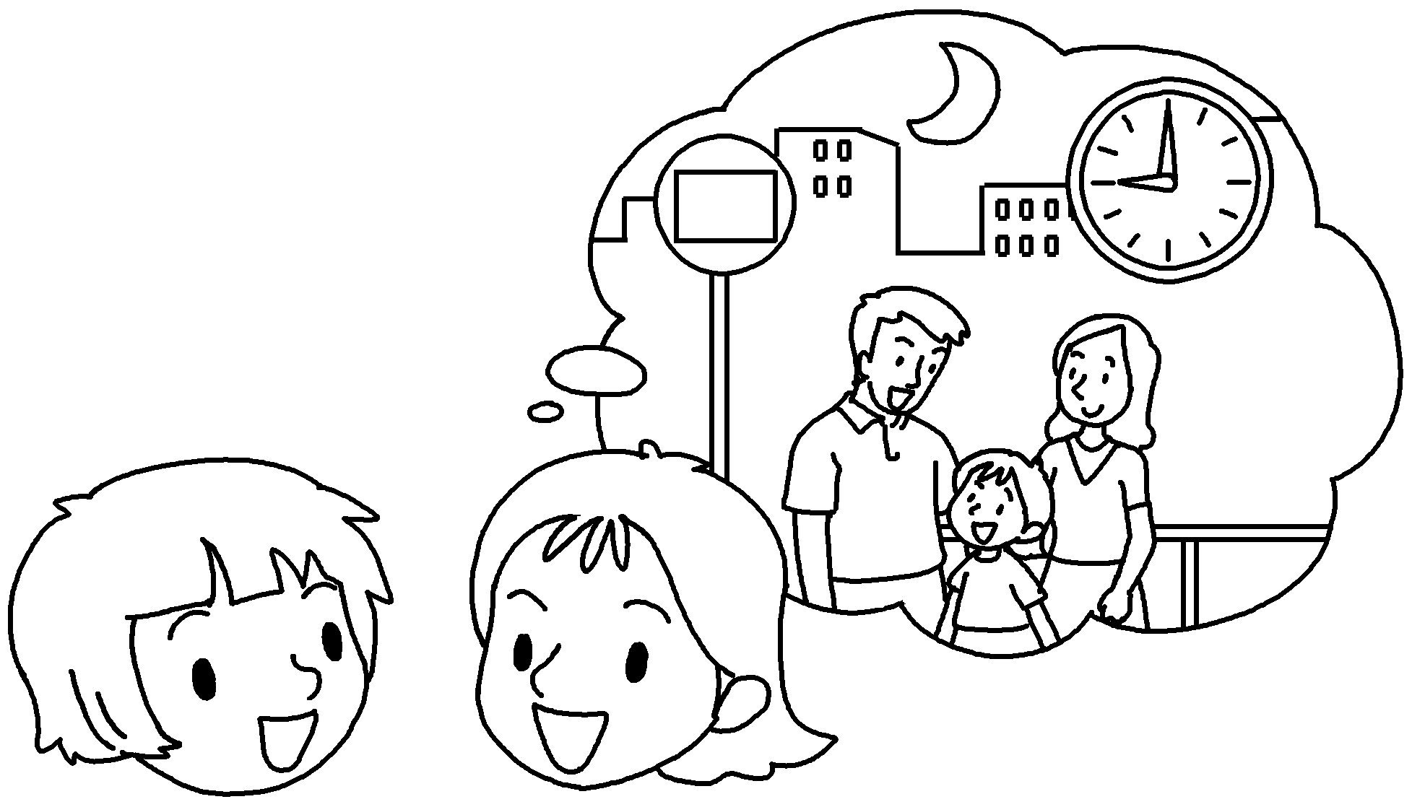 | A : What you  ( do ) at nine o’clock last night?  B : I  ( wait ) for the bus.


Book 5B Chapter 5 Graded Worksheets
Worksheet 2⬇
- was watching
- were doing
- were doing
was reading
4 were doing
was shopping
5 were doing
was waiting

