wait
Finish the questions and answers.
do
play
shop
read
watch
1  A  B | 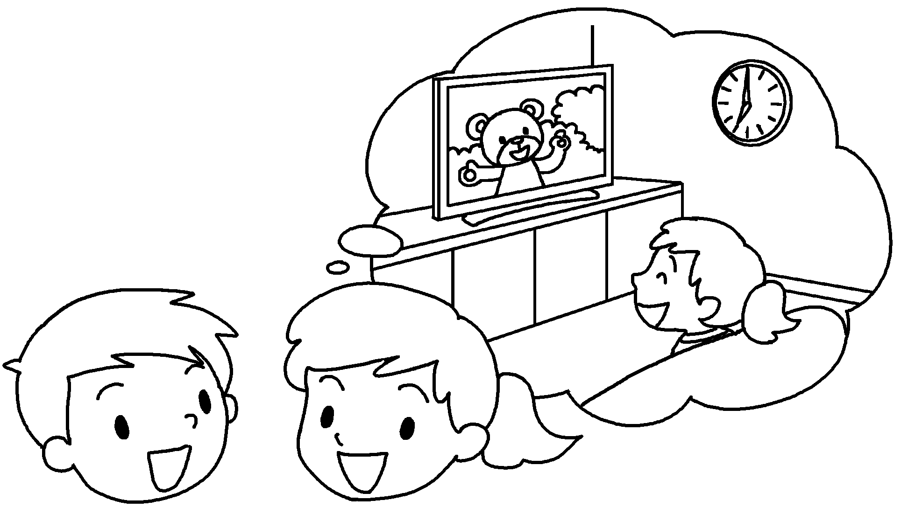 | A : What were you doing at seven o’clock last night?  B : I was TV.
2  A  B | 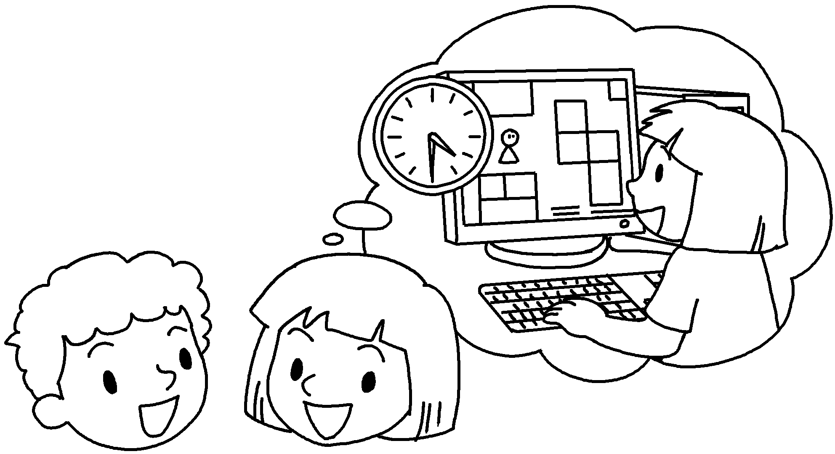 | A : What were you  at four thirty yesterday?  B : I was _______________ a computer game.
3  A  B | 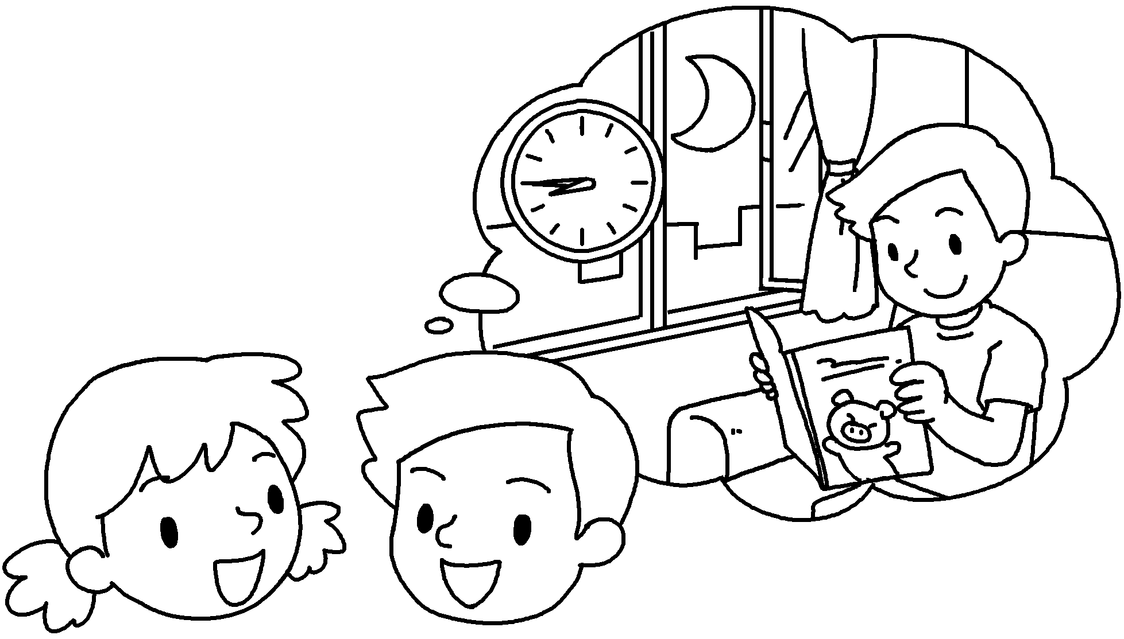 | A : What you  at eight forty-five last night?  B : I a book.
4  A  B | 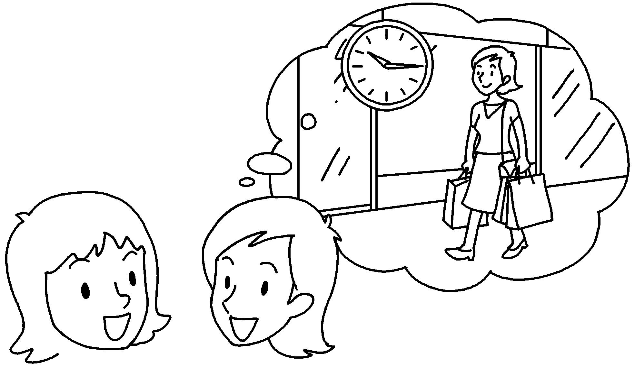 | A : What  at ten fifteen yesterday?  B : I  in Tsim Sha Tsui.
5  A  B | 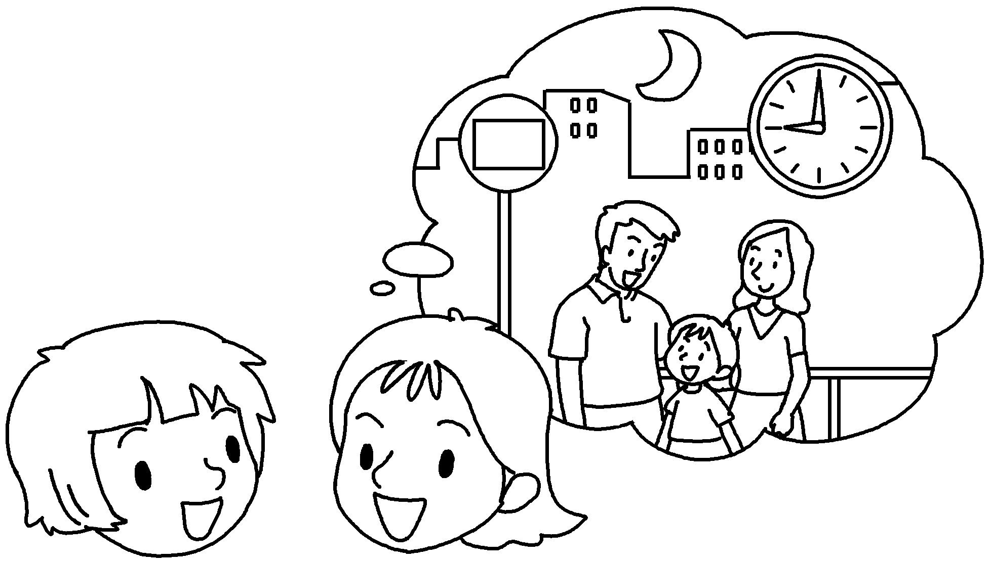 | A : What  at nine o’clock last night?  B : I  for the bus.


Book 5B Chapter 5 Graded Worksheets
Worksheet 2⬇⬇
- watching
- doing
playing
3 were doing
was reading
- were you doing
was shopping
- were you doing
was waiting

