Finish the questions and answers.

1  A  B | 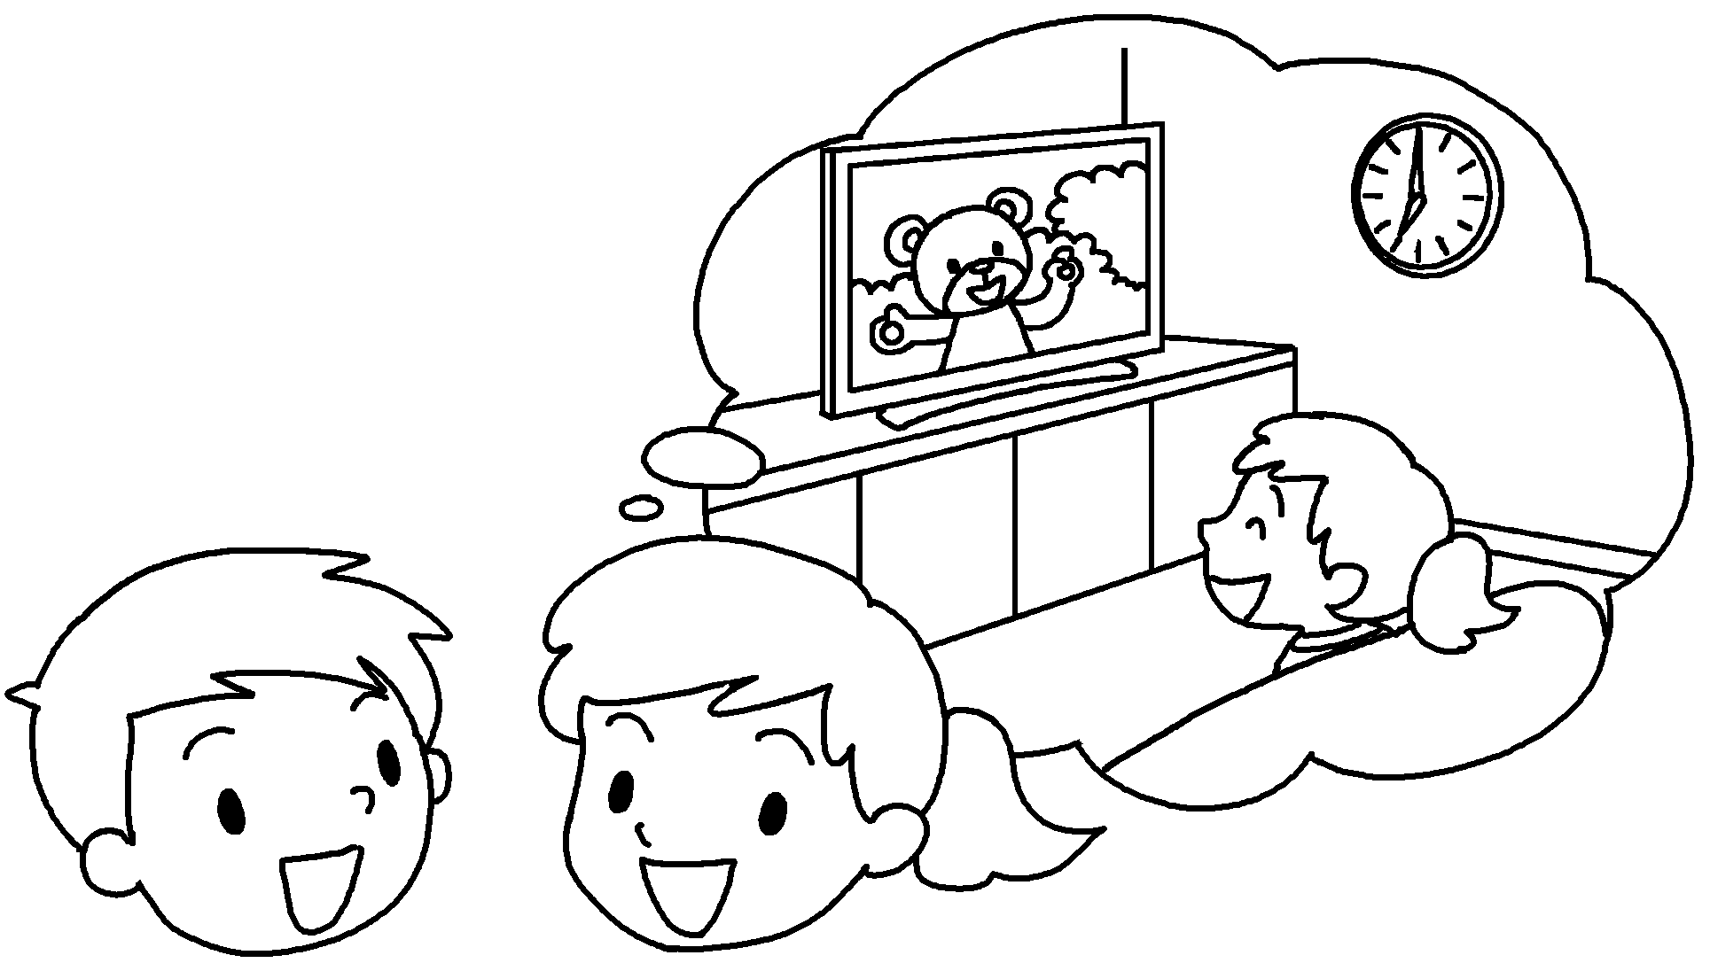 | A : What were you doing at seven o’clock last night?  B : I was TV.
2  A  B | 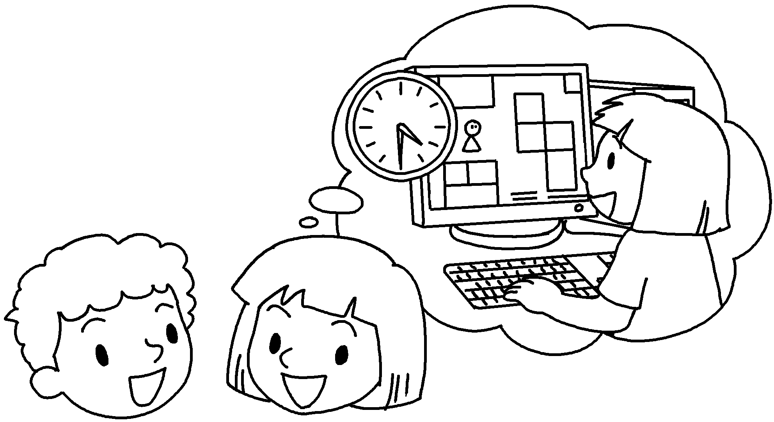 | A : What were you  at four thirty yesterday?  B : I was _______________ a computer game.
3  A  B | 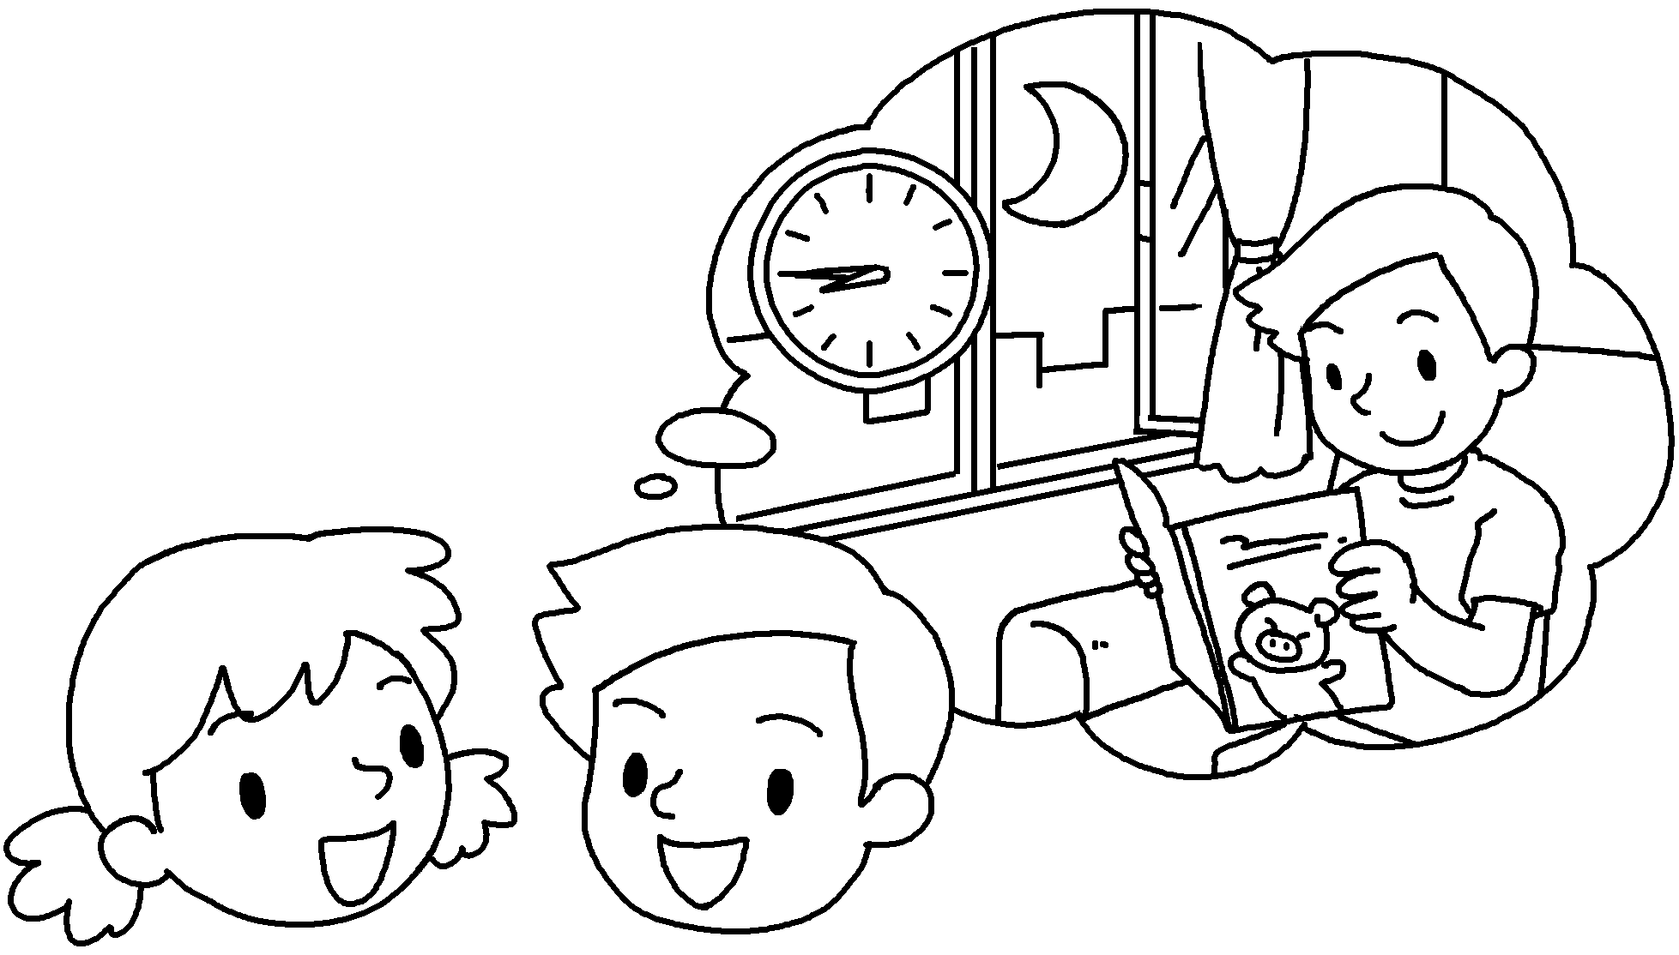 | A : What __________ you _________________  at eight forty-five last night?  B : I a book.
4  A  B | 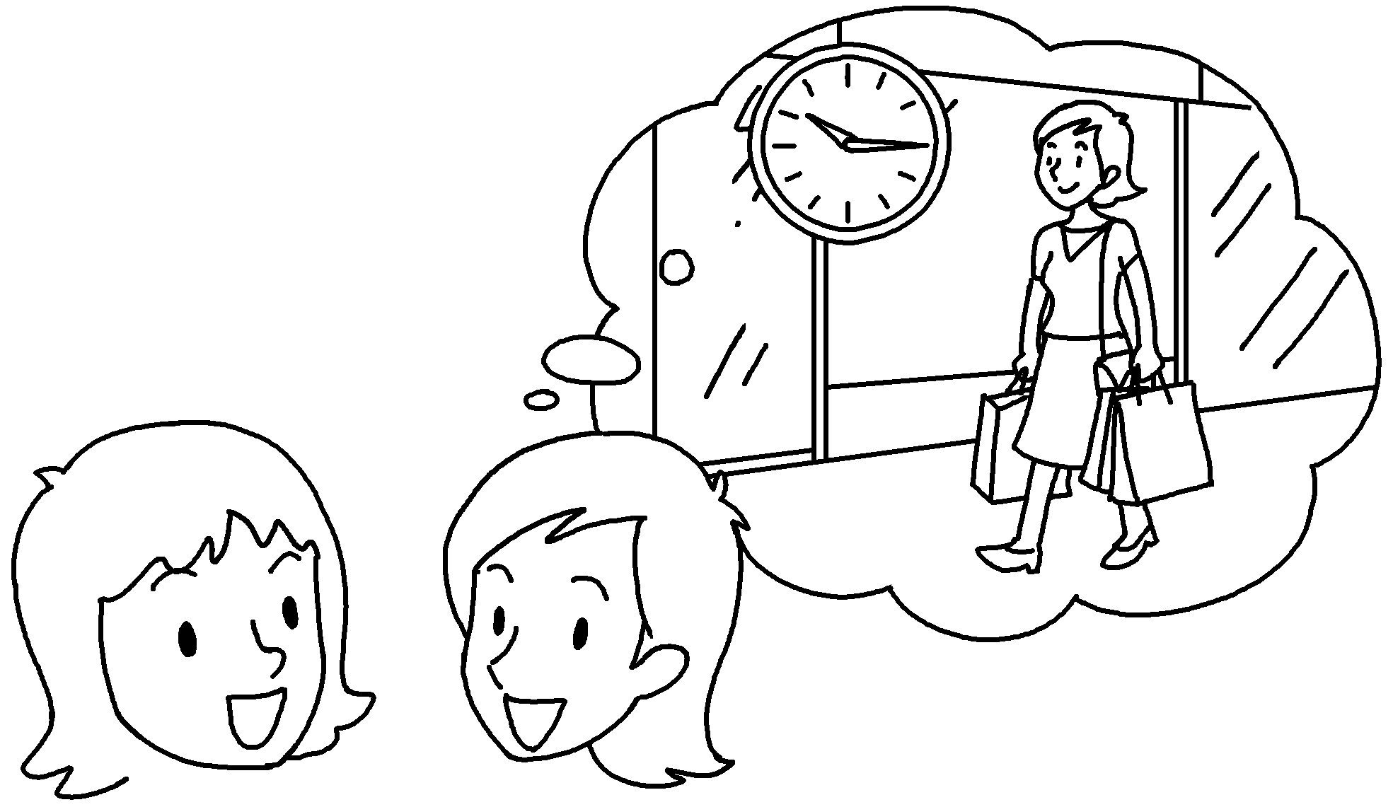 | A :  at ten fifteen yesterday?  B :  in Tsim Sha Tsui.
5  A  B | 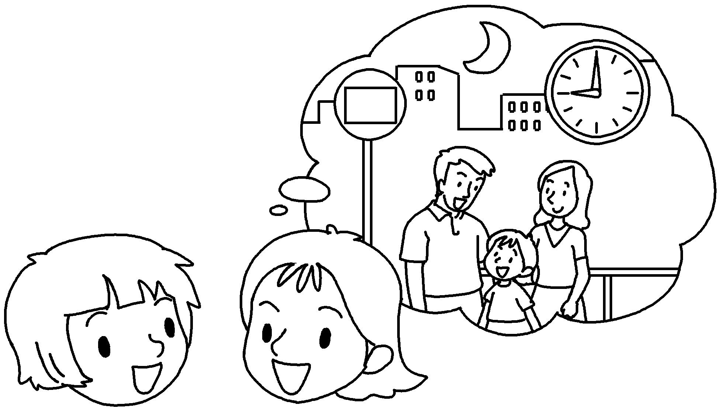 | A :  ____________________________ last night?  B :  for the bus.

Book 5B Chapter 5 Graded Worksheets
Worksheet 2⬇⬇⬇
- watching
2 doing
playing
3 were doing
was reading
4 What were you doing
I was shopping
5 What were you doing at nine o’clock
I was waiting

