Circle the correct answers.
999

1 | I ( was calling / called ) the police  when the robbers escaped. | 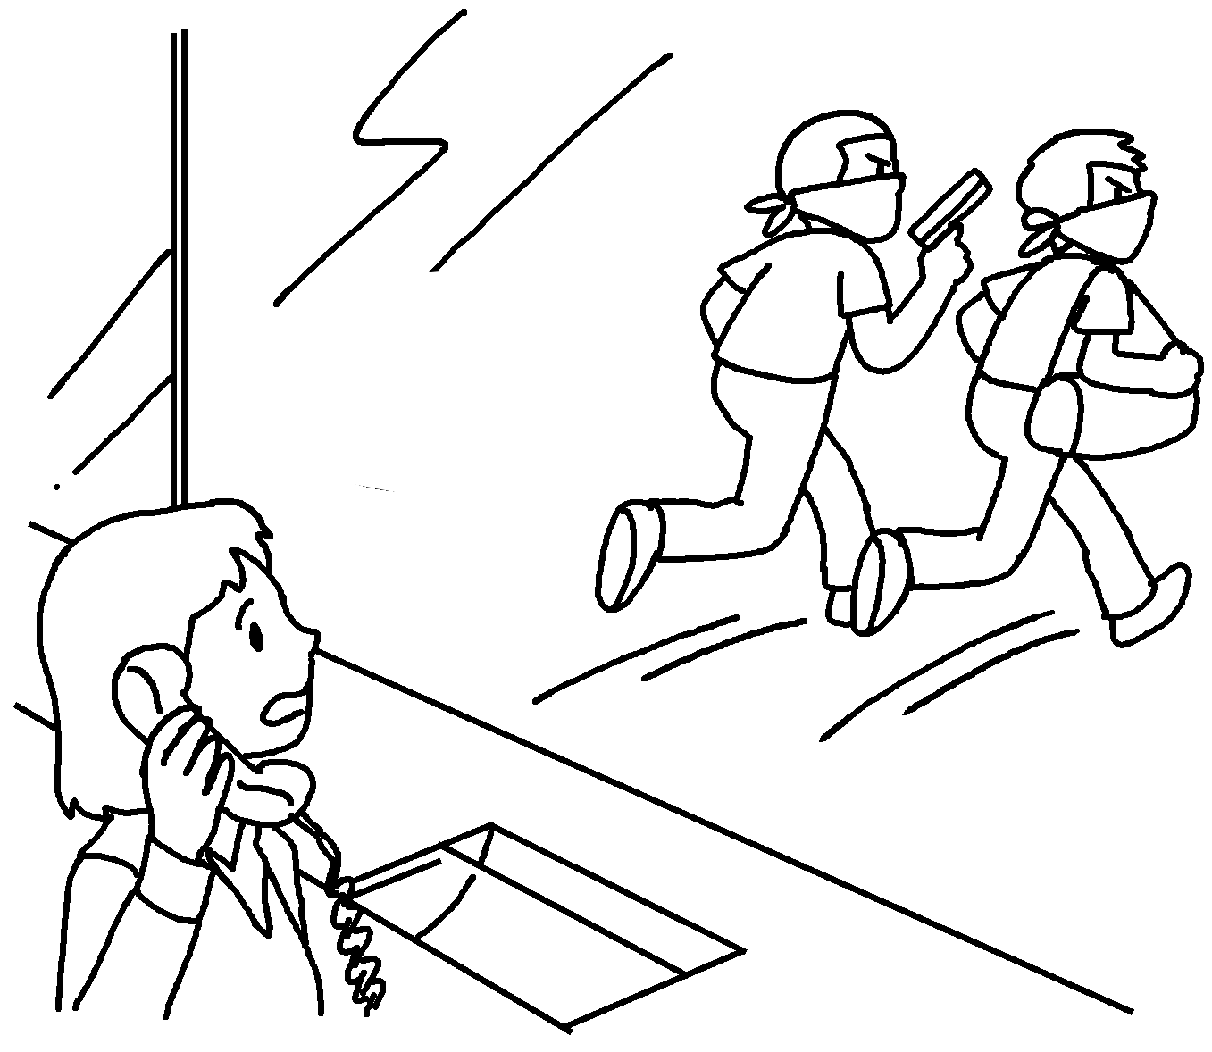
2 | I was sleeping when my cat  ( broke / was breaking ) the vase. | 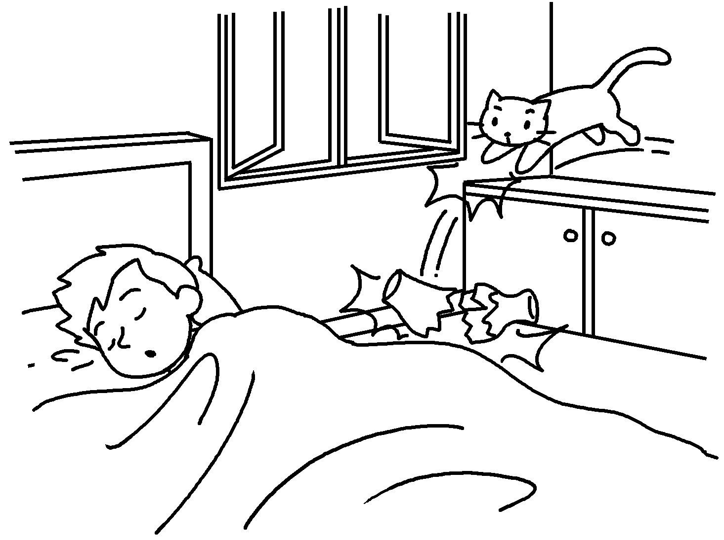
3o | I ( waited / was waiting ) for the bus when  a man ( stole / has stolen ) my wallet. | 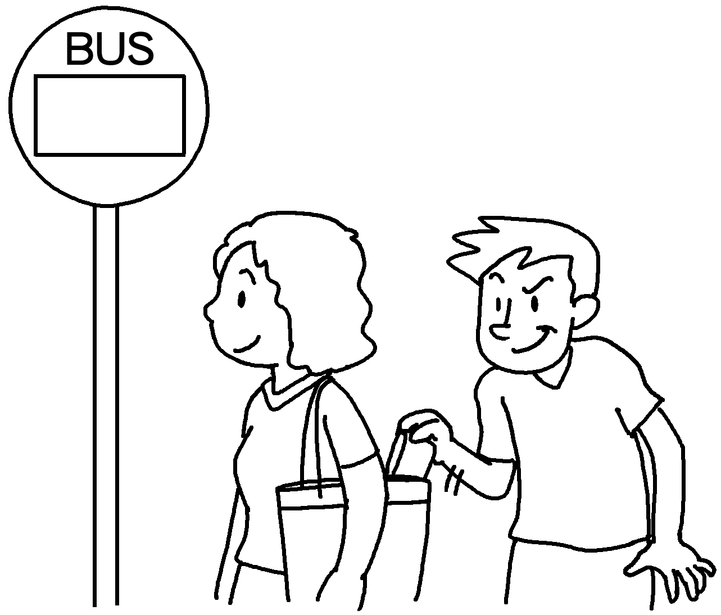
4 | I ( was chasing / have chased ) the robbers when I ( have seen / saw ) an accident. | 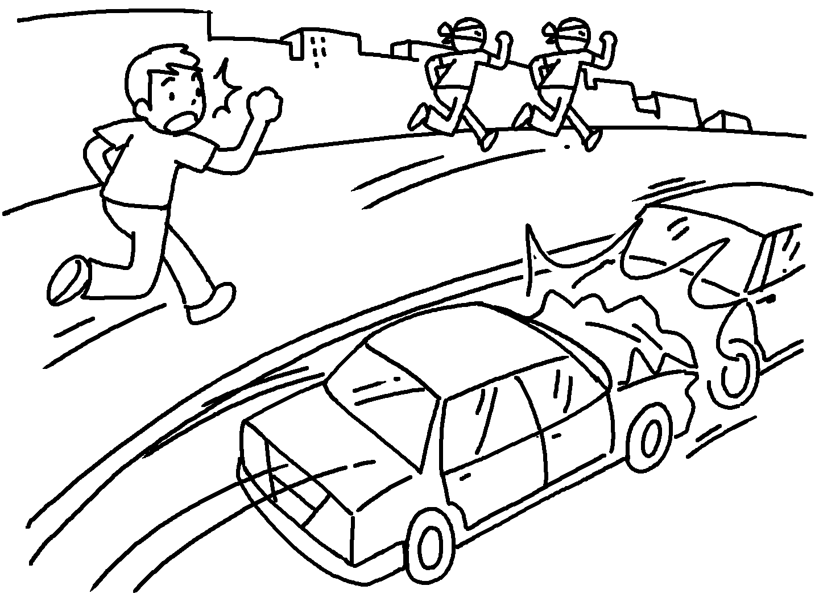
5 | I ( talked / was talking ) on the phone when my uncle ( came / was coming ) to visit me. | 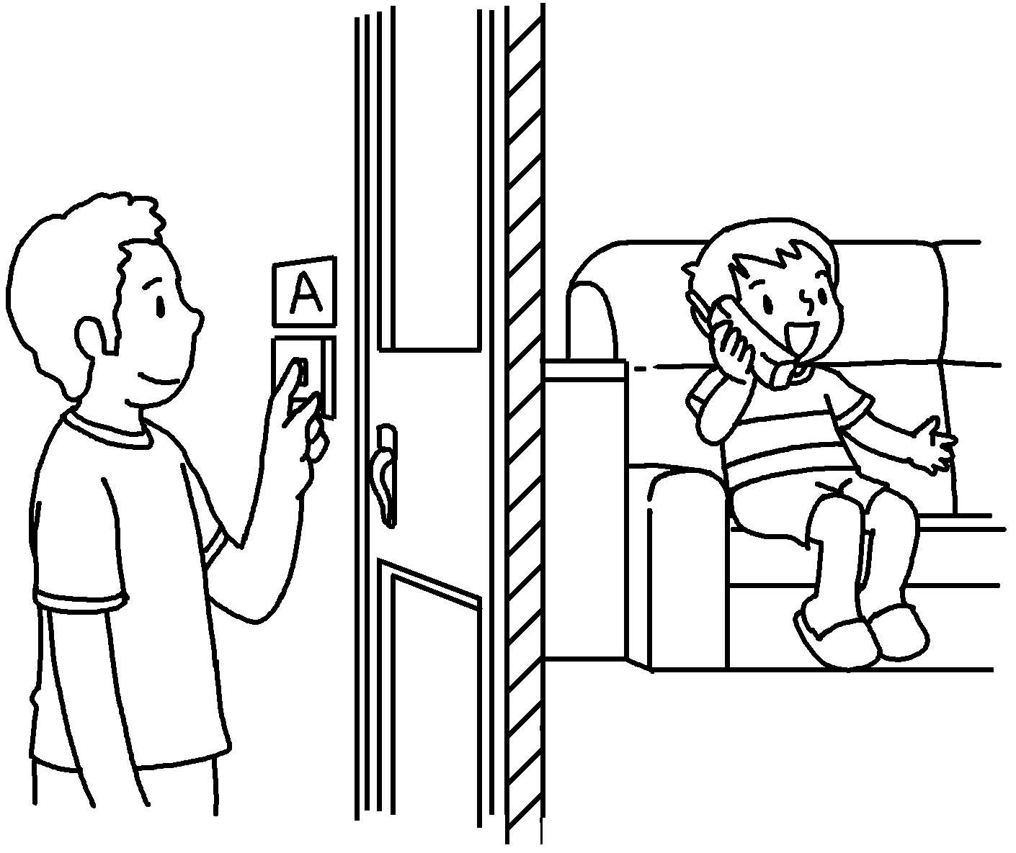


Book 5B Chapter 5 Graded Worksheets
Worksheet 3⬇
- ( was calling / called )
- ( broke / was breaking )
- ( waited / was waiting ) ( stole / has stolen )
- ( was chasing / have chased ) ( have seen / saw )
- ( talked / was talking ) ( came / was coming )

