What happened? Finish the sentences with the correct form of the verbs.
999

when
1 | I ( call ) the police  when the robbers escaped. | 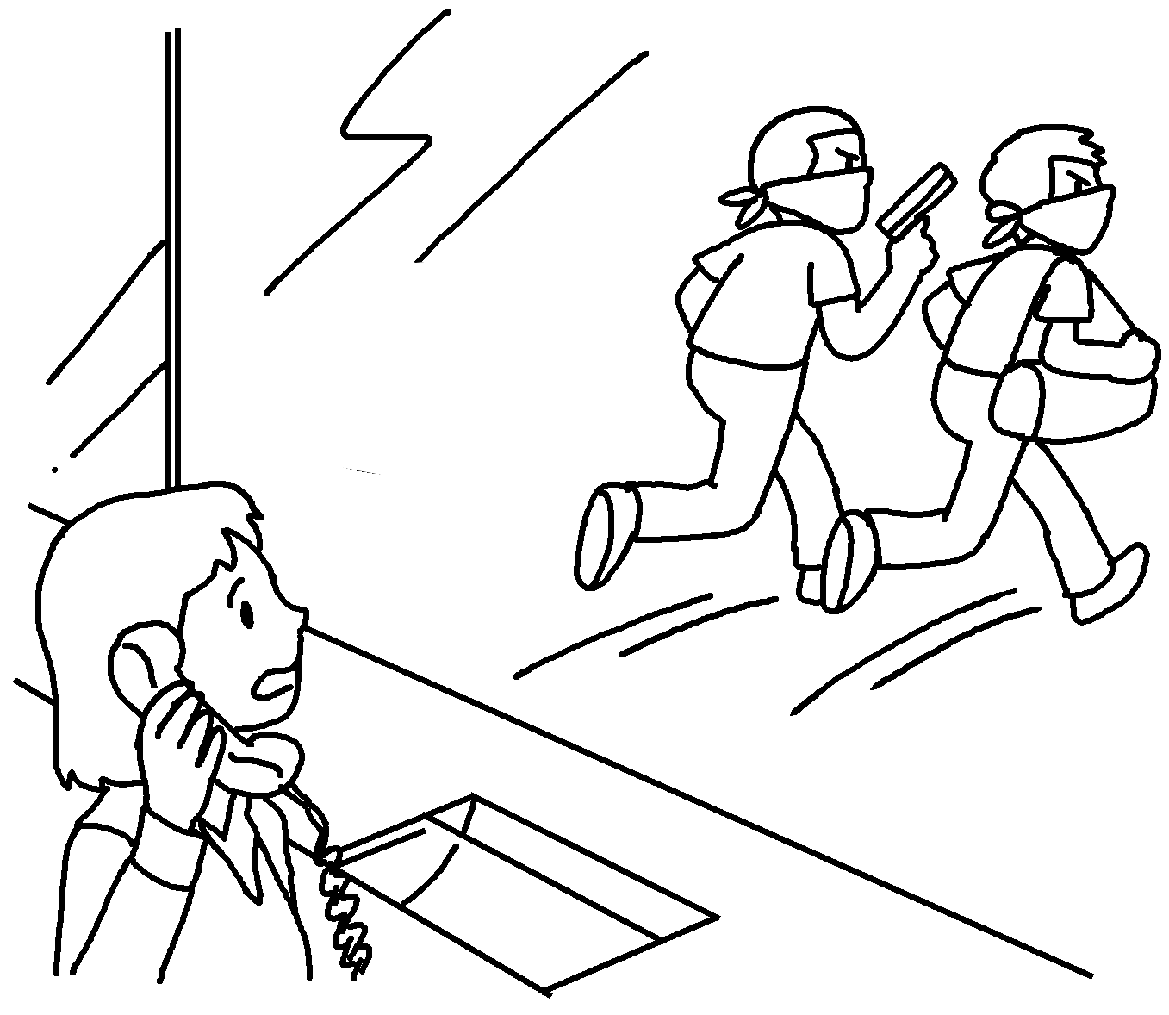
2 | I was sleeping when my cat  ( break ) the vase. | 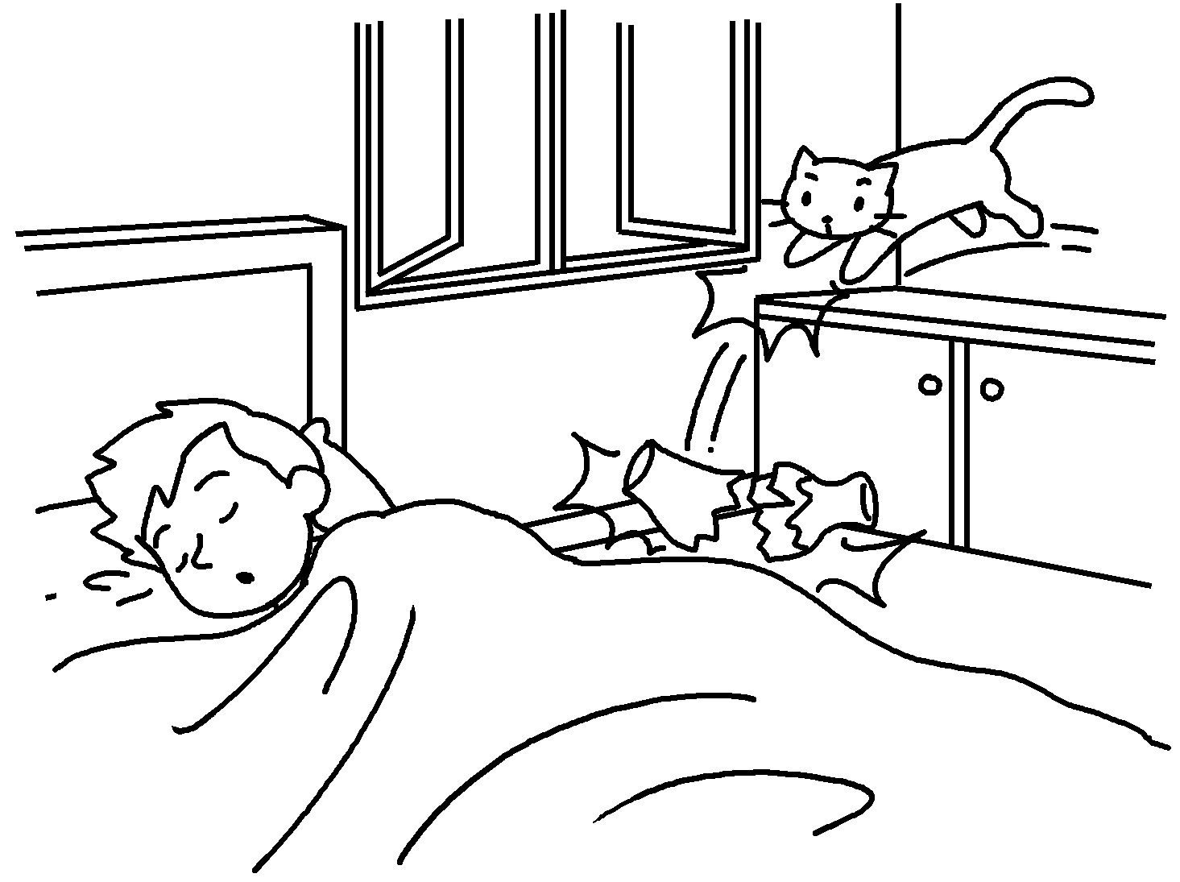
3o | I ( wait ) for the bus  a man ( steal ) my wallet. | 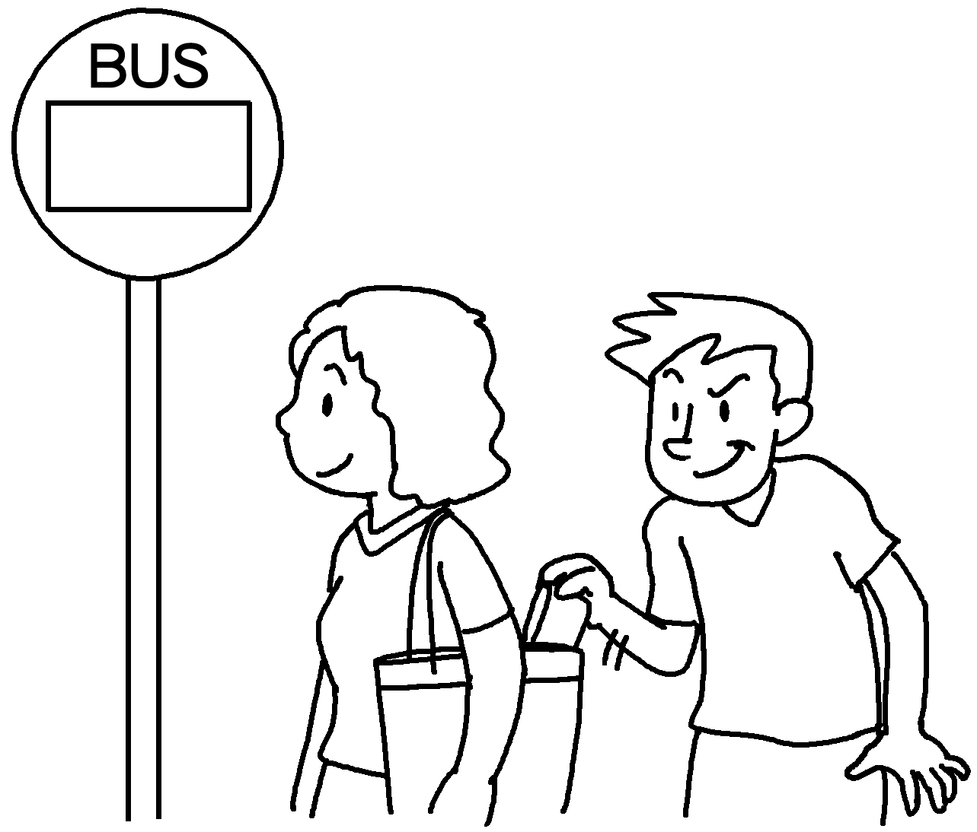
4 | I ( chase ) the robbers I ( see ) an accident. | 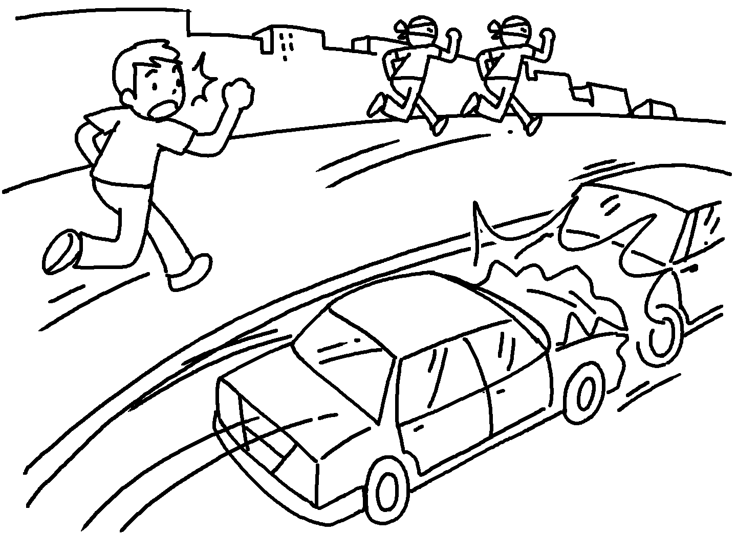
5 | I ( talk ) on the phone my uncle ( come ) to visit me. | 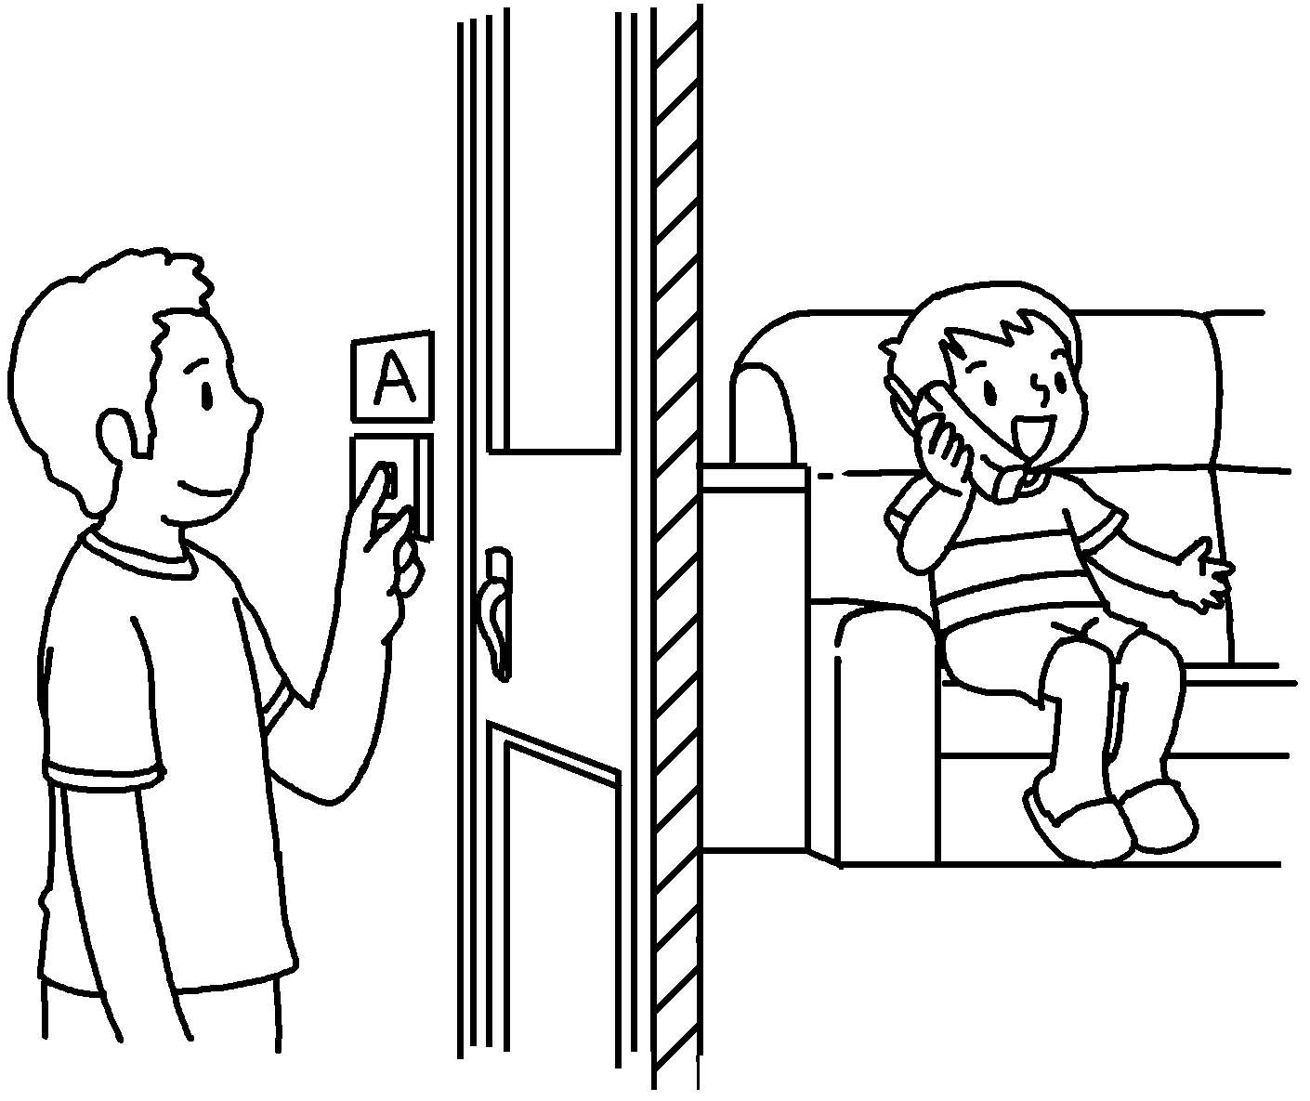


Book 5B Chapter 5 Graded Worksheets
Worksheet 3⬇⬇
- was calling
- broke
- was waiting when stole
- was chasing when saw
- was talking when came

