What happened? Finish the sentences with the correct form of the verbs.
999

break call chase come escape
when
see sleep steal talk wait

1 | I was the police when the robbers _______________ . | 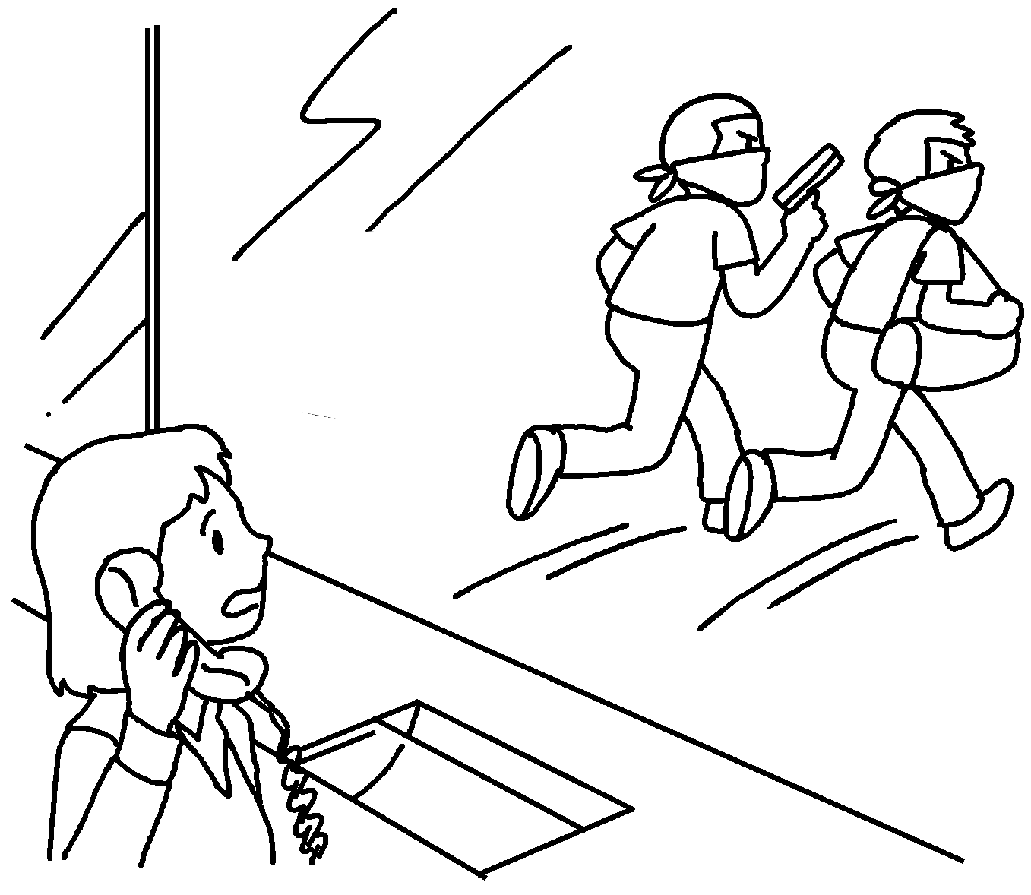
2 | I was _________________ when my cat  the vase. | 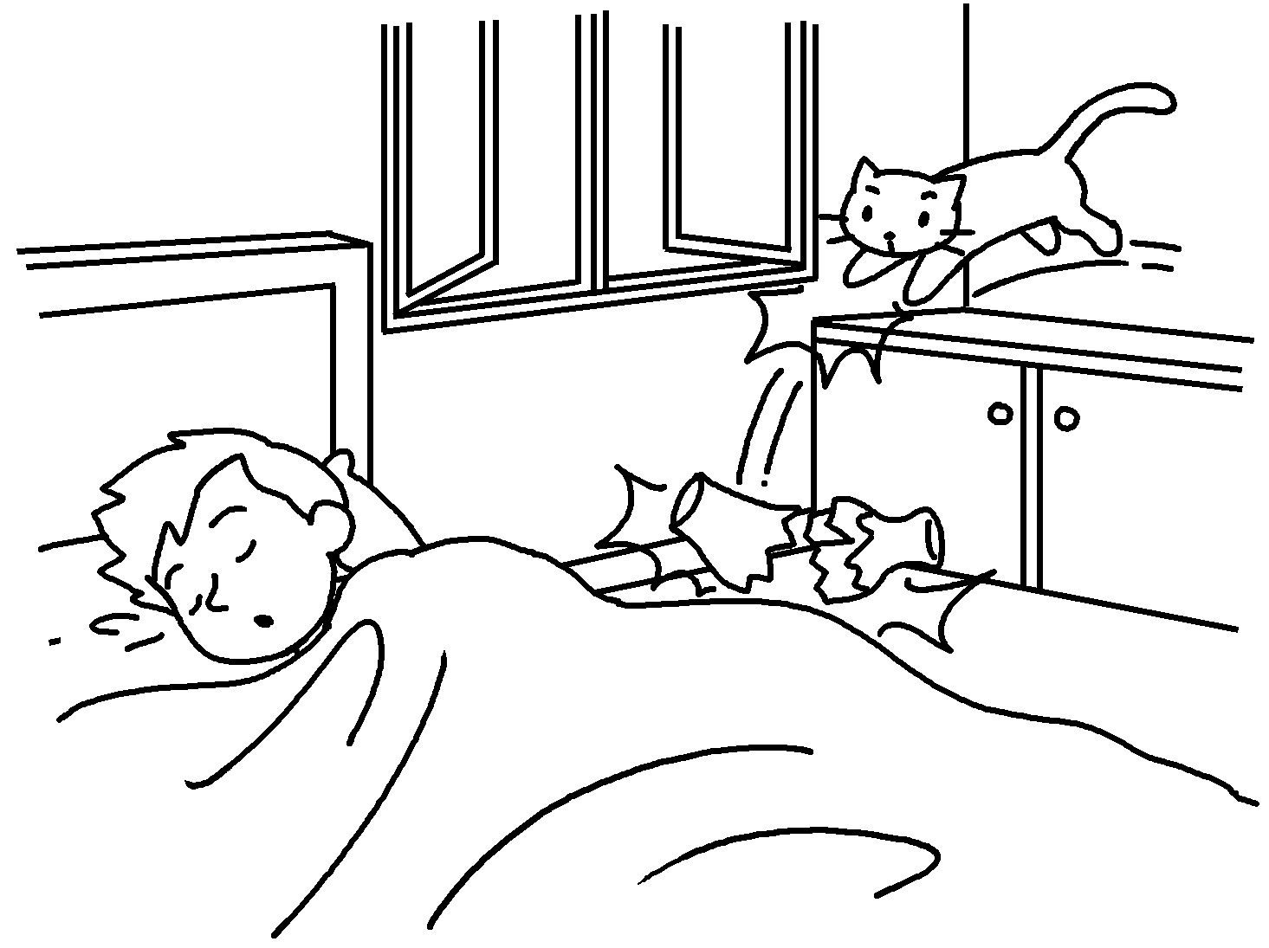
3o | I for the bus  a man my wallet. | 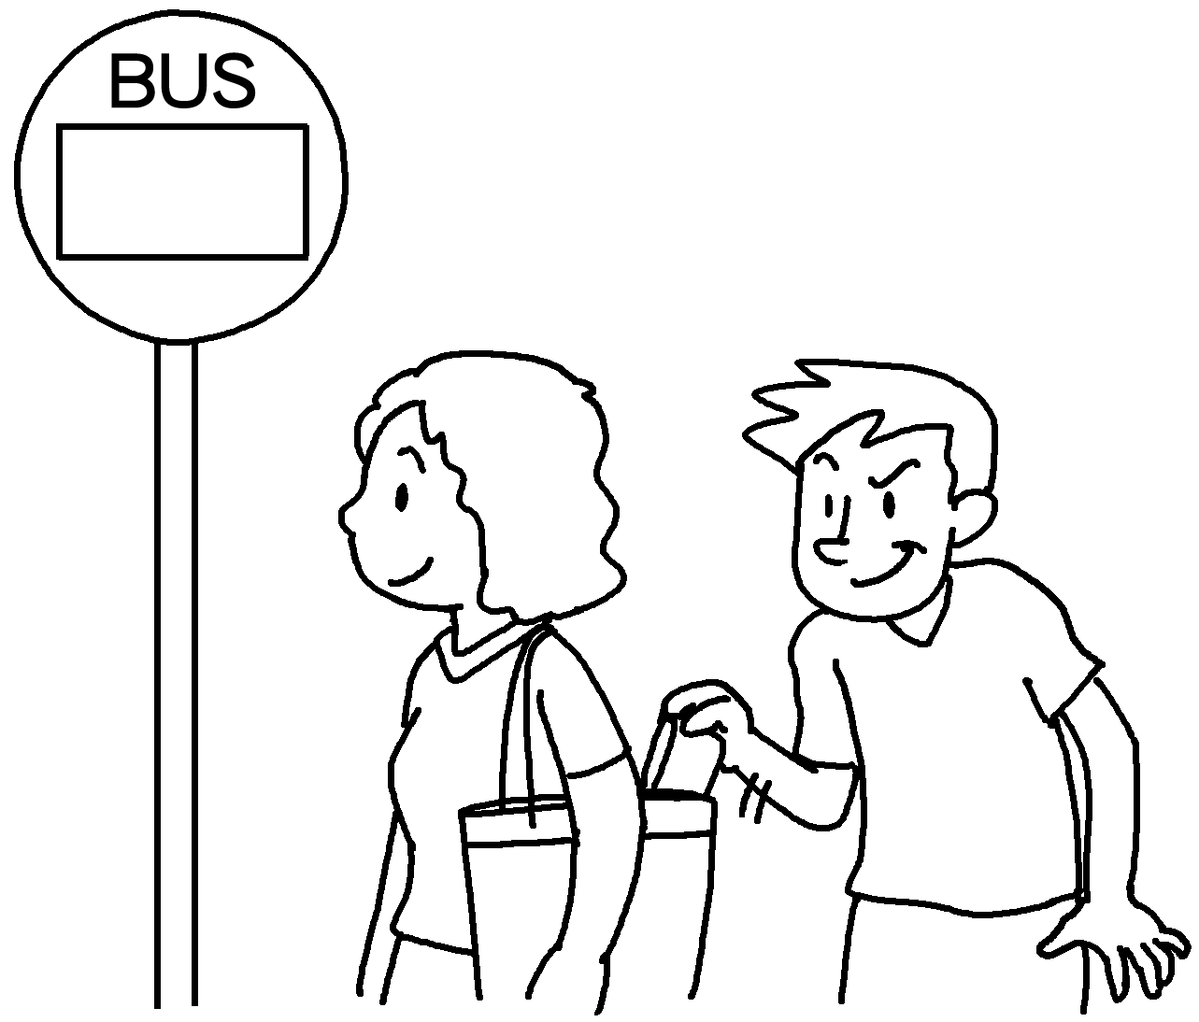
4 | I the robbers  I an accident. | 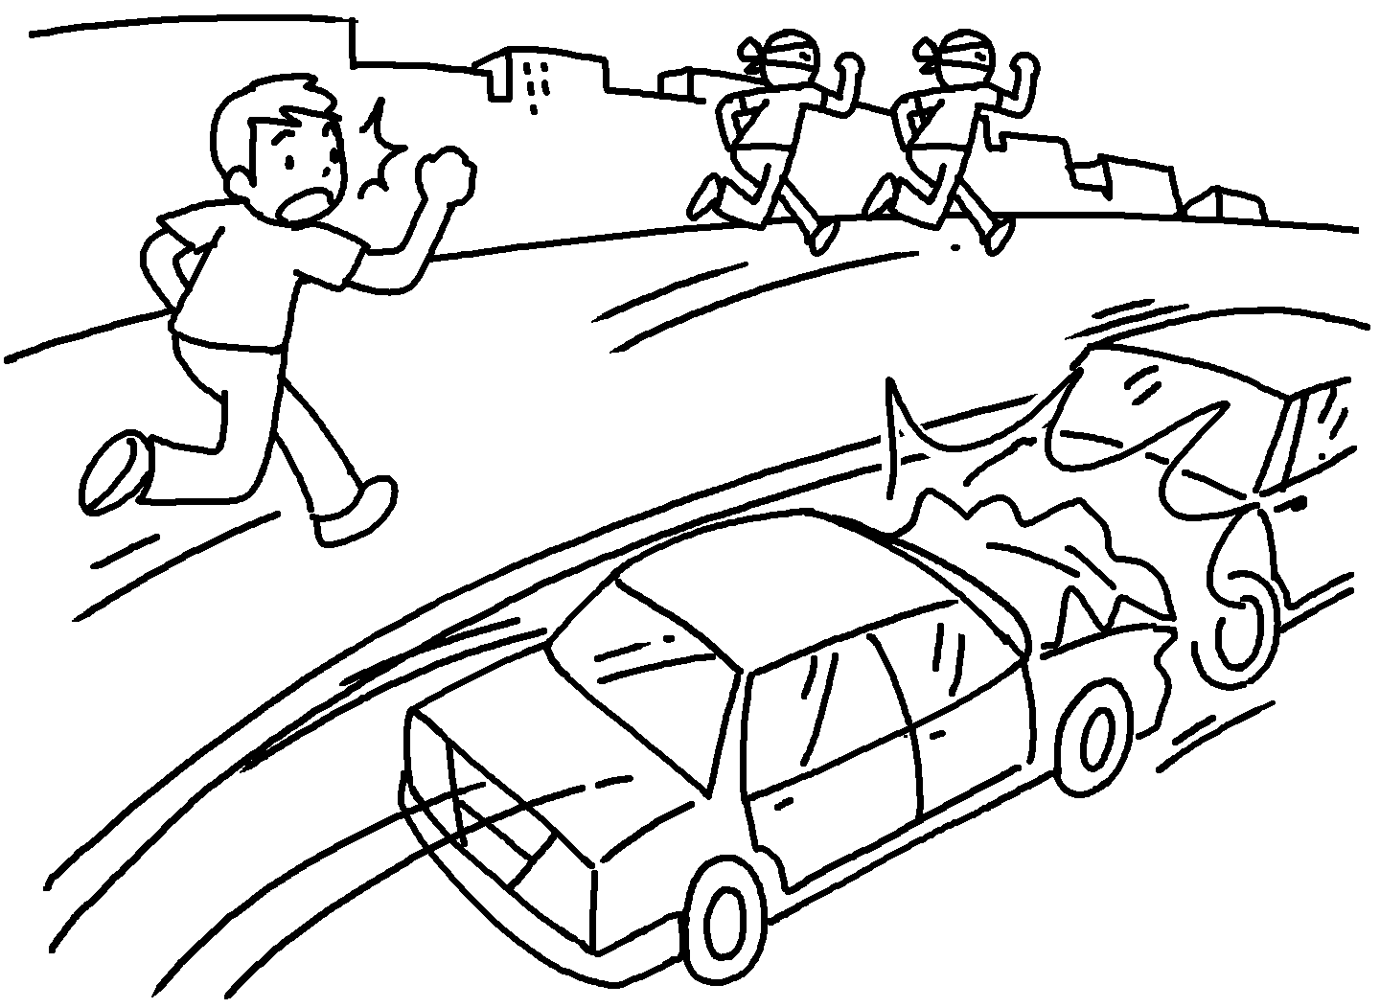
5 | I on the phone  my uncle to visit me. | 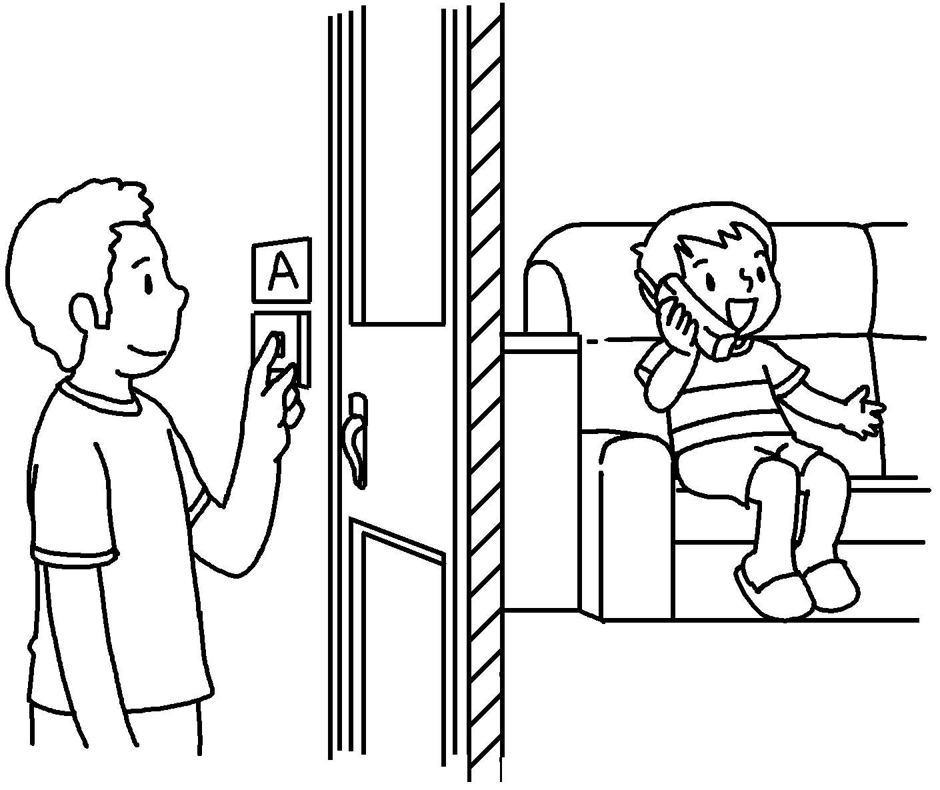


Book 5B Chapter 5 Graded Worksheets
Worksheet 3⬇⬇⬇
- calling escaped
- sleeping broke
- was waiting when stole
- was chasing when saw
- was talking when came

