- Police stories
Do you like detective stories? Read this story about a space detective and see if you can help him solve the crime.




Space Detective Zeek saw a news report in his office.

OUTER SPACE DAILY

Robbery at Bigg’s Bank

At 9 p.m. yesterday, the alarm went off at Bigg’s Bank. Money and jewellery were stolen from the safe. Mr Woof, the bank manager, told us, ‘When I got back to the bank last night, the door of the safe was still locked. But it was empty inside!’

The bank’s security guard, GX 9000, is also missing.
Bank manager Mr Woof in his empty safe
The bank’s security guard

Zeek rushed to Bigg’s Bank.

‘I’m here to help you solve the case, Mr Woof,’ said Zeek. ‘Tell me everything.’

‘My assistant, Mrs Moon, and I locked the safe at 5:30 p.m. yesterday. We left the bank together,’ said Mr Woof.

Then Zeek made some phone calls.


Daddy was watching Planet Earth at 9 p.m. last night.
My wife and I were shopping at 9 p.m. last night.
Woof family
Mr Moon
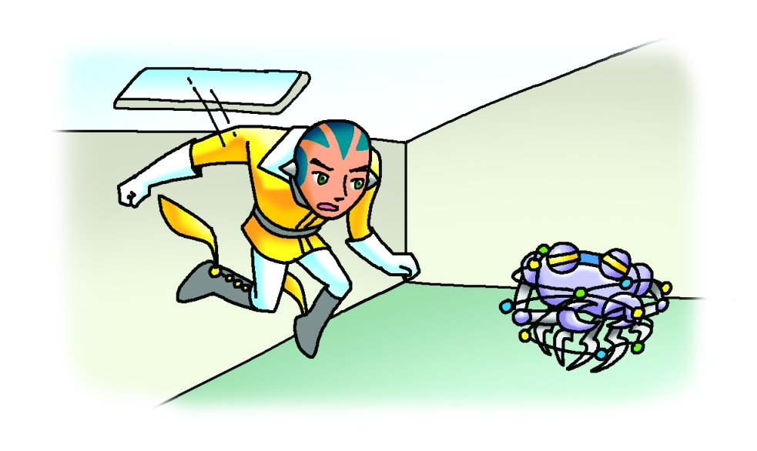
Suddenly Zeek heard a ‘beep-beeeeep-beep’ sound coming from the shop next door. Zeek jumped through an open window. He saw GX 9000 tied up inside!
‘I was standing outside the bank when I heard a banging noise. I went to investigate but a man knocked me down,’ said GX 9000.


‘He was tall and strong. He had two purple heads with green hair. He had hands like diggers.’


That night, Zeek read to his daughter.

So the clever foxes dug tunnels and escaped from the bad men … Of course!

‘I know how the robber got into the bank!’ said Zeek excitedly.

