Choose and write.
1
2
3
4
5
6
bang my headbreak my armbreak my legburn my armcut my fingertwist my ankle

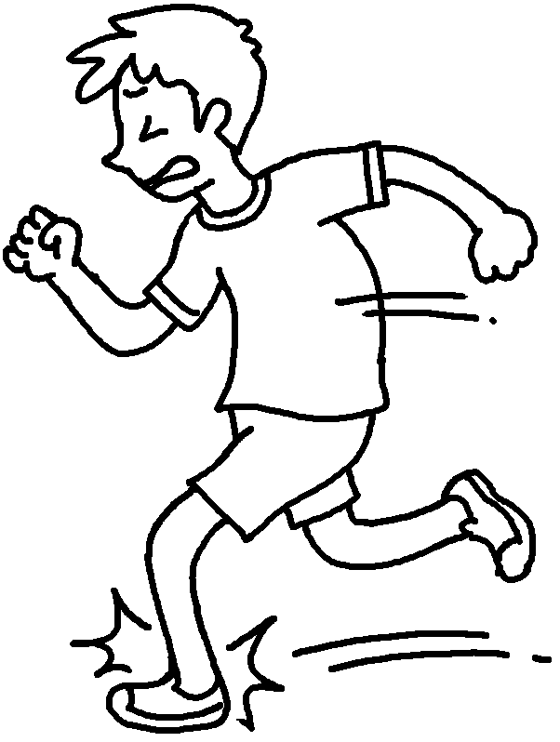 | 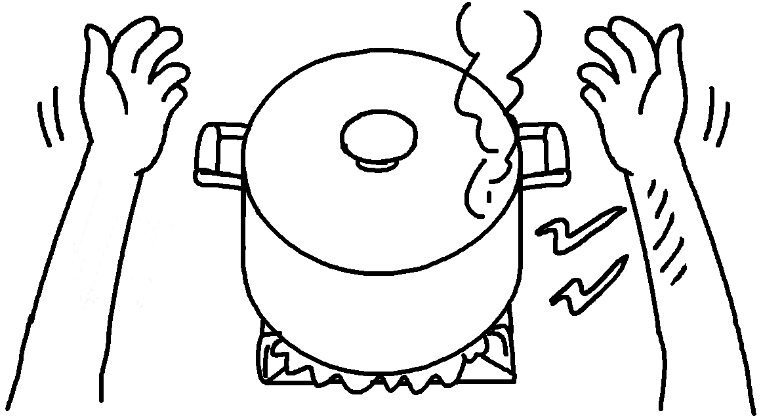
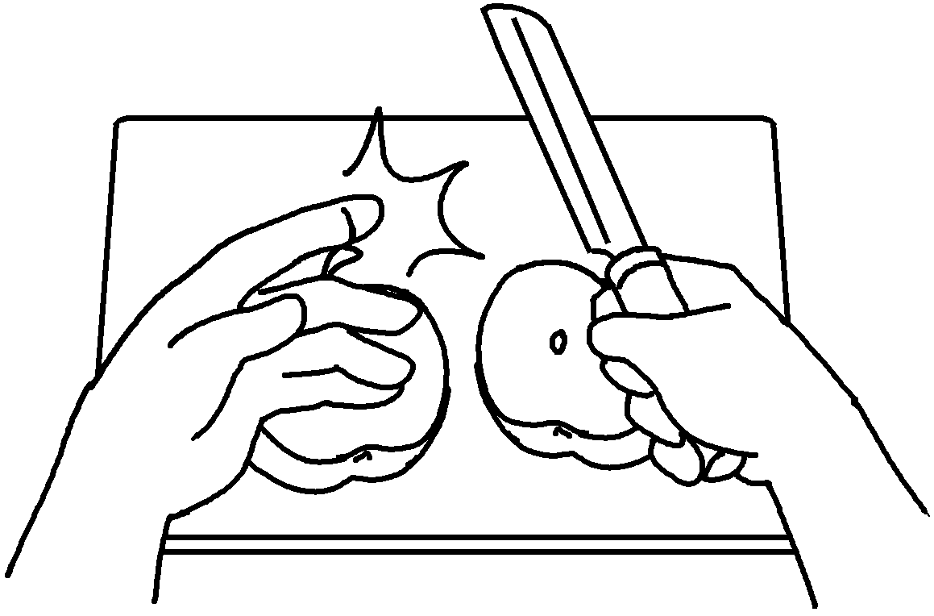 | 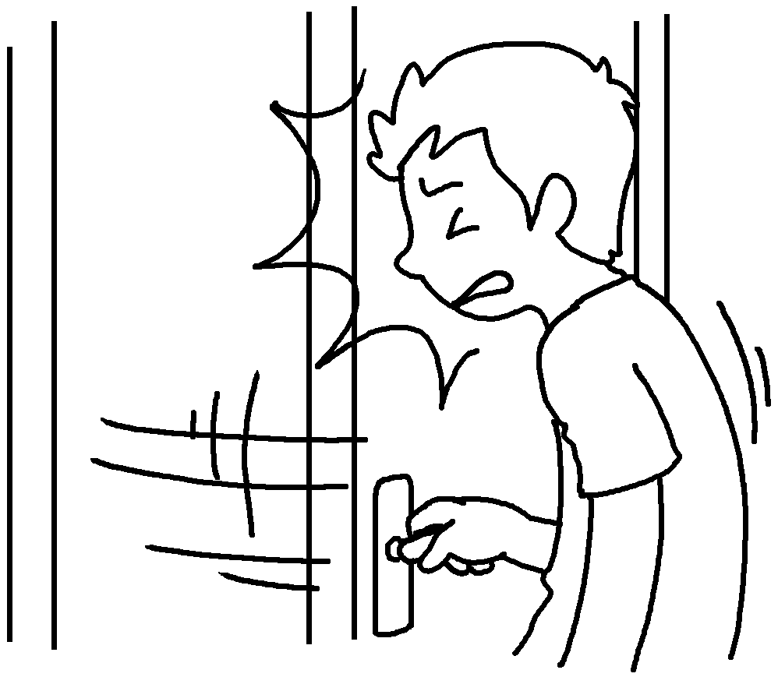
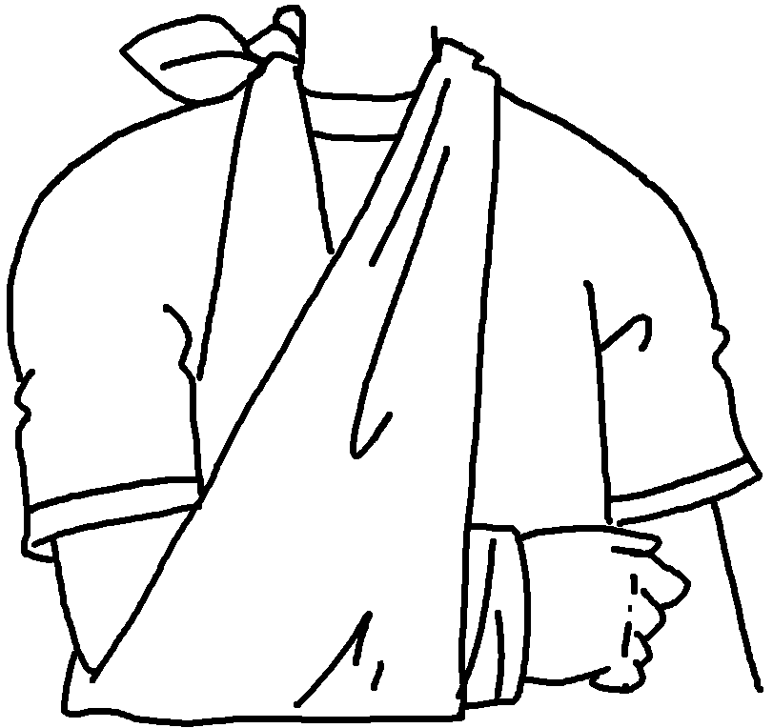 | 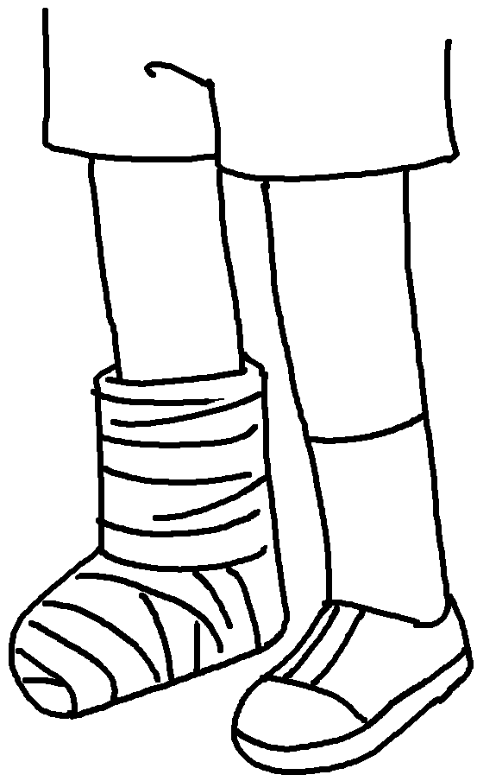

1
2
3
4
5
6



Book 5B Chapter 6 Graded Worksheets
Worksheet 1⬇
- twist my ankle
- burn my arm
- cut my finger
- bang my head
- break my arm
- break my leg

