Choose and write.
1
2
3
4
5
6

bang break burn ankle arm finger
cut twist head leg

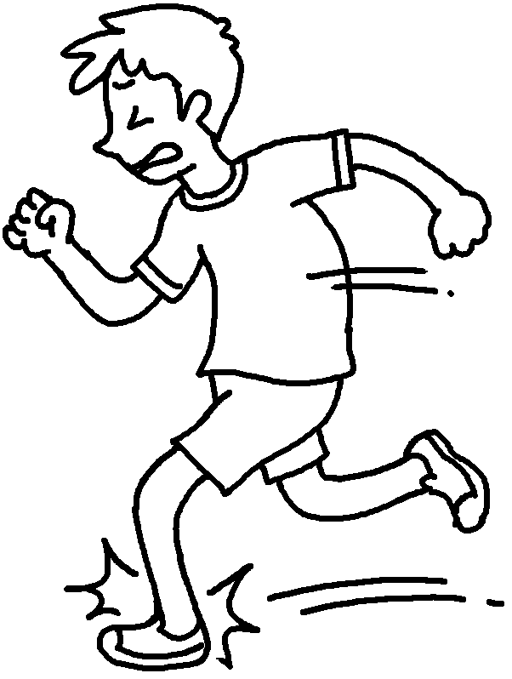 | 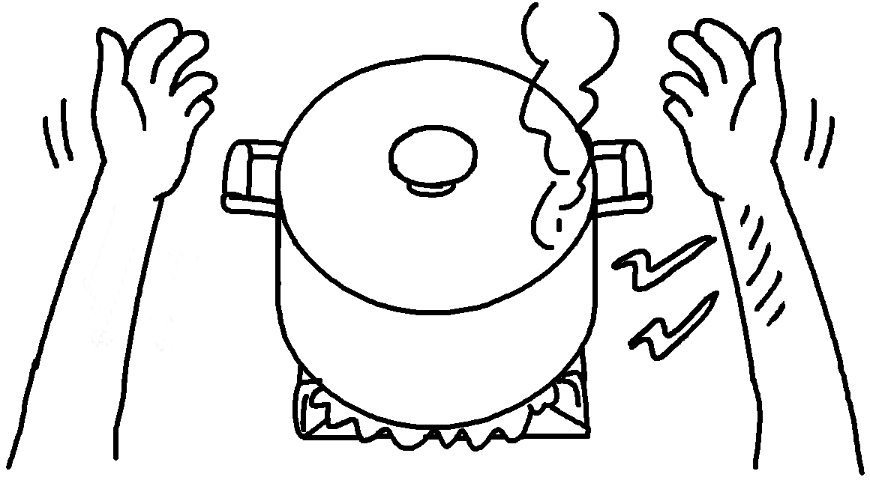
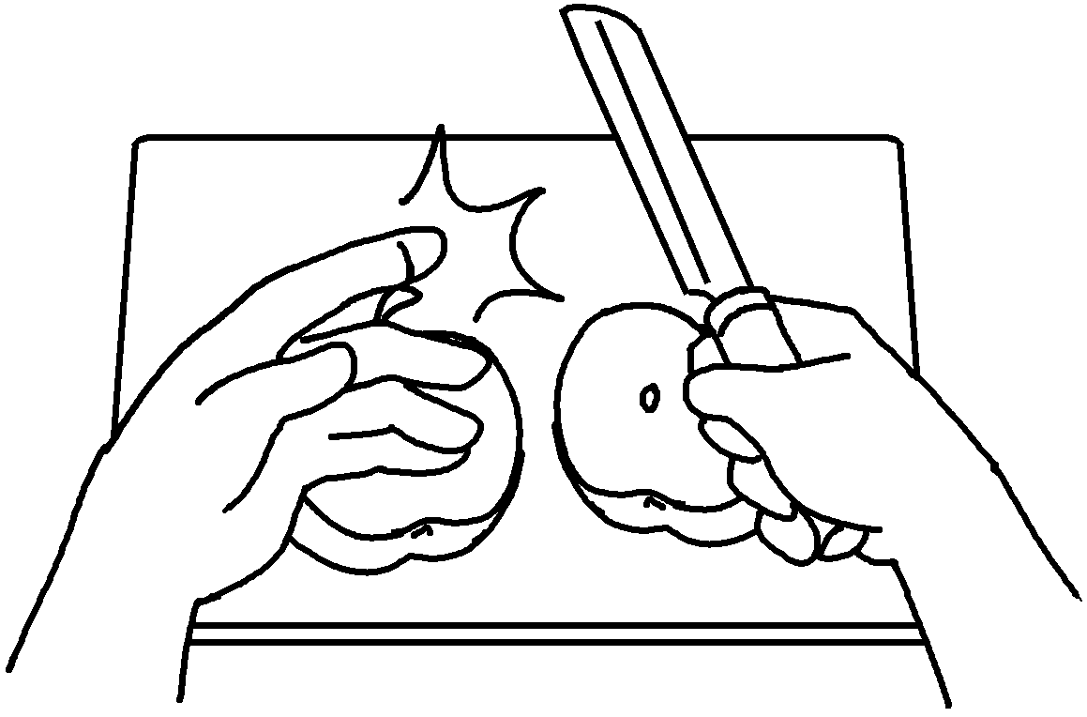 | 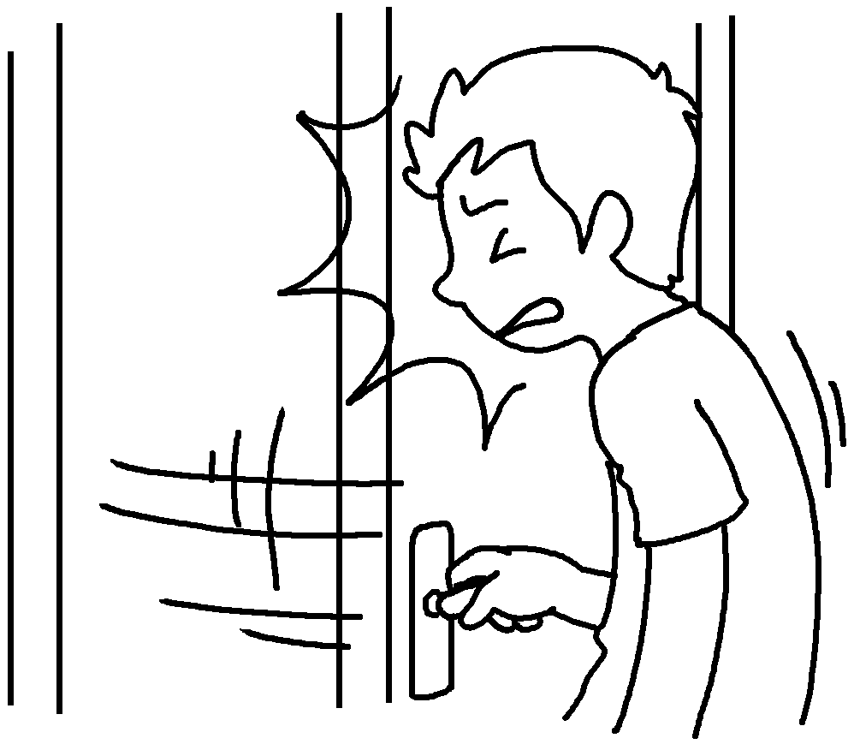
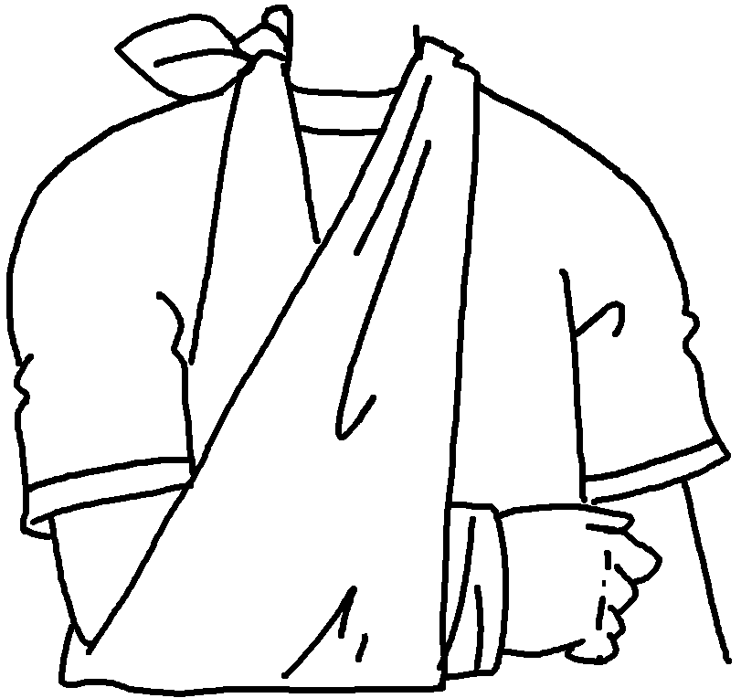 | 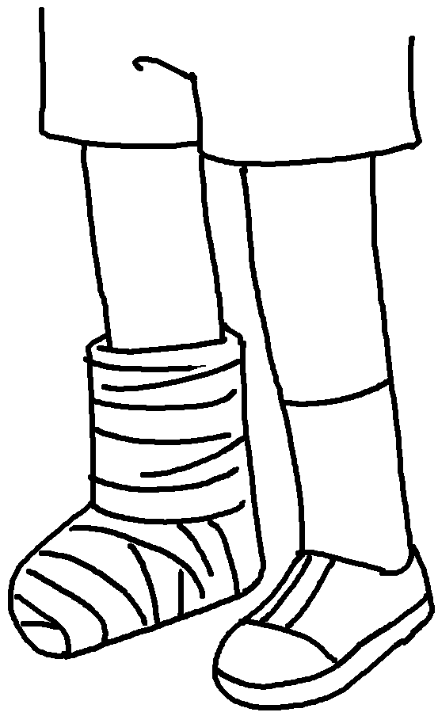

1 | __________________ my __________________
2 | __________________ my __________________
3 | __________________ _______ ________________
4 | __________________ _______ ________________
5 | __________________ _______ ________________
6 | __________________ _______ ________________



Book 5B Chapter 6 Graded Worksheets
Worksheet 1⬇⬇
- twist ankle
- burn arm
- cut my finger
- bang my head
- break my arm
- break my leg

