Look and write the injuries.
1

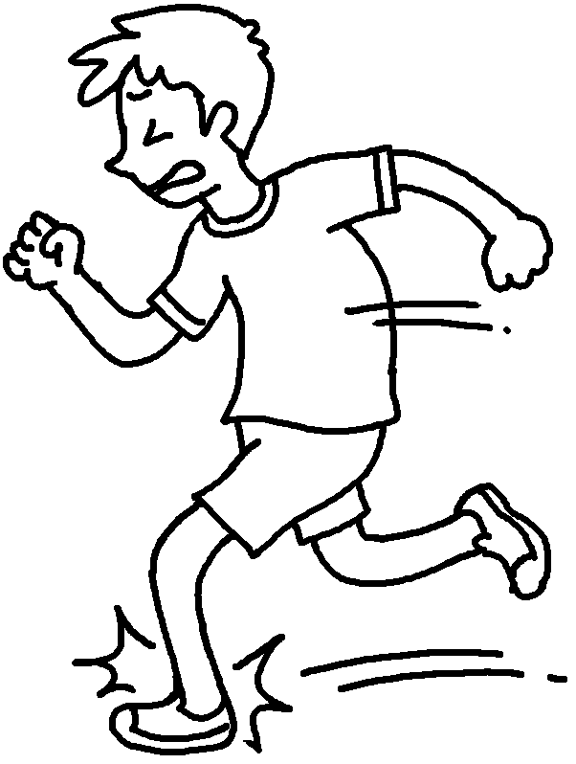 | 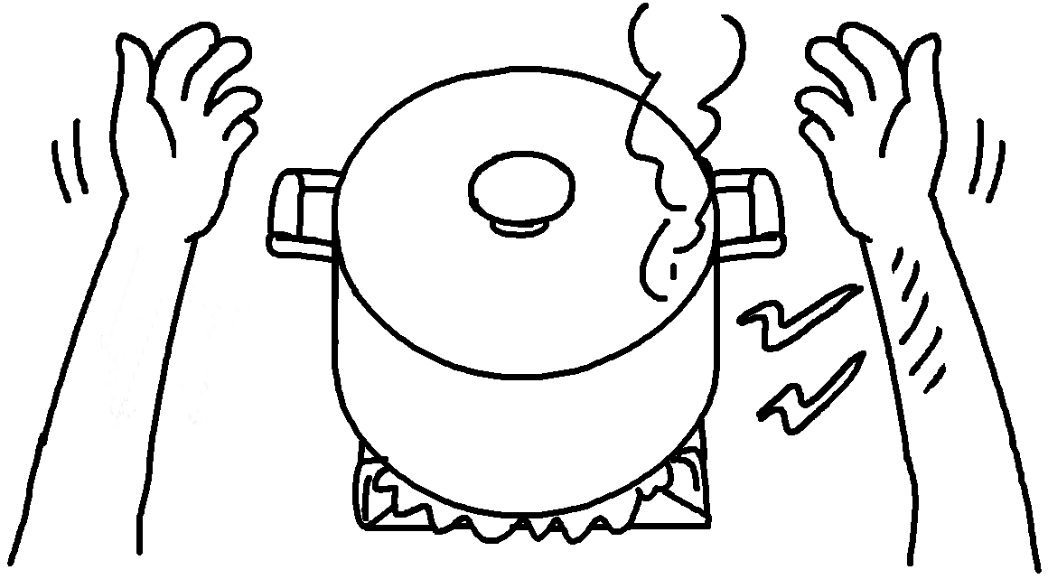  2
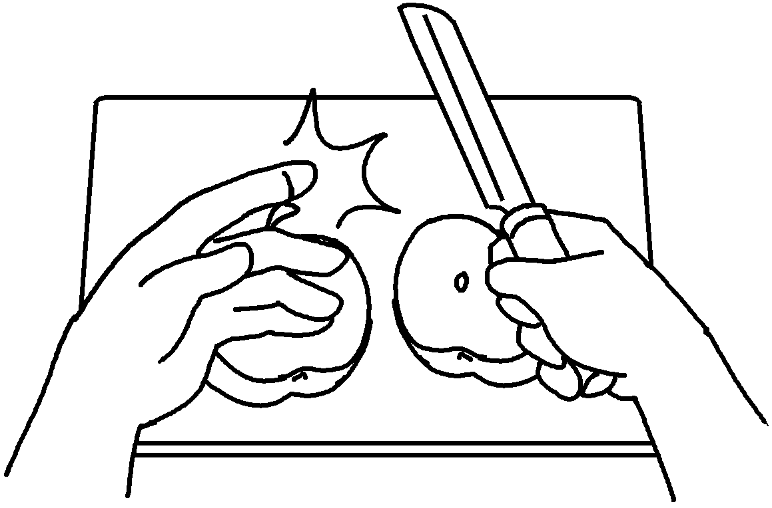  3  4 | 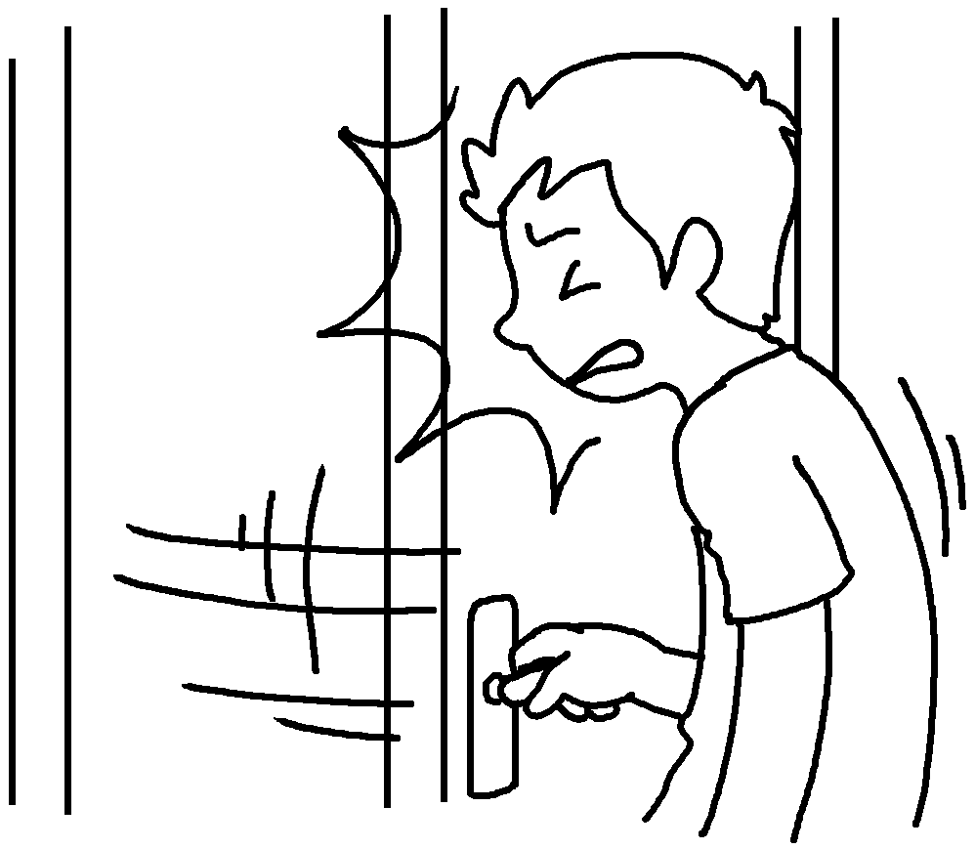
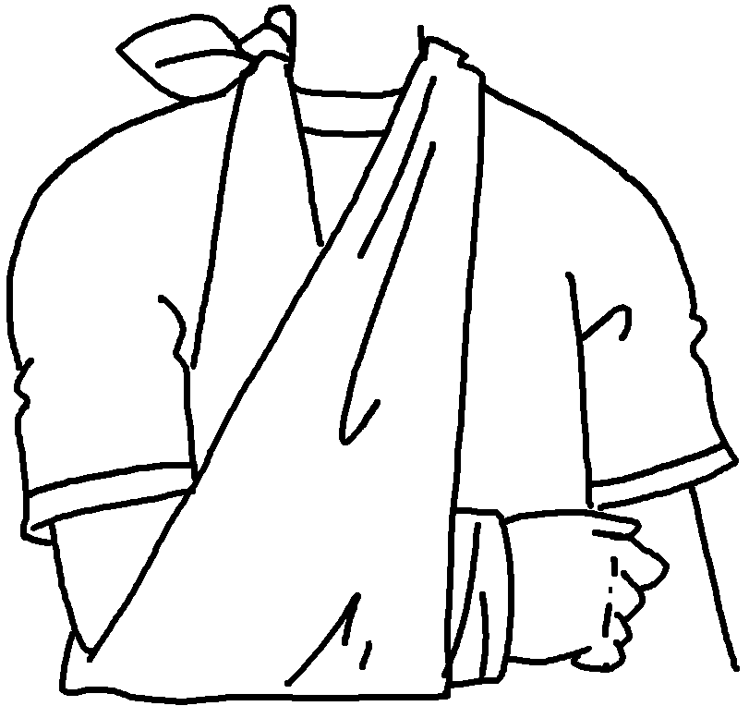  5  6 | 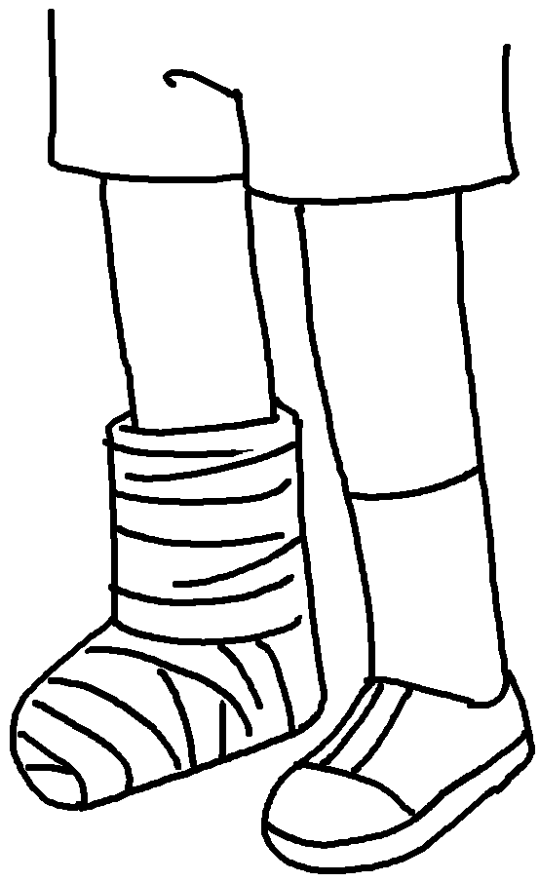

1 | __________________ my __________________
2 | __________________ my __________________
3 | ________________________________________
4 | ________________________________________
5 | ________________________________________
6 | ________________________________________



Book 5B Chapter 6 Graded Worksheets
Worksheet 1⬇⬇⬇
- twist ankle
- burn arm
- cut my finger
- bang my head
- break my arm
- break my leg

