Finish the sentences.
was
…ing
while

1 |  | Ben was drawing his dog was  sleeping.
2 |  | Peter ( look ) at the flowers while Ricky was taking photos.
3 | 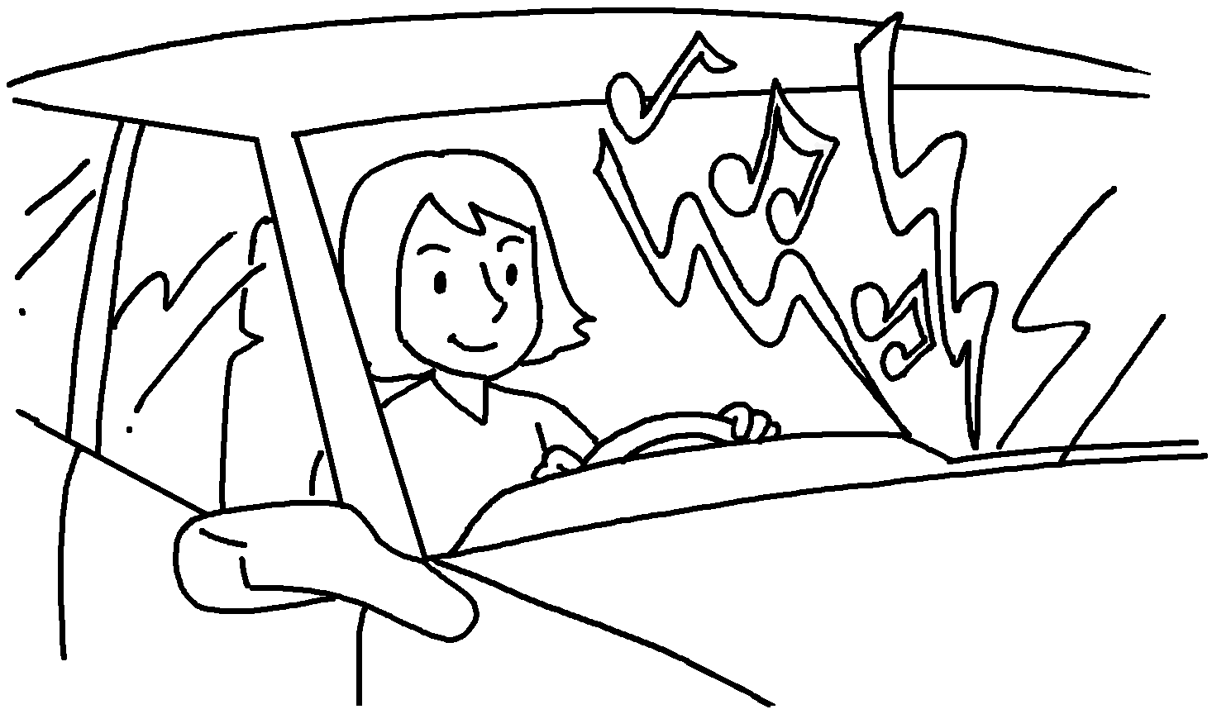 | Tina was playing music loudly while she  ( drive ) her car.
4 | 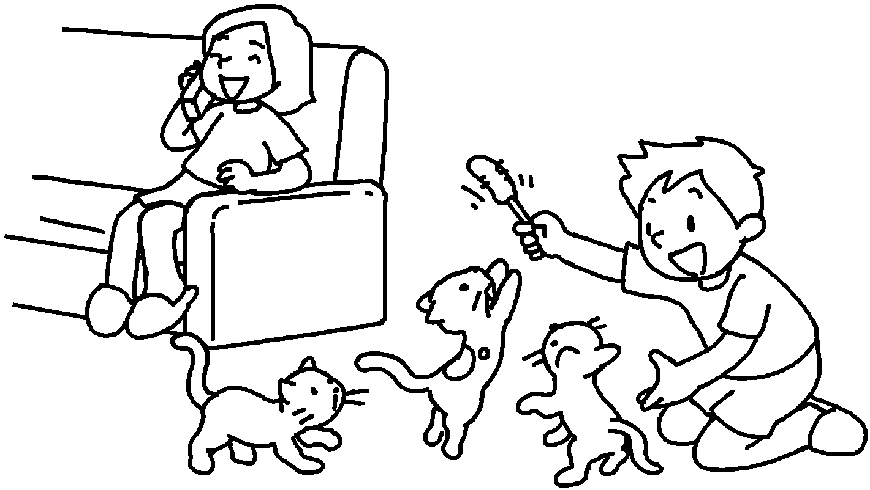 | Susie was talking on the phone  Billy ( play )  with the cats.
5 |  | Sam ( talk ) to  his sister he  ( cook ) noodles.


Book 5B Chapter 6 Graded Worksheets
Worksheet 2⬇
- while
- was looking
- was driving
- while was playing
- was talking while was cooking

