What were they doing yesterday? Finish the sentences using ‘while’.

1 | 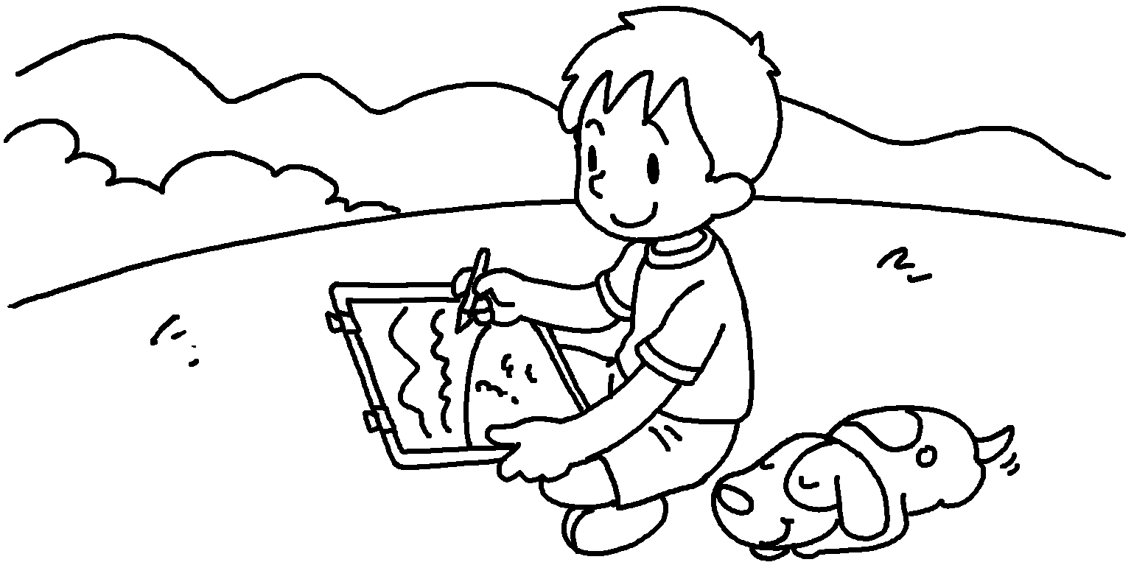  ( sleep ) | Ben was drawing while his dog __________  ___________________ .
2 | 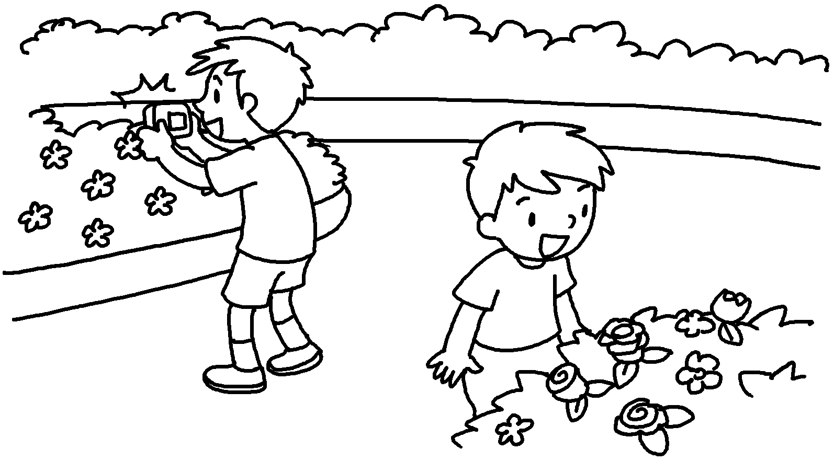  Ricky  Peter  ( look / take ) | Peter at the flowers _________ Ricky _________  _________________ photos.
3 | 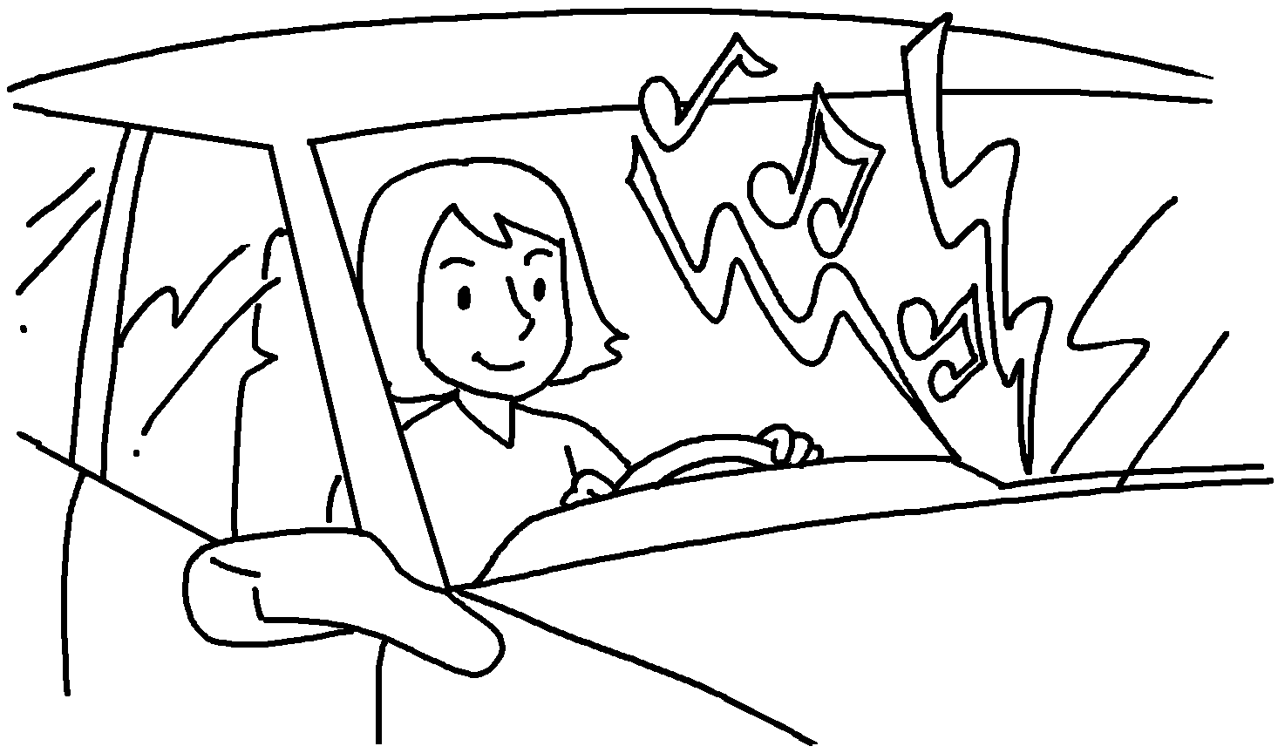  ( play / drive ) | Tina ___________________________ music loudly __________ she  her car.
4 | 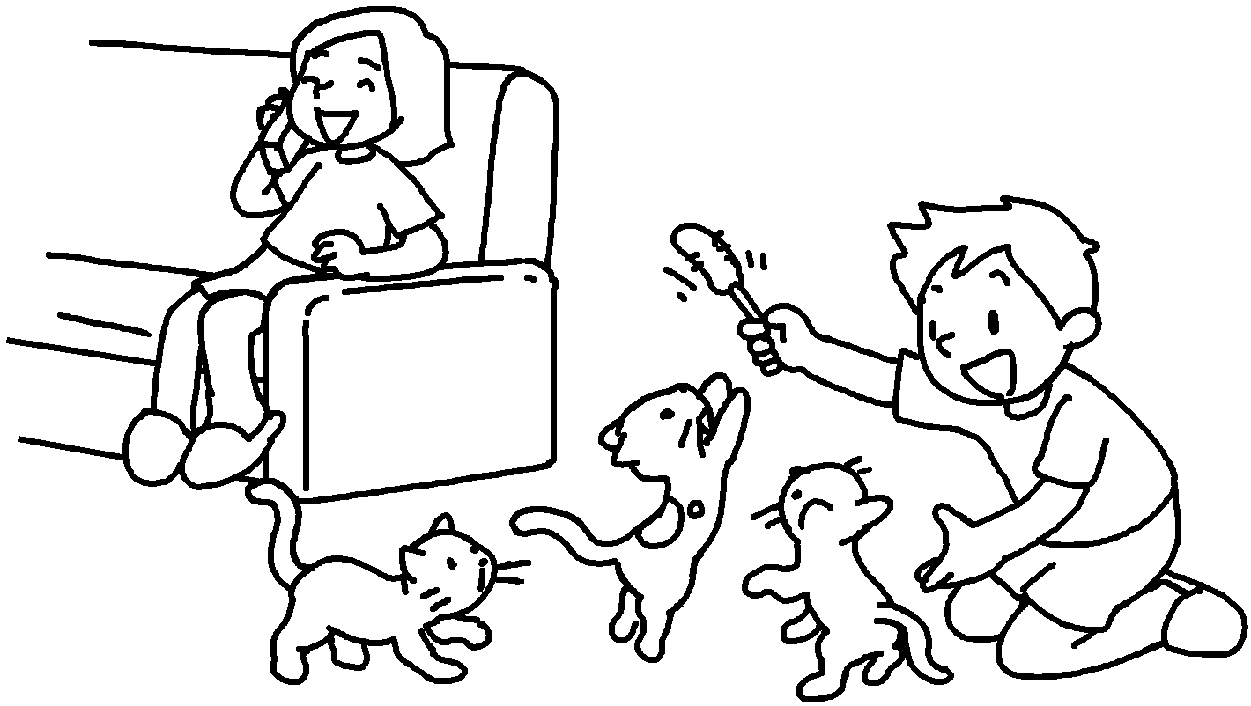  ( talk / play ) | Susie __________________________ on the phone Billy  with the cats.
5 | 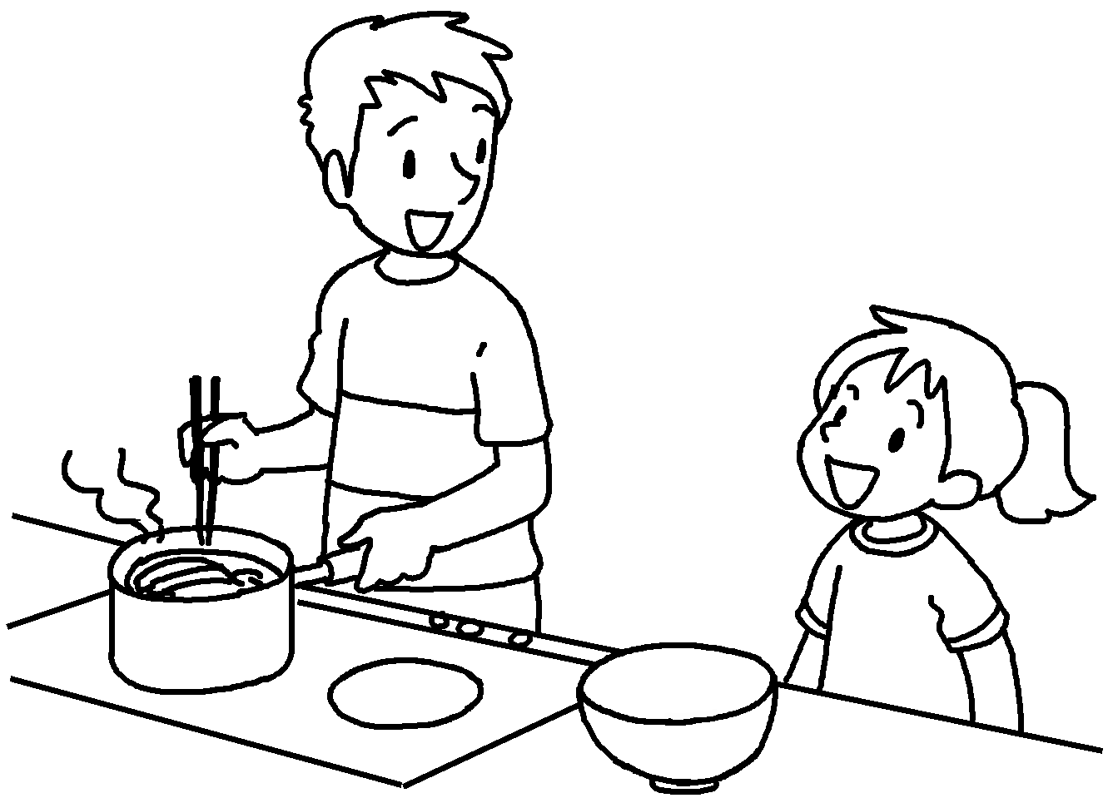  ( talk / cook ) | Sam to his sister he  noodles.



Book 5B Chapter 6 Graded Worksheets
Worksheet 2⬇⬇
- was sleeping
- was looking while was taking
- was playing while was driving
- was talking while was playing
- was talking while was cooking

