What were they doing yesterday? Finish the sentences using ‘while’.

look at the flowers talk to his sister sleep talk on the phone
drive her car cook noodles play play with the cats

1 | 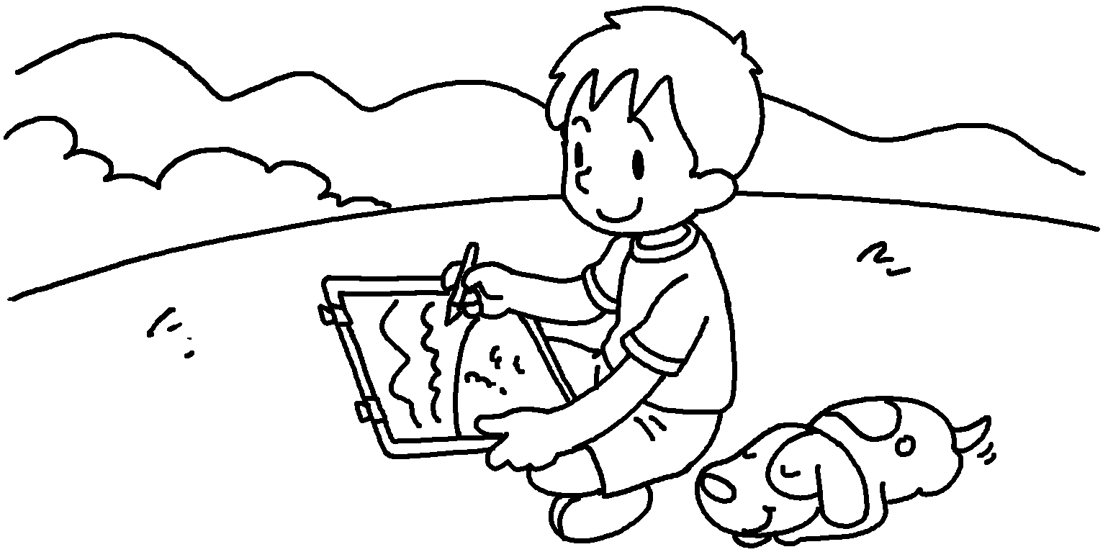 | Ben was drawing while his dog _________  ___________________ .
2 | 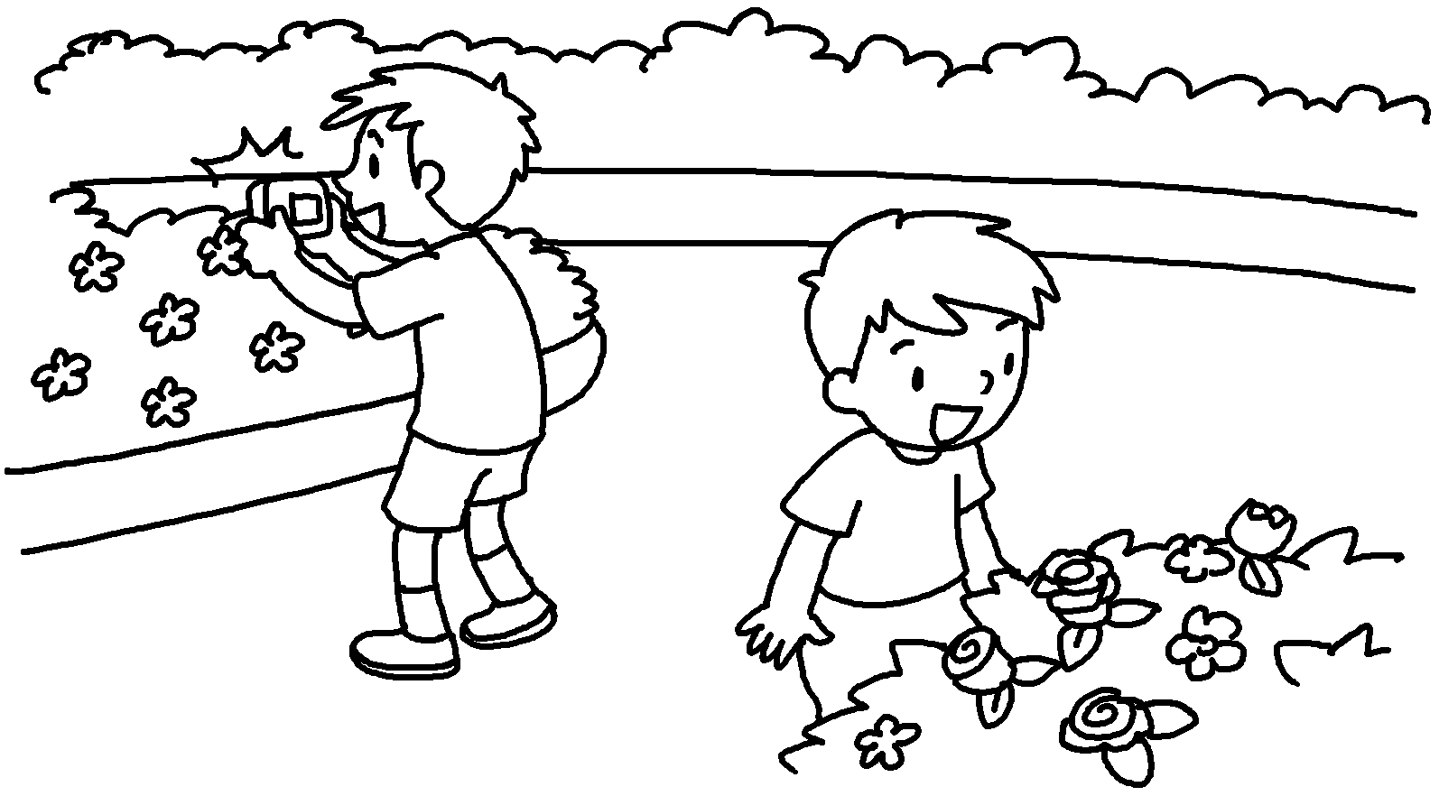  Ricky  Peter | Peter  Ricky was taking photos.
3 | 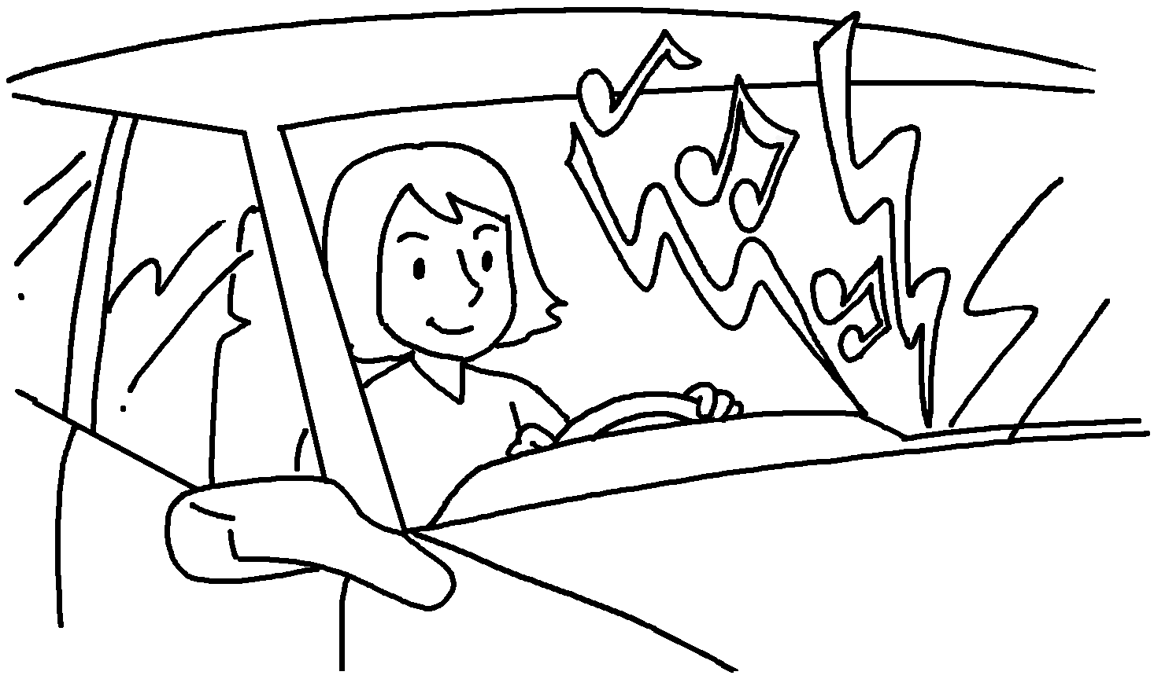 | Tina music  loudly  .
4 | 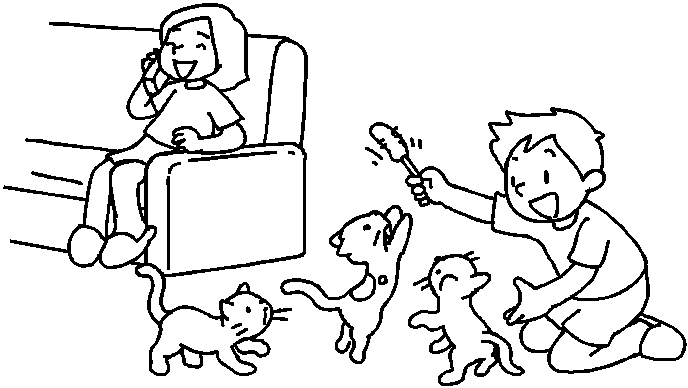  Billy | Susie  .
5 | 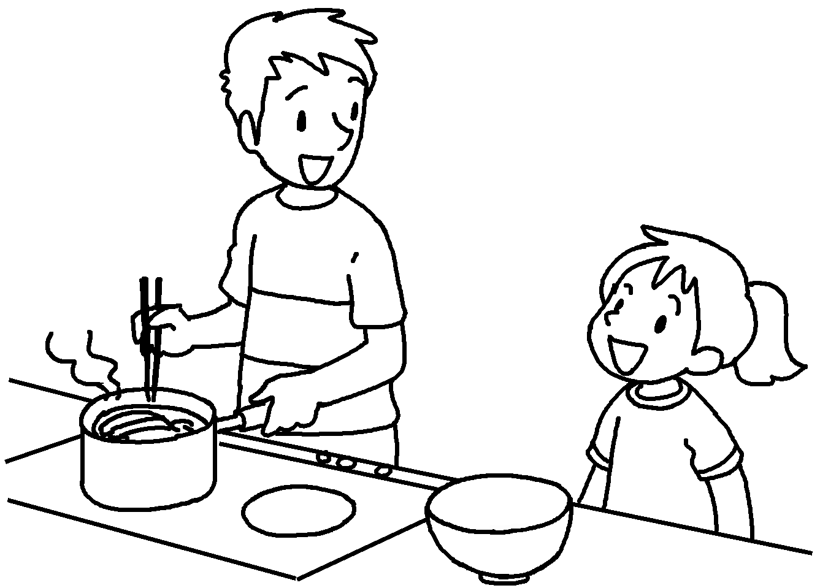 | Sam  .


Book 5B Chapter 6 Graded Worksheets
Worksheet 2⬇⬇⬇
1 was sleeping
2 was looking at the flowers while
3 was playing while she was driving her car
4 was talking on the phone while Billy was playing with the cats
5 was talking to his sister while he was cooking noodles
(Accept any reasonable answers.)

