Finish the questions and answers.
yourself
himself
herself
when

1  A | 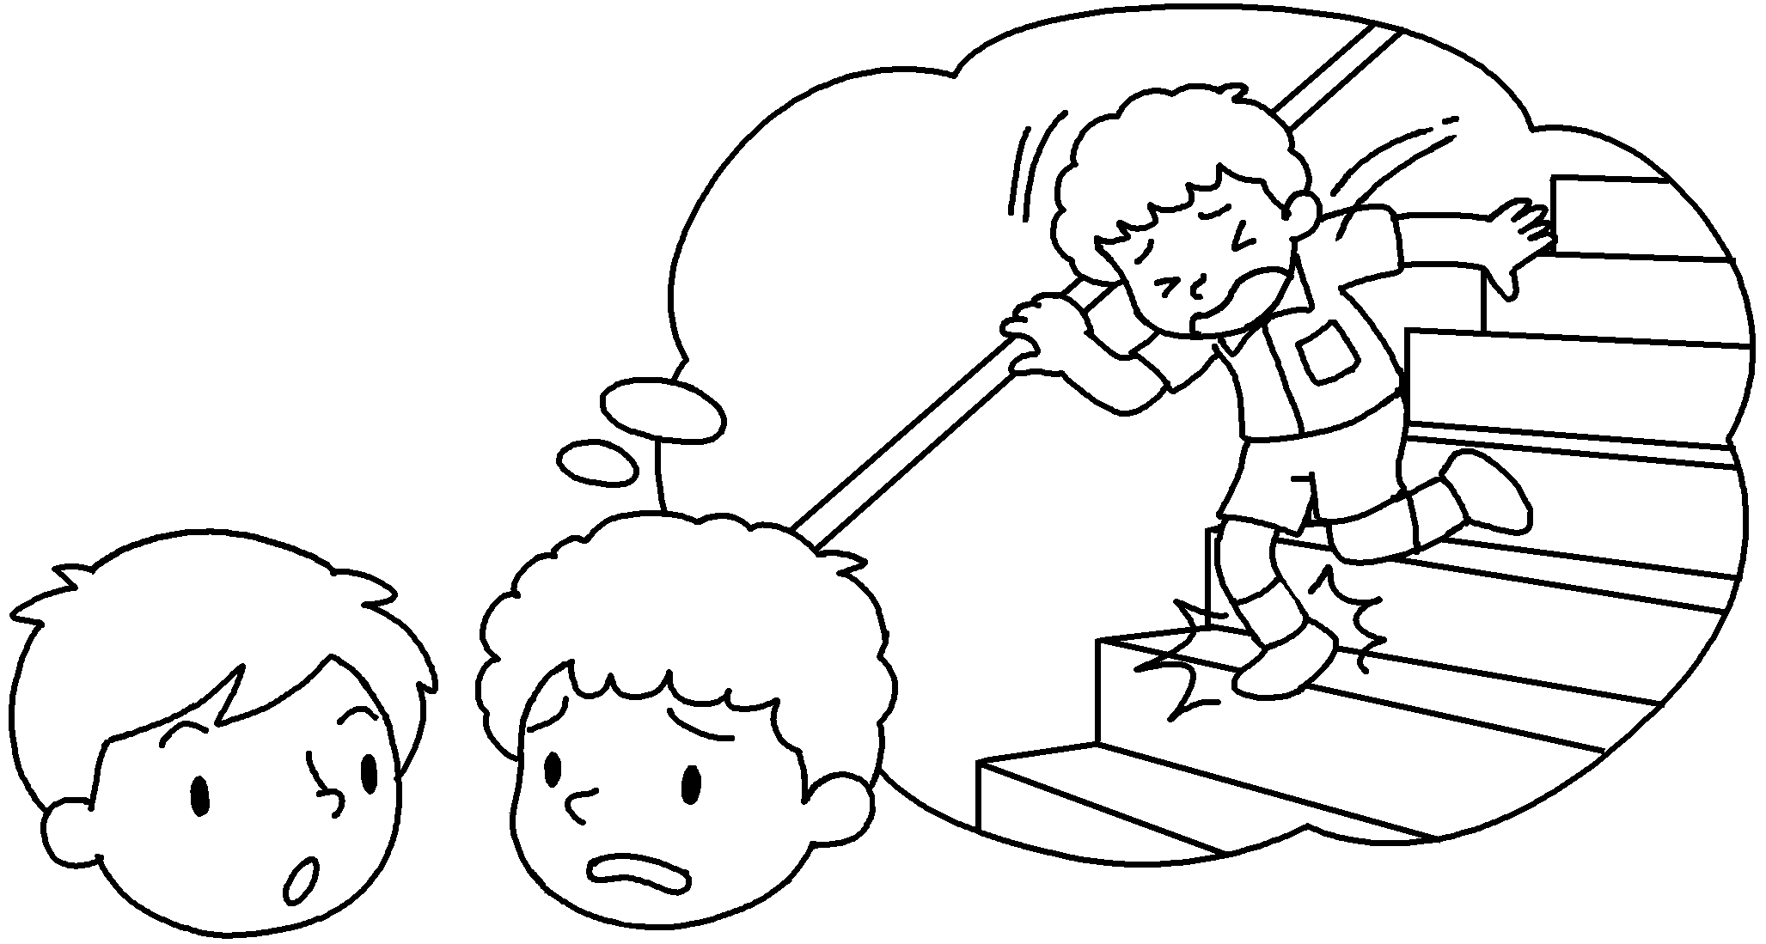  B | A : How did you hurt ?  B : I was walking down the stairs  when I twisted my ankle.
2  B | 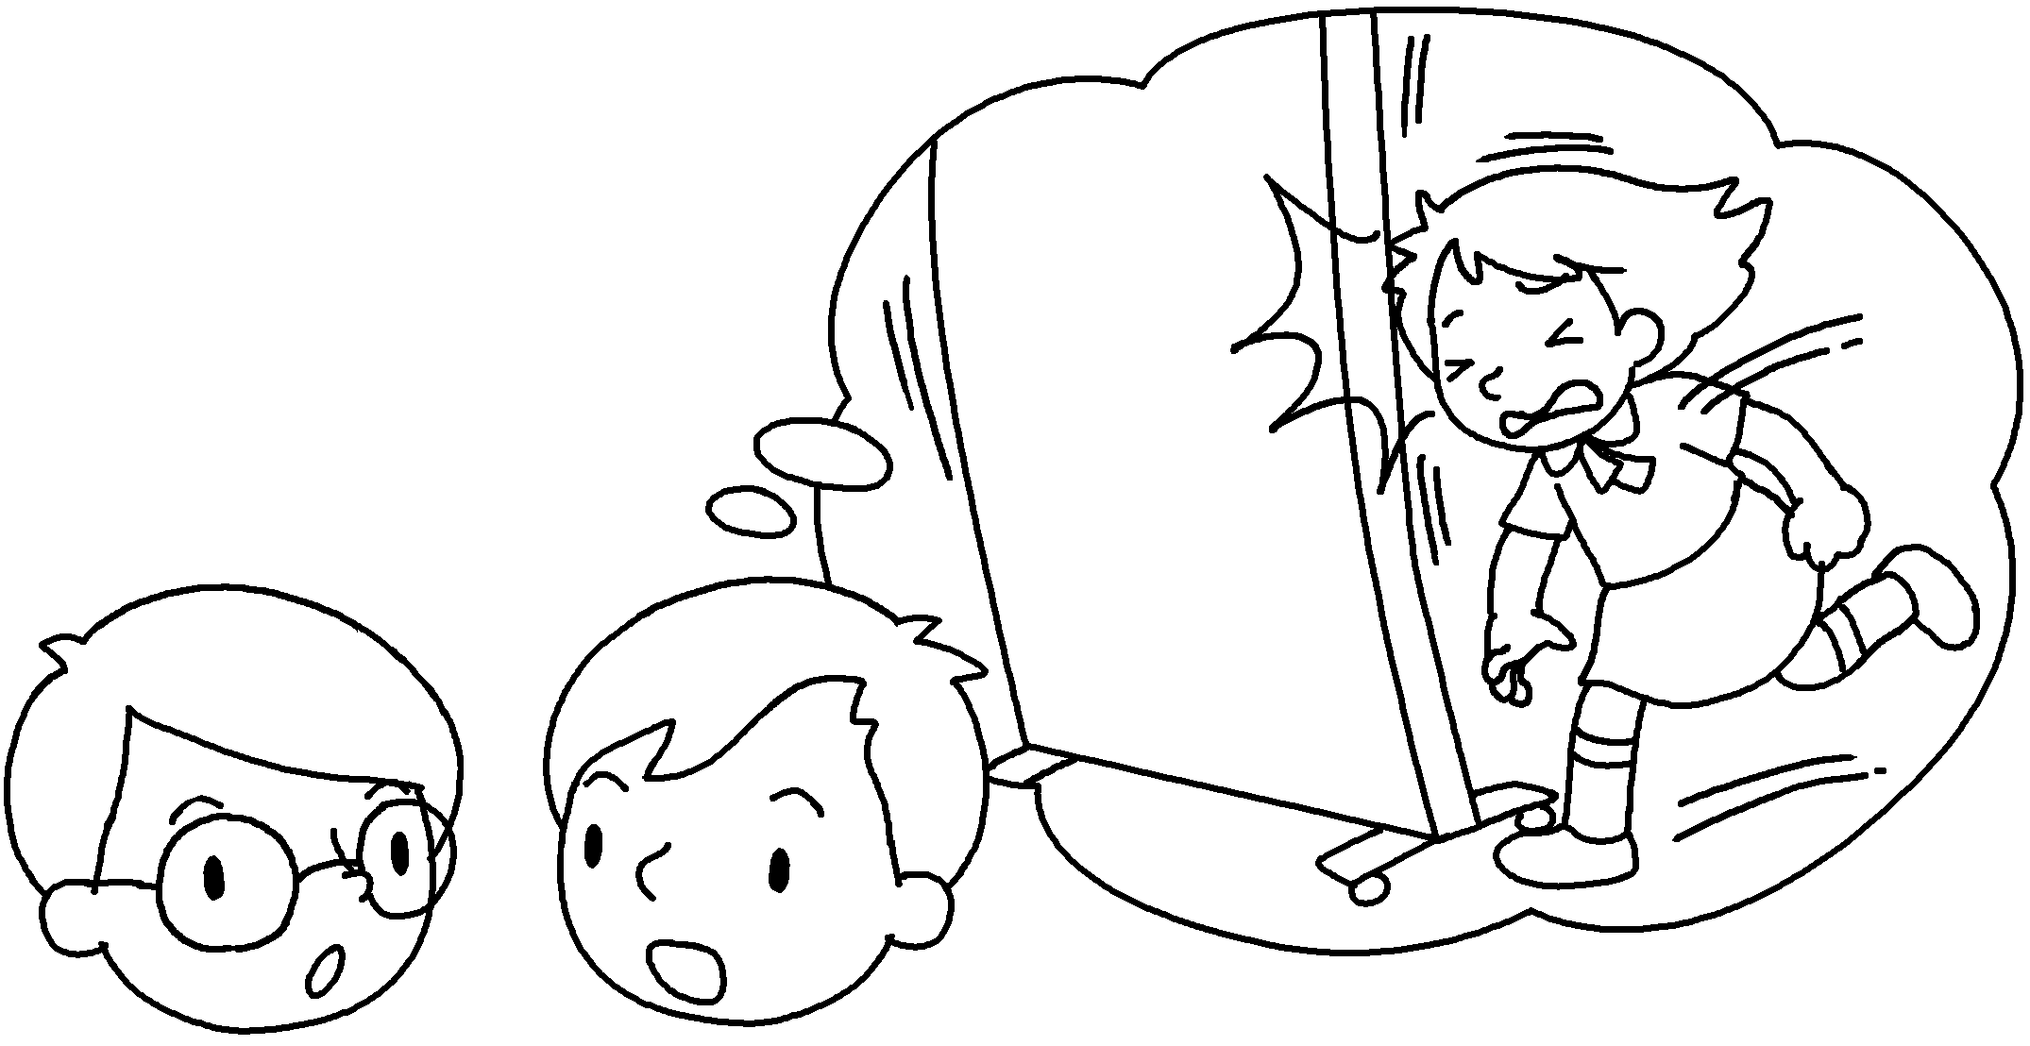  A | A : How did Amy hurt ?  B : She was running she  banged her head.
3  A  B | 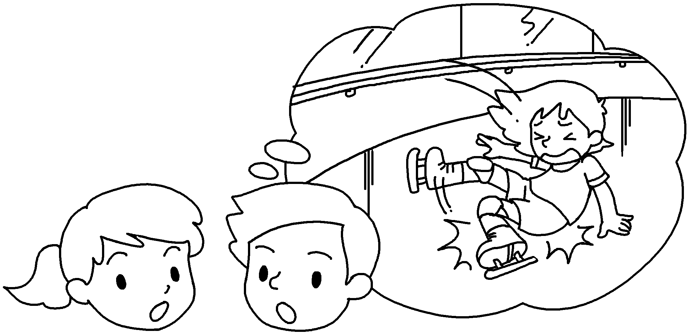 | A : How did Kitty hurt ?  B : She was ice-skating when she  ( break ) her leg.
4  B | 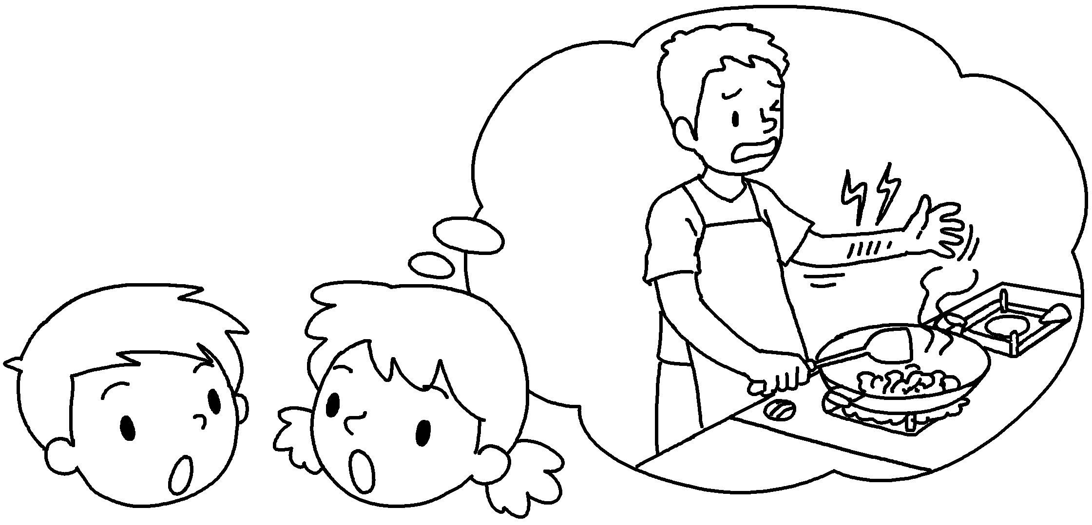  A | A : How did Mr Luk hurt ?  B : He was cooking some vegetables  he  ( burn ) his arm.
5 | 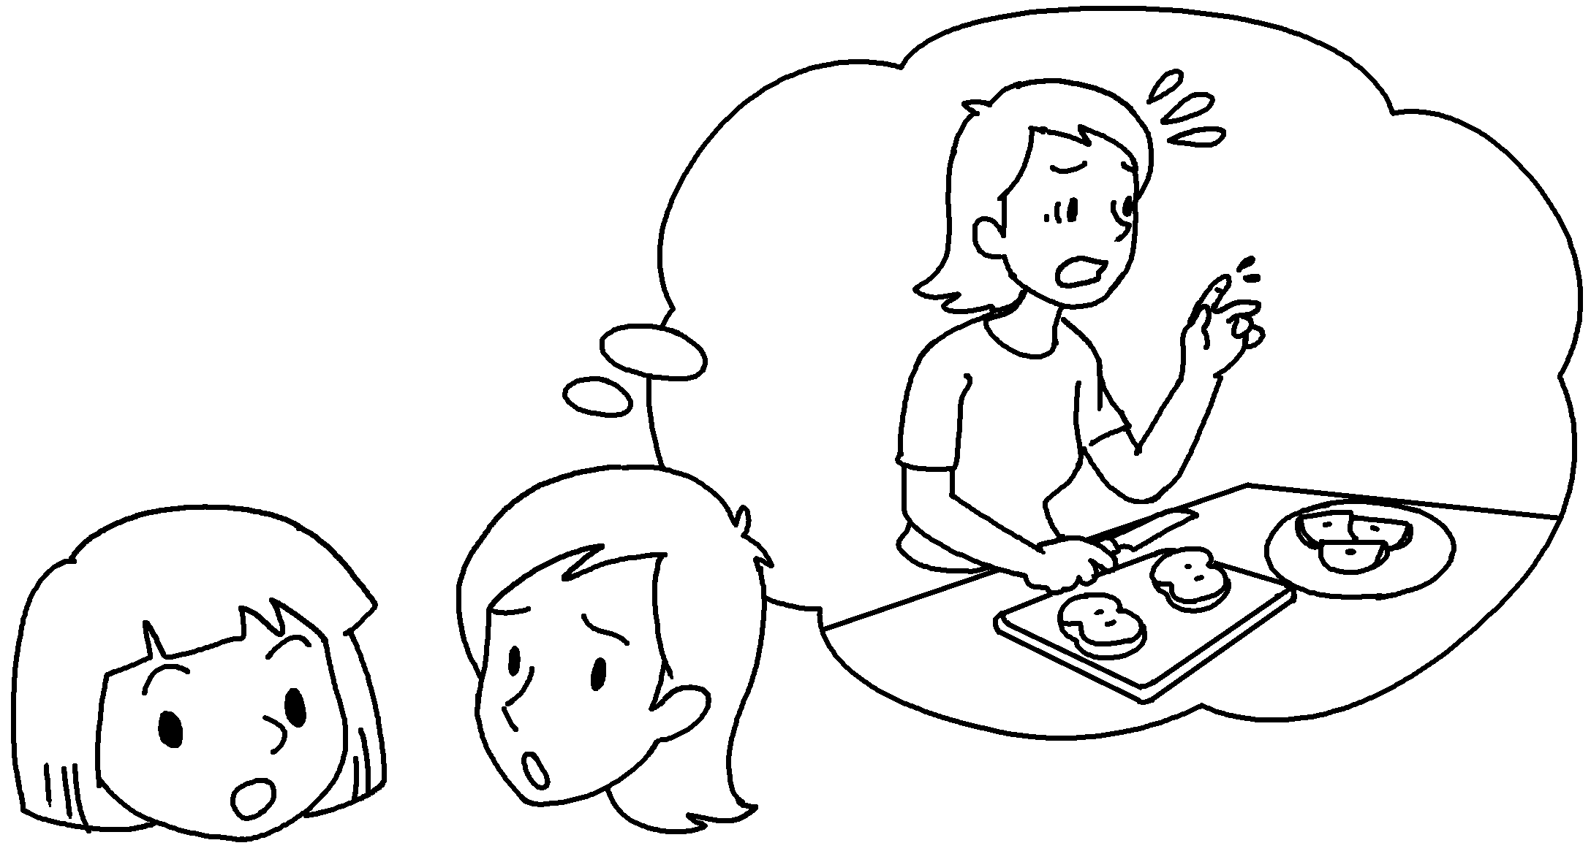  B  A | A : How did you hurt ?  B : I was cutting an apple  I ( cut ) my finger.


Book 5B Chapter 6 Graded Worksheets
Worksheet 3⬇
- yourself
- herself
when
- herself
broke
- himself
when burnt
- yourself
when cut

