Finish the questions and answers.
yourself
himself
herself

1  A | 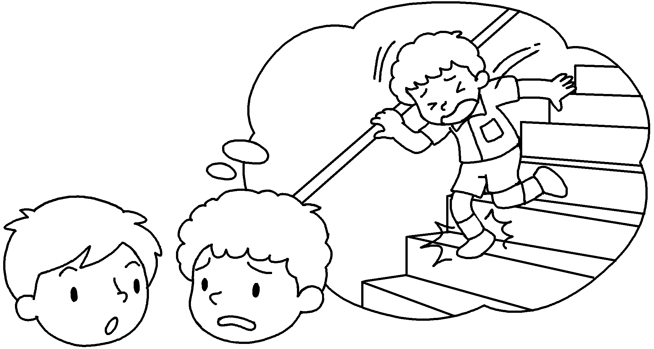  B | A : How did you hurt ?  B : I was walking down the stairs  ___________ I twisted my ankle.  when
2 | 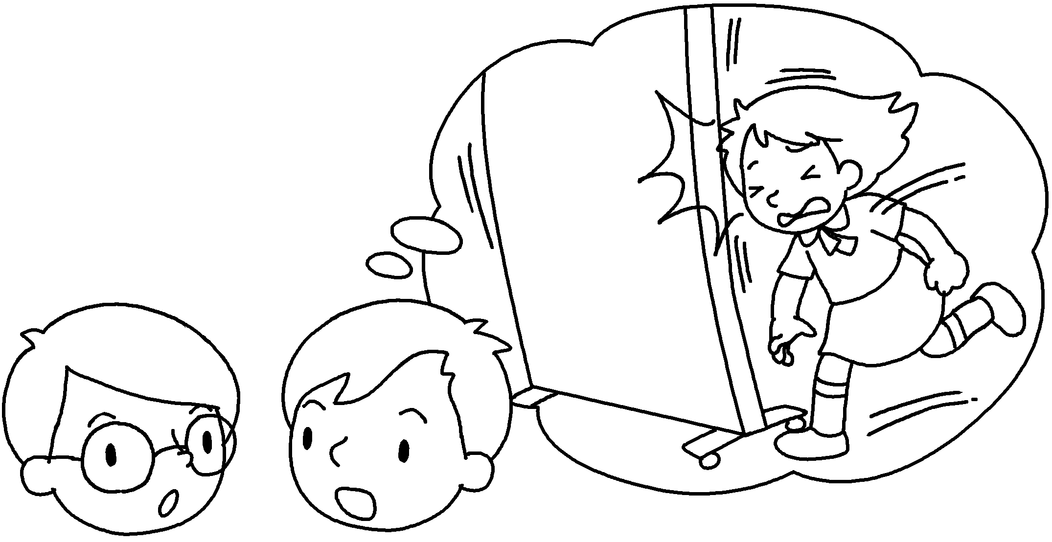  A  B  ( bang ) | A : How did Amy hurt ?  B : She was running when she  _____________ her head.
3 | 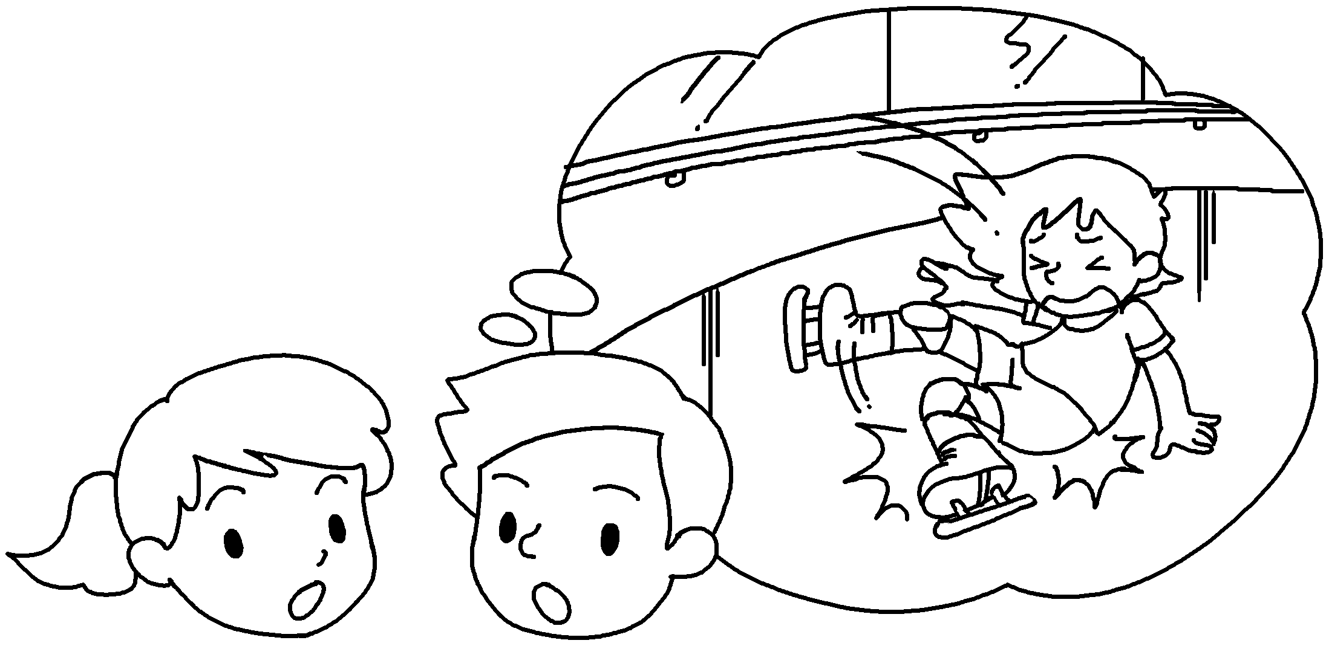  A  B  ( ice-skate / break ) | A : How did Kitty hurt ?  B : She was ____________________________  she her leg.
4 | 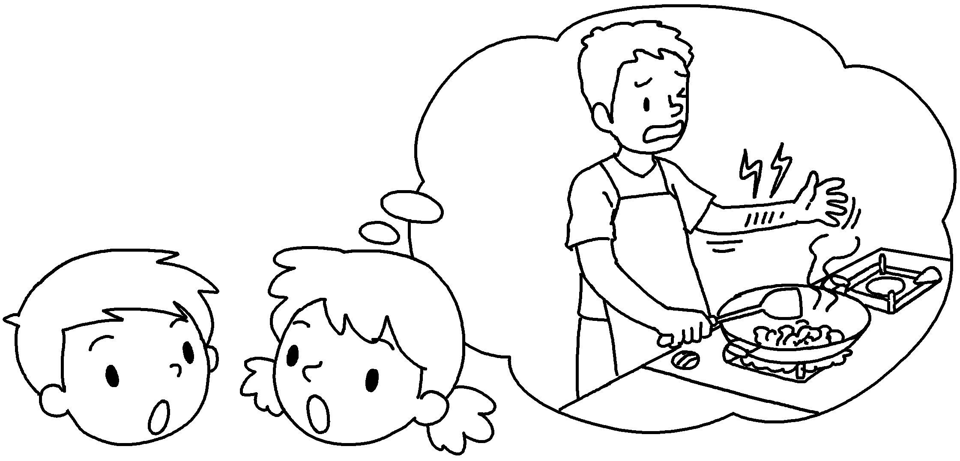  A  ( cook / burn )  B | A : How _______ Mr Luk __________  __________________ ?  B : He ___________________________ some  vegetables he  his arm.
5 | 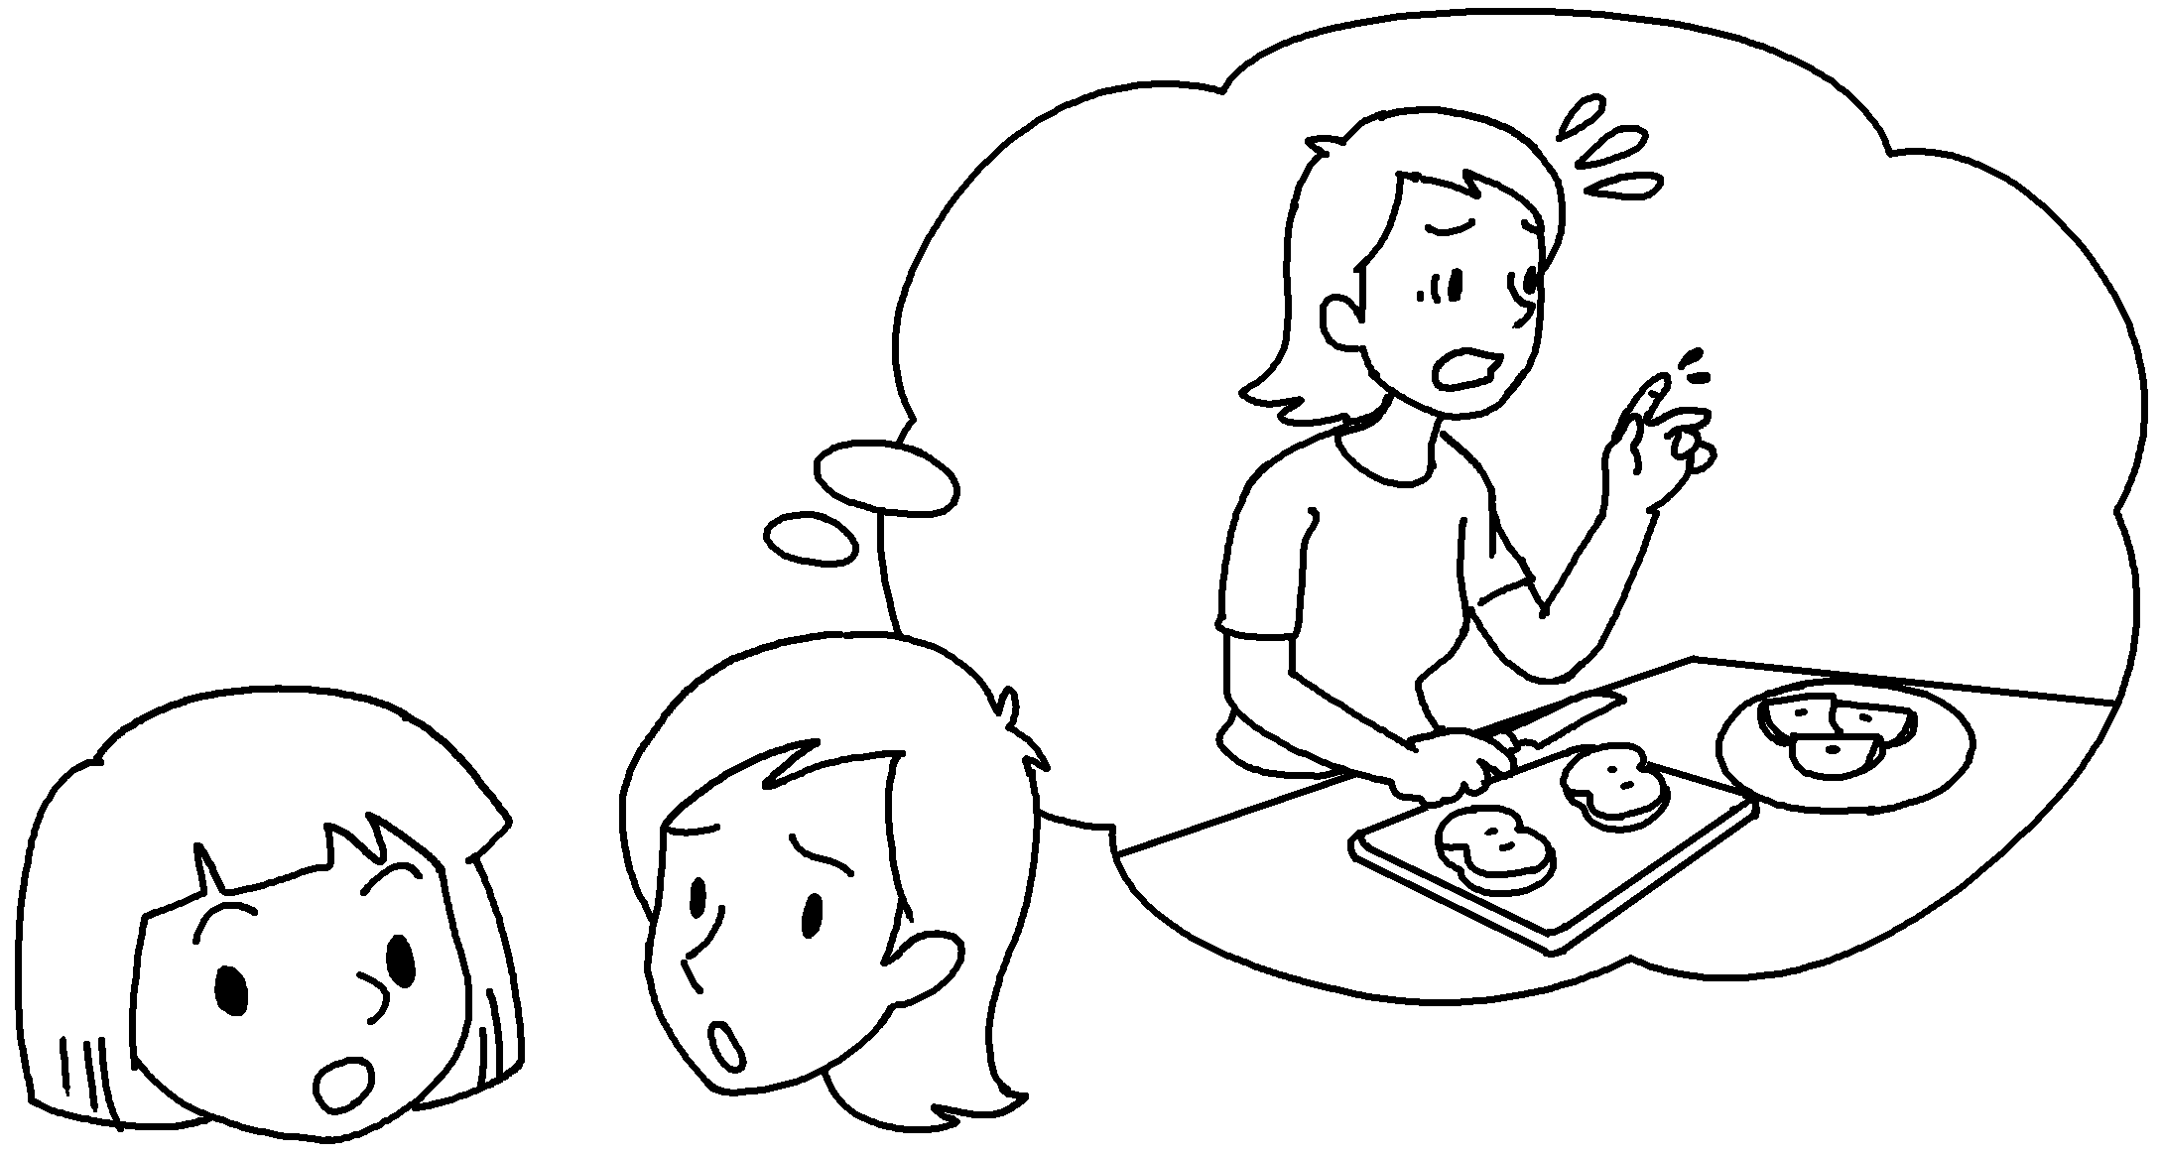  B  ( cut / cut )  A | A : How _______ you ____________  __________________ ?  B : I __________________________ an apple  ____________ I my finger.


Book 5B Chapter 6 Graded Worksheets
Worksheet 3⬇⬇
- yourself
- herself
banged
- herself
ice-skating when broke
4 did hurt himself
was cooking when burnt
5 did hurt yourself
was cutting when cut

