How did the people hurt themselves? Finish the questions and answers.

ice-skate cut an apple break her leg cut my finger
cook some vegetables run twist burn his arm

1  A | 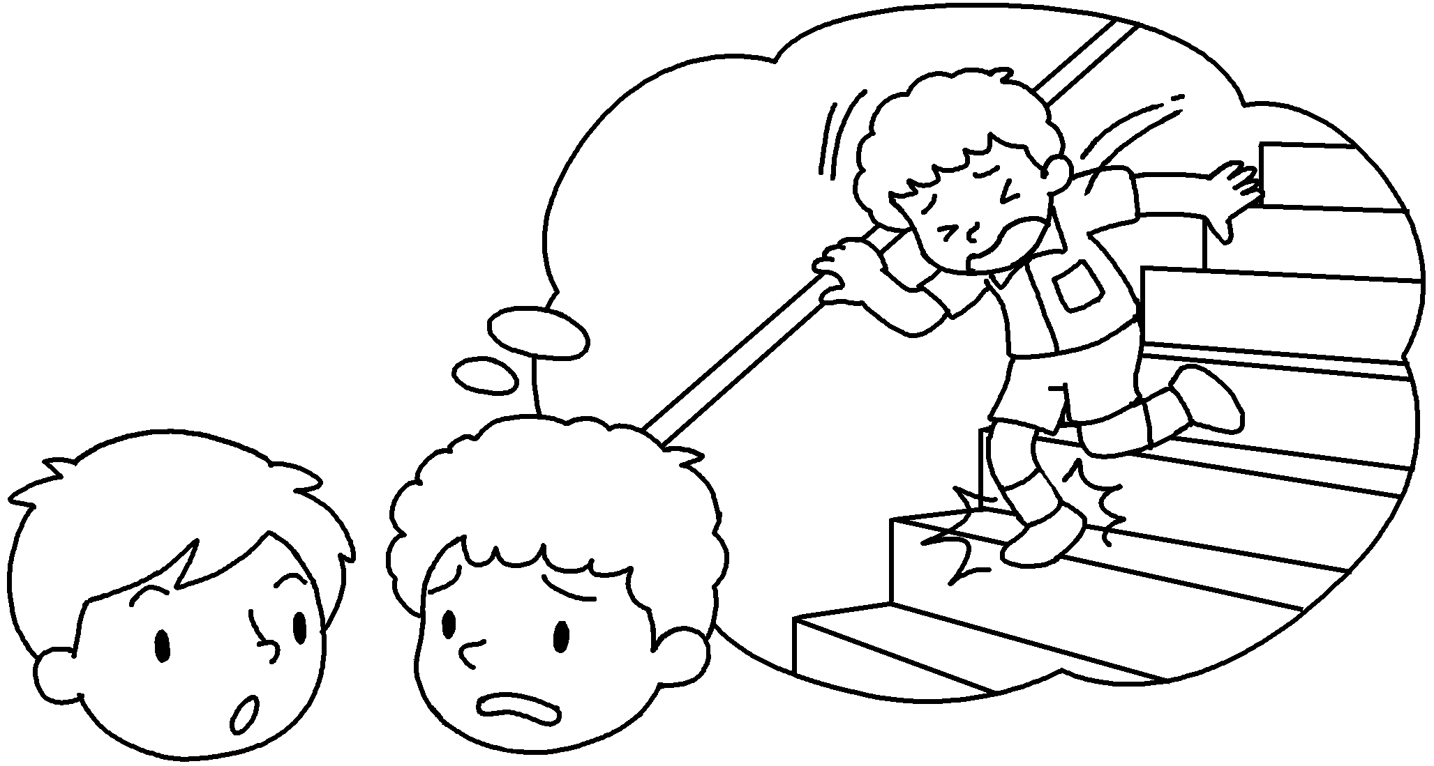  B | A : How did you hurt yourself?  B : I was walking down the stairs  when  __________ I _______________ my ankle.
2 | 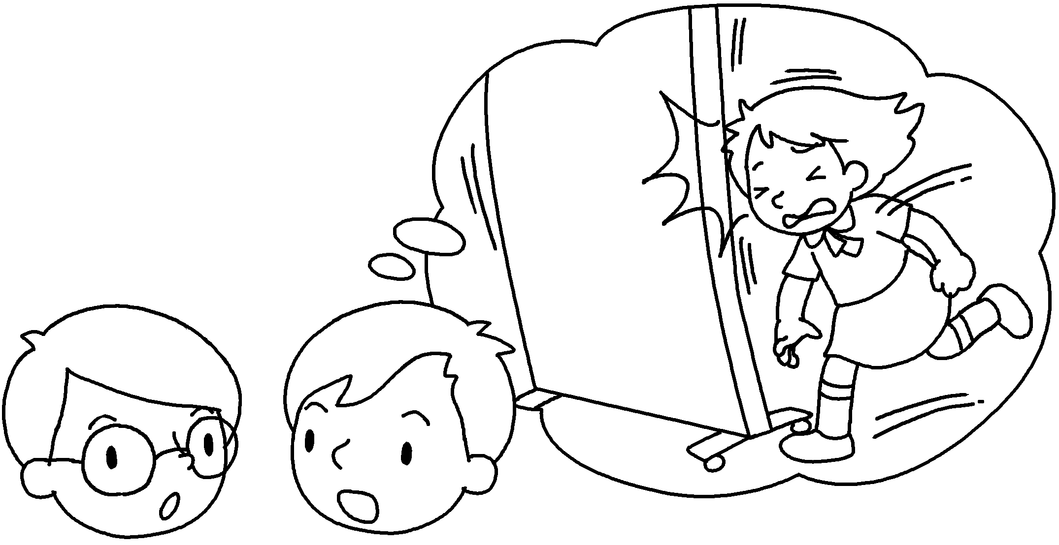  A  B | A : How did Amy hurt ?  B : She _______________________ when she banged her head.
3 | 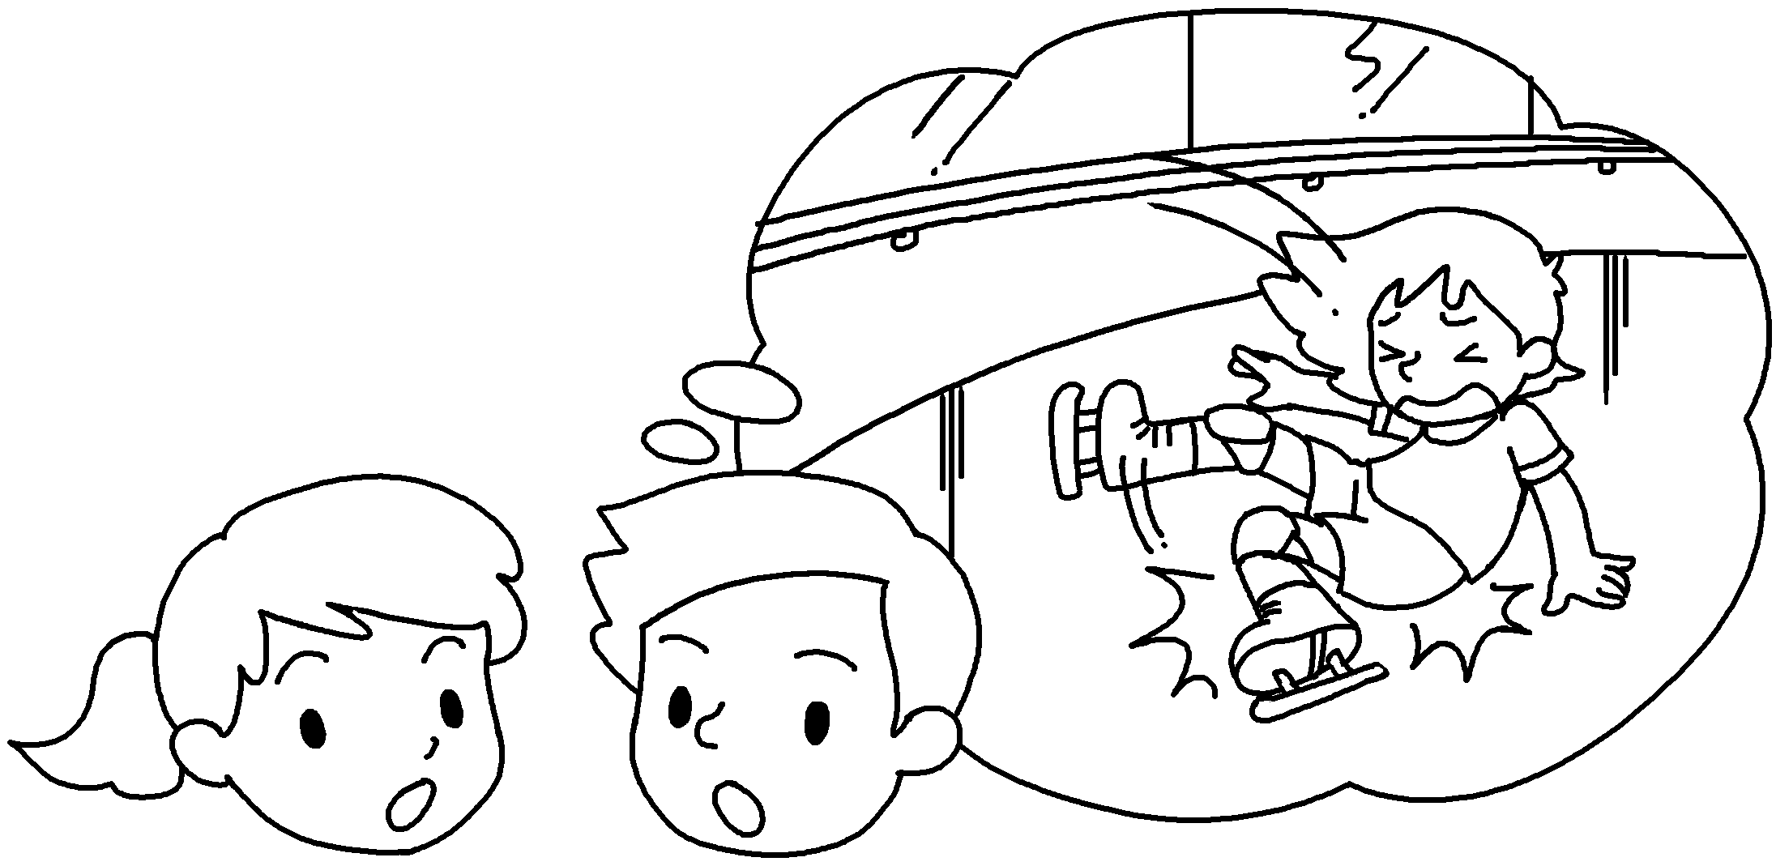  A  B | A : How _______ Kitty hurt ?  B : She was ____________________________  .
4 | 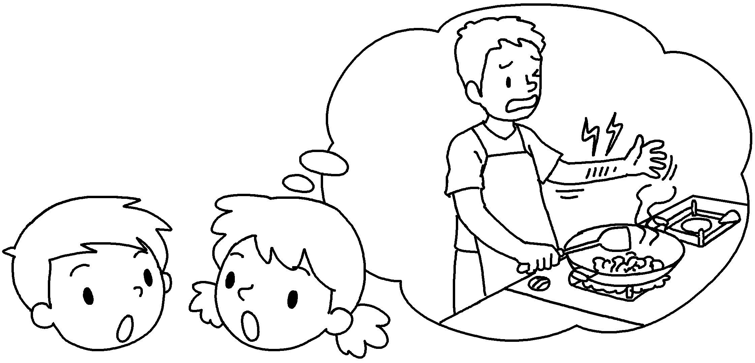  A  B | A : How _________ Mr Luk _______________  __________________ ?  B : He _________________________________  .
5 | 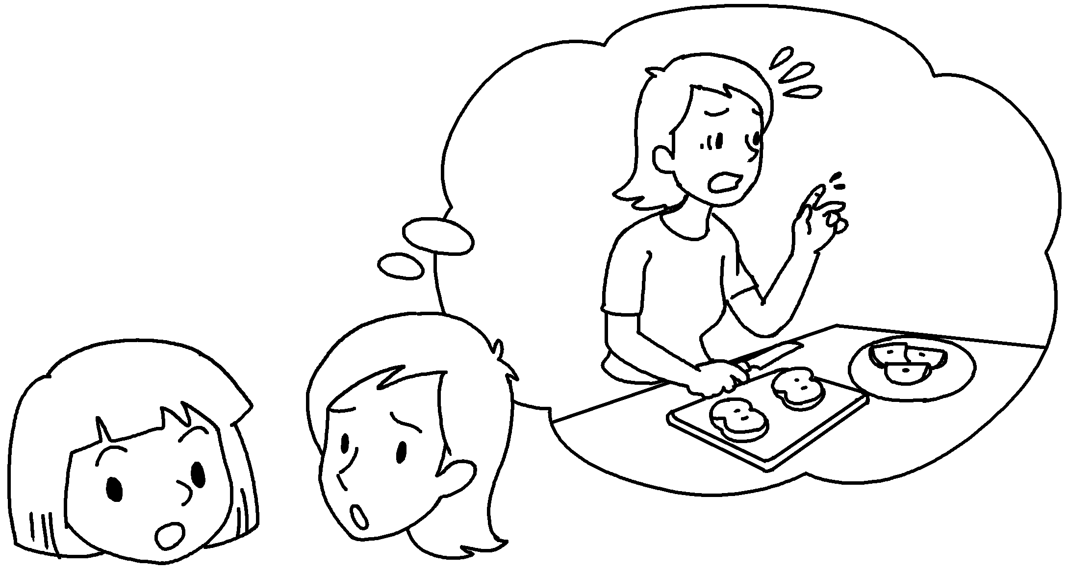  B  A | A : __________________ you _____________  __________________ ?  B : I ___________________________________  ___________________________________ .


Book 5B Chapter 6 Graded Worksheets
Worksheet 3⬇⬇⬇
- twisted
- herself
was running
3 did herself
ice-skating when she broke her leg
4 did hurt himself
was cooking some vegetables when he burnt his arm
5 How did hurt yourself
was cutting an apple when I cut my finger

