RP no: Century Gothic 15pt
(所有圈號用15pt)
Look at the pictures and write the illnesses.
5
8
4
6
1
2
3
7
 |  |  | 
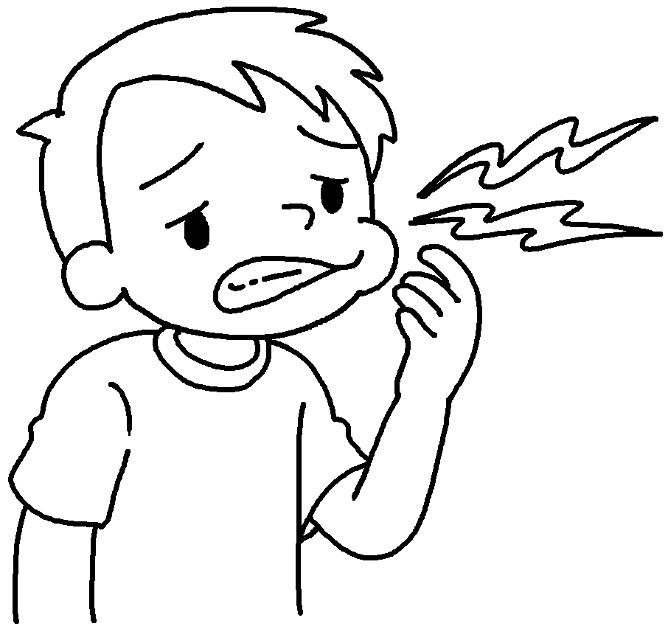 |  | 
 |  |  | 

1 | a f |  | 2 | a s
3 | a c |  | 4 | a t
5 | a s t |  | 6 | the f
7 | a h |  | 8 | a c


Book 5B Chapter 7 Graded Worksheets
Worksheet 1⬇⬇
1 fever 2 stomachache
3 cough 4 toothache
5 sore throat 6 flu
7 headache 8 cold

