Look at the pictures and write the illnesses.
5
8
4
6
1
2
3
7
 | 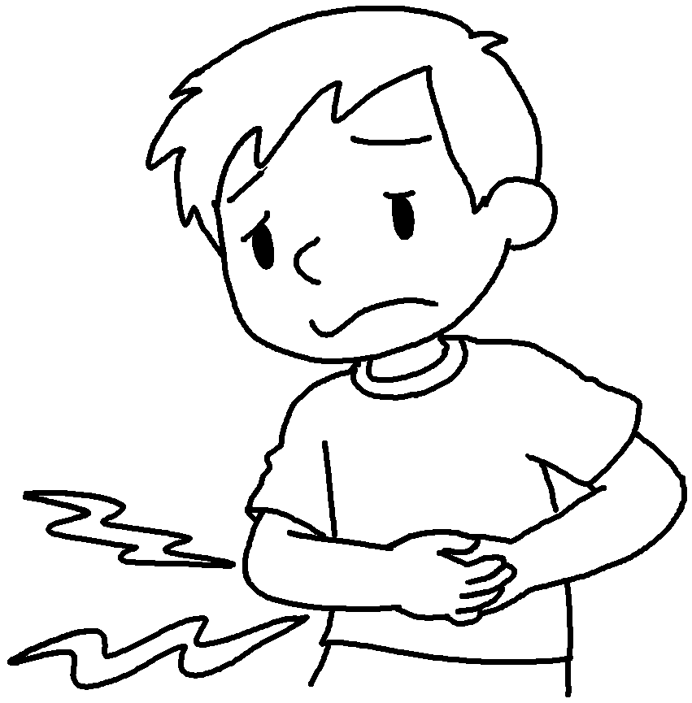 |  | 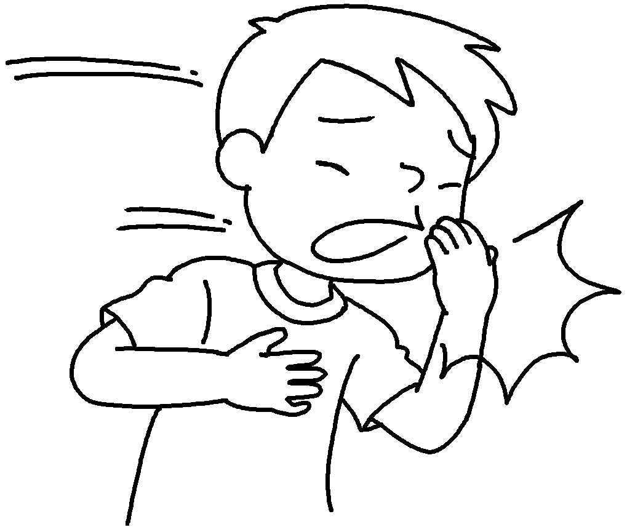
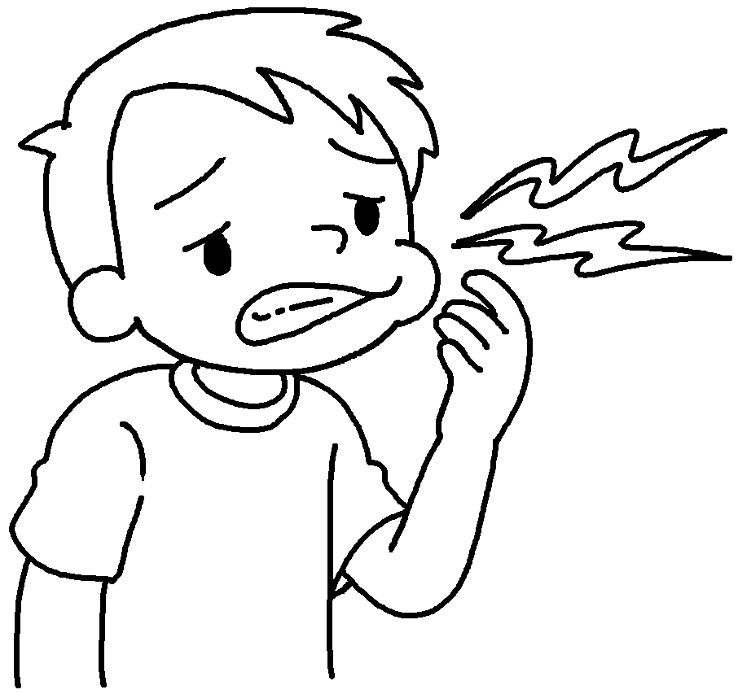 |  | 
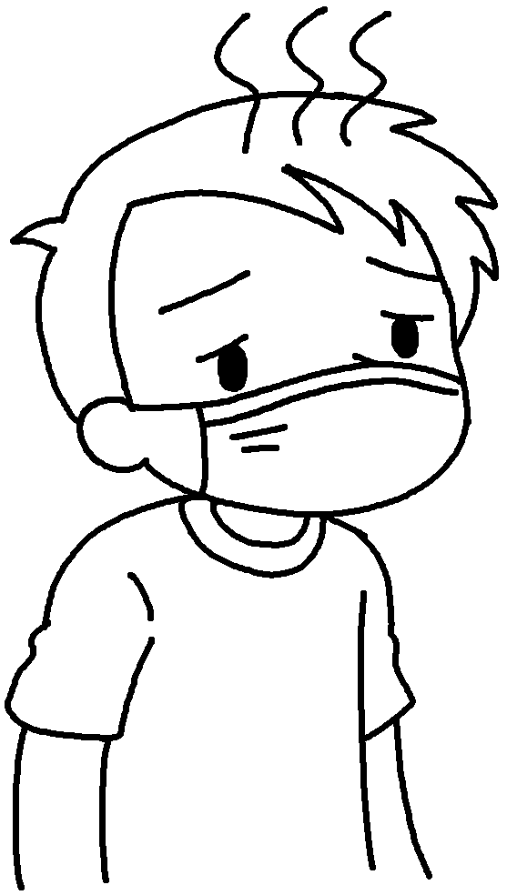 |  |  | 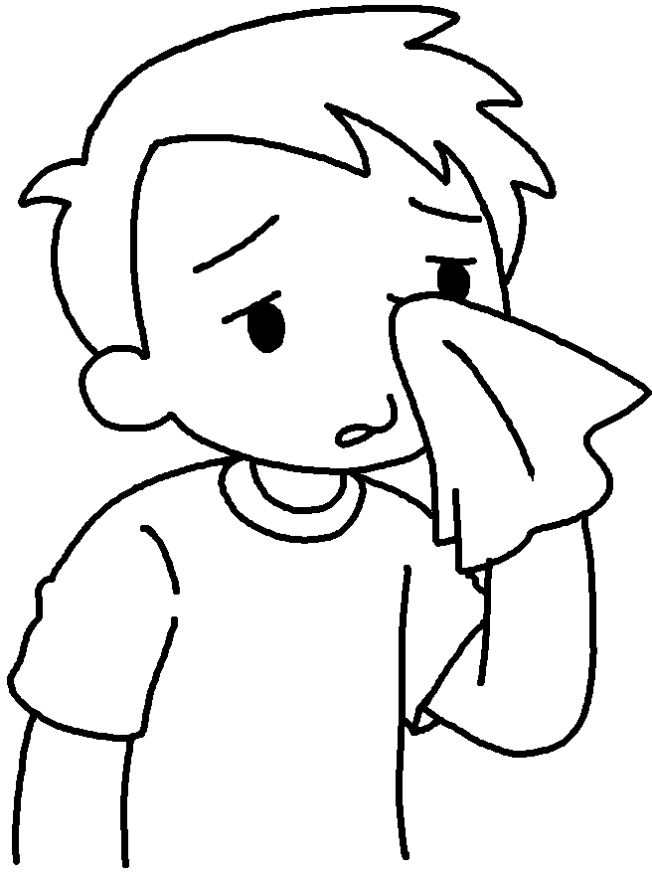

1 | a |  | 2 | a
3 |  |  | 4
5 |  |  | 6
7 |  |  | 8


Book 5B Chapter 7 Graded Worksheets
Worksheet 1⬇⬇⬇
1 fever 2 stomachache
3 a cough 4 a toothache
5 a sore throat 6 the flu
7 a headache 8 a cold

