RP no: Century Gothic 15pt
(所有圈號用15pt)

Choose and write.
What’s the matter?
A
B
A
B
A
B
A
B
A
B
I’ve
got
a fever
a toothache
a cough

1 | 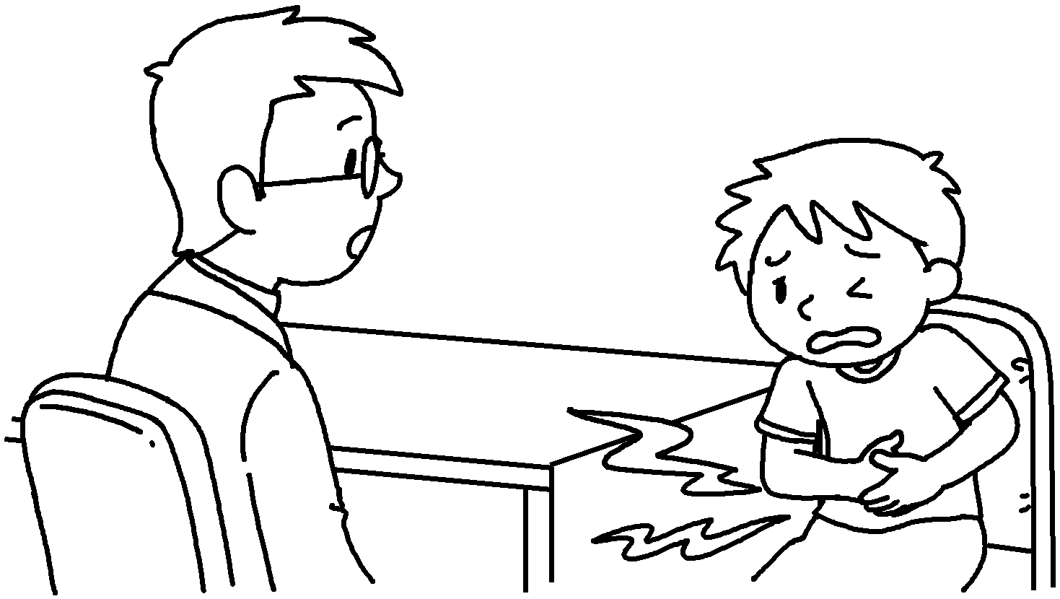 | A : What’s the matter?  B : a stomachache.
2 | 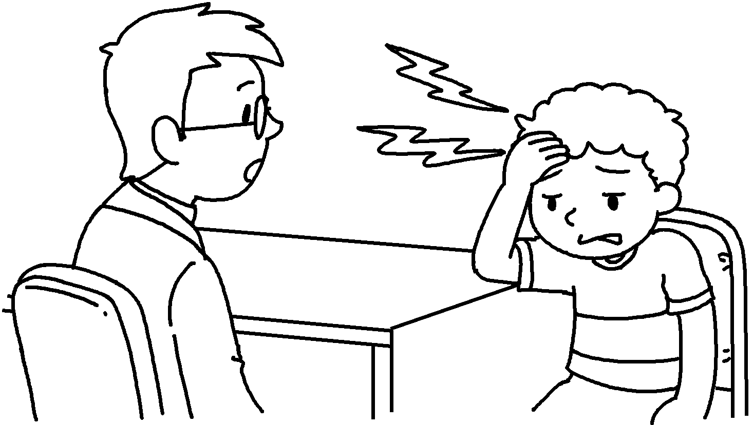 | A :  B : I’ve got a headache.
3 | 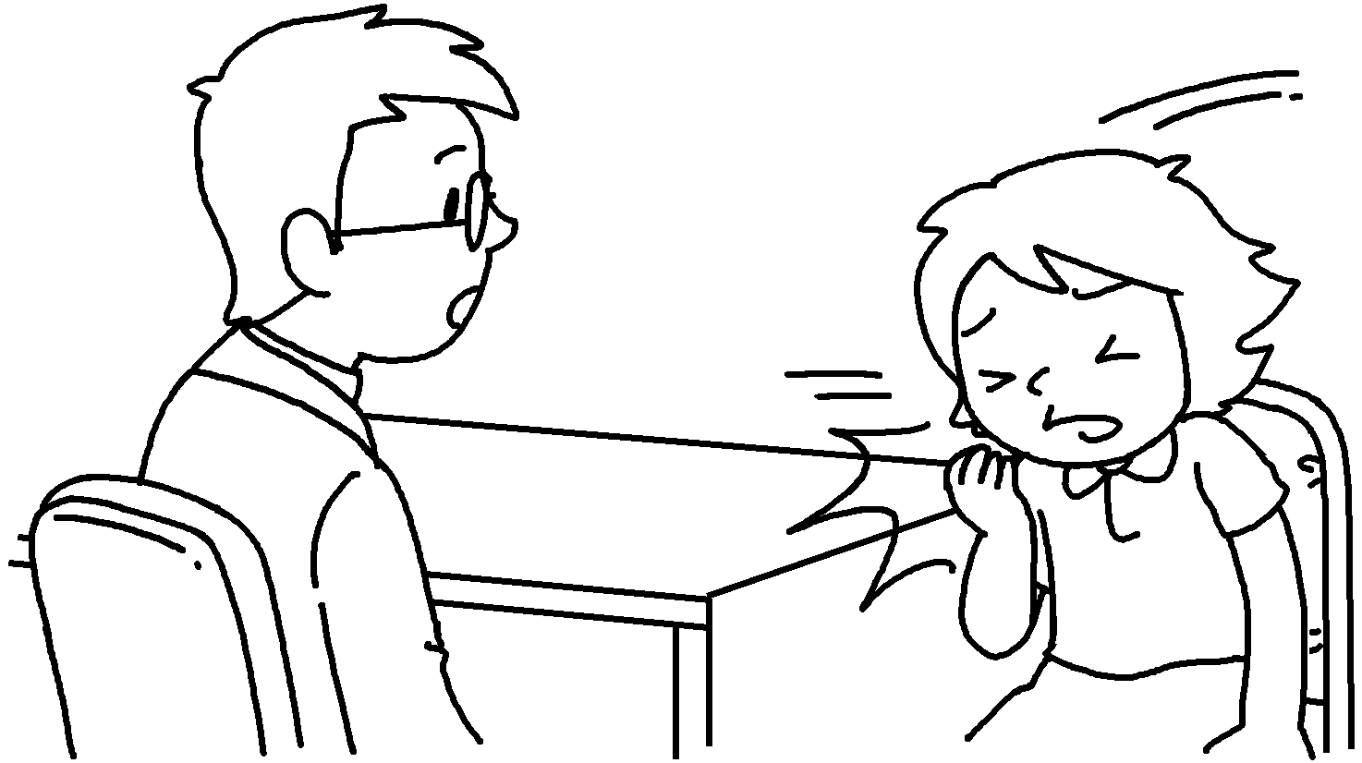 | A : What’s the matter?  B : I’ve got .
4 | 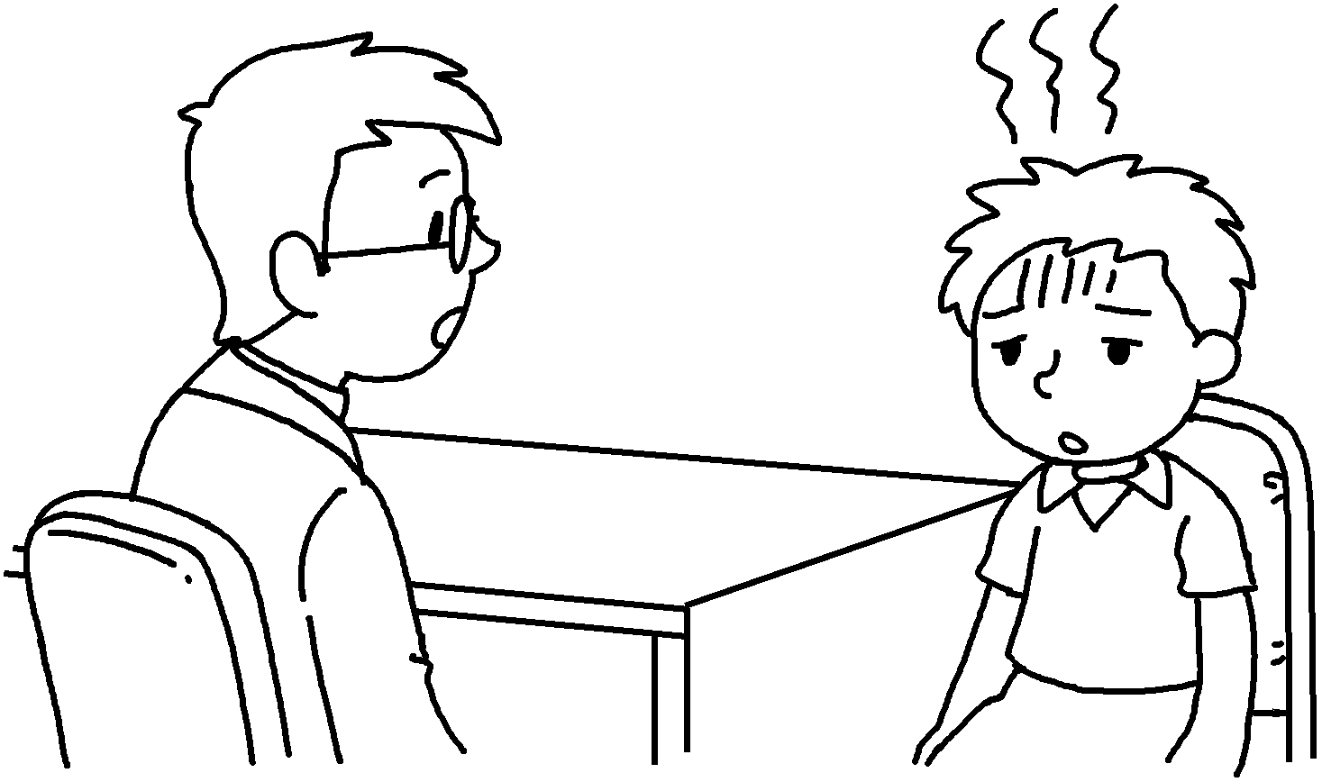 | A :  B :
5 | 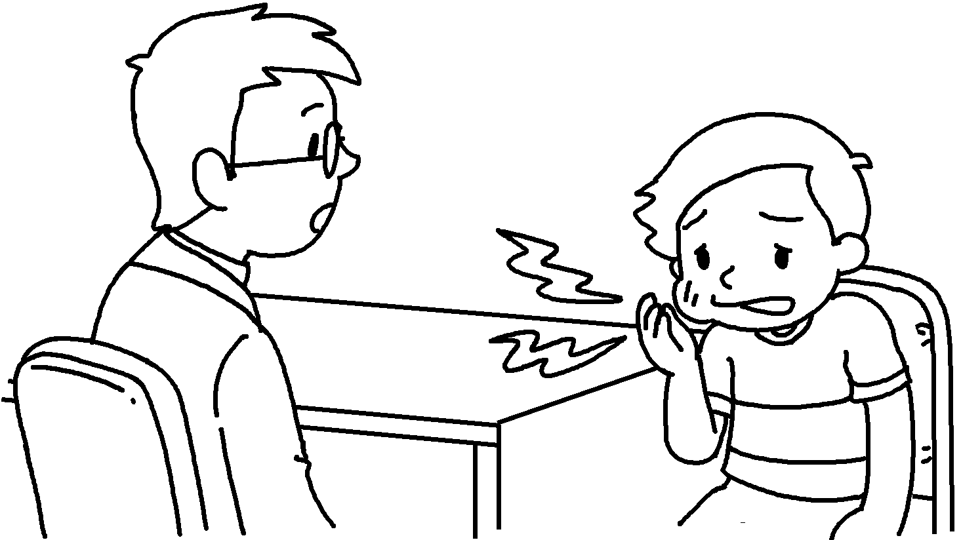 | A :  B :

RP no: Century Gothic 15pt
(所有圈號用15pt)


Book 5B Chapter 7 Graded Worksheets
Worksheet 2⬇
- I’ve got
- What’s the matter?
- a cough
- What’s the matter?
I’ve got a fever
- What’s the matter?
I’ve got a toothache.

